Maths Home Learning – week beginning 18th May

This week we are going to recap some of our learning from last term.
Monday – WALT: make doubles
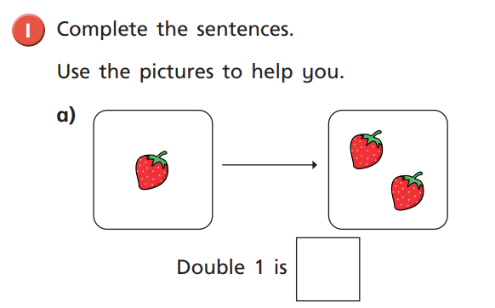
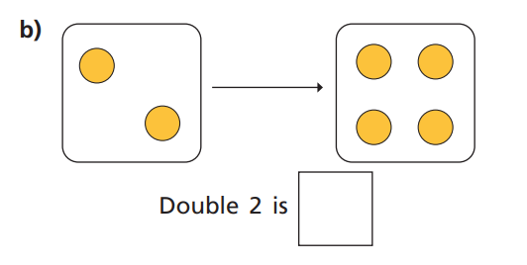
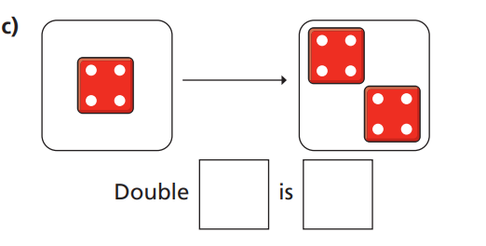
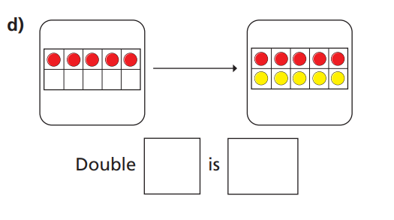
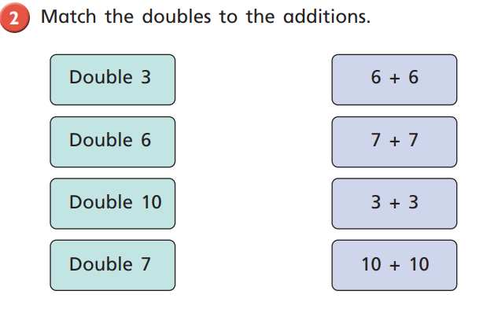
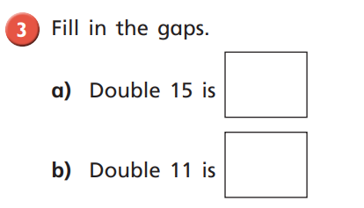
Note: The children are welcome to use resources to support them with these sums. Or they could make the doubling butterflies, which demonstrate 11 on one side of the butterfly’s wings will double up to 11 on the other wing, which equals 22 dots.
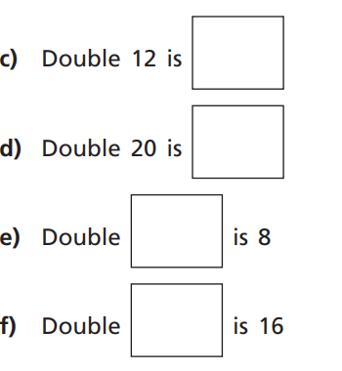

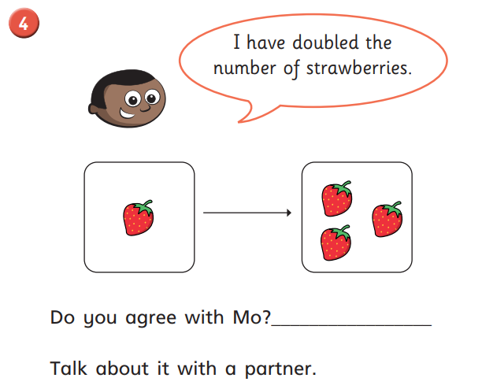

Additional Task: We did this in school not long before the school closure so the children should be familiar with this.
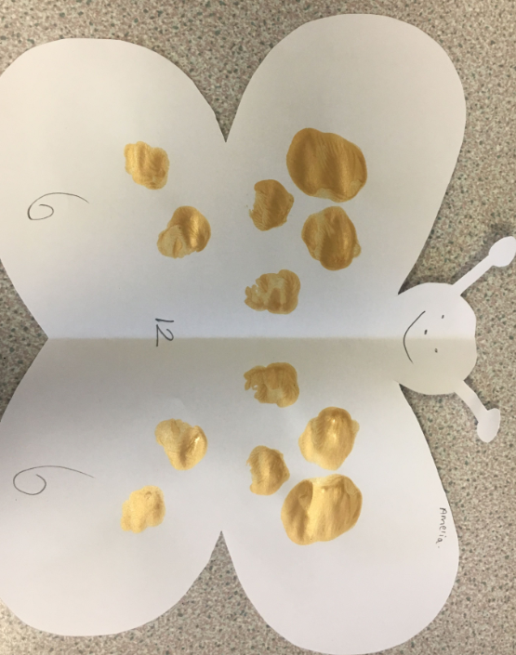
This is just to cover a child’s name; it is not part of the activity.

Tuesday – WALT: make equal groups (grouping)
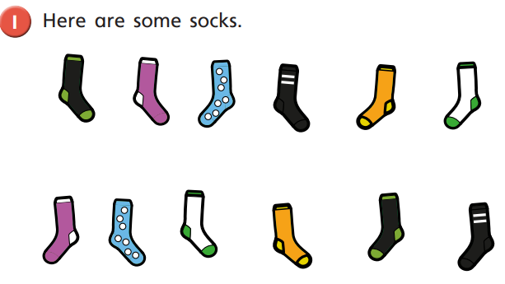
- Draw lines to match the pairs of socks
- Complete the sentences.
There are socks altogether

There are socks in each pair.

There are pairs of socks.

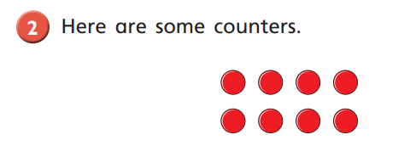
- Circle groups of 2
- Complete the sentences.
There are counters altogether

There are equal groups of 2 counters

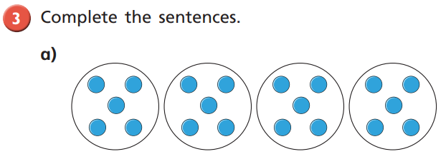
There are counters altogether.

There are equal groups of counters.

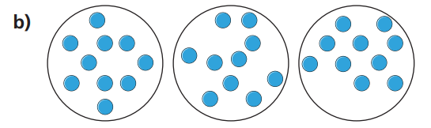
There are counters altogether.

There are equal goups of counters.

Or 30 marbles, 30 toy cars, 30 Lego bricks, 30 pebbles (your choice)
- How many equal groups of 2 can you make?

- How many equal groups of 5 can you make?

- How many equal groups of 10 can you make?
Talk about your answers with a parent.
Challenge: can you write a number sentence to represent each answer?

Wednesday – WALT: make equal groups (sharing)
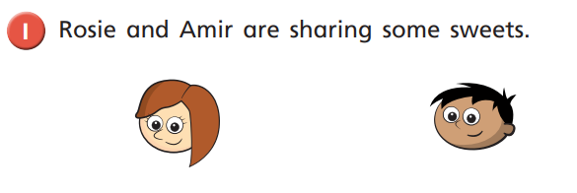
- Draw lines to share the sweets equally.
- How many sweets will each child have?

Each child will have sweets.

8 sweets shared equally between 2 people is sweets each.

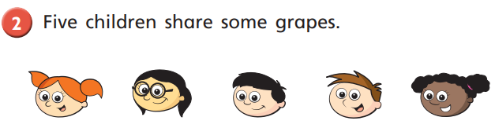
- Draw lines to share the grapes equally.
- How many grapes will each child have?

Each child will have grapes.

grapes shared equally between 5 people is grapes each.

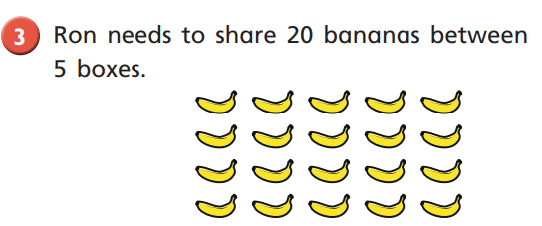
How many bananas will there be in each box?
20 bananas shared equally between 5 boxes is
There will be bananas in each box.

Or 30 marbles, 30 toy cars, 30 Lego bricks, 30 pebbles (your choice)

- Share the 30 counters (cars, Lego bricks) between 2 people. This could be between you and a sibling, or a parent.
How many counters (bricks) will each person have?

- Share the counters (bricks) between 5 people.
How many counters (bricks) will each person have?

- Share the counters (bricks) between 10 friends.
How many counters (bricks) will each person have?

Thursday – WALT: find and make number bonds
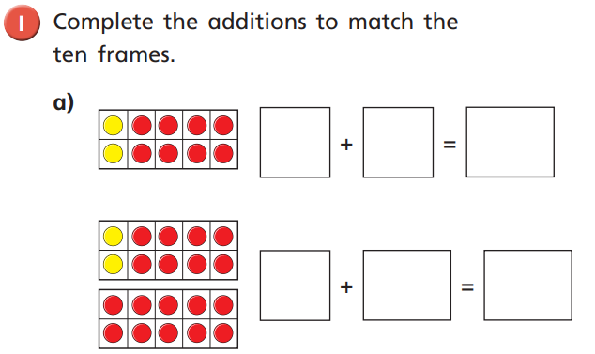
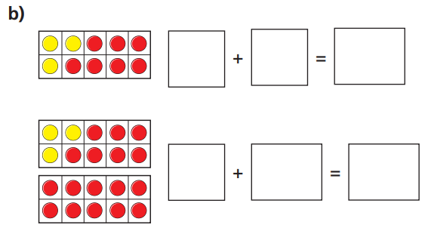
c)What do you notice?

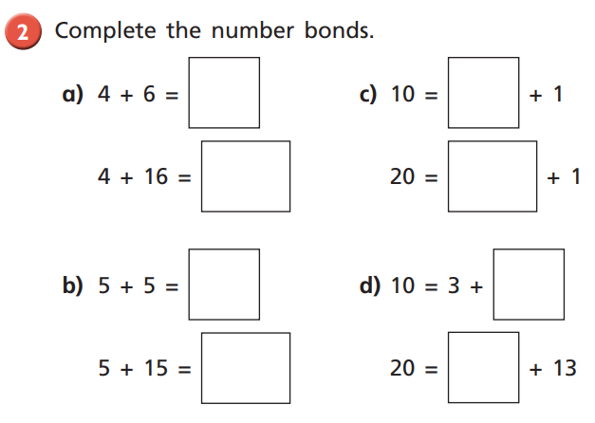

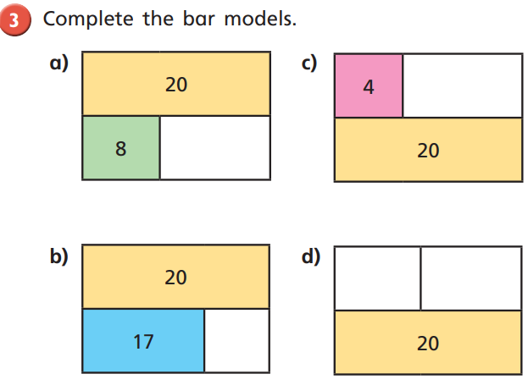

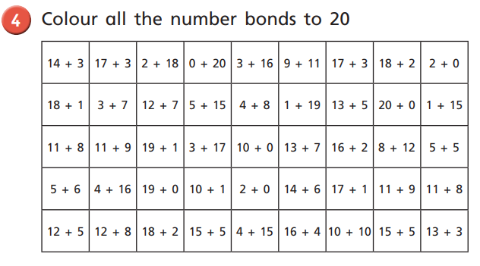
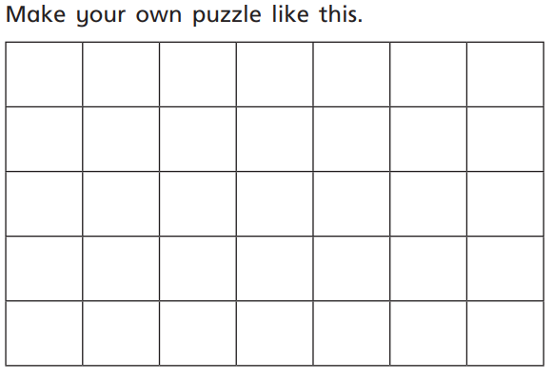
Friday – WALT: understand fact families (linking addition and subtraction)
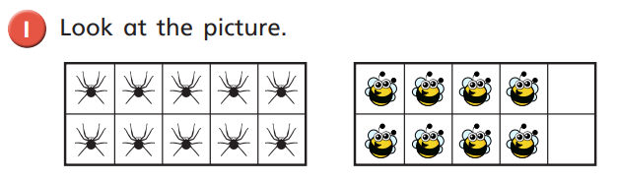
Complete the part-whole model and fact family number sentences below.
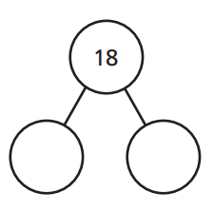
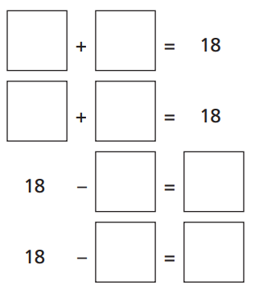
Note: the children have done this a fair bit in class, but if need resources to support their learning, that is absoultely fine!
They could use 18 of their favourite toys and physically represent the number sentneces above to support their learning and fill in the missing numbers.

Challenge: can you write the number sentences in a different way?

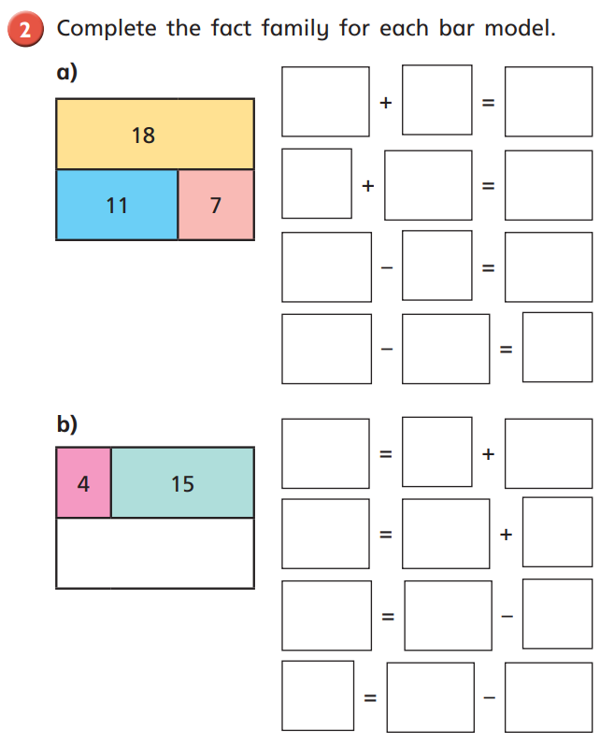

Challenge: Draw your own bar models. Ask a family member to write the fact family number sentences to match!

