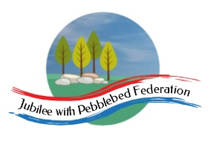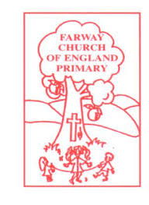

Class 2, Farway C of E Primary School

Dear Parents and Members of Class 2,

I hope you enjoyed last week’s visit to Mexico. This week, we will be heading back across to Europe – virtual travel is so much cheaper and more environmentally friendly than actual travel! We will be visiting Austria for the Vienna Festival, which should have been about to start on 15th May. Founded by Austrian artists keen to reconnect with the world after World War II, the Vienna Festival explores dance, music, theatre and the visual arts. In particular, we will focus on classical music this week as we learn about the lives and work of several famous composers, both those who were born in Austria and others who made their home there.

We are making a special scrap book in school to record some of the things you have been getting up to at home for the school archives so we would love to receive any photos or pieces of work that you would like to send in.

For more PE ideas, especially for a Monday afternoon when we would be working with Premier League, why not check out https://plprimarystars.com/home-learning

Also look out for a lovely pack from CAPUK which can be found on our website, to support children and families. Remember: stay Safe, Strong and Free. (Do you remember the actions?)

Happy learning! I’m looking forward to being with you again soon,

Mrs Marsh

The most important thing you can do to support your child’s learning whilst schools are closed is to ensure that they read every day and they continue to practise their number bonds and times tables.

Don’t forget to keep using the accounts you have through our school to practise basic skills, such as reading, reading comprehension (Bug Club), Times tables (Times Table Rock Stars) and Spelling (Spelling Shed). I have set work on TTRS each week and I shall be checking these sites regularly to keep an eye on what you’re doing. Feel free to challenge me (Irox Peel) to a Rockslam competition!

Week beginning Monday 11th May

Monday  11th May | Core activities |  |  | Suggestions for additional activities.
9.00 – 9.30 | Daily Dashboard:  Quelle est la date aujourd’hui?  C’est lundi l’onze mai 2020.  Can you write the number date in Roman numerals?  On 11th May 1981, Andrew Lloyd Webber’s musical ‘Cats’, based on ‘The Book of Practical Cats’ by T.S. Eliot, was performed for the first time. You can watch an extract of the musical here: https://www.youtube.com/watch?v=GbpP3Sxp-1U  Contrast this with Rossini’s famous ‘Cat duet’ - https://www.youtube.com/watch?v=QNyR6rsGDyg | In Argentina, South America, today is National Anthem Day (Dia del Himno Nal.) You could celebrate this by exploring and listening to a range of national anthems. Which do you like best and why? If you had to write or choose a new national anthem for our own country, what would it be and why?  Here are links to the National anthems of some of the countries we are learning about:  Austria: https://www.youtube.com/watch?v=AQfp888IRpo  Mexico: https://www.youtube.com/watch?v=Q8T9g7memUk  The Netherlands: https://www.youtube.com/watch?v=dX7sFsXG4TI  Japan: https://www.youtube.com/watch?v=cMBbkjMM8p8  Thailand: https://www.youtube.com/watch?v=BrcGzLIEsAU
9.30-10.00 | Spelling – see Spelling Resources |  |  | Use your spelling shed login to practise by playing spelling games.
10.00- 10.30 | Time for some PE…  On 11th May 1893, Henri Degrange, who later originated the famous Tour de France in 1903, set the world’s first bicycle world record, by cycling 35.325 miles per hour. Why not celebrate today by going for a ride on your bicycle?
10.30-11.30 | Maths – Use the following website to watch tutorial videos, print off activities and then use the marking guidance to see how you got on. https://whiterosemaths.com/homelearning/ |  |  | Today, we are travelling back from Mexico to Austria. Look at the chart below, showing the distances between London, our own capital city, and those of the various countries we have visited so far on our world tour and then answer the questions below.
11.30-12.00 | Have a break and play a game or do another activity that you enjoy.
12.00- 1.00pm | Lunch break. Eat a healthy lunch and, if you are able, try to get outside for some fresh air!
1.00pm – 1.30pm | Reading – Read a chapter or two more in your latest Bug Club book. Don’t forget to click on the bugs to answer the comprehension questions. |  | Alternatively, why not read more about the capital city of Austria, Vienna and answer some comprehension questions? See https://www.really-learn-english.com/english-reading-comprehension-vienna.html
1.30pm – 3.00pm | Theme  Watch the following video to learn more about Austria through the medium of song. https://youtu.be/5oKLMiSRp-U  Watch the video twice and the second time, make some notes about some of the facts that you have learned about the country.  Then, use an atlas or online map to research where Austria is and some of the important places and features of the country. Complete the Austria fact file (below) and compare it to others you have completed in recent weeks.  Have a go at the Austria word search, checking that you know what each of the words means and why they are included on an important vocabulary list for this country.  What other key words could have been included in a word search about Austria? Why not make a list of other words linked to the country and make your own word search? Alternatively, you could choose a place in the country to find out more about, using travel websites and write a report about it or make a poster for a travel agency, encouraging people to visit it. Here are a few suggestions: Vienna, Salzburg, Innsbruck, Graz, Zell Am See, Tyrol, Hallstatt.  The following website is a good place to start: https://traveltriangle.com/blog/places-to-visit-in-austria/ |  |  |  | Have another look at the Geography quizzes on https://world-geography-games.com/europe.html to help continue to develop your ability to locate and name countries, capitals and rivers in Europe. Be careful – these quizzes can get addictive! But they are really good for improving your general geographical knowledge.  You will find a lot more information about Austria here: https://kids.britannica.com/kids/article/Austria/345640

Maths Challenge:

 | London | Bangkok | Tokyo | Amsterdam | Mexico City | Vienna
London |  | 5,919 km | 9,556 km | 380 km | 5,545 km | 1,280 km
Bangkok | 5,919 km |  | 4,606 km | 5,703 km | 15,740 km | 8,435 km
Tokyo | 9,556 km | 4,606 km |  | 9,287 km | 11,294 km | 9,127 km
Amsterdam | 380 km | 5,703 km | 9,287 km |  | 9220 km | 960 km
Mexico City | 5,545 km | 15,740 km | 11,294 km | 9220 km |  | 10,145 km
Vienna | 1,280 km | 8,435 km | 9,127 km | 960 km | 10,145 km

- The distance between Mexico City and Vienna is km.

- The city closest to Vienna is .

- London is km further away from Vienna than from Amsterdam.

- The furthest of the capital cities visited from London is which is km away.

- Rounded to the nearest 100 km, the distance between Vienna and Bangkok is km.

Challenge:
If I travelled from London to Bangkok, then to Tokyo, then to Amsterdam, then to Mexico City, then to Vienna, what is the total distance I would have travelled?

Can you find a shorter route to visit these 6 cities?

How about inventing some problems of your own based on the table of distances?
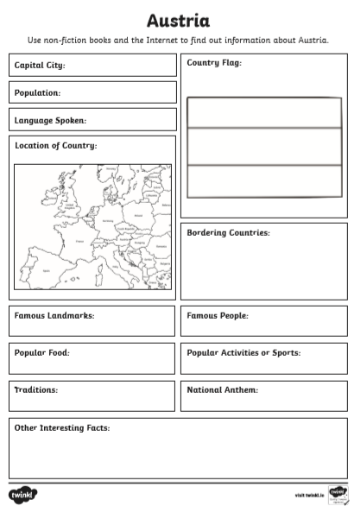

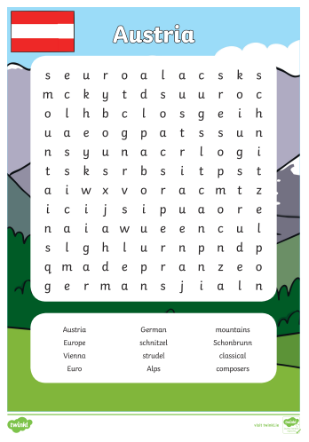

Tuesday 12th May | Core activities |  | Suggestions for additional activities.
9.00 – 9.30 | Daily Dashboard:  Quelle est la date aujourd’hui?  C’est mardi le douze mai 2020.  Can you write the number date in Roman numerals?  What is happening in the world? Have a look at https://www.bbc.co.uk/newsround or https://www.dogonews.com/ to see what is going on in the world. Choose a news article or two to read. |  | Today, 12th May, marks the anniversary of the birth of Florence Nightingale and so is International Nurses Day. Do you know any nurses that you could send some encouragement to? Why not make them a card? Alternatively, see what you can find out about the new Nightingale hospitals that have been set up around the country to help cope with additional numbers of patients due to the Coronavirus pandemic.
9.30-10.00 | Spelling – Practise spelling the following words from the statutory lists:  Y3/4 – address, exercise, experiment, position, surprise  Y5/6 – bruise, guarantee, queue, programme, rhyme  What this week’s words have in common is that they can all be used both as a verb and as a noun. Can you write sentences using each word as a verb and then another set of sentences using each word as a noun?
10.00- 10.30 | Time for some physical activity. Austria is one of the countries that is home to the Alps and is also the home of many climbers. What could you find to climb up today? (Stay safe and discuss your plans with an adult!)
10.30-11.30 | Maths – Use the following website to watch tutorial videos, print off activities and then use the marking guidance to see how you got on. https://whiterosemaths.com/homelearning/ |  | Alternatively, you could try out the new BBC Bitesize daily lessons.  How about a new game to practise maths skills?  Maths football game from Premier League Primary Stars
11.30-12.00 | Have a break and play a game or do another activity that you enjoy. | Stay connected – who could you make a phone call or send an email to to to keep in touch?
12.00- 1.00pm | Lunch break. Eat a healthy lunch and, if you are able, try to get outside for some fresh air!
1.00pm – 2.00pm | Reading/ Literacy time  Research key words: composer, opera, concerto and premiere.  Read about the famous composer Wolfgang Amadeus Mozart in the text below and answer the questions. Make a note of any other words you don’t understand so that you can look them up and practise reading them fluently. Then, write a brief biography of Wolfgang Amadeus Mozart to summarise what you have learned.  Note: There is another more complex text and a biography template in ‘Additional Information Austria’. |  |  | Alternatively, read more about Austria and its former empress Elisabeth and answer the comprehension questions here: https://www.really-learn-english.com/english-reading-practice-article-austria.html  Book suggestion – Have you readThe Mozart Question by Michael Morpurgo?
2.00pm – 3.00pm | Theme – Music  Listen to some of Mozart’s most famous music: on the following website you will find information about the composer as well as links to some of his most famous compositions. https://www.classicsforkids.com/composers/composer_profile.php?id=46  Listen to the show about Mozart and complete the quiz on https://www.classicsforkids.com/shows/shows.php?id=65  You can also play games to learn musical terms, names of instruments etc.  Here is another website containing links to videos of performances of some of Mozart’s music.  This website features an extract from the BBC’s excellent programme ’10 pieces’ about Mozart’s Horn Concerto No. 4: https://www.bbc.co.uk/teach/ten-pieces/KS2-wolfgang-amadeus-mozart-horn-concerto-no-4-3rd-movement/zmxtng8  Listen to one or two extracts of Mozart’s music and complete the Music appreciation sheet below to record your observations. You may wish to do this for more than one piece of music and compare. |  |  |  | Have you discovered the Royal Scottish National Orchestra’s music challenges? Why not have a go at one or two of these? See https://www.rsno.org.uk/rsnochallenge/

READING

Wolfgang Amadeus Mozart
Wolfgang Amadeus Mozart was one of the most famous composers in history. He composed hundreds of works that included sonatas, symphonies, masses, chamber music, concertos and operas.
Wolfgang Amadeus Mozart was born on January 27, 1756, in Salzburg, Austria. His father Leopold was a successful composer and violinist. Wolfgang had one sister, Maria Anna. Leopold started teaching his children music at a very early age. They were both very good at it.
When Wolfgang was six years old, his father took him and his sister to Munich. It was the first of their European tours: they performed in Paris, London, The Hague, and Zurich. In London, Mozart met Johann Christian Bach, Johann Sebastian Bach's youngest son.
In December 1769, Wolfgang and his father made a trip to Italy. During this time, Wolfgang wrote a new opera, Mitridate, re di Ponto. The Mozarts made more trips to Italy. After they returned from the last one, Mozart produced five violin concertos. In 1776, he turned his attention to piano concertos.
In 1781, Mozart moved to Vienna. There he wrote an opera called The Abduction from the Seraglio. It was very successful and made Mozart even more famous. When Mozart was in Vienna, he became friends with Joseph Haydn. The two composers really liked each other. In 1782, Mozart married Constanze Weber. They had six children, but four of them died. Mozart and Constanze lived extravagantly and they got into serious financial difficulties. One of Mozart’s rivals at this time was Antonio Salieri. Some people think that Salieri poisoned Mozart, but it is probably not true.
In 1785, the opera The Marriage of Figaro had a premiere in Vienna. In 1787, Don Giovanni had a premiere in Prague. Mozart’s financial problems got worse and he had to borrow money from his friends. The years 1788–1789 were really hard for him. He felt really depressed. His financial situation got better in the 1790s. Between 1790 and 1791, he composed some of his most famous works – the opera The Magic Flute, the unfinished Requiem, and many others. However, his health was getting worse.
Wolfgang Amadeus Mozart died on December 5, 1791 at age 35. At the time of his death, he was considered one of the greatest composers of all time.

1 Read the text and answer the following questions.
1 How many sisters did Wolfgang Amadeus Mozart have? _________________________________________
2 How old was Mozart when his father took him to Munich? _______________________________________
3 Who did Mozart meet in London? ___________________________________________________________
4 Which opera did Mozart compose in Italy? ____________________________________________________
5 When did Mozart move to Vienna? __________________________________________________________
6 Where did Don Giovanni have a premiere? ____________________________________________________
7 How old was Mozart when he died? __________________________________________________________

2 Are these sentences true (T) or false (F)?
1 Wolfgang Amadeus Mozart’s father was a musician. _____
2 Mozart’s sister Anna Maria wasn’t good at music. _____
3 In December 1769, Mozart made a trip to England. _____
4 Mozart was friends with another composer, Joseph Haydn. _____
5 Some people think that Mozart was killed by Antonio Salieri. _____
6 Towards the end of his life, Mozart had to borrow money from his friends. _____
7 Mozart composed many of his most famous works in the two years before his death. _____

SOURCES: https://www.biography.com/people/wolfgang-mozart-9417115

KEY

1 Read the text and answer the following questions.
1 How many sisters did Wolfgang Amadeus Mozart have? one
2 How old was Mozart when his father took him to Munich? he was six years old
3 Who did Mozart meet in London? Johann Christian Bach, Johann Sebastian Bach's youngest son
4 Which opera did Mozart compose in Italy? Mitridate, re di Ponto
5 When did Mozart move to Vienna? in 1781
6 Where did Don Giovanni have a premiere? in Prague
7 How old was Mozart when he died? he was 35 years old

2 Are these sentences true (T) or false (F)?
1 Wolfgang Amadeus Mozart’s father was a musician. T
2 Mozart’s sister Anna Maria wasn’t good at music. F
3 In December 1769, Mozart made a trip to England. F (he made a trip to Italy)
4 Mozart was friends with another composer, Joseph Haydn. T
5 Some people think that Mozart was killed by Antonio Salieri. T
6 Towards the end of his life, Mozart had to borrow money from his friends. T
7 Mozart composed many of his most famous works in the two years before his death. T

Music Appreciation

Composer:
Title of Music:

What instruments can you hear/ identify in this piece of music?

How would you describe the tempo (speed) of the music? Is it fast or slow or does this change through the piece? Describe how:

Listen carefully to the dynamics. When does the music become louder or softer? Does this change often or is it fairly constant? Describe what you notice:

What is the mood of the music? If you were to draw a picture or pattern to represent this music, what would it look like? Sketch it on the back of this sheet.

If you were to give this music a new name, what would it be and why?

Did you like this music? Why/ why not?

Wednesday 13th May | Core activities |  | Suggestions for additional activities.
9.00 – 9.30 | Daily Dashboard:  Quelle est la date aujourd’hui?  C’est mercredi le treize mai, 2020.  Can you write the number date in Roman numerals?  What is happening in the world? Have a look at https://www.bbc.co.uk/newsround or https://www.dogonews.com/ to see what is going on in the world. Choose a news article or two to read.  On 13th May 1767, Mozart’s first opera, ‘Apollo et Hyacinthus’ was first performed in Salzburg Austria. He was just 11 years old!  Can you find Mozart’s birthplace, Salzburg on a map of Austria? Investigate some of the other towns, cities and famous landmarks of the country. Can you find Innsbuck, Graz, Vienna and Linz on a map? |  | Why not research and write a short report about one or more famous places in Austria, such as:  The Spanish Riding School, Vienna  http://www.visitingvienna.com/sights/spanishridingschool/  The Schoenbrunn Palace in Vienna https://www.schoenbrunn.at/en/about-schoenbrunn/the-palace/  Swarovski Crystal World, just outside Innsbruck  https://www.austria.info/en/summer/swarovski  The following site contains an overview of some of the most famous landmarks and wonders to be seen in Austria: https://www.wondermondo.com/wonders-of-austria/
9.30-10.00 | Spelling – see Spelling Resources
10.00- 10.30 | Time for some physical exercise – Colonel Tom Moore became famous recently by deciding to walk around his garden 100 times before his 100th birthday. Have you got a garden? Could you go around it 100 times – try moving in as many different ways as you can: walking, skipping, running, hopping, crawling, side-skipping, crab-walking, jumping…
10.30-11.30 | Maths – Use the following website to watch tutorial videos, print off activities and then use the marking guidance to see how you got on. https://whiterosemaths.com/homelearning/ |  |  | How about a warm-up using Times Table Rock Stars or else play a Maths game to help practise core number facts?
11.30-12.00 | Have a break and play a game or do another activity that you enjoy. | Eat well – how could you show your appreciation to the people who prepare your daily meals? Why not make a card to say thank you?
12.00- 1.00pm | Lunch break. Eat a healthy lunch and, if you are able, try to get outside for some fresh air!
1.00pm – 1.30pm | Reading time – Read a chapter or two of your latest book on Bug Club. Don’t forget to click on the bugs and answer the comprehension questions! |  |  | Alternatively, read a chapter or two of a novel. Can you summarise a chapter in less than 20 words?
1.30pm – 3.00pm | Theme – Science/ STEM learning  Since we are focusing on the classical music of Austria this week, why not investigate how sounds are produced.  First, check that you understand what is meant by the words vibrate and vibrations. Use the BBC Bitesize resources to investigate how sounds are made, how sounds are detected and what is pitch: https://www.bbc.co.uk/bitesize/topics/zgffr82  Watch the following programme about the sounds of music and how they are made: https://www.bbc.co.uk/teach/class-clips-video/music--science-ks2-what-is-sound/zbnmhbk  Try the ‘Seeing Sound’ experiment below. |  |  |  | Explore sound further. You could set up an experiment, using an alarm clock, buzzer, phone or watch (try to make sure it is not too loud – you may need to muffle the sound by wrapping it up) to see how far sound travels. How far away do you need to move before you can no longer hear the sound? Why not compare different sounds and create a chart or graph of your results. (You could measure the distance in footsteps).

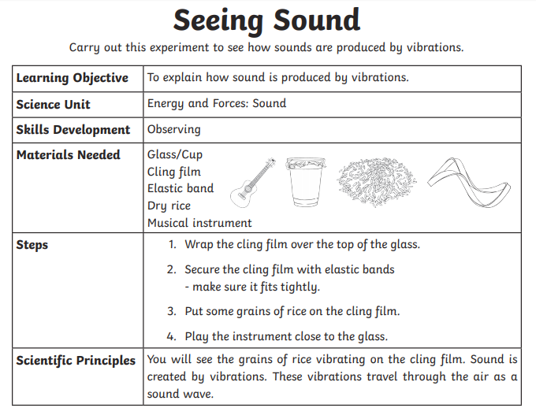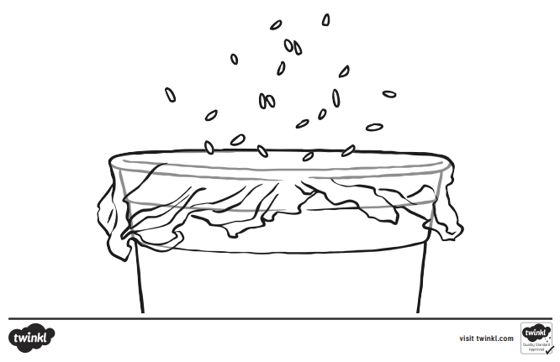

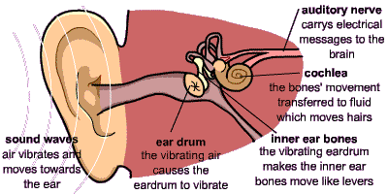
The Ear
Fill in the gaps below:
Sound travels in ____________.
Sound waves are vibrating _______.
The sound waves cause the eardrum to __________________.
The vibrating eardrums make the ________ ________ ________ move like levers.
This movement is transferred to liquid which moves hairs in the _____________.
The _______________ ________________ carries the electrical messages to the brain.
This is how our ears help us ___________________.

Questions:
How do we hear?
Why does the ear pick up sound waves instead of light waves?
How does the message from the sound waves get to your brain?
Fill in the sentences with your thoughts:
Hearing is important to me because…………………………………..
I have two ears and not one because…………………………………
Some common sounds are…………………………………….

Slightly easier version with words supplied:
The Ear
Fill in the gaps below:
Waves vibrate ear bones cochlea nerve hear air inner auditory

Sound travels in ____________. Sound waves are vibrating _______. The sound waves cause the eardrum to __________________. The vibrating eardrums make the ________ ________ ________ move like levers. This movement is transferred to liquid which moves hairs in the _____________.
The _______________ ________________ carries the electrical messages to the brain. This is how our ears help us ________________.

Questions:
How do we hear?
Why does the ear pick up sound waves instead of light waves?
How does the message from the sound waves get to your brain?
Fill in the sentences with your thoughts:
Hearing is important to me because…………………………………..
I have two ears and not one because…………………………………
Some common sounds are…………………………………….

Thursday 14th May | Core activities |  |  | Suggestions for additional activities.
9.00 – 9.30 | Daily Dashboard:  Quelle est la date aujourd’hui?  C’est jeudi le quatorze mai, 2020.  Can you write the number date in Roman numerals?  What is happening in the world? Have a look at https://www.bbc.co.uk/newsround or https://www.dogonews.com/ to see what is going on in the world. Choose a news article or two to read.  Today, we will continue to learn about some of Austria’s most famous composers. How many classical composers can you name in a minute? |  | Today is the birthday of famous film director George Lucas, who directed the Star Wars and Indiana Jones films among many others. It is also the birthday of pop singer Olly Murs, co-creator of Facebook Mark Zuckerberg and USA star footballer Rose Lavelle, who helped her team to win the 2019 World Cup. You can find a host of other holidays, birthdays and anniversaries being celebrated today around the world here: http://www.holidays-and-observances.com/may-14.html
9.30-10.00 | Spelling – see Spelling Resources
10.00- 10.30 | Time for some physical activity. Why not play a lively piece of music and make up a dance routine with your family?
10.30-11.30 | Maths – Use the following website to watch tutorial videos, print off activities and then use the marking guidance to see how you got on. https://whiterosemaths.com/homelearning/  Why not visit https://nrich.maths.org/9803 and have a go at one of the Maths investigations there. Be warned – these will really make you think! |  |  | How about a warm-up using Times Table Rock Stars or else play a Maths game to help practise core number facts?
11.30-12.00 | Have a break and play a game or do another activity that you enjoy. | Care for others – what little job around the house could you do today to show care for someone in your family?
12.00- 1.00pm | Lunch break. Eat a healthy lunch and, if you are able, try to get outside for some fresh air!
1.00pm – 1.30pm | What have you read and enjoyed lately? Why not write a book review to inspire others to read this book? Send it in to school and we can create a bank of recommendations to help others choose new books to read. Check out the website below for free access to books and read-alongs:  https://www.harpercollins.com/childrens/at-home-resources-for-kids-and-families-during-coronavirus-2020/
1.30pm – 3.00pm | Theme – Music/ Literacy  Your challenge today is to find out more about one of the following classical composers who all lived and/ or worked in Austria at some point in their lives: Johann Strauss II (composer of The Blue Danube https://www.youtube.com/watch?v=_CTYymbbEL4) , Franz Joseph Haydn (composer of the Surprise Symphony https://www.youtube.com/watch?v=tF5kr251BRs )  Franz Schubert (composer of Ave Maria https://www.youtube.com/watch?v=3d4xXvF2ukY)  Gustav Mahler (https://www.youtube.com/watch?v=39OFMgh6JwY)  Ludwig van Beethoven (who wrote Für Elise https://www.youtube.com/watch?v=e4d0LOuP4Uw and the Moonlight Sonata https://www.youtube.com/watch?v=sbTVZMJ9Z2I)  Choose a composer, listen to some of their music and write about it – you may wish to use the Music appreciation sheet from earlier in the week.  You could also research and write a brief biography of the composer you have chosen or make a fact file about their life. |  |  |  | Why not have a go at another of the Royal Scottish National Orchestra’s music challenges?  See https://www.rsno.org.uk/rsnochallenge/  You could use the composition sheet below to have a go at composing your own piece of music. You may have to improvise some instruments! Remember body percussion and voice sounds we’ve done together. If you have a limited number of players, why not record yourselves playing one instrument and then play along as you watch it back, playing another instrument, to create a more multi-layered sound!

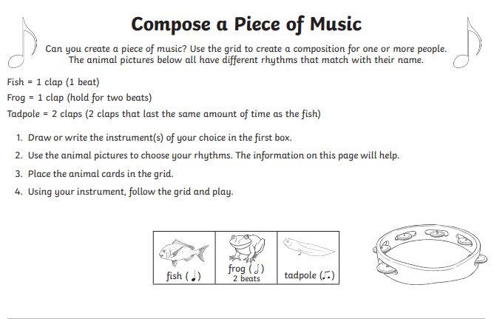
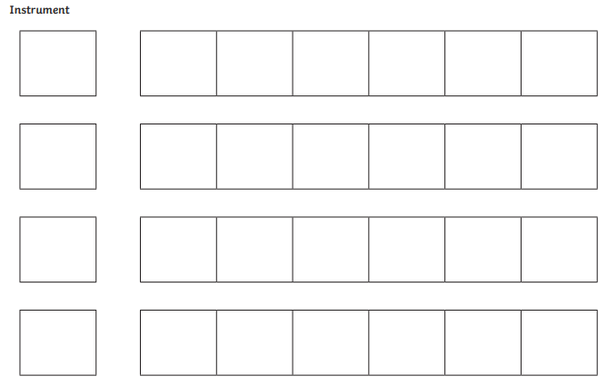
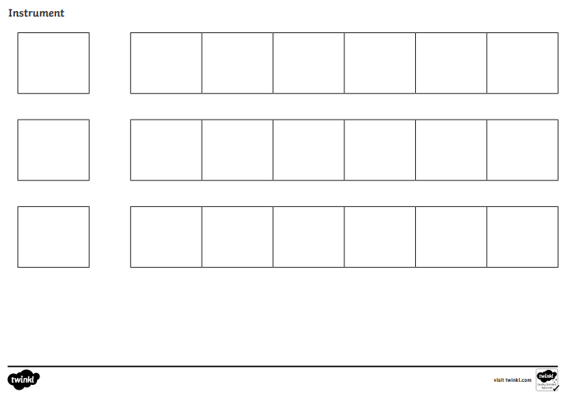

Friday 15th May | Core activities |  |  | Suggestions for additional activities.
9.00 – 9.30 | Daily Dashboard:  Quelle est la date aujourd’hui?  C’est vendredi le quinze mai, 2020.  Can you write the number date in Roman numerals?  What is happening in the world? Have a look at https://www.bbc.co.uk/newsround or https://www.dogonews.com/ to see what is going on in the world. Choose a news article or two to read.  Today is the day the Vienna Festival 2020 was due to start. The Wiener Festwochen (Vienna Festival) is a cultural festival in Vienna that takes place every year for five or six weeks in May and June. The Wiener Festwochen was established in 1951, when Vienna was still occupied by the four Allies. Each year the festival attracts about 180,000 visitors.  Find out more about what was planned for 2020 on the Festival website: https://www.festwochen.at/en/latest-update |  |  | If you were planning an arts festival, what sort of events or acts would you include? Or, if you were visiting an arts festival, what events would you want to visit – dance, theatre, music, art exhibitions etc?  The main language spoken in Austria is Austrian German. Why not learn a few words of German today?  Watch https://www.youtube.com/watch?v=QWcZGv_fWR8 and/ or  https://www.youtube.com/watch?v=aZJhkghsWGM and  https://www.youtube.com/watch?v=g4wQ2PNNaWY
9.30-10.00 | Spelling – Have a look back over the words you have practised this week. Test yourself (or ask someone to test you) to see how well you have remembered these words. Then practise any words you still need to secure.
10.00- 10.30 | Time for some physical activity. What about setting up a variety of circuit-training activites? You could include: star jumps, burpies, calf raises, skipping, bicep curls (use water bottles for weights), shuttle runs, bear crawls, high knee running… what other exercises can you think of?
10.30-11.30 | Maths – Use the following website to watch tutorial videos, print off activities and then use the marking guidance to see how you got on. https://whiterosemaths.com/homelearning/ | How about a warm-up using Times Table Rock Stars or else play a Maths game to help practise core number facts?  Why not try a BBC Supermovers Maths video to help warm up your Maths brain while getting in a bit of movement?  https://www.bbc.co.uk/teach/supermovers/ks2-maths-collection/z7frpg8
11.30-11.45 | Have a break and play a game or do another activity that you enjoy. |  | Be proud of your very being! What have you done well this week? Why not award yourself a certificate!
11.45 – 12.00 | Why not join in with the act of Collective Worship that you will find on the school website. Take time to think about how you can use your own creativity to make life a little brighter or easier for someone else.
12.00- 1.00pm | Lunch break. Eat a healthy lunch and, if you are able, try to get outside for some fresh air!
1.00pm – 1.30pm | Reading  How are you getting on with reading on Bug Club? Spend some time reading one of the books allocated to you and answer the comprehension questions by clicking on the bugs. |  |  | Alternatively, read a chapter or two of a novel. Pick out a few of your favourite sentences and consider what the author has done to make them have an impact on the reader. Share your thoughts with someone at home.
1.30pm – 3.00pm | Theme: STEM  On Wednesday, we looked at how sounds are made. Today, let’s explore further how musical instruments produce sound.  Watch https://www.bbc.co.uk/bitesize/clips/zqtxpv4  You may also find it helpful to watch the following clips about understanding sound https://www.bbc.co.uk/bitesize/clips/z9h6n39 and what makes sounds higher or lower https://www.bbc.co.uk/bitesize/clips/z29c87h.  Have a go at making your own musical instrument. You could use the instructions below, or invent your own. Will you make the sound by hitting, plucking or blowing? Can you find a way to make a tuned instrument (that is, one on which you can alter the pitch (how high or low the notes are) and play a tune?  Evaluate your instrument. Does it sound like you had hoped? If you made another, how could you improve or adapt it?  You could use the instrument/s you have made to create your own musical composition.  Or, you could write an explanation text about your instrument and how it works. |  |  | Alternatively, you could continue to explore ways to create your own musical compositions, using instruments you have at home or ones you improvise from household objects.  You might want to do some more research about different musical instruments in a classical orchestra:  https://www.classicsforkids.com/music/instruments_orchestra.php  You can explore further and test your knowledge with an interactive quiz on https://www.dkfindout.com/uk/music-art-and-literature/musical-instruments/orchestra/
That’s it folks for our musical visit to Austria. Next week, the plan is to head further east to Russia for the White Nights Festival in St. Petersburg.

Hope you have had a great week and remember to stay safe!

