Grammar and Spelling Resources: Week Beginning Monday 29th June 2020
Monday: Year 3 and 4 – Present Perfect Tense
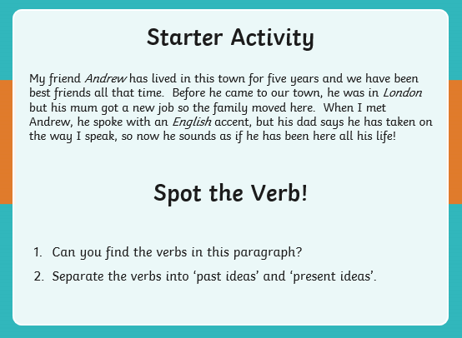
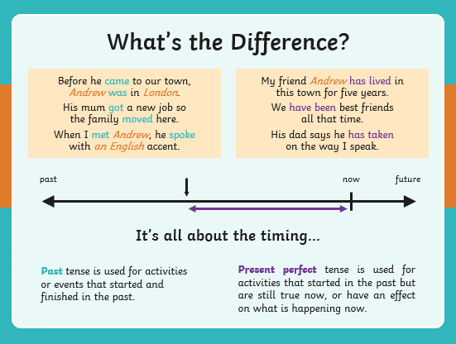

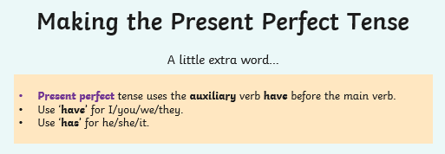
- My friend Andrew lived in this town for five years.
- We been best friends all that time.
- His dad says he taken on the way I speak.
- Unfortunately, the cat been sick on the carpet – yuk!
- Mum asked, “Where you been all this time?”
- What a shame; Sports Day been postponed because of the rain.
- every person chosen a partner now?
- “What happened to all my pencils?” asked the teacher.

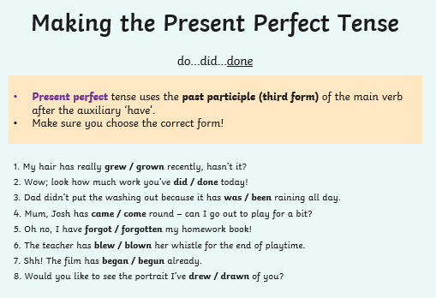

Answers:
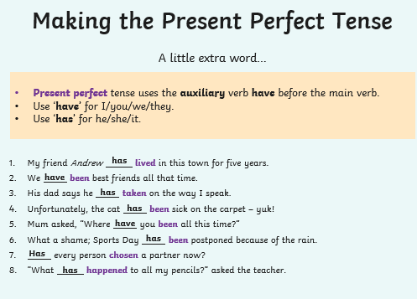
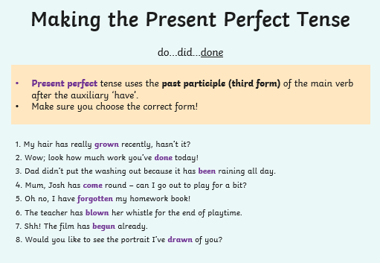
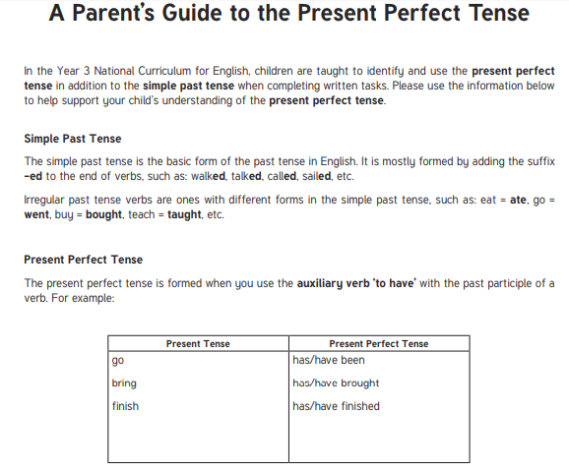
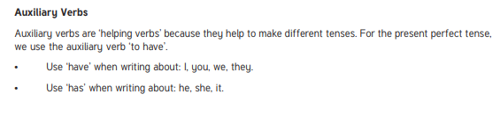

Monday – Year 5 and 6: Revision
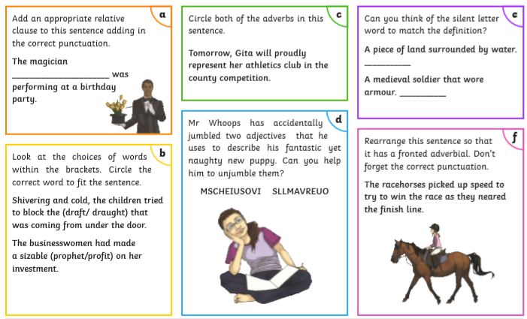
Answers:
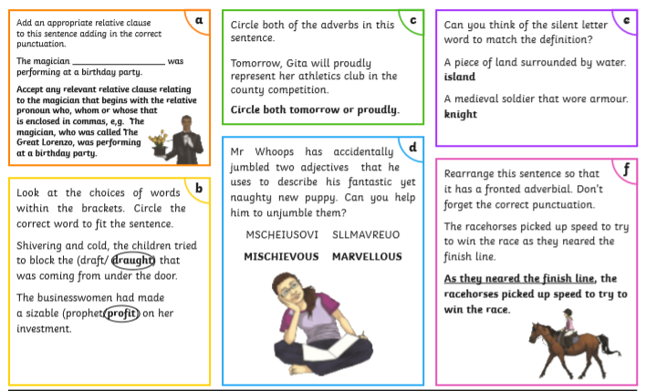
Tuesday – Year 3 and 4
This week’s words to practise from the statutory word list are below. First, practise writing them in neat, cursive writing, following the example carefully. Listen carefully as you say the words to how each phoneme is pronounced. What patterns or similarities do you notice between these words? Which two are different to the others? How? How are they similar to the others?
Now practise using each of the words in a sentence. Then underline the spelling word and explain its function in your sentence. Is it being used as a noun, verb, adjective or adverb?

Tuesday – Year 5 and 6
This week’s words to practise from the statutory word list are below. First, practise writing them in neat, cursive writing, following the example carefully. All of these words contain an unstressed vowel sound. This is a vowel that, rather than making the usual sound of the letter, makes a sort of ‘uh’ sound. Can you find the unstressed vowel in each word?
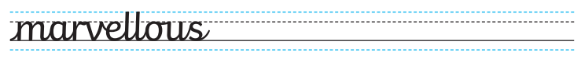
Now practise using each of the words in a sentence. Then underline the spelling word and explain its function in your sentence. Is it being used as a noun, verb, adjective or adverb?

Wednesday – Year 3 and 4: Present Perfect Tense
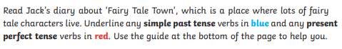
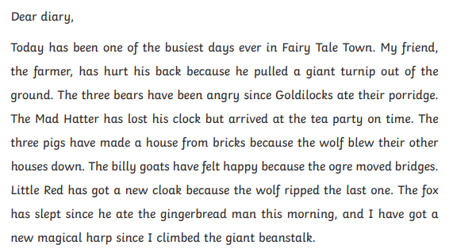
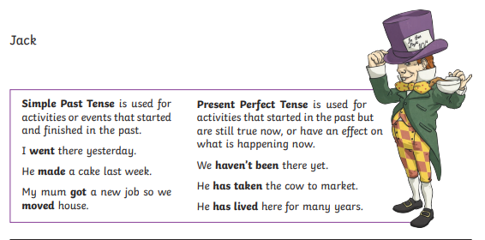

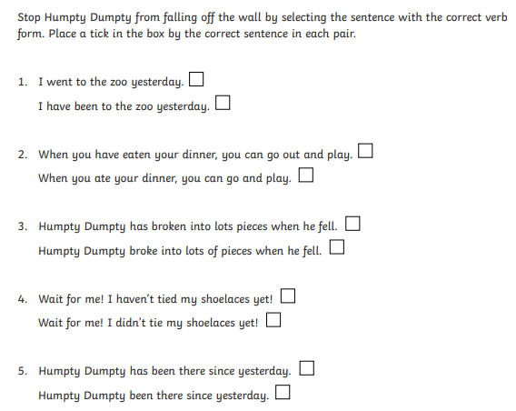
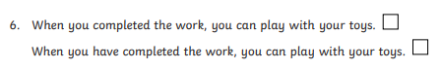

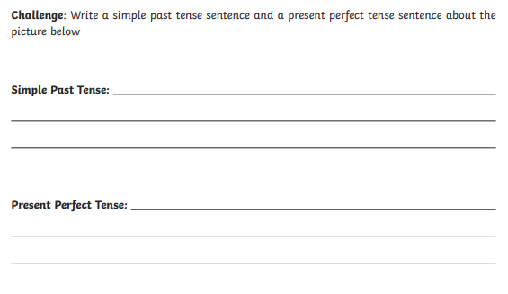
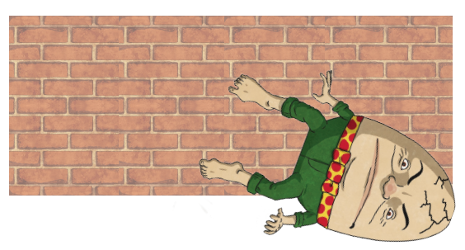

Answers:
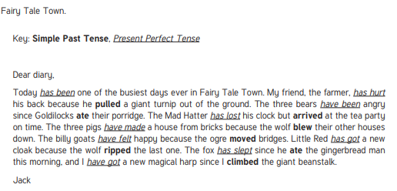
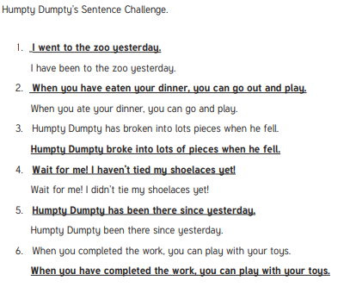
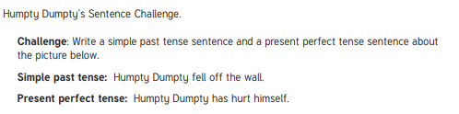
Wednesday - Year 5 and 6: Revision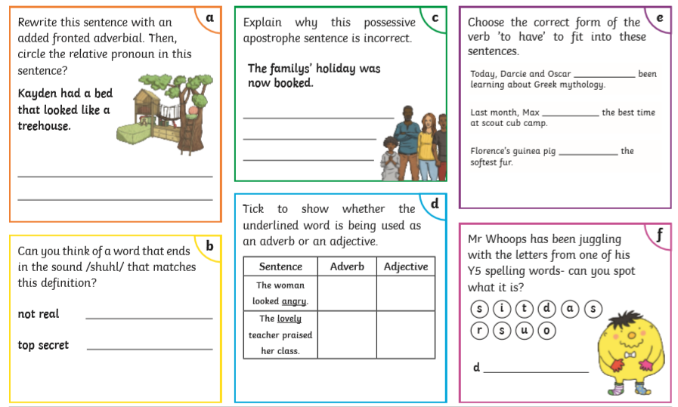
Answers
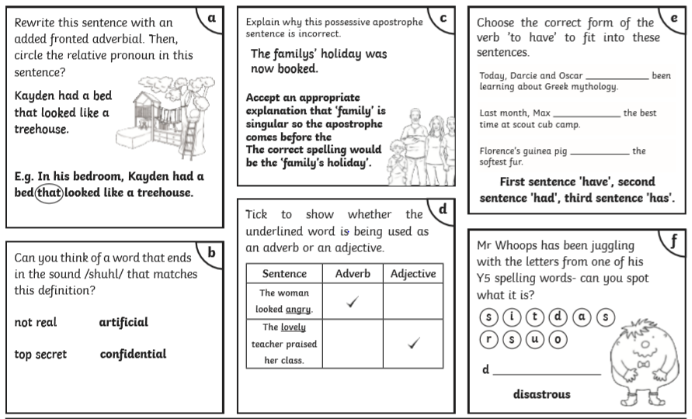
Thursday – Year 3 and 4: Present perfect tense
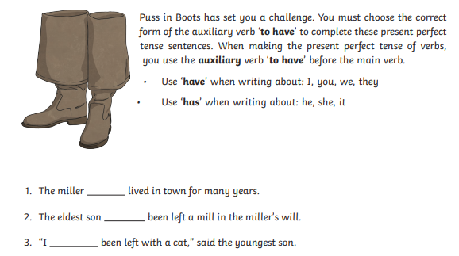
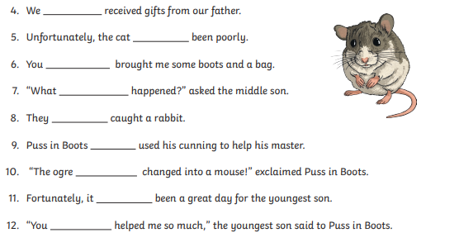

Answers
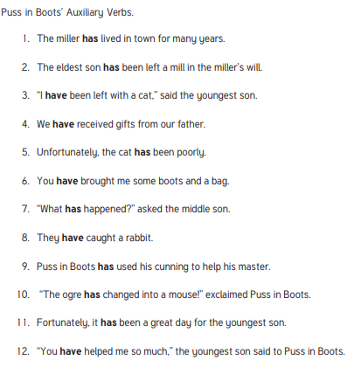

Thursday – Year 5 and 6: Revision
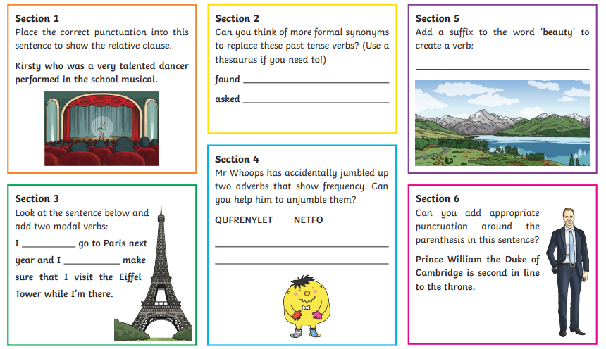
Answers
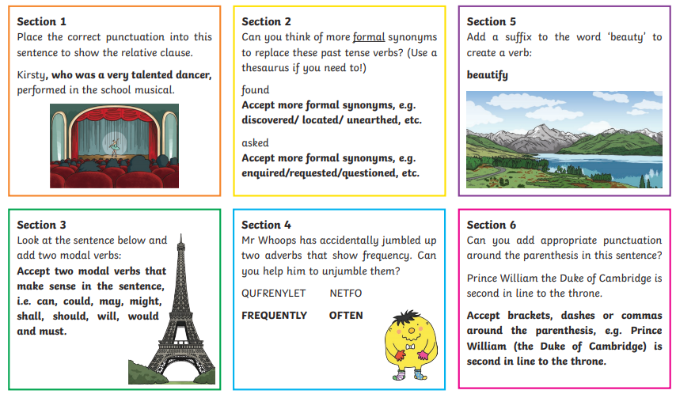
Friday – Year 3 and 4: Present Perfect Tense
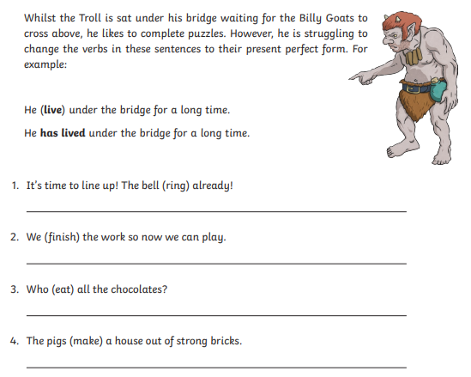
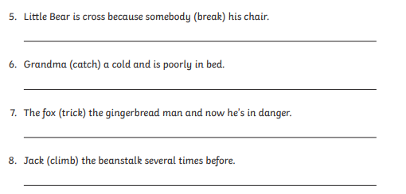

Answers
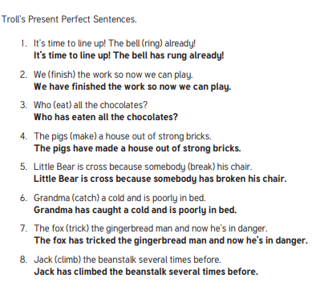

Friday – Year 5 and 6: Revision
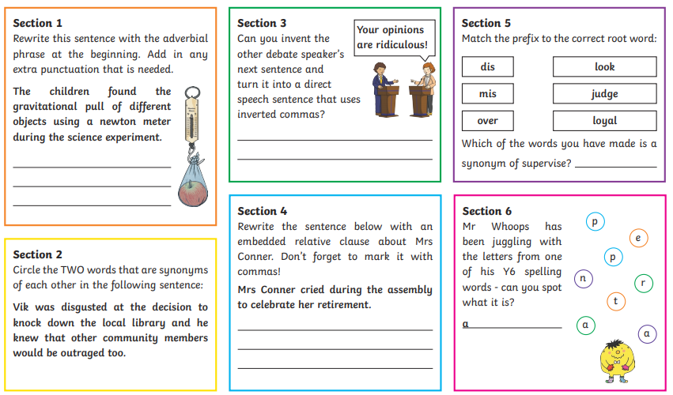
Answers
