Friday 15th May 2020

We have gathered together to worship God the Father, God the Son and God the Holy Spirit.
Today we are going to find out about a Christian Prayer initiative called Thy Kingdom Come that runs every year between Ascension and Pentecost.
Before we do that , I would like you to listen and watch Susan Boyle singing the Lord’s prayer. Please click on the link to watch.
https://www.youtube.com/watch?v=-HaEoCqH47Y
We are now going to hear a story about a Princess names Aurelie but before we do, have a good look at the pictures of the tiles below. They all part of The Pater Noster Church in Jerusalem. The tiles all say the same thing but in different languages. I wonder what they say?
Let’s listen to the story and find out.
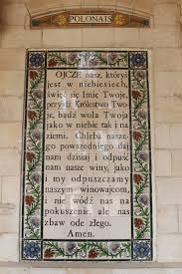
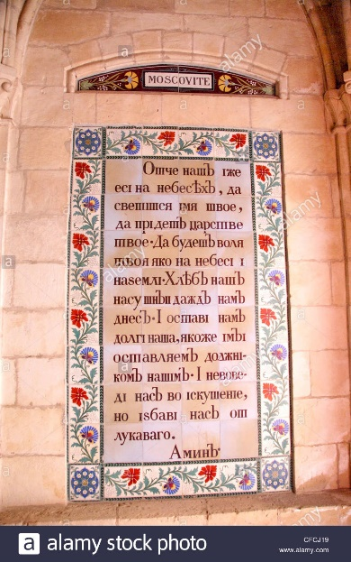
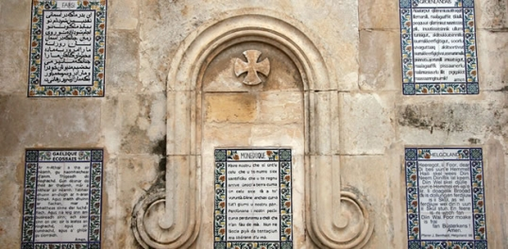
Over 150 years ago, a French princess called Princess Aurelie ( who’d been born in Italy) moved to Israel. Whilst she was there, she started her own collection of special words which were all written in different languages. She had a good start with her collection as she could speak fluent French and Italian. •
The princess loved these words so much that she had her favourite words painted onto beautiful ceramic tiles with flowers around the edge .
In total, she had 39 copies of her favourite words written in 39 different languages on huge tiles which are now part of the Pater Noster Church in Jerusalem.
Her favourite words were the words that Jesus taught his disciples when they asked him how to pray.
Lets hear that story from the Bible:
Luke Chapter 11 verses 1 – 4

Jesus’ Teaching on Prayer
11 One day Jesus was praying in a certain place. When he finished, one of his disciples said to him, “Lord, teach us to pray, just as John taught his disciples.”
² He said to them, “When you pray, say:
“‘Father,^{[a]}
hallowed be your name,
your kingdom come.^{[b]}
³ Give us each day our daily bread.
⁴ Forgive us our sins,
for we also forgive everyone who sins against us.^{[c]}
And lead us not into temptation.^{[d]}’”

Princess Aurelie’s favourite words were the words of the Lord’s Prayer. Tourists from all over the world visit the tiles today; at the spot where Jesus taught the prayer to his disciples. And today there are even more languages. The princess believed these were the words of God’s Son, Jesus. She repeated them many times every day. She wanted everyone to know the words and she wanted everyone to know about Jesus.
There are nearly 7000 languages in the world and during the ten days between Ascension day and Pentecost, Christians across the globe will be praying for other people during this time, praying that they will come to know Jesus. Next Thursday on the 21st May , it is Ascension Day which is when Christians remember the day that Jesus said goodbye to his disciples and ascended into heaven. Therefore it is the start of the Thy Kingdom Come initiative when Christians pray for others each day for ten days.
We would like you to complete some of the activities on the Thy Kingdom Come website as part of your home learning next week and send them into school with a short blurb about what you have done so that we can make a special Thy Kingdom Come book to share with each other when we are back at school.
There are also some podcasts that you can listen to with your family each day during Thy Kingdon Come. The podcasts are about 10-12 minutes long. They feature a game, an interactive Bible story,a chance to pray and great music.
The link to the podcasts is below:
https://www.thykingdomcome.global/resources/digital-family-prayer-adventure-map

Let’s join together in prayer and say the words of the Lords Prayer .
Our Father, who art in heaven,
hallowed be thy name;
thy kingdom come;
thy will be done;
on earth as it is in heaven.
Give us this day our daily bread.
And forgive us our trespasses,
as we forgive those who trespass against us.
And lead us not into temptation;
but deliver us from evil.
For thine is the kingdom,
the power and the glory,
for ever and ever.
Amen.

This prayer is said across the world in many different languages. Christians believe God understands every language and every prayer. Do you haveanybody in your family who could say this prayer in a different language?
Do you know that the word Amen is Hebrew and it means ‘I agree’?

To finish our assembly , if you would like to, you can listen to a video of a famous singer ‘Cliff Richard’ singing the Lord’s Prayer to the tune of Auld Lang Syne which is a song sung at midnight on New Years Eve. Cliff Richard recorded this song 20 years ago for the new Millenium when the world said goobye to the year 1999 and welcomed the year 2000 which was the start of a new millennium. This number one music hit showed that the Lord’s Prayer is still very important to Christians today. Jesus gave it to Christians over 2000 years ago and Christians all over the world still pray it today.
https://www.youtube.com/watch?v=mL9yDb134Rk

