Grammar and Spelling Resources: WB Monday 22nd June 2020
Monday: Year 3 and 4 – Using Determiners
Check that you have remembered our previous work on determiners by completing the following consolidation work:
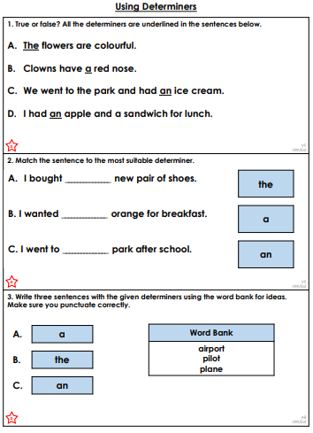

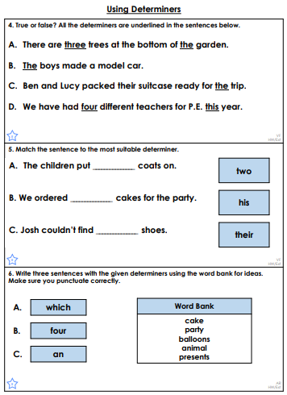

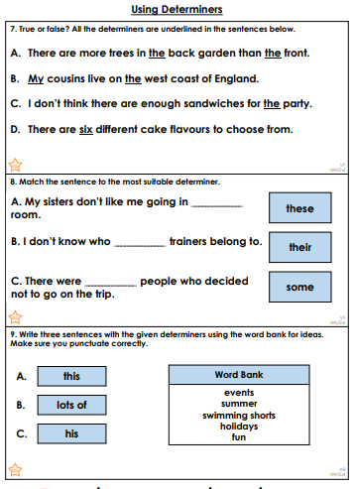
Answers
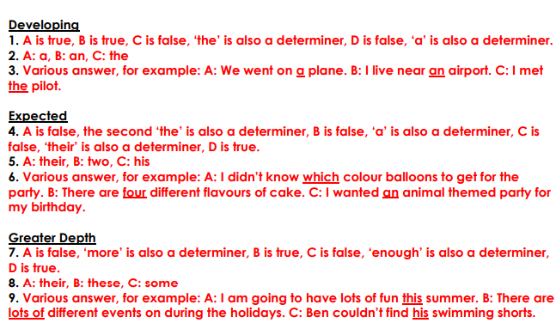

Monday – Year 5 and 6
This week we are going to practise using expanded noun phrases and revise relative clauses.
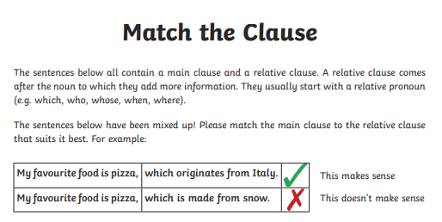
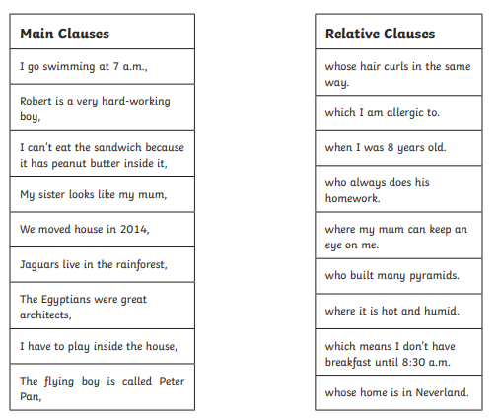
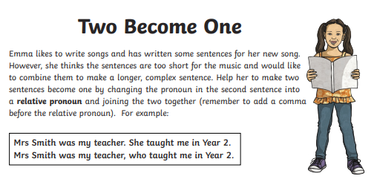
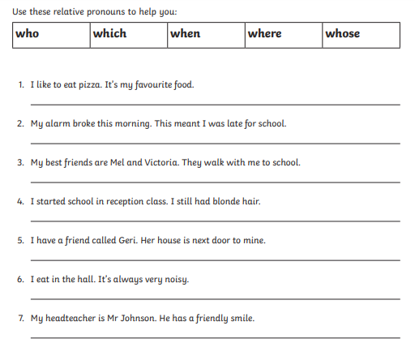

Answers
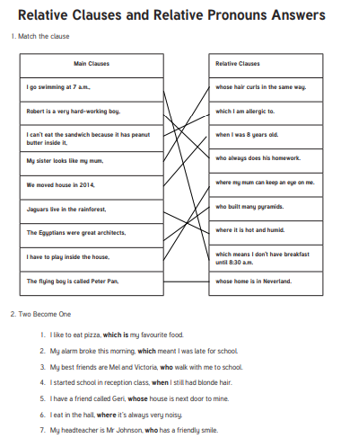

Tuesday – Year 3 and 4
This week’s words to practise from the statutory word list are below. First, practise writing them in neat, cursive writing, following the example carefully. What patterns or similarities do you notice between these words? Which one is the odd one out? Why?
Now practise using each of the words in a sentence. Can you use any of them in two ways (eg. as a verb and also as a noun or adjective?)

Tuesday – Year 5 and 6
This week’s words to practise from the statutory word list are below. First, practise writing them in neat, cursive writing, following the example carefully. What patterns or similarities do you notice between these words? Which one is the odd one out? Why?

Now practise using each of the words in a sentence. Can you use any of them in two ways (eg. as a verb and also as a noun or adjective?)

Wednesday – Year 3 and 4 – Prepositions
Look at https://www.theschoolrun.com/what-are-prepositions where you will find an explanation of what prepositions are and a long list of examples. (Just in case you don’t remember where you’ve heard of them before!) Then have a go at the work below:
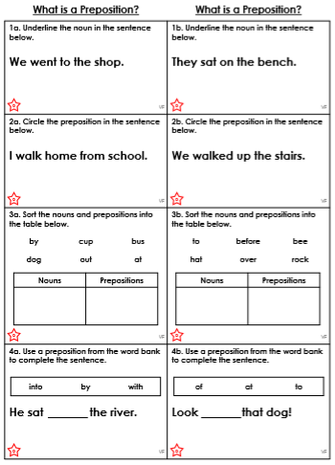

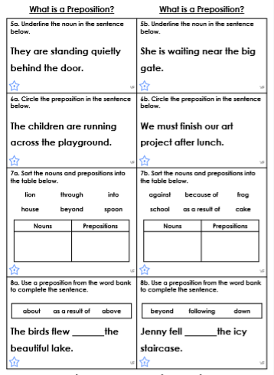

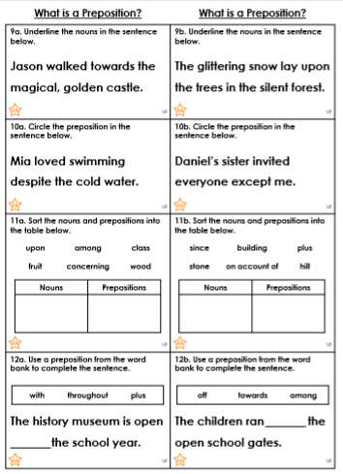

Answers

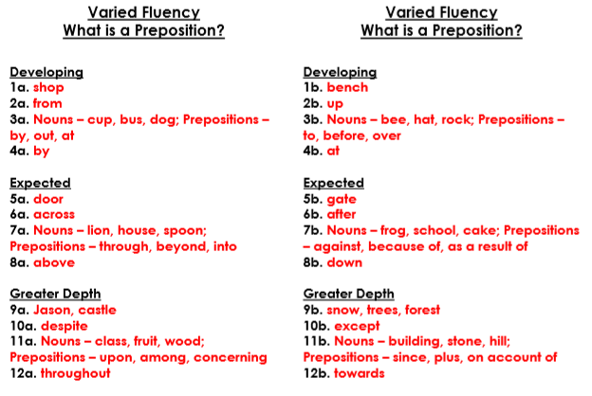

Wednesday – Year 5 and 6 – Relative Clauses
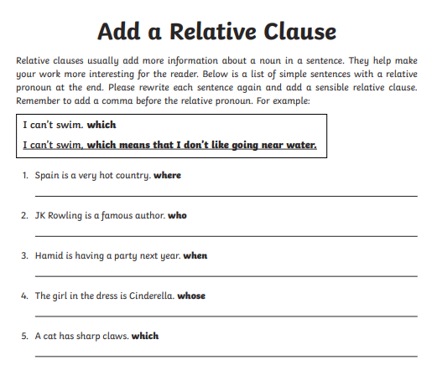
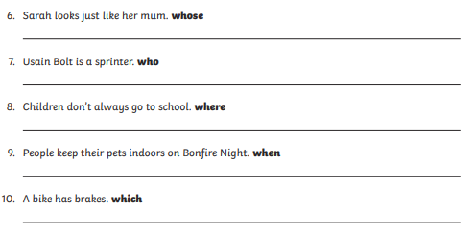

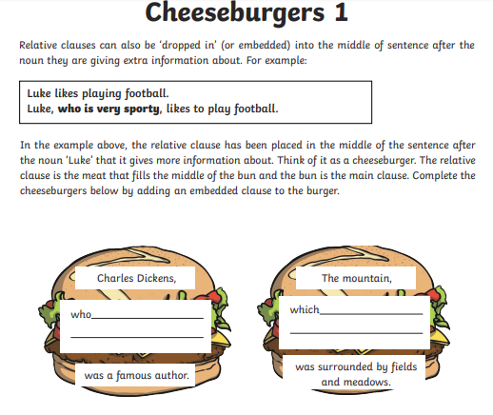
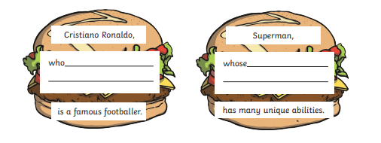

Thursday – Year 3 and 4 - Prepositions
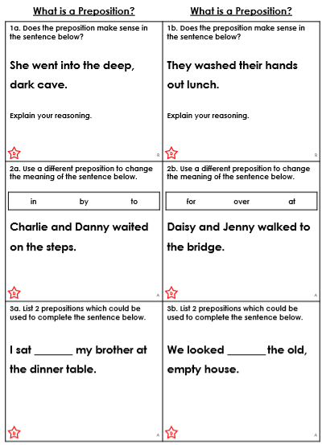

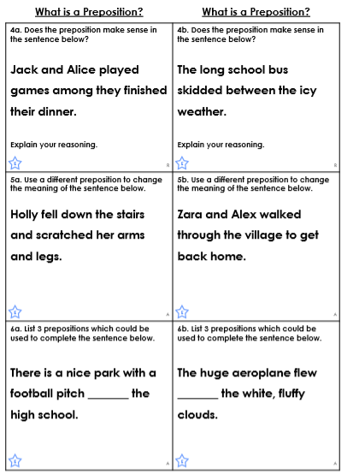

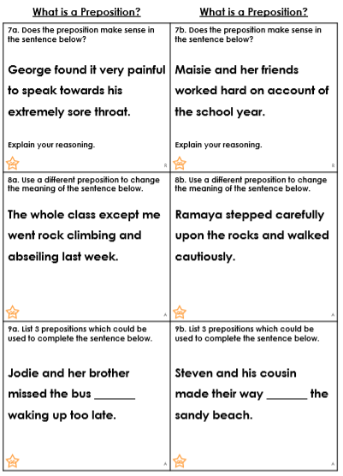

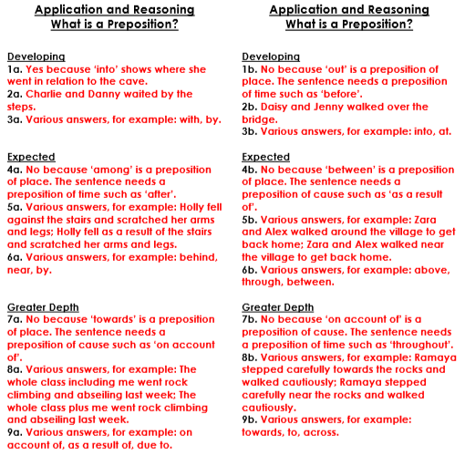

Thursday - Year 5 and 6: Relative Clauses
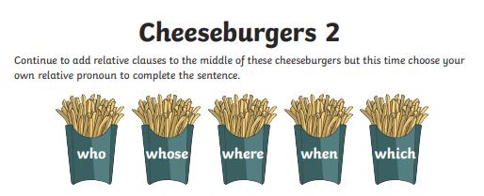
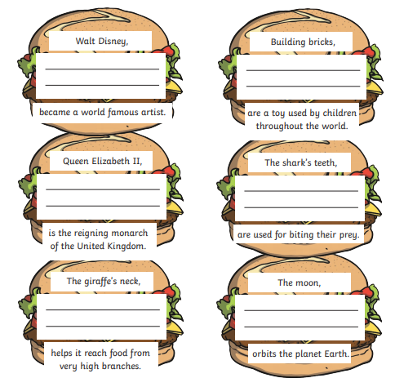

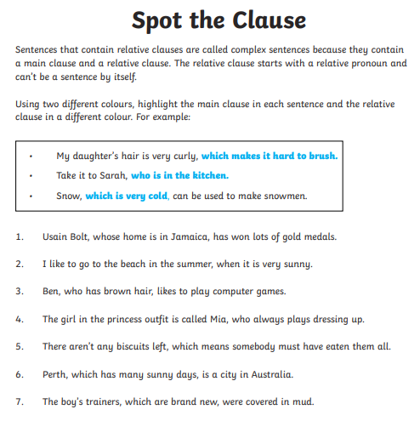
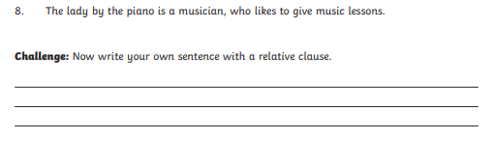

Answers:
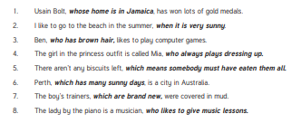

Friday – Year 3 and 4: Preposition
This week, we have practised identifying and using prepositions. Today, we are going to use preposition phrases (ie. A group of words beginning with a preposition) to write a simple poem. First, have a look at the poems below and identify the prepositions:
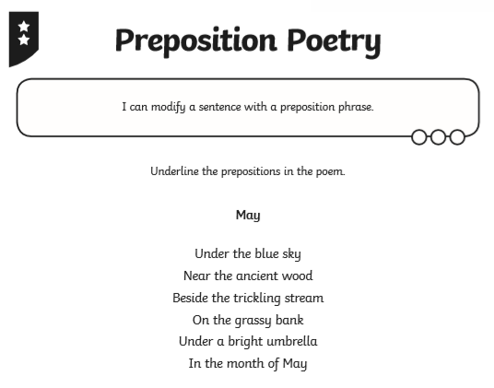
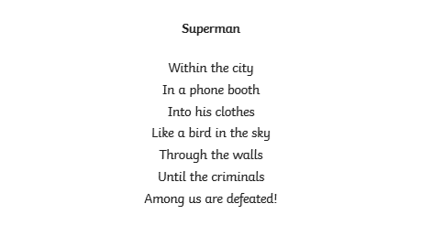

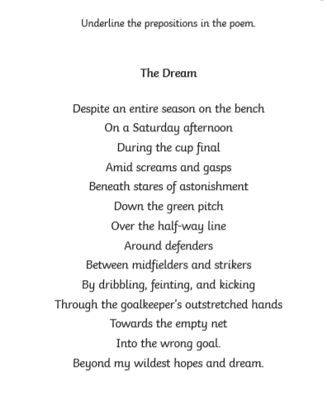

Now, have a go at writing your own poem using a series of preposition phrases. First, you will need to decide on a place to write about. Think carefully about how you might end your poem – perhaps with a surprise.

Friday – Year 5 and 6: relative clauses

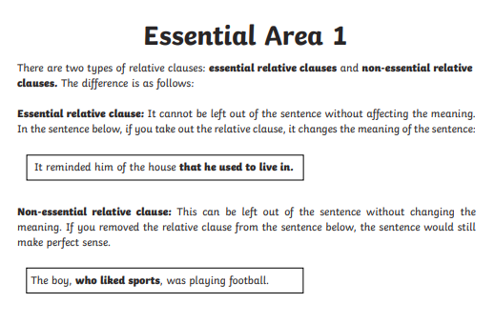
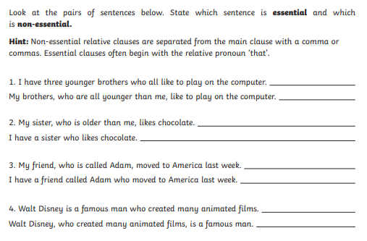

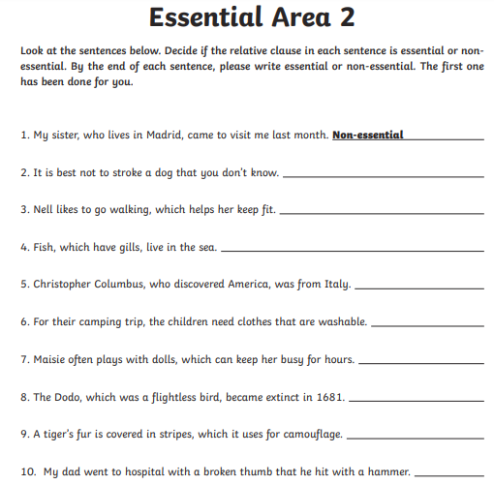
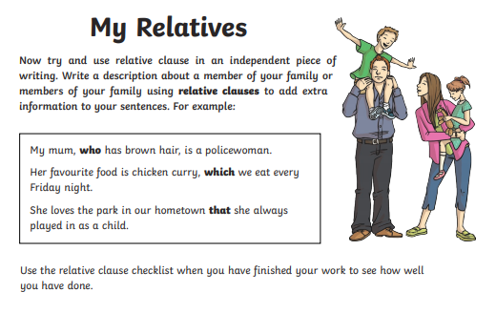
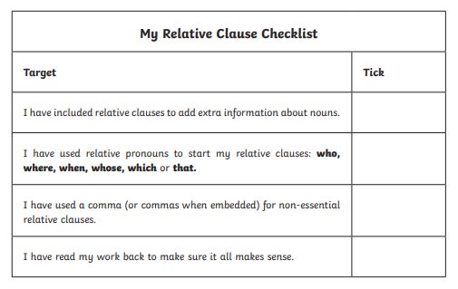

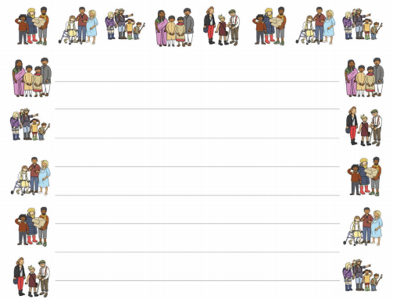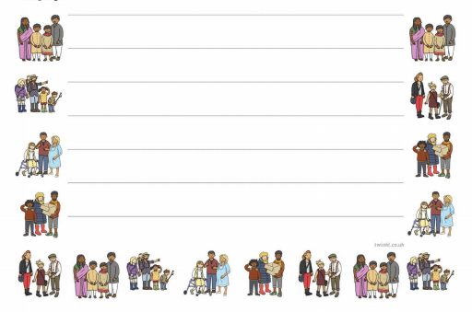
Answers:

