24.4.2020

Dear Class 1,
How are you all? It is a very strange time not seeing you all. I am missing you all and wondering how you are getting on with the home learning and what you are doing to keep yourselves busy, during this time.
Please do send some photos in of anything you would like me to see. I would love to see what you are all up to.
Below is the home learning for this week. It would be great for you to have a go but please make sure you are happy and well. I have added some extra ideas this week, in case you would like to try something different, but please don’t feel you have to do it all this week. A bit of Literacy, Maths and reading each day is plenty. The other activities are for you to have a go, should you wish to.
Thinking of you all.

Kind Regards,
Mrs Jackson

Home Learning Class 1 Farway - Week 3 – beginning 27.4.2020
Monday
Last week we started our learning about life cycles. I hope you are enjoying them. It is my favourite subject to teach!
To start our literacy this week, let’s recap on the story of ‘The Teeny Weeny Tadpole’, by Sheridan Cain and Jack Tickle.
If you follow the link below, on your computer, you will be able to listen to the story again.
https://www.bing.com/videos/search?q=bedtime+stories+teeny+weeny+tadpoles&&view=detail&mid=D9515019A8E8916E49F0D9515019A8E8916E49F0&&FORM=VDRVRV

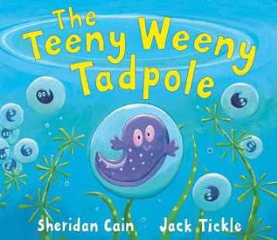
This is a lovely story about a little tadpole, who longs to grow up and be able to jump. Once you have listened to the story, talk to your parent about your favourite part of the story and discuss why. Then answer these questions.

- Why do you think the tadpole was so desperate to grow up and be able to jump?
- Can you think of something you might like to be able to do when you are grown up?
- Discuss your thinking with a parent or sibling, then draw me a picture for our class book.

Challenge – write a description under your picture to describe what it is you would like to be able to do and why.

Now, using the story to support your thinking, can you identify the four stages of the frog life cycle?
- Frogspawn (egg)
- Tadpole
- Froglet
- Adult frog

Cut out the pictures below and order them correctly within the life cycle frame, using the story, ‘The Teeny Weeny Tadpole’ to help you.
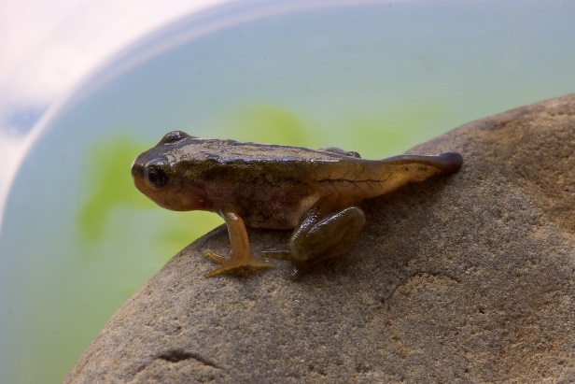  Froglet | 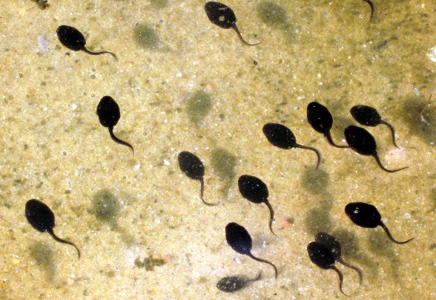  Tadpoles
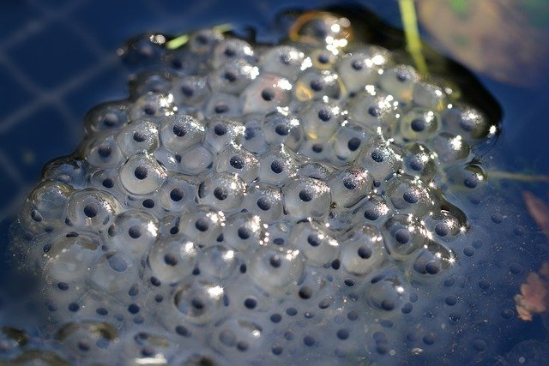  Frogspawn | 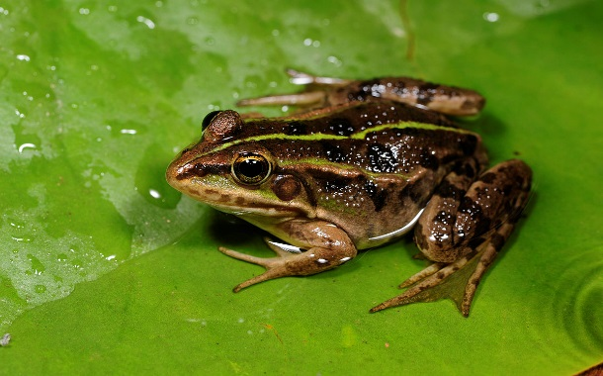  Adult Frog
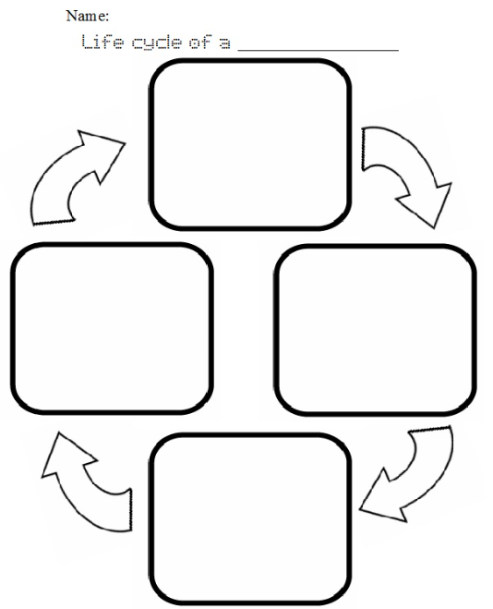

Tuesday
If we were in school, we would follow this lesson on by creating our own fun, artistic representations of the life cycle of the frog. Have a look at some of the ideas below, for inspiration, then get creative! Please take a photo and send to admin@farway.devon.sch.uk, so I can have a look at them and add to our class book.
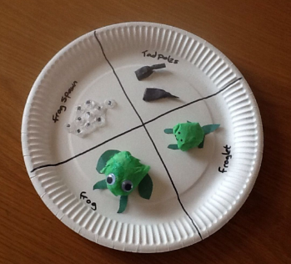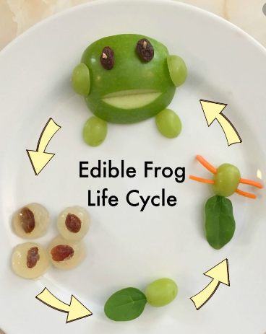

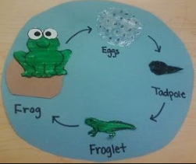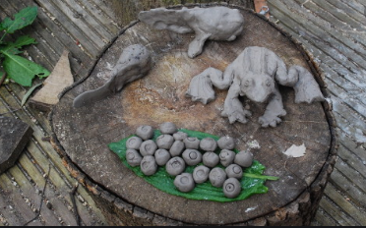

Wednesday
Yesterday you made a lovely model representation of the frog’s life cycle. Today I would like you to use these to help you write a chronological descriptive text about the life cycle of a frog. These are similar to the text you wrote about the life cycle of the chicken, but remember the names of the life stages are different and the frog life cycle includes some interesting vocabulary, such as: metamorphosis,
Challenge: find out what the word metamorphosis means. Can you put it into a sentence?

Remember, when we are writing a chronological descriptive text we need to include times connectives, to ensure the reader knows the order in which the stages happen. For examples: First, Next, Then, Later, Finally.
It may be useful to watch the link below, again:
Copy and paste this link into your search bar and you can watch the life cycle of the frog in action.
https://www.generationgenius.com/?share=54D71

Title: The Life Cycle of a Frog

First,

Next,

Then,

Finally,

I have done the first one for you as an example. Remember! Use your life cycle models to support your writing!

First, the adult frog lays eggs in the pond or water.

Challenge: see if you can add more detail to your writing about the stages.

First, the adult frog lays eggs in the pond or water. These eggs are called frogspawn.

Your turn…

Please send your descriptive text into admin for Mrs Jackson to read!

Thursday
As a surprise for you all I ordered some caterpillars for us to observe, during this sequence on ‘life cycles’. Unfortunately, they have still not arrived.
However, I was talking to a friend about it and saying how disappointed I was, and the next day she arrived at my house and placed a bucket on my drive way before running back to her house (social distancing rules applied of course).
Can you predict what was inside that bucket?
...
I will give you some clues:
- There was more than one (nine in fact)
- They all have tails
- They are amphibians
- They go through a process called metamorphosis

Challenge: find out what the words amphibian and metamorphosis mean. Can you put them into a sentence?

So, I looked inside the bucket and was extremely excited to see nine little tadpoles swimming around, in a pool of water! How fantastic!
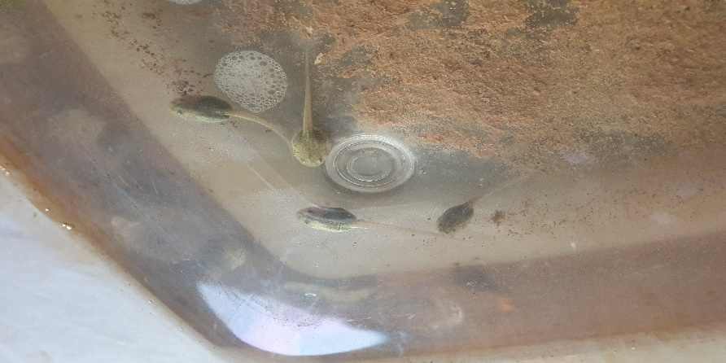
This inspired me to plan today’s lesson: WALT: use alliteration to create a suitable name for one of our class tadpoles.
In the autumn term, we studied the book ‘Meerkat Mail’, as part of our literacy sequence. During this sequence we discussed the use of alliteration – when two or more words in a sentence all begin with the same sound. For example: Meerkat Mail, both begin with the sound ‘M’.

Today, have a go at inventing a name for one of Class 1’s tadpoles using alliteration.
First, have a think. What sound does the word tadpole begin with?
Next, have a think about what sound does the word frog begin with?
Are you going to invent a name for your tadpole? Or for your tadpole when he/she has metamorphosed into a frog?
Then, make a list of names or words that have the same initial sound as your chosen stage (tadpole or frog).
I have done one example for you:
Words with ‘t’ as their initial sound | Words with ‘f’ as their initial sound
Tiny Tim | Flashy

Finally, put your words together with either ‘tadpole’ or ‘frog’, to create your name.
For example:
- Tiny Tim Tadpole
- Flashy Frog

Lastly, send your chosen names to Mrs Jackson!

Additional Challenge: practise using alliteration in your writing.

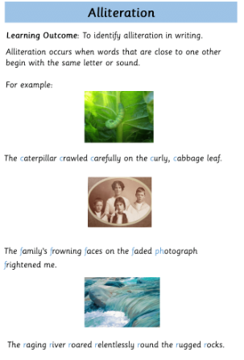

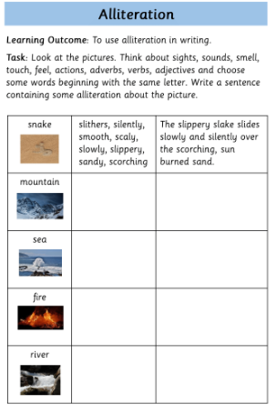

Friday
Today is the 1st May, typically known as May Day.
May is also known as National Smile Month!
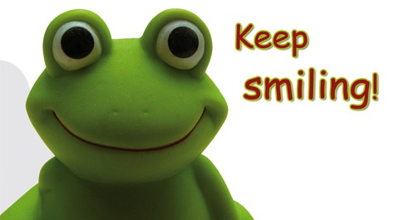

In honour of this, I would love you to just enjoy making each other smile today! Write a postcard or letter to someone you love and are missing. Tell jokes to your family to make them smile and laugh!

Here are some frog jokes to get you started:
Q: Why are frogs so happy?
A: They eat whatever bugs them!

Q: What happens when two frogs collide?
A: They get tongue tied!

Q: What happens when you mix a frog with a bathtub scrubby-mit?
A: A rubbit!

Q: What’s green, green, green, green, green?
A: A frog rolling down a hill!

Q: What does a frog say when he sees something great?
A: Toadly awesome!

Challenge: write some jokes of your own!
In addition, try jumping around your garden like jumping frogs, racing your family!
Here’s some rosettes to print, to award first, second, third, fourth and fifth place. Have fun!
