Grammar and Spelling Resources: Week Beginning Monday 6th July 2020 Year 3 and 4
Monday: Sentence Punctuation
This week, we will have a focus on using punctuation correctly. Let’s start by revising the use of correct sentence punctuation. (Answers are given at the end of the document.)
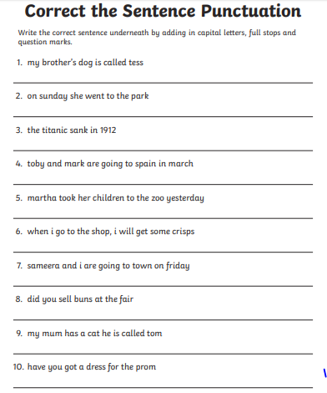

Tuesday: Spelling and Handwriting
Practise spelling the following words from the Year 3 and 4 statutory list. Can you see any patterns or similarities in these words? Which would you say is the ‘odd one out’? Why?
Now practise writing some sentences containing the words you have been learning. Take care to punctuate your sentences with care!

Wednesday: Punctuation - commas
Remember, commas are used to separate units of meaning in a sentence. They are used between items in a list and between clauses to help the reader make sense of a sentence.
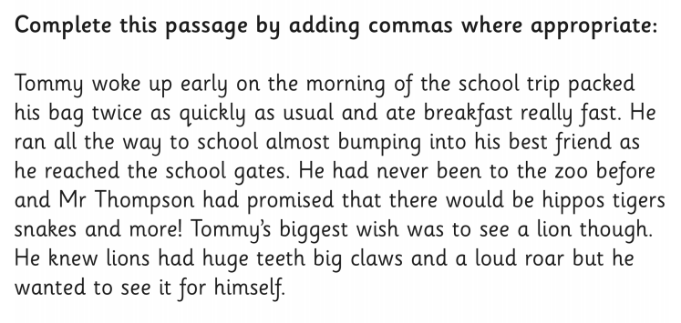

Thursday: Punctuation – apostrophes
Remember, apostrophes are used to show where a letter is missed out (omission) in contractions. They are also used to show possession. They are not used for plurals.
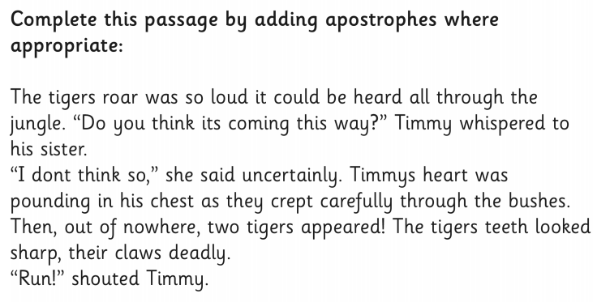

Friday – Year 3 and 4: Punctuation – sentence punctuation and inverted commas
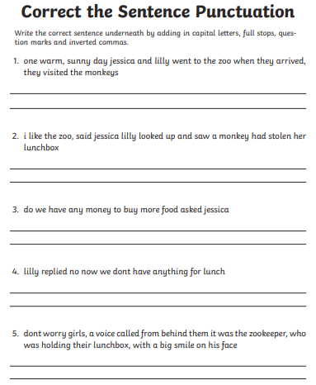

Answers:
Monday: Sentence Punctuation
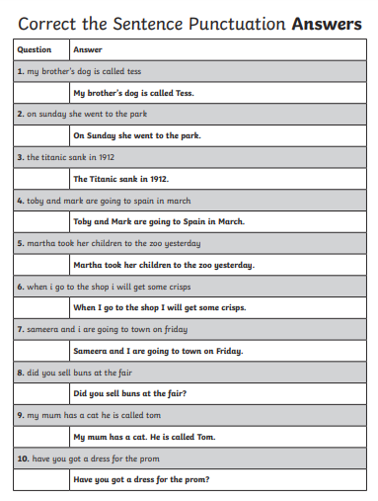

Wednesday: Punctuation - commas
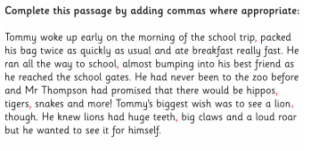

Thursday: Punctuation – apostrophes
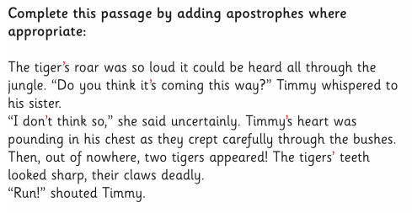

Friday: Punctuation – Sentence punctuation and inverted commas
