Home Learning – Maths – Week 4 (week beginning 4.5.2020)

Monday – WALT: describe whole, half, quarter and three quarter turns.
Can you guide Yoda safely to his friend, the Ewok, without getting caught by a Storm Trooper or an AT-AT?
Cut out the image of Yoda, below and place him on top of the Yoda image on the grid.
Remember – Yoda needs to be facing the way he is walking so you may need to turn him using, half, quarter and three quarter turns.
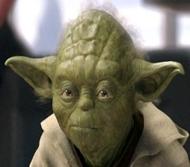

Key Vocabulary you will need:

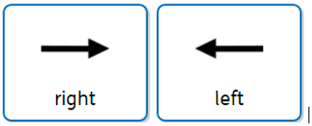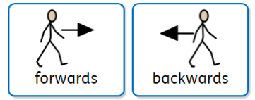
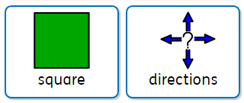
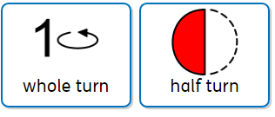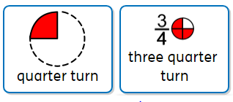

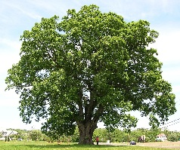
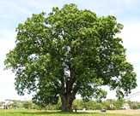
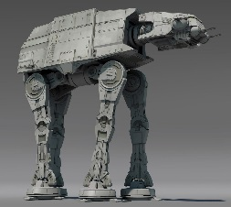

Please describe your chosen route to an adult, using the key vocabulary on the previous page.
You can write your directions in your home learning books, or an adult can record your thinking for you. The main focus is on your thinking and your verbal descriptions using the key vocabulary.

Please have a good go, first, before reading the answer below…
Answer: Yoda, turn one quarter turn to his left, then move forward three squares. Turn a quarter turn to his right and move forward three squares. Turn one quarter turn to his right and move forward two squares. Then, turn another quarter turn to his left and move forward two squares. Finally, turn one quarter turn to his left and move forward three squares, to his friend Ewok.
Is there another way Yoda could get to Ewok safely? Can you guide him using different directional instructions?

Tuesday – WALT: gain a secure understanding of the key vocabulary, whole (full), half, quarter, three quarter turns.
Yesterday, we were introduced to the key vocabulary and practised using it to direct Yoda to the Ewok. Today we are going to continue to practise using this key vocabulary, by guiding a parent or sibling around your house or garden.
Practise using the key vocabulary and observe. What do you notice? Do they turn the direction you thought you had instructed them to? Can you safely guide them from the kitchen to the living room, or to your bedroom?
Remember to use the key vocabulary: whole (full), half, quarter, three quarter turns, left, right, forwards and backwards.
You could ask an adult to take photographs of yourself acting out each of the directions and label them to ensure you are gaining a secure understanding of this key vocabulary.

Wednesday - WALT: apply our knowledge of directional language (turns) to pictorial representations.

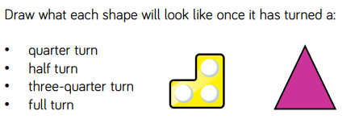

If this activity is hard to visualise why not cut the shapes out (below) and physical try turning them, as described by the directions, then drawing what it looks like.
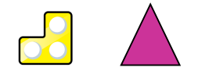

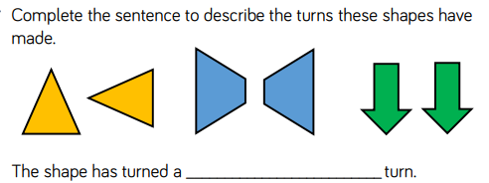
What part of the whole (full) has the shape / object turned?

- Are these statements correct? Is there more than one answer?
Explain how you know.

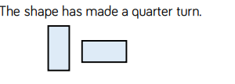

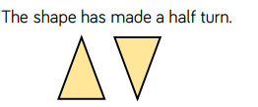

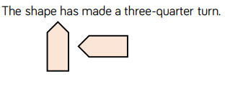
- Today’s challenge:
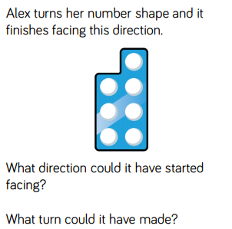
Thursday – WALT: apply our knowledge of positional and directional language.
Recap: forwards, backwards, left and right.

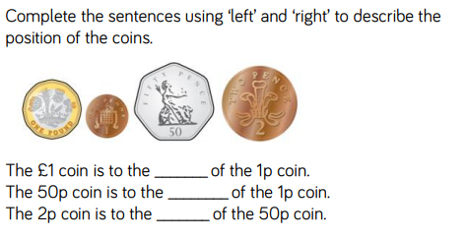
- Use the clues to colour the shapes.

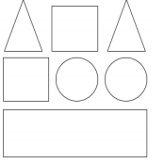
- The circle in the middle is blue.
- The circle on the right is red.
- The shape up from the right circle is green.
- The shape down from the circles is green.
- The square to the left of the green triangle is red.
- The four-sided shape up from the rectangle is blue.
- The triangle on the left is red.

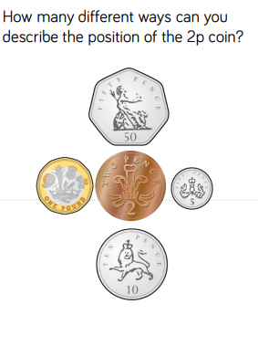

Challenge: problem of the day.
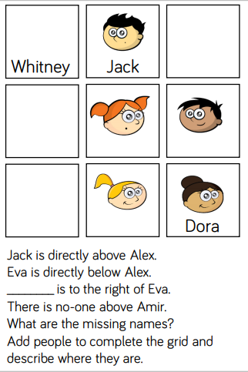

Friday – May Bank Holiday!
Enjoy your extra day with your family!

