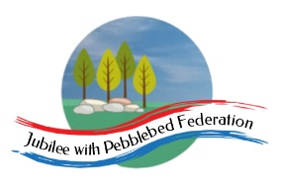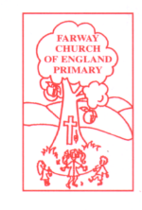

Class 2, Farway C of E Primary School

Dear Parents and Members of Class 2,

This week in our virtual travels around the world, we are heading to Australia, also known as the ‘land down under’ due to its position in the Southern Hemisphere. I hope you will enjoy learning more about the climate, landscape and unusual animals of this fascinating country, while also learning a little history and appreciating its links to Britain.

I hope I’ve provided a mixture of activities that can be accessed online and those that involve more traditional or practical learning media. All of you have different access to computers, tablets, printers and other resources. Do get in touch with me via the school admin email address if you need further support to access the activities and resources suggested or if you’d like me to print out the pack.

Happy learning!

Mrs Marsh

The most important thing you can do to support your child’s learning whilst schools are closed is to ensure that they read every day and they continue to practise their number bonds and times tables.

Don’t forget to keep using the accounts you have through our school to practise basic skills, such as reading, reading comprehension (Bug Club), Times tables (Times Table Rock Stars) and Spelling (Spelling Shed).

I have set work on TTRS each week and I shall be checking these sites regularly to keep an eye on what you’re doing. Please visit studio and soundcheck to update me on your tables speed and accuracy. Feel free to challenge me (Irox Peel) or Miss Moss (Dot McRock) to a Rockslam competition!

Week beginning Monday 29th June
Monday 29th June | Core activities |  |  | Suggestions for additional activities.
9.00 – 9.30 | Daily Dashboard:  Quel est la date aujourd’hui?  C’est lundi le vingt-neuf juin 2020.  Can you write the number date in Roman numerals?  What is happening in the world? Have a look at https://www.bbc.co.uk/newsround or https://www.dogonews.com/ to see what is going on in the world. Choose a news article or two to read.  On this day in 1613, The Globe Theatre burnt down. Can you tell someone at home about what you remember about Shakespeare and The Globe from our Tudor studies? |  | Today is Veterans Day in the Netherlands, a day to commemorate the Dutch citizens who fought in both World Wars. Since 2005 it has been organized on the birthday of the late Prince Bernhard. Take a moment to remember all the human beings who have given their lives over the years during warfare.  In 2007, the iphone was released: the first mobile phone that incorporated a music player as well as a camera. In USA, today is Camera Day – a day to commemorate photographs, the camera and their invention.  Read this article for suggestions of things you could do to celebrate camera day.  https://www.digitalcameraworld.com/uk/news/5-ways-to-celebrate-national-camera-day
9.30-10.00 | Spelling/Grammar - see Spelling/Grammar Resources
10.00- 10.30 | Time for some physical activity. The famous bike race, The Tour de France, should have run this year from June 27th-July 19th but has been postponed at least until the end of August. Wimbledon should also have begun today but was cancelled! Why not go for a bike ride or play some tennis today? You could practise your serve in the garden, or against a wall, if you don’t have a partner.
10.30-11.30 | Maths – follow the links to find online lessons for each year group:  Year 3: https://classroom.thenational.academy/lessons/compare-capacity-and-volume  Year 4: https://classroom.thenational.academy/lessons/shape-and-symmetry-to-compare-and-order-angles  Year 5: https://classroom.thenational.academy/lessons/to-solve-problems-related-to-decimals  Year 6: https://classroom.thenational.academy/lessons/understand-percentages |  |  | Why not try a BBC Supermovers Maths video to help warm up your Maths brain while getting in a bit of movement?  https://www.bbc.co.uk/teach/supermovers/ks2-maths-collection/z7frpg8  Or play an online Maths game at https://www.primarygames.com/math.php Although American, this site has a whole host of games that are useful for practising and improving your core Maths skills.
11.30-12.00 | Have a break and play a game or do another activity that you enjoy. | Be proud of your very being!  Can you think of 5 things you have already done today to ‘fill someone else’s bucket?’ Why not plan 5 more that you could do by the end of today? It could be as simple as a smile, a phone call or an encouraging message and picture.
12.00- 1.00pm | Lunch break. Eat a healthy lunch and try to get outside for some fresh air!
1.00pm – 1.30pm | There are two short reading tasks below.  First is information about the Australian Flag. How was it created? What do all three flags have in common? You could design your own British flag, including the Union Flag somewhere in your design (remember, it’s only called a Union Jack if it’s at sea).  Then you could read the information and answer the questions below about the continent of Australasia, which includes Australia and the surrounding islands. |  |  |  | Don’t forget to read a bit more of your latest book on Bug Club and answer the questions. What have you most enjoyed reading lately? Write a brief recommendation of it for a friend, explaining why you enjoyed it.
1.30pm-2.00pm | Mental Health: Feelings and Emotions  This week, we are continuing to think about our feelings and emotions. Sometimes it can be difficult to recognise or describe how we are feeling and we may need to stop, take time to think and untangle our emotions as it is entirely possible to be feeling several different things at once. Watch the video at https://www.bbc.co.uk/bitesize/clips/zk2w2hv  Have a go at using the Mandal Hand Mindfulness activity to develop awareness of your own feelings. This might be a mash-up of a mixture of different feelings for different reasons. See https://www.counselorkeri.com/2019/05/21/mindfulness-group-art-activity/
2.00pm – 3.00pm | Theme  Use the ‘Directions’ worksheet below to help you revise the points of a compass and directions using a map of places in Australia (found in Additional Information). Use an atlas (online address below or from a book if you have one) to find out more about the features of Australia and label them on the map below. Can you trace the outline of Australia? Can you find this country on a map of the world? What are its neighbouring countries, seas and oceans?  Go to http://www.3dgeography.co.uk/australian-geography  to find information to help you fill in the fact file below. |  | Watch a 5-minute time lapse video about Australia’s Gold Coast – were you surprised by any of the images?  https://video.nationalgeographic.com/video/short-film-showcase/0000014a-1233-d942-a7cb-b7f37cbf0000?source=searchvideo  Like America, Australia is a country with links to the British Empire.  If you don’t have internet access, you could find out what you and your family know about Australia already. Take notes when interviewing family members. You could record the information you’ve found on a mind map that organises for instance, all the animals in one section and all the landmarks in another.  Or you could use the information you have discussed to write a short report on Australia.

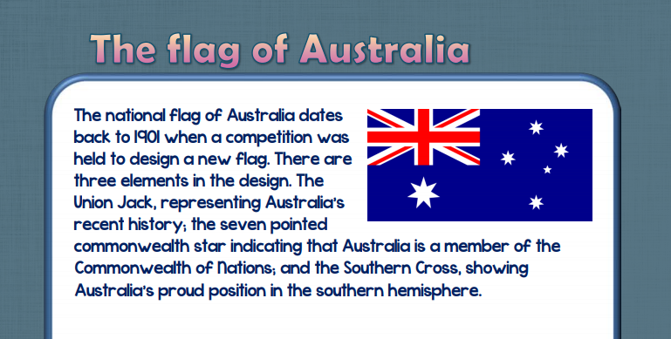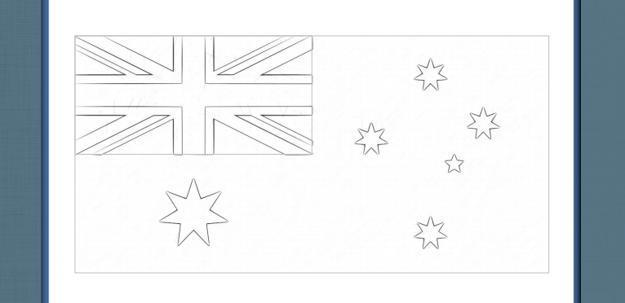
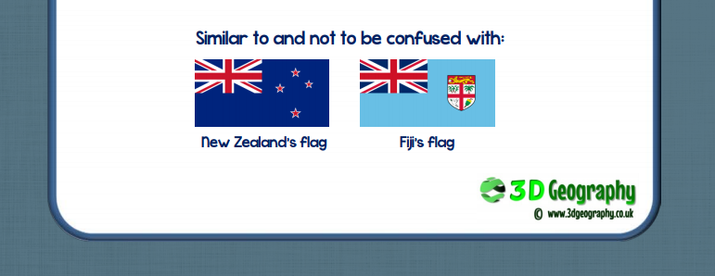

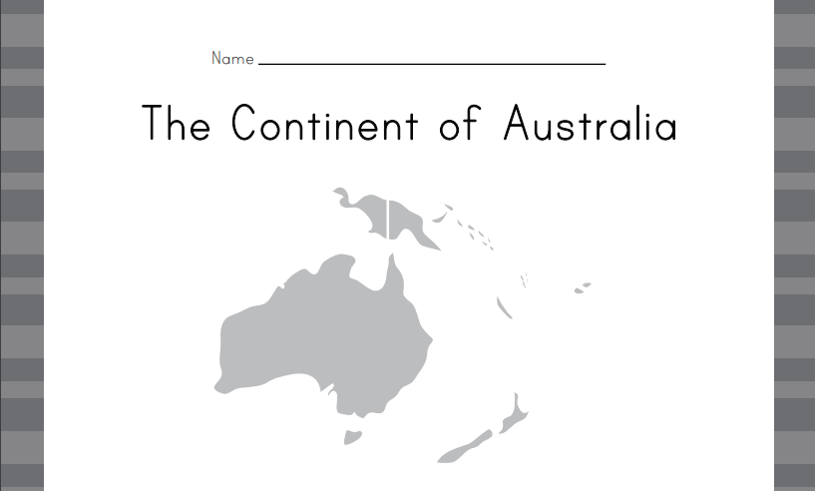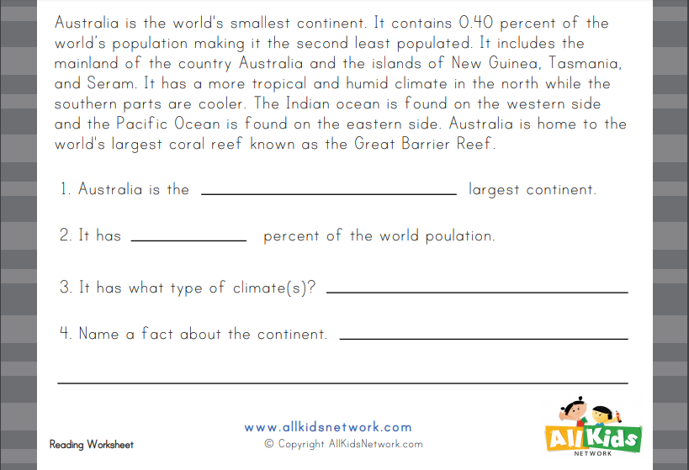

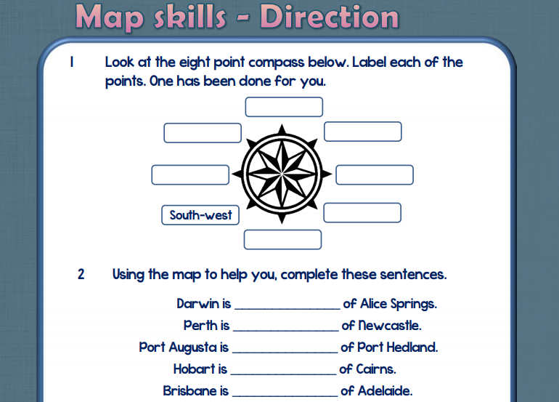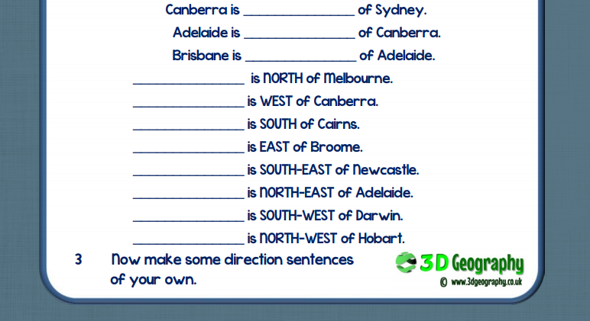

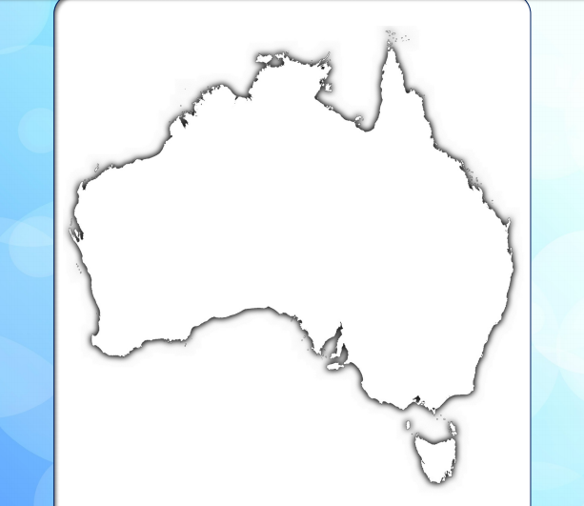
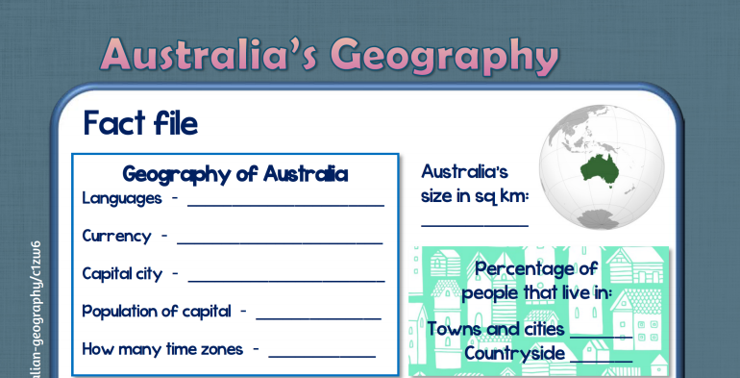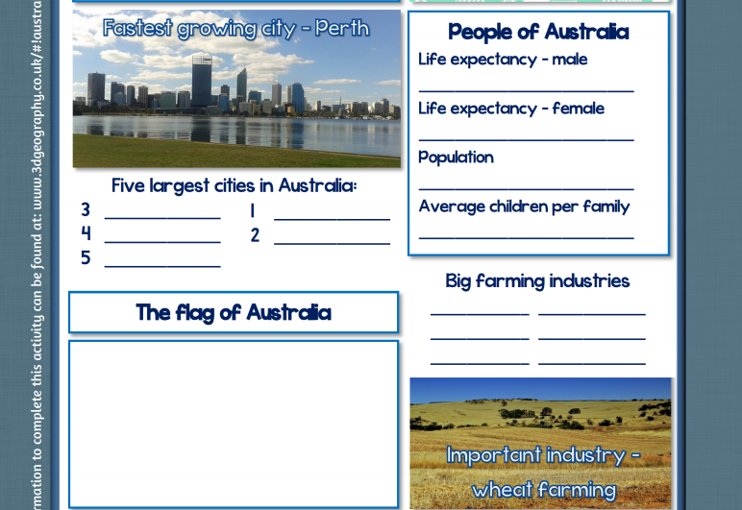

Tuesday 30th June | Core activities |  |  | Suggestions for additional activities.
9.00 – 9.30 | Daily Dashboard:  Quel est la date aujourd’hui?  C’est mardi le trente juin 2020.  Can you write the number date in Roman numerals?  What is happening in the world? Have a look at https://www.bbc.co.uk/newsround or https://www.dogonews.com/ to see what is going on in the world. Choose a news article or two to read.  Watch the following video about Australia, taken in 2018 – https://video.nationalgeographic.com/video/news/00000162-407a-d433-ad73-d1fbdf9b0000?source=searchvideo  Do you remember when the bush fires were raging at the beginning of the year, before the Coronavirus? |  | It’s Meteor Day today! Although the winter months are when there are the most shooting stars, today is the day to celebrate the wonders in the sky. Maybe you could lie out in the garden tonight and watch for a ‘shooting star’ – don’t forget to make a wish!  Learn what a meteor actually is courtesy of SciShow Kids.  https://www.youtube.com/watch?v=F4xavj2hqSU  What is a meteorite?  Want to know more? Check out the NASA website for more videos and stories:  https://www.nasa.gov/audience/forstudents/k-4/more_to_explore/Asteroids-Comets-Meteorites.html  https://spaceplace.nasa.gov/search/meteor/
9.30-10.00 | Spelling/Grammar - see Spelling/Grammar Resources
10.00- 10.30 | Time for some physical activity. I’ve included a space-themed dance ideas sheet below from youthsporttrust.org. (Can you find their funny spelling mistake?)
10.30-11.30 | Maths – follow the links to find online lessons for each year group:  Year 3: https://classroom.thenational.academy/lessons/ordering-capacity-and-volume  Year 4: https://classroom.thenational.academy/lessons/shape-and-symmetry-to-identify-right-angles  Year 5: https://classroom.thenational.academy/lessons/to-investigate-multiplying-decimals  Year 6: https://classroom.thenational.academy/lessons/equivalences-between-fdp |  |  |  |  | Don’t forget to keep practising times tables regularly on TTRS. A few minutes every day is all it takes to build fluency. If you cannot access the online programme, why not email us and ask us to send you some paper times table practice sheets?
11.30-12.00 | Have a break and play a game or do another activity that you enjoy. | Listen to some Australian folk songs such as Waltzing Matilda or Kookaburra. Links here:  https://www.youtube.com/watch?v=lsvNUv5x37o  https://www.youtube.com/watch?v=ysaskdFpPz8  Big Band Version https://www.youtube.com/watch?v=7UFmwArST-I
12.00- 1.00pm | Lunch break. Eat a healthy lunch and try to get outside for some fresh air!
1.00pm – 1.30pm | Reading time – Find out more about Meteor Day here: https://www.daysoftheyear.com/days/meteor-watch-day/ |  |  | Alternatively, read a chapter or two of a novel.
1.30pm-2.00pm | Mental Health: Understanding our emotions  Have a look at https://schools.beano.com/lesson-plans/understanding-our-emotions-2/  Here you will find some useful lessons to help you understand your own emotions and those of others a little better. Why not see if you can print and play the board game in the ‘Understanding our Emotions’ lesson with your family? Alternatively, arrange to play it in a Zoom or Skype chat with one or more of your friends.
1.30pm – 3.00pm | Theme – Geography/Literacy  Use yesterday’s learning to fill out the cities and territories on the sheet below. Today we will be investigating the geography of Australia.  Australia is not only huge it has different landscapes, depending on where you are. Watch these videos from National Geographic to find out more.  South Australian Outback  https://video.nationalgeographic.com/video/travel-source/00000152-6ae1-de97-ad5b-7ffd718b0000?source=searchvideo  South Australia  https://video.nationalgeographic.com/video/travel-source/00000152-40cf-d480-a756-5bef284a0000?source=searchvideo  North East Australia – The Great Barrier Reef  https://video.nationalgeographic.com/video/travel-source/unesco-world-heritage-sites/00000164-1369-d652-abe4-777d98d80000?source=searchvideo  Choose one of the videos above and write a descriptive paragraph about the landscape shown. Alternatively, you could write a poem then illustrate it. |  |  |  | Further familiarise yourself with Australian city names with the wordsearch found below.  Choose from the maps below to record geographical data.  Look at the notes you made yesterday about your present knowledge of Australia. You may have key words and phrases such as ‘hot and sunny’, kangaroo, koala bear, ‘the bush’ and boomerang.  Include your Australian words in a story. It could be an adventure or mystery story. Remember the key text we read ‘Window’? That was based in Australia. Maybe you could write a story based on the boy in the story?

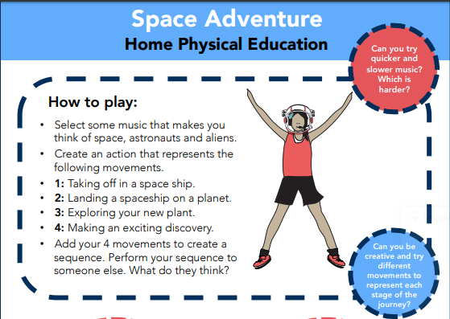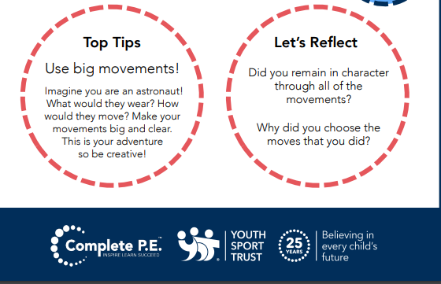

#

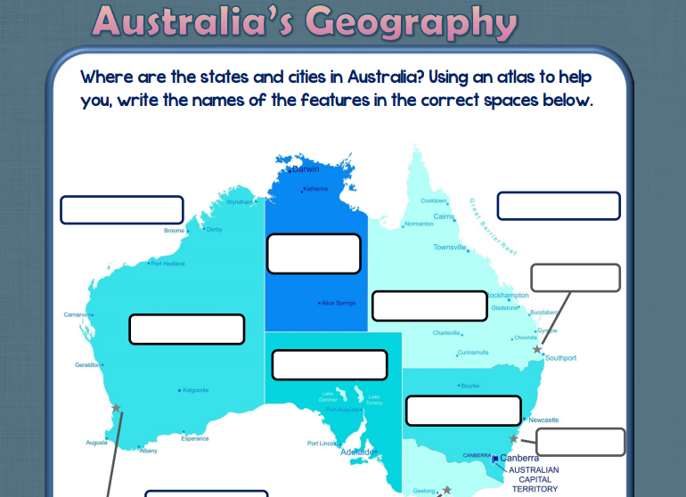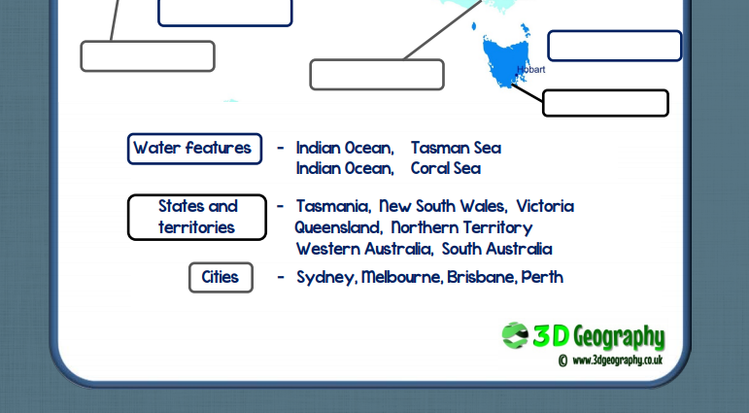

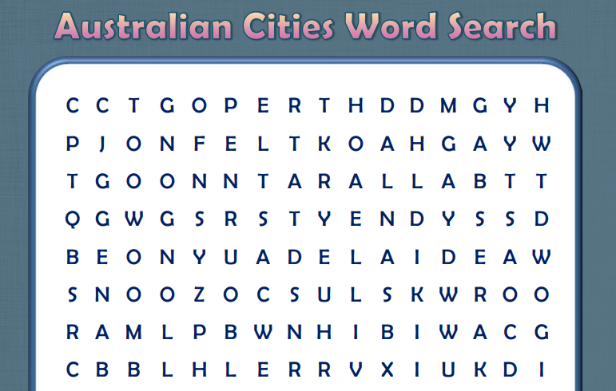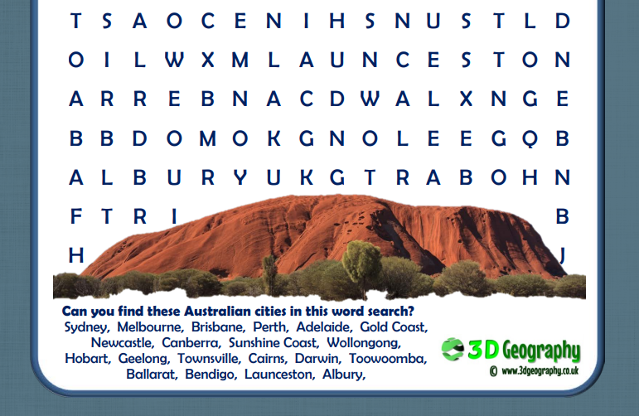

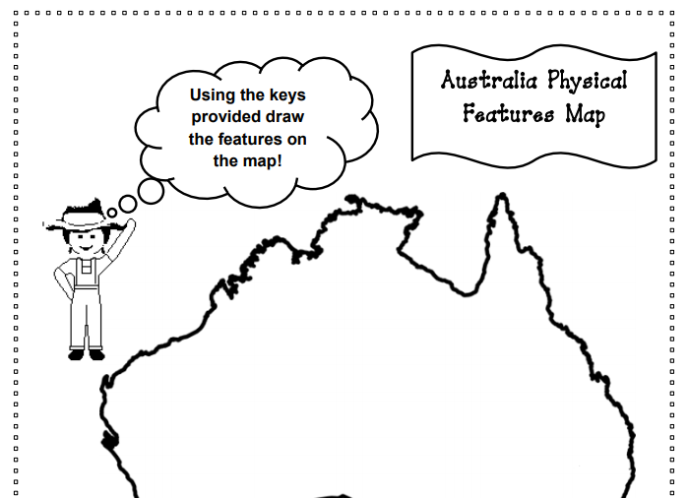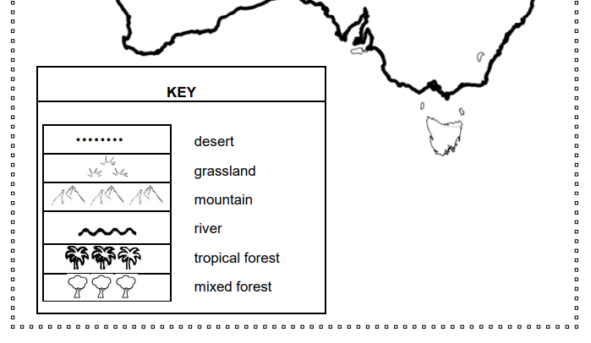

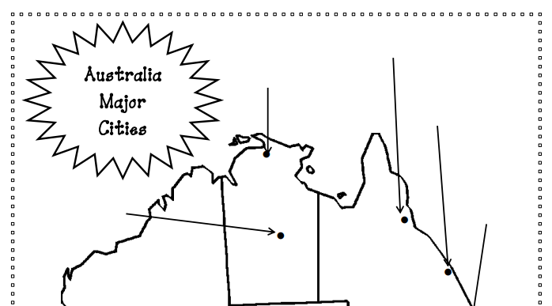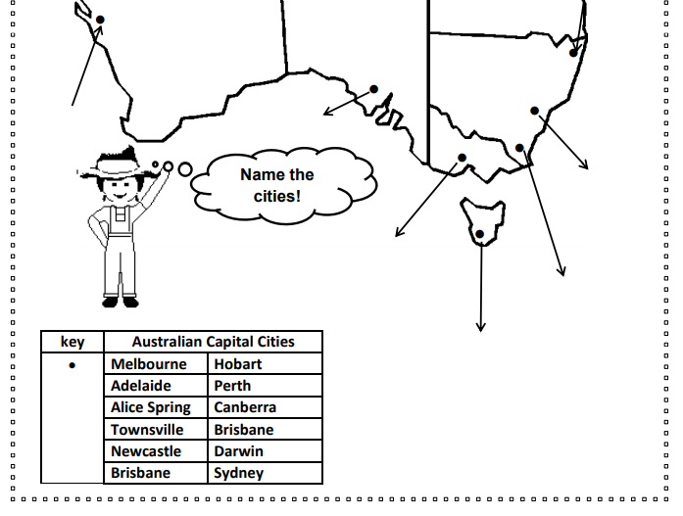

Wednesday 1st July | Core activities |  |  |  | Suggestions for additional activities.
9.00 – 9.30 | Daily Dashboard:  Quel est la date aujourd’hui?  C’est mercredi le premier juillet, 2020.  Can you write the number date in Roman numerals?  What is happening in the world? Have a look at https://www.bbc.co.uk/newsround or https://www.dogonews.com/ to see what is going on in the world. Choose a news article or two to read.  In 2007 England banned smoking in indoor public places. Prior to the smoking ban, people would smoke while travelling on buses, trains and planes, in cinemas and museums, even in restaurants! Do you think smoking should be banned completely in public? In parks, in the woods, on the street, while waiting on a bus? Why not make a poster to ban smoking in areas that you play? |  |  | Today in 1903 was the Inaugural race of the Tour de France bicycle race, which began in Montgeron, a suburb of Paris.  1961 - Diana Spencer, Princess of Wales, was born (d. 1997) Ask someone at home if they remember the Royal wedding of Prince Charles and Lady Diana in 1981 - https://www.youtube.com/watch?v=97DiJlZ03Ps  Clean Beaches Week starts today. Why not take a carrier bag with you on your next walk at the beach and see how much rubbish you can pick up? What’s the most common litter? What is found on the shoreline (deposited by the sea) and what is found further up the beach? Did you find anything unexpected?
9.30-10.00 | Spelling/Grammar – see Resources
10.00- 10.30 | Time for some physical activity. What about looking at some of the fun Youtube dances of Australians Koo Koo Kanga Roo? https://www.youtube.com/watch?v=Imhi98dHa5w
10.30-11.30 | Maths – follow the links to find online lessons for each year group:  Year 3: https://classroom.thenational.academy/lessons/add-and-subtract-capacity-and-volume  Year 4: https://classroom.thenational.academy/lessons/shape-and-symmetry-to-identify-acute-and-obtuse-angles  Year 5: https://classroom.thenational.academy/lessons/to-multiply-decimals-by-whole-numbers  Year 6: https://classroom.thenational.academy/lessons/problems-with-percentages-of-amounts |  |  |  | How about a warm-up using Times Table Rock Stars or else play a Maths game to help practise core number facts?  Investigate Australian currency (money). At the time of writing this, one British pound (£1) is worth 1.80 Australian dollars ($1.80). What other countries do you know of that have dollars as their currency?  How much money in Australian Dollars would you get if you exchanged £10, £20, £100, £50?
11.30-12.00 | Have a break and play a game or do another activity that you enjoy. | Today is International Joke Day. What’s your favourite joke? Why not have a joke telling session with your family! I like surreal, unexpected and pun jokes. My favourite joke is: What do you get hanging from banana trees? (Answer found at the end of Friday!)
12.00- 1.00pm | Lunch break. Eat a healthy lunch and, if you are able, try to get outside for some fresh air!
1.00pm – 1.30pm | Reading time: This blog will give you information on Australia’s big five native animals.  https://www.austravel.com/blog/australias-big-five-native-animals  Which ones did you know already? Choose one and write a fact card about it using bullet points and key information. |  | On this day in 1908, SOS is adopted as the international distress signal. Find out more about Morse Code here in this video from Peekaboo Kids https://www.youtube.com/watch?v=ORIDAmGf_yQ  I’ve included a morse alphabet below. A dot is a short flash and a dash is a longer flash.  Can you spell your name in Morse Code?  (Check out kiddle.com for more information)
1.30pm – 2.00pm | Mental Health: Coping with Anger  We all sometimes feel angry and there is nothing wrong with that. But sometimes we can lose control and express our anger in ways we later regret. Watch the videos about anger at https://www.bbc.co.uk/bitesize/clips/zjxqxnb and https://www.bbc.co.uk/bitesize/clips/zkq8q6f.  Make a list of positive or negative ways to deal with anger. Here are some ideas to get you started:  Push a Wall (pushing an immovable object helps release physical tension of anger)  Count to 10/Count back from 20 (to give your brain thinking time)  Clap it out (clap for 20 seconds - stop - the tingle in your hands is the anger leaving)  Have a cold drink (anger makes us feel hot due to increased blood flow)  Hands under cool water (particularly wrists to help cool)  Look at the Childline ‘Calm Zone and experiment with one or two of the games or activities: https://www.childline.org.uk/toolbox/calm-zone/
2.00pm -3.00pm | Theme – science  Today’s question is ‘What animals are found in Australia?’ You could research the animals on the sheet below, finding out their habitat, food and whether they are prolific or endangered.  Some good sites to use are:  https://www.activewild.com/australian-animals-list/  https://kids.kiddle.co/Fauna_of_Australia  https://www.animalfactsencyclopedia.com/Australian-animals.html  If you prefer videos there’s one here  http://kiddopedia.net/australian-animals-kids/  Or there’s lots of videos on The National Geographic site – this one is about kangaroos:  https://video.nationalgeographic.com/video/animals-source/00000167-3669-d99d-a1ff-3679c4750000?source=relatedvideo  A new species of marine life has been found in Australian waters:  https://video.nationalgeographic.com/video/news/00000144-0a32-d3cb-a96c-7b3f95550000?source=searchvideo  Think about what you have learnt about Australian animals today. You could put your scientist hat on and classify them according to different headings. Start with reptile/mammal/amphibian/bird. Where would platypus fit in? |  |  |  |  | Practise spelling Australian animals names using the wordsearch below.  Look in Additional Information for some simple facts about Australian animals to read.  Try the science research crossword on lizards and amphibians found below. You might need to look up some of the answers – it includes creatures from places other than Australia!

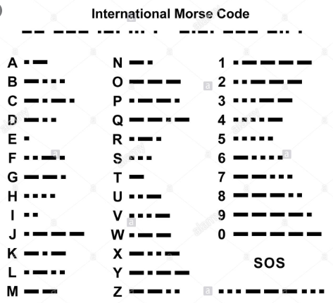

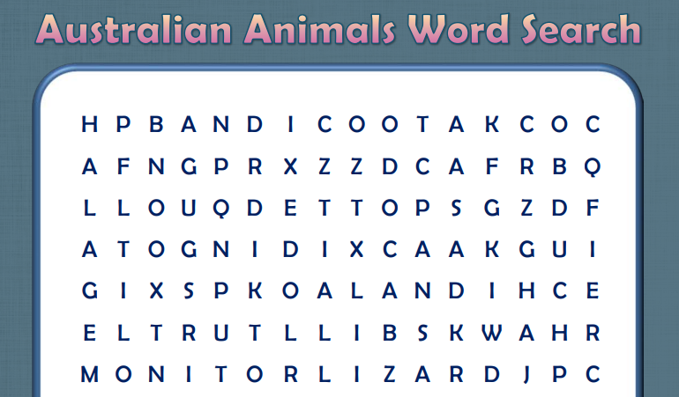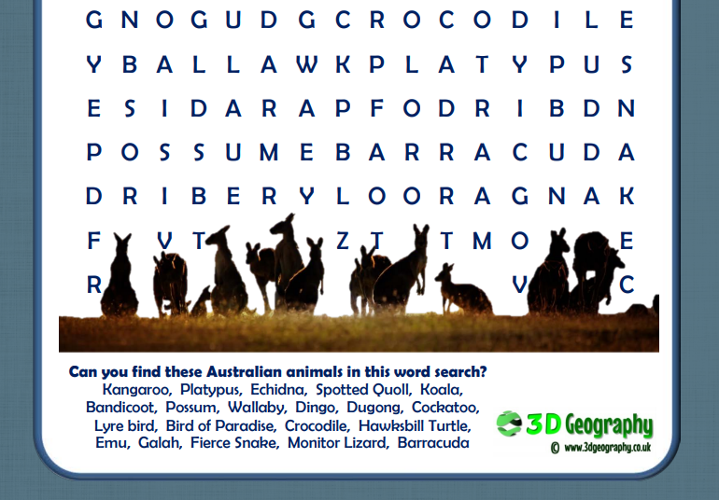

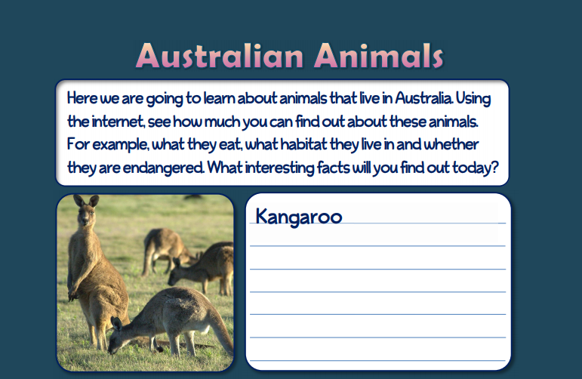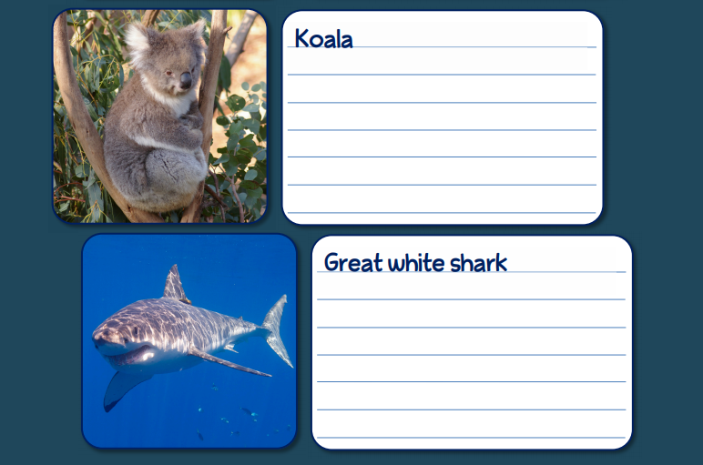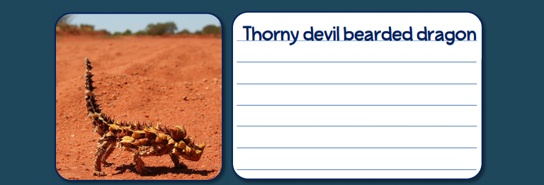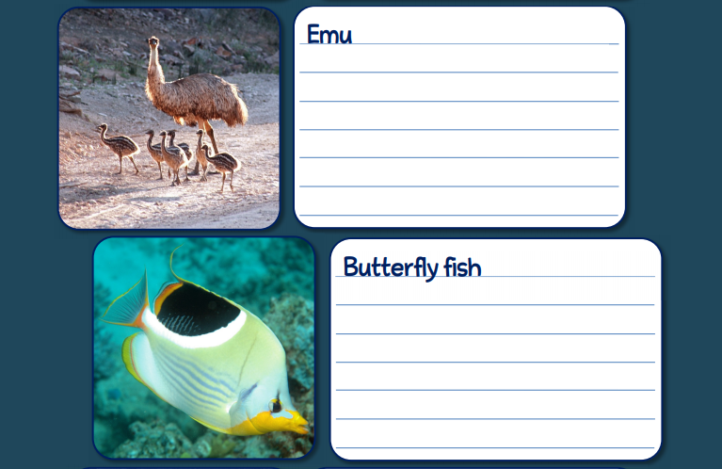
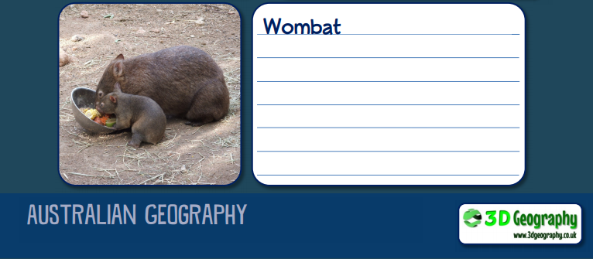

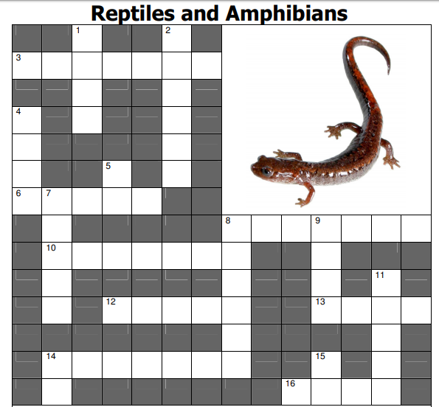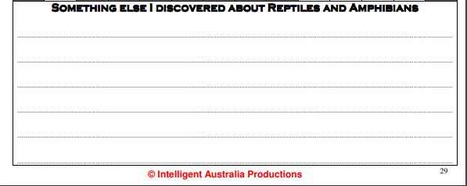

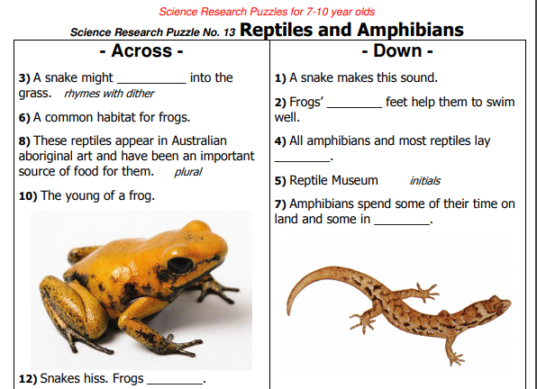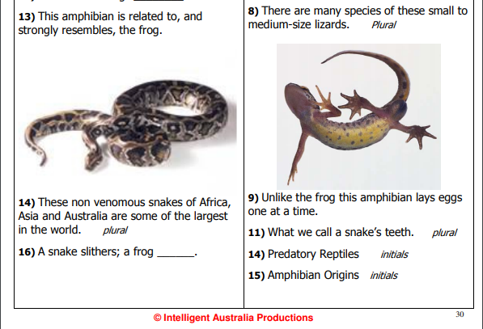

Thursday 2nd July | Core activities |  |  |  | Suggestions for additional activities.
9.00 – 9.30 | Daily Dashboard:  Quel est la date aujourd’hui?  C’est jeudi le deux juillet, 2020.  Can you write the number date in Roman numerals?  What is happening in the world? Have a look at https://www.bbc.co.uk/newsround or https://www.dogonews.com/ to see what is going on in the world. Choose a news article or two to read. |  |  | Although the main language in Australia is English, below you will find common words and phrases that are used everyday. This is called dialect. How many can you identify? There’s a few we use in this country. Answers provided at the end of Friday!
9.30-10.00 | Spelling/Grammar – see Resources
10.00- 10.30 | Time for some physical activity.
10.30-11.30 | Maths – follow the links to find online lessons for each year group:  Year 3: https://classroom.thenational.academy/lessons/solve-problems-involving-capacity-and-volume  Year 4: https://classroom.thenational.academy/lessons/shape-and-symmetry-to-investigate-angles-within-shapes  Year 5: https://classroom.thenational.academy/lessons/to-multiply-decimals-using-a-formal-method  Year 6: https://classroom.thenational.academy/lessons/interpret-mean-as-an-average |  |  |  | How about a warm-up using Times Table Rock Stars or else play a Maths game to help practise core number facts?  Why not visit https://nrich.maths.org/9803 and have a go at one of the Maths investigations there. Be warned – these will really make you think!
11.30-12.00 | Have a break and play a game or do another activity that you enjoy. |  | Drink lots! Don’t forget to stay well hydrated.
12.00- 1.00pm | Lunch break. Eat a healthy lunch and, if you are able, try to get outside for some fresh air!
1.00pm – 1.30pm | Reading time – Today we will be learning about Aboriginal stories and art. I’ve included an aborignal myth below, that describes a possible reason that led to Corcoran Lake. Read it then answer the questions. | Alternatively, read a chapter or two of a novel. Pick out a few of your favourite sentences and tell an family member what the author has done to make them have an impact on the reader.
1.30pm – 2.00pm | Mental Health: Celebrating Yourself  One of the keys to maintaining good mental health is to maintain positive self-esteem. This means feeling good about yourself or ‘being proud of your very being’. This is an important part of our school vision: “Be who God meant you to be and you will set the world on fire.”  To celebrate who you are today, why not type up some sentences about yourself and print them out using them and oil pastels/chalks/paint to decorate around a photo of yourself pulling a confident pose. This makes a very effective artwork and will remind you of your many amazing qualities when you are feeling blue. Here are some examples:  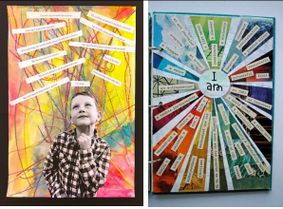  Alternatively, can you write lots of facts about yourself around a design in the shape of your fingerprint?  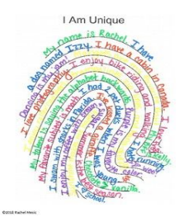
2.00pm -3.00pm | Theme- history/literacy  The belief systems of Indigenous Australians have a strong connection to the land. Each group has its own traditions and customs. For indigenous Australians the dreaming is the sum of wisdom, understanding and tribal law that is passed from one generation to the next. It includes Dreamtime stories about how the natural world was formed (creation stories). It also provides rules for Aboriginal people to live by.  Read online Dreamtime stories from:- http://dreamtime.net.au/dreaming/story-list/  I’ve also included Rainbow Serpent in Additional Information. Check out You tube by searching Dreamtime aboriginal for videos.  Which did you like and why?  Have a go at writing your own story in the style of an Aboriginal Dreaming story – perhaps ‘How the Kangaroo learnt to Hop’ or ‘How the Rainbow Serpent Created Sydney Harbour’. |  |  |  |  | For some background information about Australian Aborigines and their life before colonisation, see Additional Information.  Why not choose an aspect of Australian culture that you are curious about and do some research to find out more? You could present the information in a short report.  Or use secondary sources to investigate and complete the Australia fact file sheet below.
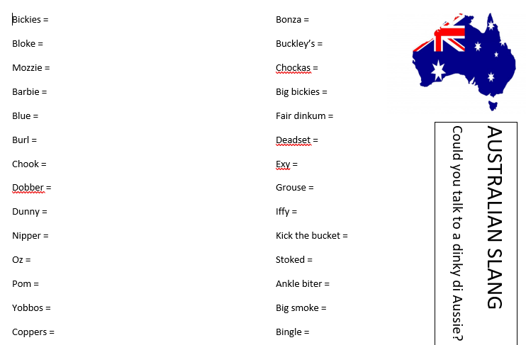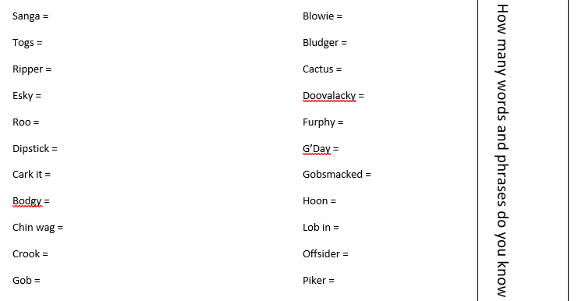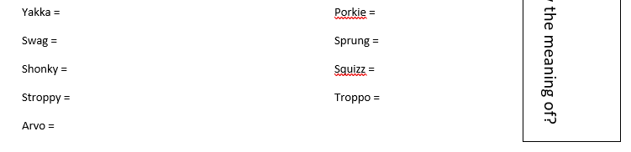

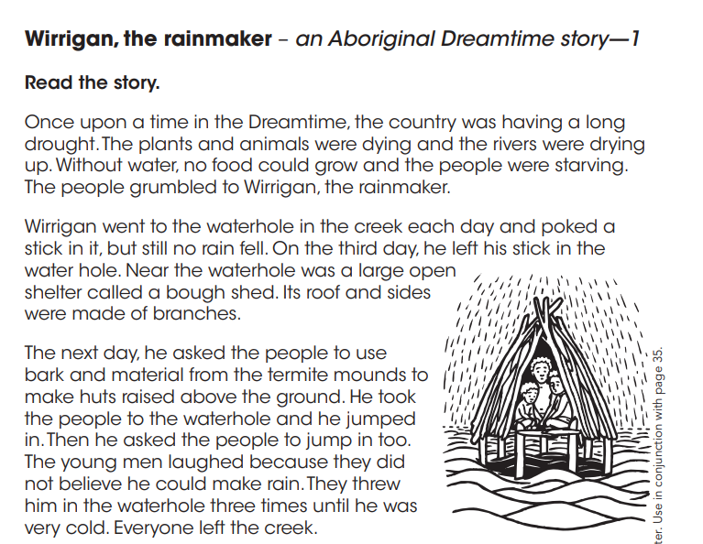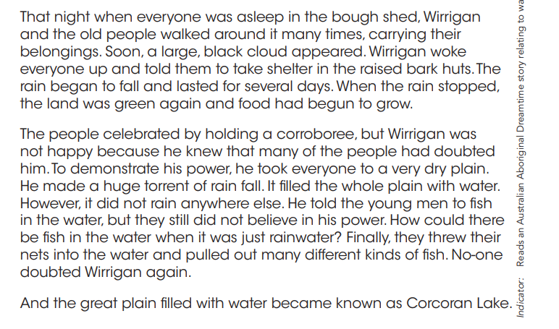
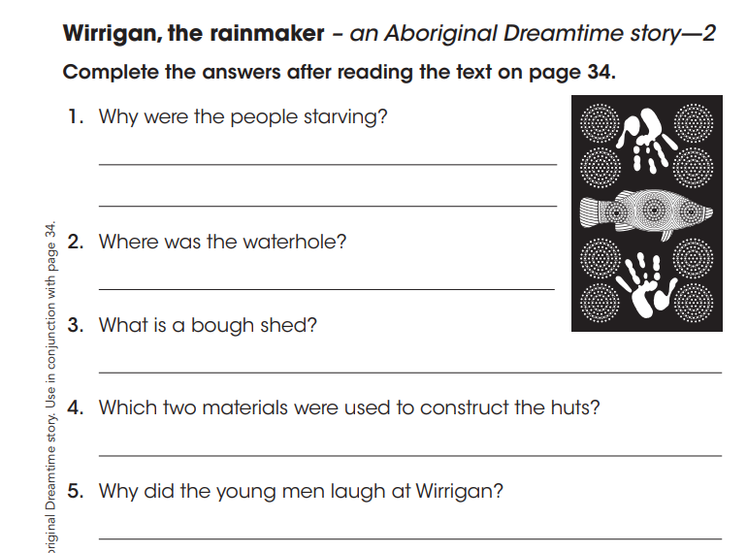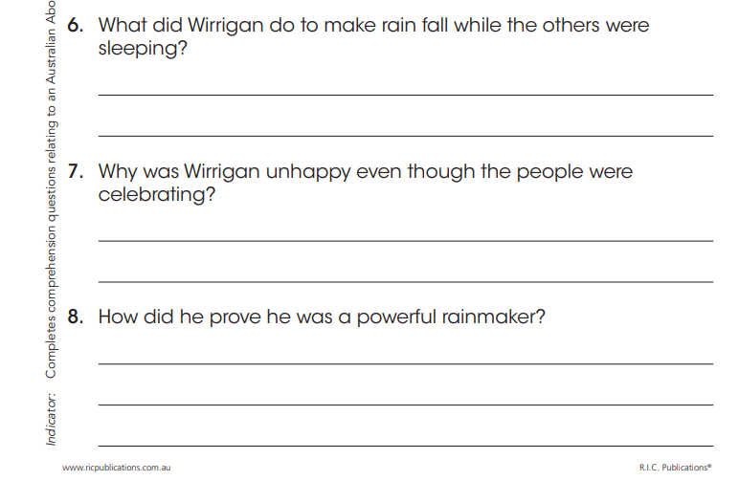

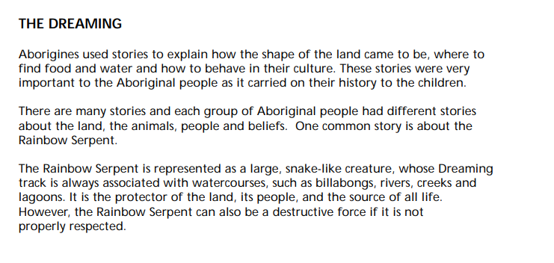

Friday 3rd July | Core activities |  |  | Suggestions for additional activities.
9.00 – 9.30 | Daily Dashboard:  Quel est la date aujourd’hui?  C’est vendredi le trois juillet, 2020.  Can you write the number date in Roman numerals?  What is happening in the world? Have a look at https://www.bbc.co.uk/newsround or https://www.dogonews.com/ to see what is going on in the world. Choose a news article or two to read.  Today is our last day of learning about Australia – why not have a go at drawing two of the most famous Australian animals? Instructions below. |  |  |  | Tom Cruise’s birthday is today – famous for films such as Mission Impossible  https://www.youtube.com/watch?v=wb49-oV0F78  Can anyone in your family name any of his earlier films?
9.30-10.00 | Spelling – Have a look back over the words you have practised this week. Test yourself (or ask someone to test you) to see how well you have remembered these words. Then practise any words you still need to secure.
10.00- 10.30 | Time for some physical activity. Have you visited Joe Wicks recently?
10.30-11.30 | Maths – follow the links to find online lessons for each year group:  Year 3: https://classroom.thenational.academy/lessons/estimate-mass-and-capacity  Year 4: https://classroom.thenational.academy/lessons/shape-and-symmetry-to-solve-problems-based-on-angles  Year 5: https://classroom.thenational.academy/lessons/to-use-a-range-of-multiplication-strategies  Year 6: https://classroom.thenational.academy/lessons/interpret-line-graphs |  |  |  |  | How about a warm-up using Times Table Rock Stars or else play a Maths game to help practise core number facts?
11.30-11.45 | Have a break and play a game or do another activity that you enjoy. | Mrs Marsh’s favourite joke: What do you get hanging from banana trees?  Sore arms!
11.45 – 12.00 | Why not join in with the act of Collective Worship that you will find on the school website. Take time to think about or pray for people that might be anxious or upset, ill or suffering.
12.00- 1.00pm | Lunch break. Eat a healthy lunch and try to get outside for some fresh air!
1.00pm – 1.30pm | Reading  Back to National Geographic for Kids today, to read about Aboriginal art and its origins.  https://www.natgeokids.com/uk/discover/history/general-history/aboriginal-arts-and-culture/ |  | Alternatively, read a chapter or two of a novel. Pick out a few of your favourite sentences and consider what the author has done to make them have an impact on the reader.
1.30pm-2.00pm | Celebrating Myself  What we tell ourselves can really affect our self-confidence and how we can talk to ourselves in ways that promote confidence. The more you do it, the more it becomes your inner voice. https://www.youtube.com/watch?v=lEDcb9VHXRI  Can you make a positive affirmation fortune teller? The more you tell yourself positive things about yourself the more you will believe them and this will improve your mental health. See the template below.  or Make a Positive Self Talk Tree. Think about things that you say about yourself. Write them on post its. Sort the post its onto the apple tree. The rotten apples that have fallen off the tree are around the bottom (the negative talk) and the positive self-talk apples stay on the tree. (see the template below).
2.00pm – 3.00pm | Theme/ History /Art  Today we are going to look at some of the artwork Aboriginal Australians are famous for. Their pictures are often used to help them tell their dreamtime stories. They are created with a type of mud called ochre and often include dots and lines in patterns.  Why not have a go at illustrating your story from yesterday? You could use paint or felt tip pens or even create a mud mixture paint!  Find out more below.  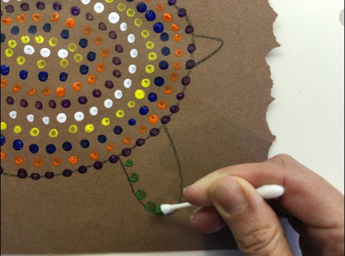  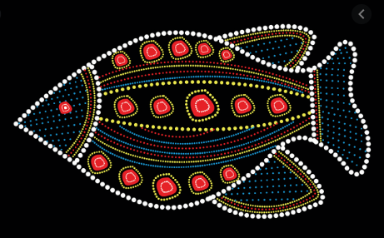 |  |  | What are the most interesting things you have learned about Australia? Why not make a little booklet, fact file or poster or write a diary entry about your ‘visit’ to Australia.
That’s it for our visit to Australia – next week we hope to travel to one of the countries you used in your project! Have you sent in your ideas to the school admin email address? Remember to stay safe in the sun over the weekend.

