Maths Home Learning for Summer Term 1 - Week 3

Monday - WALT: consolidate our learning of halves and quarters.

Last week we started to look at fractions. Let’s recap our learning.

- Colour in one quarter of these shapes - remember one quarter is one of four equal parts.
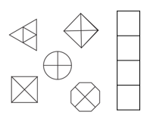

- Colour in one half of these shapes – remember one half is one of two equal parts.
Discussion: How many parts will you need to colour in, to show half, if your shape has been cut into four equal parts?

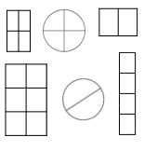
- What did you notice when you coloured in one half of the shape, when the shape had been divided into four parts?
How many parts did you colour in?

You may have noticed that when a shape is divided into four equal parts, you need to colour in two of those equal parts, to show one half.
This is because 2 is half of 4.

Now we are going to recap our knowledge of finding half and a quarter of an amount.
For these questions you may want to use real life resources, for example: Lego bricks, toy cars.
Reception children can have a go at these amounts, but they may need to use smaller amounts, such as: half of 8, a quarter of 8, half of 12, a quarter of 12. Have fun!
For example: Half of 4 frogs is 2 frogs. I can show this by drawing 4 frogs and circling half of the amount.

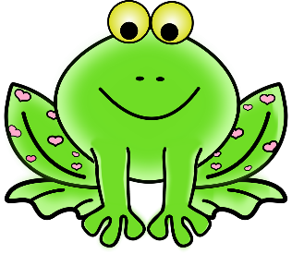

- What is half of 16 frogs? Can you draw something to explain your thinking, in the space below?

One half of 16 frogs is _________ frogs.

- What is a quarter of 16 frogs? Draw something to show your thinking.

One quarter of 16 frogs is __________ frogs.

- What is half of 24 flowers? Draw something to show your thinking.

One half of 24 flowers if _________ flowers.

- Find one quarter of 24 flowers. Show me your thinking.

One quarter of 24 flowers is _________ flowers.

Tuesday – WALT: represent one half and one quarter using their fraction symbols.

So, you have a good understanding of finding one half and one quarter.
One half can also be written as: ½
This symbol shows – the 1 on top represents one equal part.
The 2 on the bottom shows the one whole, has been cut into two equal parts.
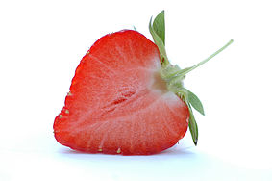 of 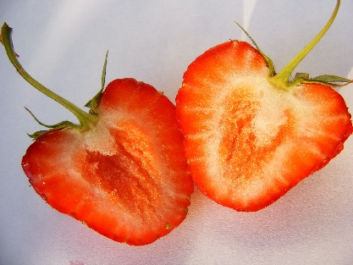 = ½
1 of 2 equal parts

So, sometimes you will see a question that says: Find ½ of 10.
This is the same as: find one half of 10.Which you know is 5.

Reception and year 1 do not need to know this yet, but it is a good time to show them the symbol so that when they see it next year it will be more familiar.

In the same way, one quarter can also be written as: ¼
The 1 on top represents one equal part (just like ½)
The 4 on the bottom shows the one whole, has been cut into four equal parts.

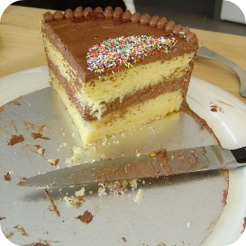 of 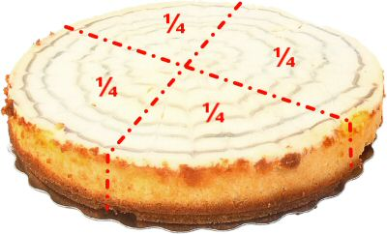
1 of 4 equal parts = ¼

With these symbols in mind have a go at the attached Dolmino game.
Cut out the Dolmino cards and have a go at matching the symbols to the amount shown on the picture.
Remember: the number on the top (numerator) tells you how many pieces are coloured in. The number on the bottom tells you how many equal parts there are in total!

Photos of your completed Dolmino trails would be fantastic to see! admin@farway.devon.sch.uk

Wednesday – WALT: apply our knowledge of finding half of an amount to solving word problems.

Warm yourselves up this morning playing your Fraction Dolmino game again. Or you can play a simple fractions game on topmarks – Choose the Fractions game for 5-7 years olds.
https://www.topmarks.co.uk/Search.aspx?q=fractions%20ks1

Now, have a go at solving some of these fraction word problems. Remember to show your thinking and use resources (or draw something) if you need to.
- Daisy has 14 sweets. She gives half of the sweets to Jessica. How many sweets does she have left?

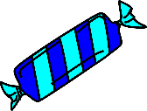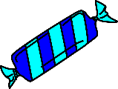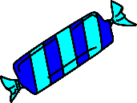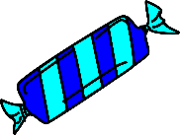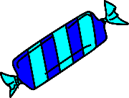

Daisy will have ______ sweets left, because I know half of 14 sweets is _______ sweets.

- Elodie has 10 teddy bears. She gives ½ of her teddy bears to Izabelle, to play with. How many teddy bears would Elodie have left?

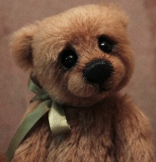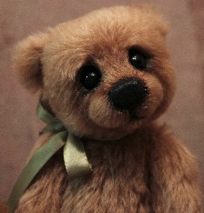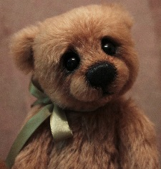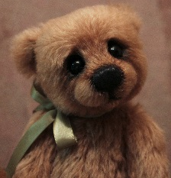

Elodie will have _______ teddy bears left, because I know that half of 10 teddy bears is _________ teddy bears.

- Oliver was playing with 16 toy cars. He gave half of his toy cars to his friend Ollie. How many toy cars will Oliver have left?
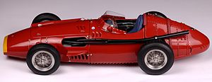

Oliver will have _________ toy cars left, because I know that half of 16 toy cars is _________ toy cars.

- Make up your own word problems to challenge your family members to find half of an amount.

Thursday – WALT: apply our knowledge of finding one quarter of an amount to solving word problems.

First, warm up your maths brains by solving this problem:
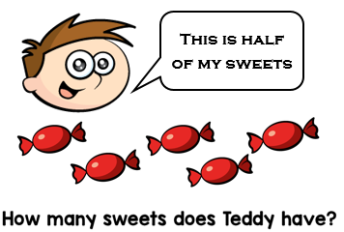 Explain your thinking.

      - Oliver has 8 apples. He gives a quarter of the apples to Sarah Lucy, to bake an apple pie. How many apples has he given to Sarah Lucy?

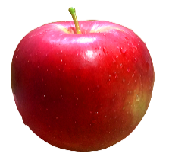
Oliver will give_______ apples to Sarah Lucy, for her apple pie, because I know one quarter of 8 apples is ________ apples.

      - Jessica has baked 20 cakes. She gives ¼ of her cakes to Elodie. How many cakes has she given to Elodie?

Elodie will have ______ cakes, because I know that ¼ of 20 is _____cakes.

Challenge – If Jessica has given Elodie ¼ (one quarter) of her 20 cakes. Elodie will have 5 cakes. How many cakes will Jessica have left?

Explain your thinking…

      - Olli has been ordering marbles on line with his mum. He has ordered 16 marbles. He decides to give one quarter of his marbles to Daisy. How many marbles has he given to Daisy?
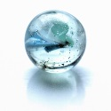
Olli will give ______ marbles to Daisy, because I know that one quarter of 16 marbles is _______ marbles.

      - Izabelle has 24 carrots to feed her horse. On Thursday, she feeds one quarter of the carrots to her horse. How many carrots does she feed her horse on Thursday?
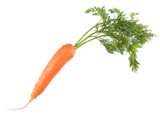

Izabelle will feed her horse _____ carrots, on Thursday. I know this because I know _______ carrots is one quarter of 24 carrots.

Challenge: If Izabelle feeds one quarter of her 24 carrots to her horse, on Thursday, she will feed him 6 carrots. How many carrots will she have left to feed her horse for the rest of the week?

- Make up your own word problems to challenge your family members to find one quarter of an amount.

Friday – recap on what you know about finding one half and one quarter
Warm up your maths brain with this challenge, below. Think about how you can show your thinking.
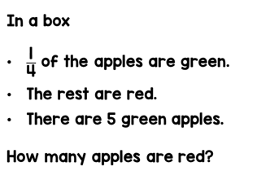
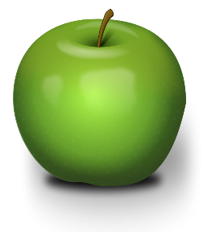
Tasks today:
- Have a go at the Fraction Dolmino game (available to download from the school website)
- Explore TopMarks fraction games (they have a large selection) https://www.topmarks.co.uk/Search.aspx?q=fractions%20ks1
- Bake a batch of cupcake or cookies. Count how many you have made and calculate one half and one quarter of the amount. Then give one half or one quarter of your amount to a neighbour, to bring a smile on their faces, to celebrate National Smile Month (May).
- Have Fun! If you have completed all the work from this week you have done amazing and should spend the day just doing something you love doing!

