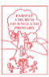
8.5.2020

Dear Class 1
How are you all? I hope you have had a good week. It has been nice to see the sunshine back in the sky again. On Wednesday, I had to take our class froglets back to their home pond because they were all metamorphing quickly into frogs and had started to jump up the sides of their tank. It would have been a shame for them to escape, or to have been caught by our cat, Benny!
Here is a picture of one of our class frogs.
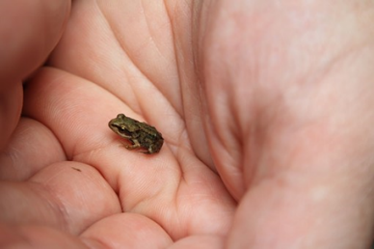
As you can see, they are miniscule, but they are now safely home and will continue to grow into adult frogs, before laying eggs of their own and continuing the life cycle of the frog.
I hope you have all seen the video on the website. We wanted to let you all know that we are thinking of you and are all still here for you.
Have fun with your home learning, this week. If you should want anything extra a website called: Oak National Accademy, has some really good resources. Follow the link below if you should like to have a look.
https://www.thenational.academy/

I hope you had a fabulous bank holiday weekend!

‘We’ll meet again’
Mrs Jackson
Literacy Home Learning – week beginning 11th May.

Monday – WALT: create our own story, in the style of ‘Oi Frog!’
Last week, we were looking at the story, ‘Oi Frog!’ by Kes Gray and Jim Field.
Please follow this link below to listen to the story again, to remind yourselves, if you need to.
https://www.youtube.com/watch?v=2da5yu6rpdg

On Thursday, you were asked to pick a theme for your own story and create a list of words, associated with your chosen theme, along with their rhyming pair.
For example, I have chosen to create a story about Star Wars, in the style of ‘Oi Frog!’. My list of words and their rhymming pair can be seen below:
Word | Rhyming pair
Yoda | Cream soda
Ewok | Rock
Bear | Chair
Droid | Lloyd
Rey | Tray
Hans Solo | Mint Polo
Storm Trooper | Tutor
Chewbacca | Alpacca

Today, we will begin creating our own story, using these rhyming pairs. I have written out a section of the text from ‘Oi Frog!’, highlighting the rhyming pairs, that you will need to replace with your own pairs.
For example:

Oi Frog!

‘Oi Frog! Sit on a log!’ said the cat.
‘’But I don’t want to sit on a log,’’ said the frog.
‘’Logs are all nobbly and uncomfortable. And they can give me splinters in my bottom.’’
‘’I don’t care,’’ said the cat.
‘’You’re a frog, so you must sit on a log.’’

‘’Can’t I sit on a mat?’’ asked the frog.
‘’Only cats sit on mats,’’ said the cat.

Now, replace the high-lighted words (nouns) with your own rhyming pairs. The character highlighted in blue will be replaced with your chosen ‘main’ character. In my story, this is Yoda. My first rhymming pair – Yoda and soda. The character highlighted in pink will become the frog, in your story.
You may want to leave the high-lighted descriptions the same as in ‘Oi Frog!’ Or, you may want to change them, depending how confident you feel.

I have written a Star Wars themed version of ‘Oi Yoda!’ to support you all with this.
Oi Yoda!

‘’Oi Yoda! Sit on the cream soda!’’ said the frog.

‘’But I don’t want to sit on cream soda,’’ said Yoda.
‘’Soda is all bubbly and cold. And it makes me go hipper.’’

‘’I don’t care,’’ said the frog.
‘’You’re Yoda, so you must sit on the cream soda.’’

‘’Can’t I sit on a rock?’’ asked Yoda.

‘’Only Ewoks sit on rocks,’’ said the frog.

You only need to write up to: ‘’Only cats sit on mats,’’ said the cat. But if you are enjoying this activity and would like to have a go at the rest of the script, then please do!
Please check your work for any spelling mistakes and to make sure your sentences make sense. This is something we were practising a lot before the school closure and you were all becoming experts at this!

Tuesday – WALT: continue creating our own story, in the style of ‘Oi Frog!’

Yesterday, you made a good start at creating your own story, in the style of ‘Oi Frog!’ Today, we are going to continue this. Some of you may have found this quite fun and not too challenging. If this was you, then please try and use the text from last week to support you to continue with this.
Remember, you can keep the majority of the text similar to the ‘Oi Frog!’ But you must use your own theme and rhyming pairs. Have fun! You can be as creative as you like.

Idea: You could fold paper to create a book, to write your story in. We will be illustrating them on Thursday.

For those that found it more challenging I have written the remaining ‘Oi Frog!’ text below (from the point we left off yesterday), leaving blank spaces for you to fill in your own rhyming pairs. Remember to use the pairs you created on Thursday.

‘’Perhaps I could sit on a ________?’’ said the ______.

‘’_______ sit on __________,’’ said the frog.

‘’What about a _______?’’ said the _______. ‘’I could stretch right out on a ________.’’
‘’_________ sit on ___________,’’ said the frog. ‘’It’s very simple really.
_________ sit on _________,
_________ sit on _________,
__________sit on _________,
__________sit on __________,
__________ sit on __________.’’

‘’What do _________ sit on?’’ Asked the _______.

‘’__________ sit on _________,’’ said the frog.

‘’Ouch!’’ said _____. ‘’What do ________ sit on?’’

‘’_________ sit on __________,’’ said the frog. ‘’ ________ sit on _______ and _________ sit on __________.’’

‘’Doesn’t sound very comfortable to me,’’ said ________.

‘’It isn’t about being comfortable,’’ said the frog. ‘’It’s about doing the right thing.’’

Below, I have written a story, called ‘Oi Yoda!’ to support you further on this. It is quite challenging trying to plan this in a coherent way to ensure children feel successful at this. The main objective is for them to create their own story, in the style of ‘Oi Frog!’ (Using the rhyming pairs). So, if their story takes on a different twist then that is absolutely fine!!!

Oi Yoda!

‘’Oi Yoda! Sit on the cream soda!’’ said the frog.

‘’But I don’t want to sit on cream soda,’’ said Yoda.
‘’Soda is all bubbly and cold. And it makes me go hipper.’’

‘’I don’t care,’’ said the frog.
‘’You’re Yoda, so you must sit on the cream soda.’’

‘’Can’t I sit on a rock?’’ asked Yoda.

‘’Only Ewoks sit on rocks,’’ said the frog.

‘’What about a chair?’’ said Yoda
‘’I wouldn’t mind sitting on a chair.’’

‘’Bears sit on chairs,’’ said the frog.

‘’Perhaps I could sit on a droid?’’ asked Yoda.
‘’Lloyd sits on droids,’’ said the frog.

‘’What about a tray?’’ said Yoda.
‘’I could stretch right out on a tray!’’

‘’Rey sits on trays,’’ said the frog.
‘It’s very simple really...
Ewoks sit on rocks,
Bears sit on chairs,
Lloyd sits on droids,
Rey sits on trays,
And Yoda sits on cream soda.’’

‘’What does Han Solo sit on?’’ asked Yoda.

‘’Solo sits on mint Polos,’’ said the frog.

‘’Oooh!’’ said Yoda.
‘’What do Storm Troopers sit on?’’

‘’Solo sits on Mint Polos,
And Storm Troopers sit on Tutors.’’

‘’Doesn’t sound very cozy to me,’’ said Yoda.

‘’It’s not about being cozy it’s about doing the right thing!’’ said the frog.

Wednesday – WALT: create a humorous ending for your story.
Well done on your fantastic stories so far!
I would love to see your creations, so please do email them to Mrs Jackson, at admin@farway.devon.sch.uk. We could make our own class book!!
In the ‘Oi Frog!’ story, the story ends with the main character (frog) asking,
‘‘What do dogs sit on?’’
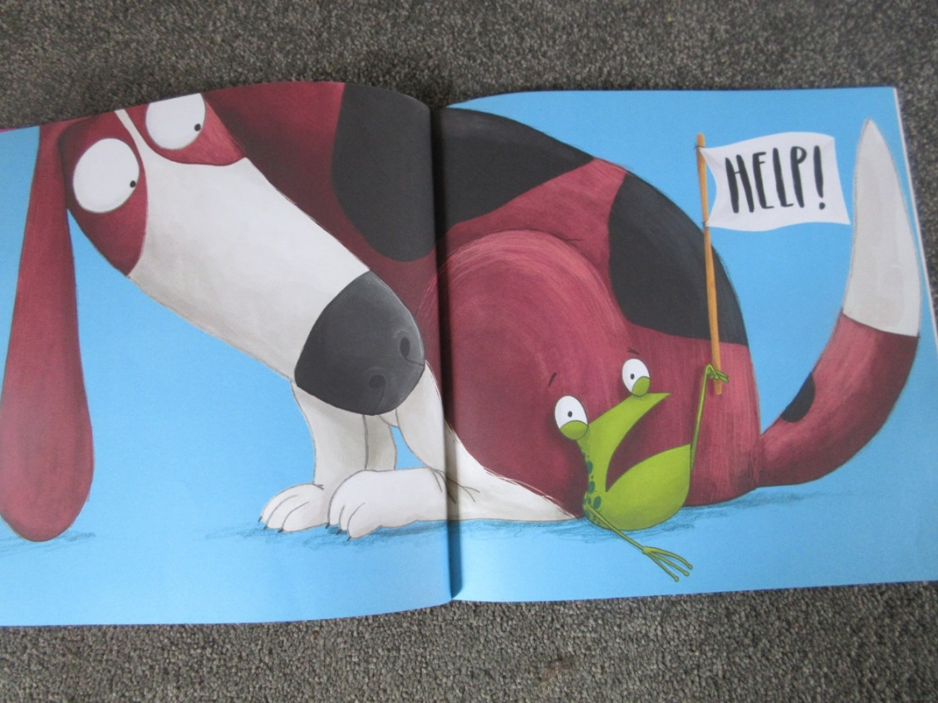
Kes Gray and Jim Field have created a series of ‘Oi ___!’ books, in which the end of the story is often quite humourous.

In ‘Oi Dog!’, the follow-on edition to ‘Oi Frog!’ The frog has had enough of being told where he can and can’t sit and decides to take control, shaking up all the rhyming pairs, before ending the story by defying all rhyming rules and decides he will sit on a ‘sun-lounger’… just because!
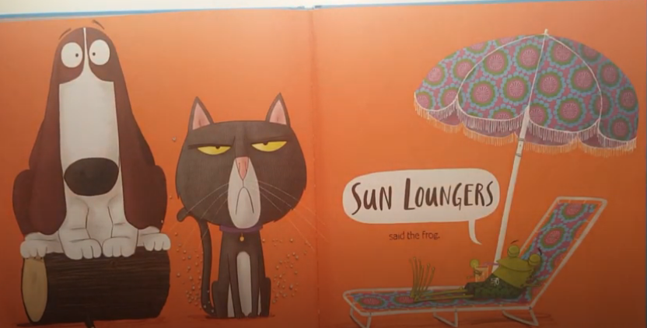
With these ideas in mind, have a think about how you would like to end your story. What humourous ending could you have? Will your ending rhyme or will you chose to have a funny, non-rhyming ending? Be as creative and outragous as you like!

This is the ending of my story, ‘Oi Yoda!’ I have chosen to end the story with a rhyming pair, but deviated from the ‘sitting’ idea (I was struggling to think of rhyming pairs for Yoda!):

‘’So, what would Chewbacca sit on?’’ asked Yoda.

‘’Chewbaccas sit on alpaccas’’, said the frog.
‘’Chewbaccas sit on alpaccas and R2D2 sits on a pew.’’

‘’Okay! I get this,’’ said Yoda.
‘’So, if Ewoks sit on rocks,
Bears sit on chairs,
Lloyd sits on droids,
Rey sits on trays,
Hans Solo sits on mint polos,
Storm troopers sit on Tutors,
Chewbacca sits on alpaccas,
And R2D2 sits on a pew…

So, couldn't I just practise yoga?’’

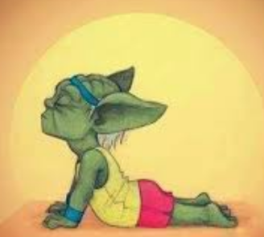

Thursday – WALT: illustrate our stories
Today we are going to have a go at illustrating our stories. First watch the clip below, of Axel Schneffler giving his 3 top tips for a budding illustrator!
https://safeyoutube.net/w/Aab7
Axel Schneffler is the illustrator of Julia Donaldson’s stories, such as: The Gruffalo, Stick Man, The Detective Dog, and The Highway Rat.
His top tips are:
- Have a story and think about what you would want your main character to look like.
- Look at work from other illustrators and be curious
- Draw lots and try out lots of different styles, using different materials.

So, following Axel’s top tips:
- Have a look at your own story and who your main character is. What do you want your character to look like? What do you want your pages to look like?

- Have a look through your favourite picture books at home. Which illustrations do you like best? Why do you like them? How do they make you feel?
Below are some links to explore different techniques of different illustrators.
https://vimeo.com/51609068 - Simon James (Baby Brains)
https://safeyoutube.net/w/Apb7 - Nick Sharratt
https://safeyoutube.net/w/nXa7 - Oliver Jeffers

Have a look through these clips, then study these illustrations, below, in detail.
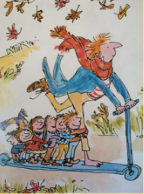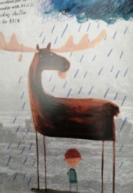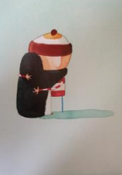
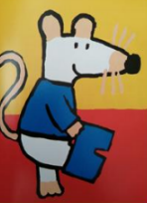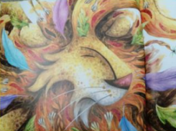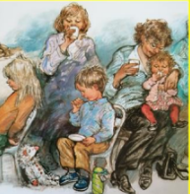
Make a note of the illustrations that you like best? Why do you like them? How do they make you feel? What do you dislike about them? Why?
What medium (e.g. pencil crayons, water colours, oil pastels) has the illustrator used? Which effect do you like best and why?
- Now try drawing lots and lots, whilst trying out different styles, using different materials. Remember, this is your own story so you can create the characters and illustrations as you choose to!

Friday – WALT: complete our stories and read them aloud
For Literacy today, I would love you to spend some time finishing your stories. Finish the writing. Finish drawing those beautiful illustrations and decorating them as you please. Be proud of your finished creation!
When you have finished, try reading your story aloud to a family member. You could even ask a parent to film you, whilst reading your story and send it to a grandparent or to Mrs Jackson!! We would all love to hear your fabulous story and see those amazing illustrations!
Keep creating. Keep reading.

