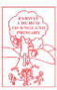
1st June 2020

Dear Class 1,
I hope you have had a fabulous half term and are looking forward to some exciting home learning this week. I am looking forward to seeing those of you that will be returning soon.
This week, our class caterpillars have been very busy eating and growing and metamorphosing. On day one, they started out very tiny, then they ate and ate, and turned into great big caterpillars. Just like the caterpillar from ‘The Very Hungry Caterpillar’, by Eric Carle. On Friday morning, I came downstairs to discover they had all formed their chrysalides and were beginning their transformation into butterflies. They will stay inside their chrysalides for around two weeks, liquefying and re-arranging their cells and organs to become a butterfly. Once their wings are string enough, we can release them into the wild to continue their life cycle as a Painted Lady butterfly.
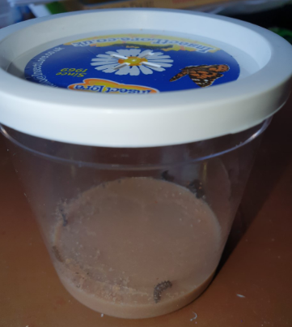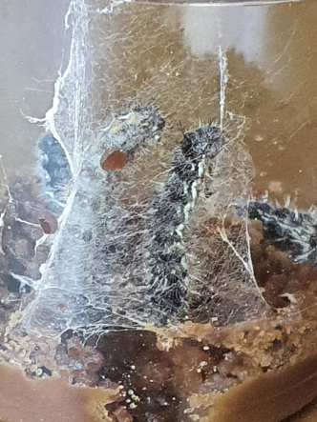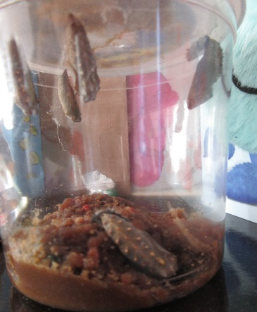
Day 1 Day 3 Day 7

Please do get in contact if you have any questions, regarding the home learning or would like to share any news, or work the children are proud of.
Kindest Regards
Mrs Jackson
Literacy Home Learning – week beginning 1st June
For the next few weeks we are going to be exploring our emotions and feelings, focusing on different stories to support our understanding and ability to verbalise these more easily. This week we will begin to look at colour and our feelings, using the story, ‘The Day the Crayons Quit’, by Drew Daywalt.
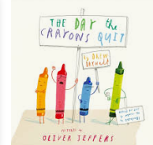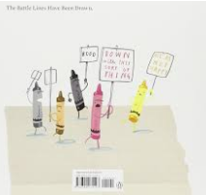

Monday – WALT: ask questions and make predictions

Today, we are going to start this new Literacy sequence exploring your own colouring crayons at home. Do you have them neatly placed in their packet still? Or do you have a draw filled with different coloured crayons that you have collected over the years?
First, look closely at your colouring crayons.
Next, discuss with your parent or sibling:
- “What has happened to the crayons?”
- “Why are some shorter than others or broken?”
- “Which crayon is most popular?”
- “Which crayon is rarely used and why?”
- ‘’How do you know the crayon is most or least popular?’’

Maybe you could make a tally chart to find out how many of each coloured crayon you have? Or perhaps you could explore which colour crayon is the most popular amongst your friends and family, and why?
Finally, have a look at the front cover of the story, ‘The Day the Crayons Quit’, by Drew Daywalt and make a prediction about what you think the story will be about and why?
Write these in your home learning books.

I predict the story will be about…
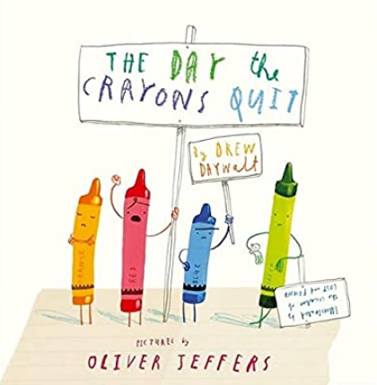
Because…
Why do you think the crayons quit?

I think the crayons quit because__________________________________ ______________________________________________________________________________________________________________________

When things become difficult we sometimes might feel like quitting (giving up), but this is not the only option and is often not the best option.

What do you think they could have done instead of quitting?
Draw a picture to show your thinking.

Tuesday – WALT: retrieve information from a text

Read the letter, below to your parent.
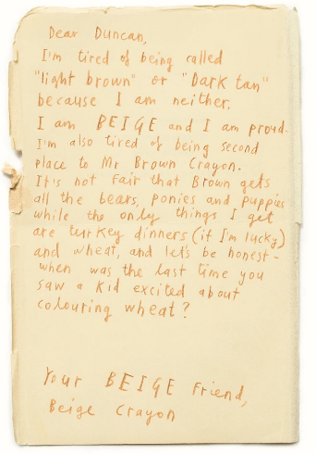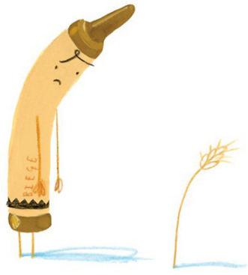

After you have read the letter, discuss who you think Duncan might be and why?
Then, explore any unfamiliar language together. For example: what colour is beige?

Can you colour this crayon beige.
Use the letter above to answer these questions.
How has Duncan used the beige crayon?

How does this make the
crayon feel?

What does the crayon want Duncan to do?

How does the crayon try to persuade Duncan to use the crayon differently?

What could would you do to make the crayon happy?

Now, read the letters below, from black and blue crayon and have a go at answering the questions for these crayons.

How has Duncan used the black crayon?

How does this make the
crayon feel?

What does the crayon want Duncan to do?

How does the crayon try to persuade Duncan to use the crayon differently?

What could would you do to make the crayon happy?

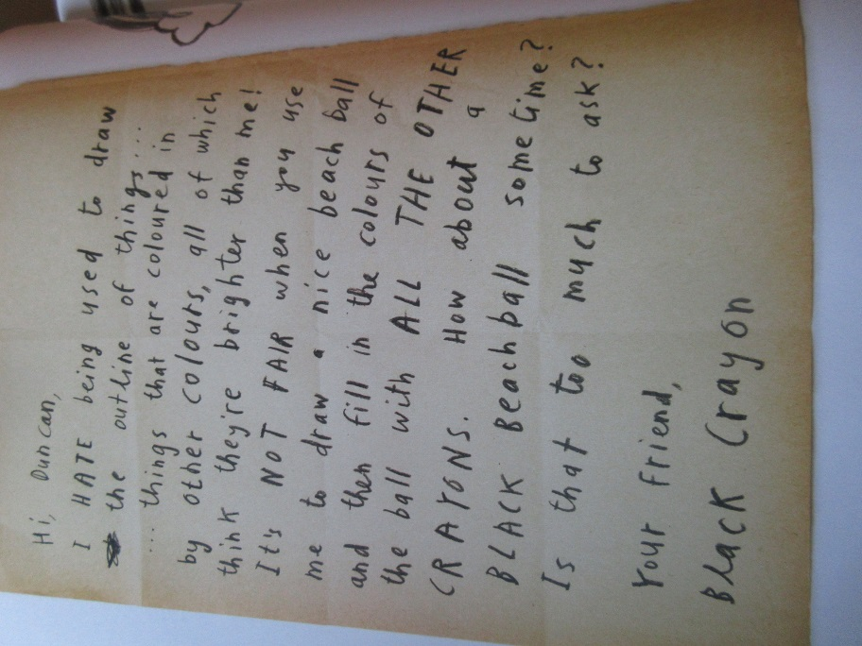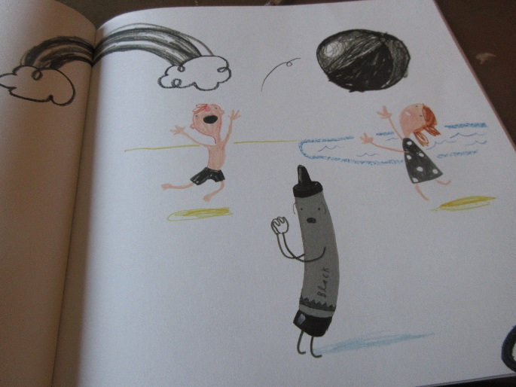

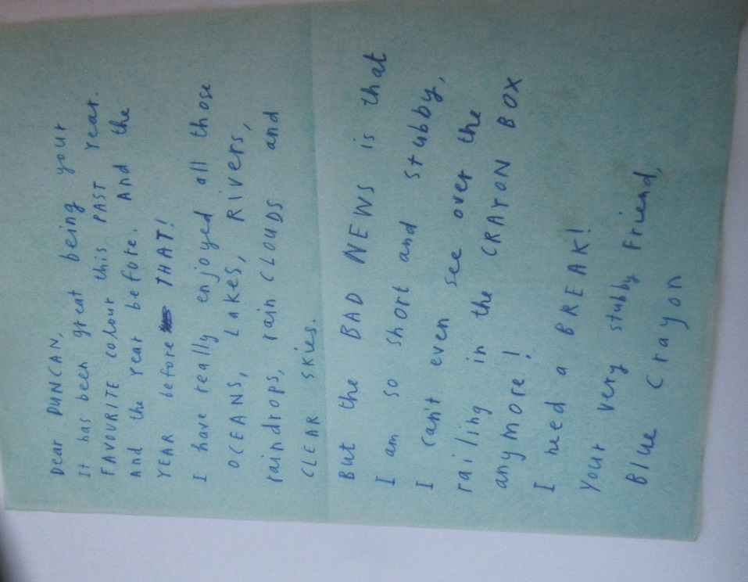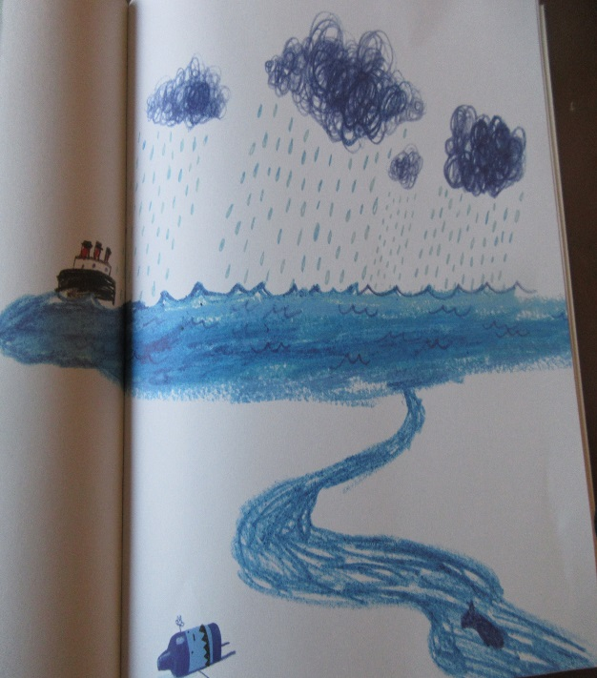

How has Duncan used the blue crayon?

How does this make the
crayon feel?

What does the crayon want Duncan to do?

How does the crayon try to persuade Duncan to use the crayon differently?

What could would you do to make the crayon happy?

Wednesday – WALT: box-up ideas.

Use the link below to listen to the full story of, ‘The Day the Crayons Quit’, by Drew Daywalt.
https://www.youtube.com/watch?v=489micE6eHU
If you have the story at home, please feel free to read it instead.

Today, we are going to write a letter to Duncan as your favourite coloured crayon.
First, discuss:
- Do the crayons all have the same problem?
- What is your favourite colour crayon and why?
- What do you like to draw with your favourite colour crayon?
Next, draw a picture with your favourite colour crayon.

Then, use the box-up chart to create some of your ideas.
What is your favourite colour crayon?
How has Duncan used the ______ crayon?

How does this make the
crayon feel?

What does the crayon want Duncan to do?

How does the crayon try to persuade Duncan to use the crayon differently?

What could would you do to make the crayon happy?

Finally, have a go at writing a letter to Duncan (in your home learning books) as your favourite colour crayon.
Feel free to use the template below.
Dear Duncan,
I am your __[favourite colour]_ crayon. I am writing to you because I feel _[emotion].__I have loved being used to _[examples of uses]_ but now I am _[opinion/ problem]_.
In the future, please could you _[what could be done to resolve the problem]_.

Your Friend,
_[favourite colour] Crayon.

Below, I have attached a summary of the crayon’s feelings and problems to support your thinking, but please try and create your own ideas!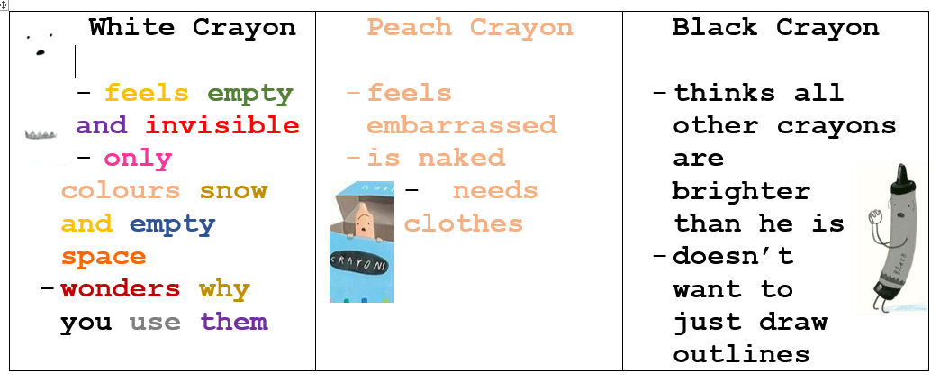
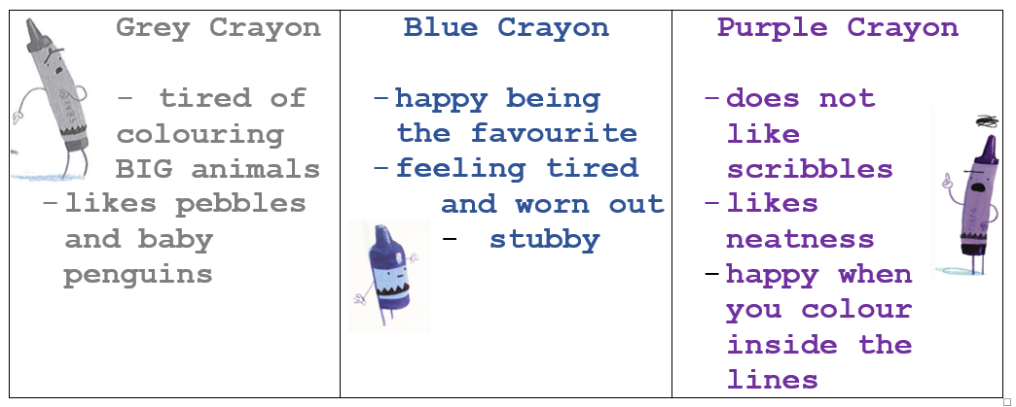
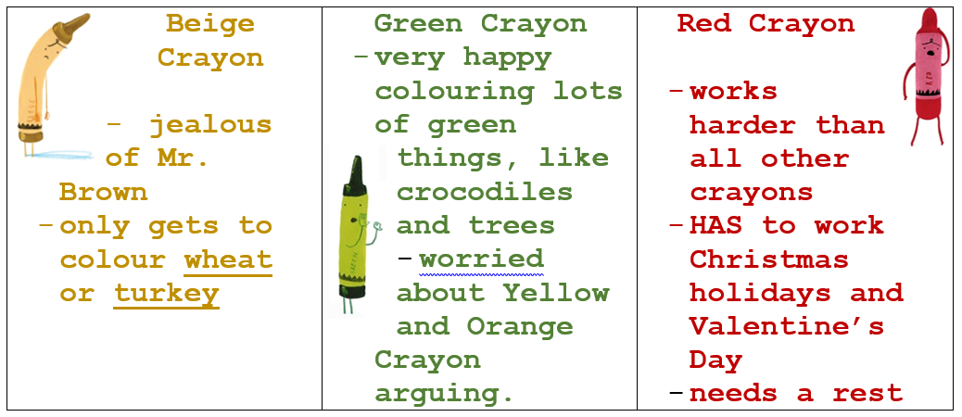
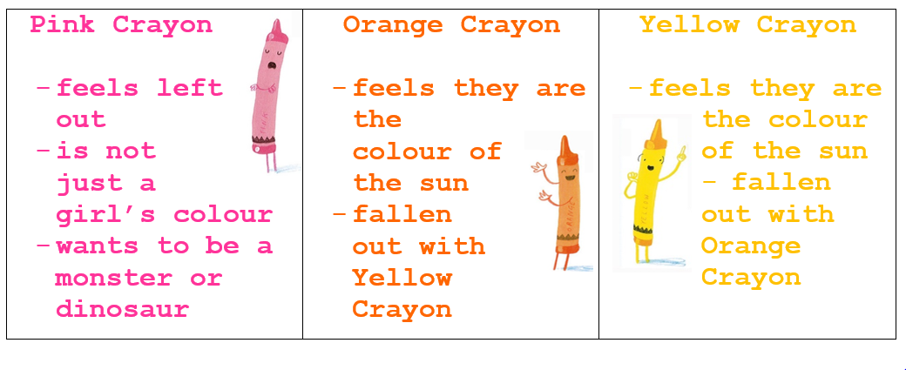

Thursday – WALT: write a written response
Read back through the letters from Beige Crayon, Black Crayon and Blue Crayon.
- How do you think Duncan would respond?
- Does Duncan need to apologise to all of the crayons?
- Is there a problem Duncan needs to resolve?
- If so, how will he resolve it?
- How would you start your letter?
I wonder, how would Duncan respond to your favourite colour crayon?
Today, you are going to write a letter from Duncan, to your favourite crayon.
Have a go at creating a mind-map to help you generate ideas.
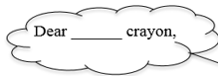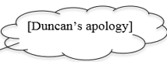
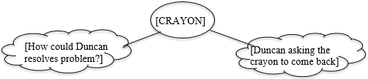

When you have gathered your ideas and created Duncan’s response to your favourite colour crayon, have a go at writing your letter, using the template below.
Dear ,
Please do not quit. I need you when I want to draw a…

From,
Devastated Duncan.

Challenge: write a letter to Duncan, using the letter features, as shown on the next page.
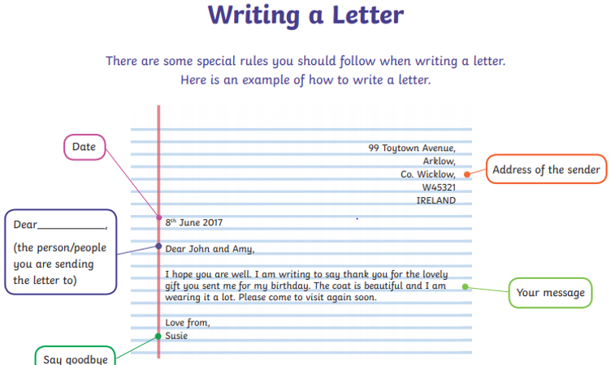

Friday – WALT: write a letter to share our thoughts and feelings
Before we start writing today, have a look at the link below, from the Cbeebies series, Maddie Do You Know? – have you ever wondered how colour crayons are made? This clip shows you how.
https://www.bbc.co.uk/iplayer/episode/b07x182k/maddies-do-you-know-series-1-14-carousel-and-wax-crayons

This week we have been looking at the story ‘The Day the Crayons Quit’, by Drew Daywalt. The book is full of colours and different emotions, that the crayons are feeling.
When we think of our feelings, we often think of different colours. For example: feeling sad is often associated with the colour blue.

Even in the film, ‘Inside Out’, Sadness was a blue character.
Take a look at these images of different emotions and discuss:
‘What colour would you associate with each feeling?’
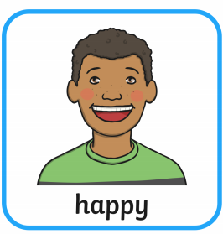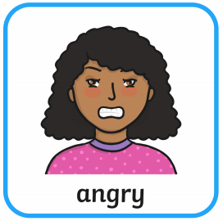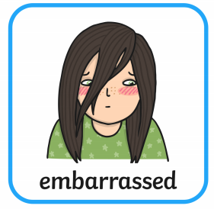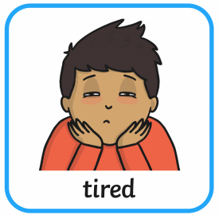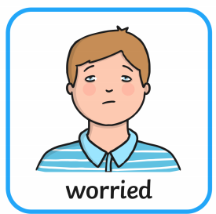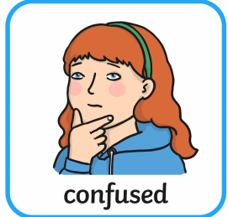
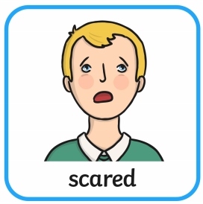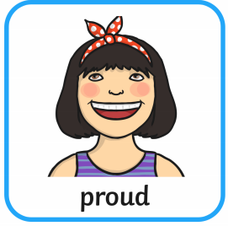

Today, I would love for you to have a think about how you are feeling? Are you feeling excited? Nervous? Happy? Sad?

You might like to draw a picture to show how you are feeling, using the coloured crayon that you associate with this feeling?
Are you feeling more than one emotion? Do you need more than one colour for your drawing?

Now, have a think about this question:
If you could be any coloured crayon, what colour would you be and why?

Please write your answers in a letter to Mrs Jackson (using the letter format from yesterday), to tell her what colour crayon you would be and why. If you would like to include any other thoughts, feelings, pictures or news that is absolutely fine.
Then send your letter to:
Mrs Jackson,
Farway Church of England Primary School,
Colyton,
EX24 6EQ.

It would be lovely to hear from you and you may even get a response!
Happy writing!

