Week Beginning 11th May
Spelling Task Monday

Year 3: The /ʌ/ sound spelt ‘ou’
Look at the list of words below and read each of the words:
young | double | touch
trouble | country | rough

What sound does the grapheme ‘ou’ make in each of these words?
Notice the spelling of the /f/ phoneme at the end of ‘rough’. This is a very unusual example.

Sound out each word and write it down. This is a good chance to practise your handwriting. Check that the o and u are the same height and that the tall letters are nice and straight.
Then draw a box around the ‘ou’ and ‘take a picture of it’, committing it to memory. You could try drawing a picture with each word to help remember them.

Year 4: Prefixes ‘un-’, ‘dis-’, ‘in-’, ‘re-’, ‘sub-’, ‘inter-’, ‘super-’, ‘anti-’, ‘auto-’

un def in | fin | ish al ite | ing ed es ly ist ise ive
un re | at de | tach | ing ed es able ment

Have a look at the matrix above. Use the prefixes, roots and suffixes to create as many words as you can - eg. unfinished
Notice how the words are built up from the different parts. Take care to check that all your words are real words!
Can you use the words you have created in meaningful sentences? Remember to start some with fronted adverbials – what punctuation will you use to mark the clause?

Year 5: Suffixes -age
Can you identify the words to math each of these pictures, all of which end with the suffix –age? If you get stuck, have a look at the answers below.
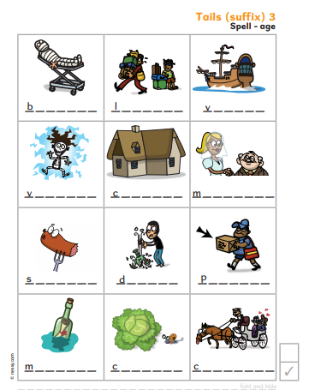

Can you find other words that end in the same way?
Look at https://www.spellzone.com/word_lists/list-frame-73.htm
Note the two exception words: knowledge and college. How could you try to remember how to spell these two words? Can you invent a mnemonic?

Spelling Task Wednesday

Year 3: The /ʌ/ sound spelt ‘ou’

Have another look at the words from Monday’s lesson: young, country, double, trouble, rough, touch.
If you have a device on which you can record your voice, record yourself reading the words out slowly. Then hide the words and play it back, writing each word down as you hear it. Alternatively, use the ‘look, say, cover, write, check’ strategy to practise spelling the words. Can you write a short paragraph containing each of the 6 words? Check your sentence punctuation is accurate.

Challenge: Can you include sentences using the conjunctions while, although and as? Experiment with the position of the subordinating (conjunction) clause – do you prefer it before or after the main clause?

Year 4: Prefixes ‘un-’, ‘dis-’, ‘in-’, ‘re-’, ‘sub-’, ‘inter-’, ‘super-’, ‘anti-’, ‘auto-’

un | super | way | highway | finished
dis | inter | merge | national | attach
in | anti | marine | twine | create
re | auto | do | aircraft | marine
sub | cover | man | natural | lock
do | matic | drive | evitable

Cut up the word cards and lay them on the table, with the prefixes in the centre, surrounded by the words. Then pick up a prefix card and a word card and test to see if it makes a real word. If so, write it down, using this as an opportunity to practise writing in neat, joined handwriting. Then cover the word and try again to write it to check you can spell it. Keep the list of words you have created to use them again tomorrow.

Year 5: Suffixes
Have a look at the chart below. Earlier this year we focused on adding 2, 5 and 8 in spelling time. Today you could focus on the suffix in 1 and 7 before revisiting the others.
Read through the lists and identify any words you are unfamiliar with – look some up in a dictionary then practise using them in sentences. Choose about 8 or 10 words that you think will be challenging to spell, perhaps due to double letters unexpected vowels. Write them carefully and neatly on cards/ pieces of paper. On the back of each card, write a definition of the word on the front, without using the word itself. Then go through the pile of cards you have made, reading the definitions and attempting to spell the appropriate word.
1 2 3 4 5 6 7 8
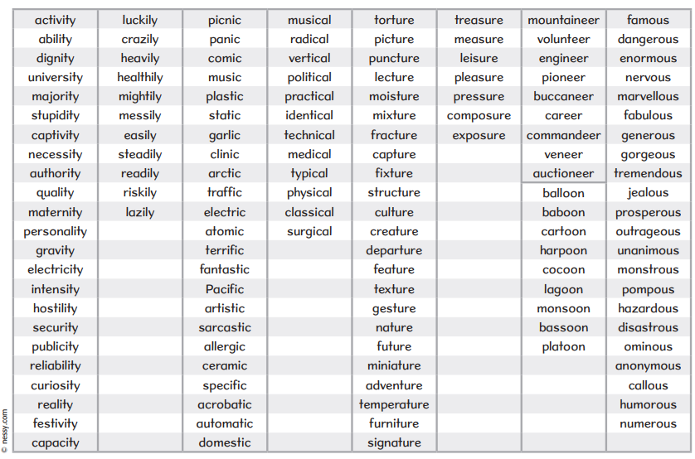
Keep your cards to have another look at these tomorrow.

Spelling Task Thursday

Year 3: The /ʌ/ sound spelt ‘ou’
Have another look at the words rough, touch, country, double, trouble and young. Check that you can remember how to spell these words – of possible, ask someone else to test you.
Look at the words on https://www.spellzone.com/word_lists/list-7890.htm . Read the sentences to check you can read and understand the words. Then use ‘Look, say, cover, write, check’ to practise spelling them. Finally play some of the games to help you remember the words.

Year 4: Prefixes ‘un-’, ‘dis-’, ‘in-’, ‘re-’, ‘sub-’, ‘inter-’, ‘super-’, ‘anti-’, ‘auto-’
Look again at the words you created in yesterday’s lesson. Can you write sentences using these words in a way that makes sense? Why not call a friend from your year group and dictate your sentences to one another to see if you can write them accurately?

Year 5: Suffixes
Have another look at the suffixes card you made on Wednesday and check that you can still spell the words you practised.
You may wish to practise a few more words from the chart. Alternatively, you could see if you can add to the lists by finding other words that contain these suffixes.

Answers – Monday – Year 5
