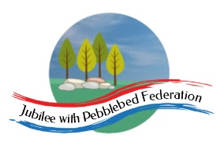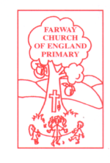

Class 2, Farway C of E Primary School

Dear Parents and Members of Class 2,

I hope you enjoyed your visit ‘Down Under’ to Australia last week! This week we are heading North to the Northern Hemisphere, to Scandinavia and the Nordic region. Scandinavia is made up of 3 countries: Sweden, Norway and Denmark. Together with Finland and Iceland they form what the French dubbed the Nordic Region. We will be focusing on Norway, Sweden and Denmark in the afternoon although you might decide to focus on Iceland or Finland. There are opportunities to use lots of physical and human geography vocabulary this week.

Next week we will remain in Europe but will be travelling Southwards to France, with a historical connection with Scotland, before returning to Devon. Then, in the final 4 days of the school year, we will be looking back over our trip around the world and thinking about what we have learnt this year.

This week’s PE is based on resources recommended by the Honiton Learning Community, who organise our sporting events throughout the year. However, you might choose to do Joe Wicks every day, or replace it with a walk or a bike ride: whatever fits in best with your family.

Also, the end of the #Devon Virtual Games tournament, organised by Active Games and the School Games Organisers, is coming up on 13th July. There is only one event left (the Andy Murray 100 volley challenge). More details can be found at www.activedevon.org, where the new challenge for this week will be posted and where you can submit entries to the competition.

Happy learning! I look forward to seeing you all again soon,

Mrs Marsh

The most important thing you can do to support your child’s learning whilst schools are closed is to ensure that they read every day and they continue to practise their number bonds and times tables.

Don’t forget to keep using the accounts you have through our school to practise basic skills, such as reading, reading comprehension (Bug Club), Times tables (Times Table Rock Stars) and Spelling (Spelling Shed). I have set work on TTRS each week and I shall be checking these sites regularly to keep an eye on what you’re doing. Feel free to challenge me (Irox Peel) to a Rockslam competition!

Week beginning Monday 6th July

Monday 6th July | Core activities |  |  | Suggestions for additional activities.
9.00 – 9.30 | Daily Dashboard:  Quelle est la date aujourd’hui?  C’est lundi le six juillet 2020.  Can you write the number date in Roman numerals?  On this day in 1535, Sir Thomas More was beheaded on London’s Tower Hill for refusing to accept Henry VIII as head of the church. He lifted his beard from the axe, on the basis that it had committed no offences against the king! There was a Swedish King who was similar to Henry VIII- you’ll learn about him later in the week.  Watch this montage of Scandinavian scenes to give you a flavour of Northern Europe, ready for this week.  https://www.youtube.com/watch?v=CMxuevR0RMQ |  |  |  |  | Louis Armstrong, a famous trumpet player and singer songwriter, died on this day in 1971. (1901-1971) Listen to arguably his most famous song here: https://www.youtube.com/watch?v=CWzrABouyeE  Today is the birthday of George W. Bush, 43rd President of the United States. If he was born in 1946, how old is he today?
9.30-10.00 | Grammar – see additional Grammar resources |  |  | Use your spelling shed login to practise by playing spelling games.
10.00- 10.30 | Time for some PE –  Here is the link to Joe Wicks, if you haven’t done his workout for a while: https://www.youtube.com/user/thebodycoach1  Or you might have a go at Golf:Rolling. This is suitable for indoors or outside, courtesy of the Youth Sport Trust: https://www.youthsporttrust.org/sites/default/files/Home%20PE%20Golf%20Rolling.pdf
10.30-11.30 | Maths – follow the links to find online lessons for each year group:  Year 3: https://classroom.thenational.academy/lessons/develop-an-understanding-of-clocks  Year 4: https://classroom.thenational.academy/lessons/to-investigate-the-place-value-of-different-number-systems  Year 5: https://classroom.thenational.academy/lessons/decimals-to-derive-addition-and-subtract-decimal-facts  Year 6: https://classroom.thenational.academy/lessons/construct-line-graphs |  |  |  |  |  | Don’t forget to keep logging on to Times Table Rock Stars to practise your times tables. A few minutes practice every day will soon improve your recall of key facts!
11.30- 11.45 | Have a break and play a game or do another activity that you enjoy. | Keep active in mind and body – why not do a puzzle or other activity today that will help to stretch your brain and keep your mind active?
11.45- 12.00pm | Collective Worship - You will find an Act of Worship designed for use at home by families at https://www.churchofengland.org/faith-action/faith-home/faith-home-videos . This month there are a range of themes to choose from, including kindness, resilience, and patience. There are plenty of these available if you would like to build in a daily worship time as a family.
12.00- 1.00pm | Lunch break. Eat a healthy lunch and, if you are able, try to get outside for some fresh air!
1.00pm – 1.30pm | Mental Health: Believing in yourself/ Aspirations  Watch/listen to the Will.I.Am song at  https://www.youtube.com/watch?v=cyVzjoj96vs&app=desktop  and the following song about believing in yourself, no matter the cards you are dealt with at https://www.youtube.com/watch?v=aqpaTT6EcXM&app=desktop  What are the messages in these two songs? Do you agree with this message? Why/ why not?  Read or listen to the book ‘You Choose’ by Nick Sharratt at https://www.youtube.com/watch?v=4x9B0uMeyQM  Design a star to show your best qualities – see https://youngminds.org.uk/media/3533/star-qualities-final.pdf  I would love to see these!
1.30pm – 2.00pm | Reading - read the map of Scandinavia and the Nordic Region below, then answer the questions that follow.  To read the full article this comes from, pop over to TripSavvy: https://www.tripsavvy.com/countries-of-scandinavia-1626694 |  |  |  | Keep reading online and completing Bug Club Comprehension questions  Or  Read a chapter or two of your latest reading book.
2.00pm-3.00pm | Theme/Geography  Scandinavia and the Nordic Region are made up of 5 countries: you could remember them using the acronym F.I.N.D.S. They are Finland, Iceland, Norway, Denmark and Sweden.  Learn more by reading through the information below and studying the photos. Follow the instructions as you go! This document will also be useful if your internet is temperamental as the week goes on.  Next, use the map to fill out task 1A – you will need an atlas or internet to name other cities.  If you have access to google street view, you will be able to complete task 1D. Remember urban means cities and rural means countryside.  Here are some links to National Geographic articles and photo montages. Choose the Nordic country you’d like to know more about and click to find out more.  Finland:  https://www.nationalgeographic.com/travel/destinations/europe/finland/  Norway:  https://www.nationalgeographic.com/travel/destinations/europe/norway/  Sweden:  https://www.nationalgeographic.com/travel/destinations/europe/sweden/ |  | In Additional Information you will find a fact file about Finland, Denmark and Norway to use in place of the internet. Finland also has a sheet to fill out – if you choose Denmark or Norway you could use the Finland sheet to guide you on what information to select and record.  To find out more about Finland and the Finnish flag check out this site https://finland.fi/facts-stats-and-info/the-finnish-flag/  http://justfunfacts.com/interesting-facts-about-finland/  Use this online atlas to find out more about Finland  https://www.worldatlas.com/webimage/countrys/europe/fi.htm  Sweden had their own version of Henry VIII where religion was concerned. Find out who he was here:  https://www.worldatlas.com/webimage/countrys/europe/se.htm  Or you can search funfacts.com and worldatlas.com using the name of another Nordic country.
Below is a good overall website for each Nordic country if you are focusing on one this week. I used the acronym FINDS to help me type this!
www.visitfinland.com
www.visiticeland.com
www.visitnorway.com
www.visitdenmark.com
www.visitsweden.com

Once on the website, click on the top tab, called experiences, things to do or what to do. For Norway, scroll down and for Iceland, click on the three lines in the top right corner to find ‘things to do’ section.

Or for amazing general images, click here:
https://www.visitnordic.com/en/cool-nordic-moments
Read the information on this map of Scandinavia and the Nordic Region. It includes the names of the countries, their capital cities and the language spoken there.
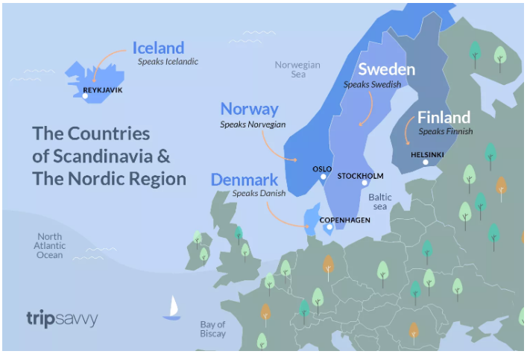
Can you represent the information on this map as a table? Remember to use a ruler if you do it by hand! I have used four columns in the table provided below but only labelled one! You’ll need to label the others.

Name of country

Find the UK on the map. Write a few sentences to describe where these Nordic countries are in relation to the UK.

What can you predict about these countries now you have identified their geographical position?

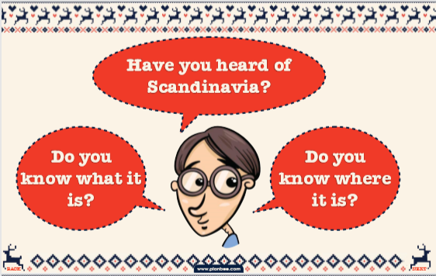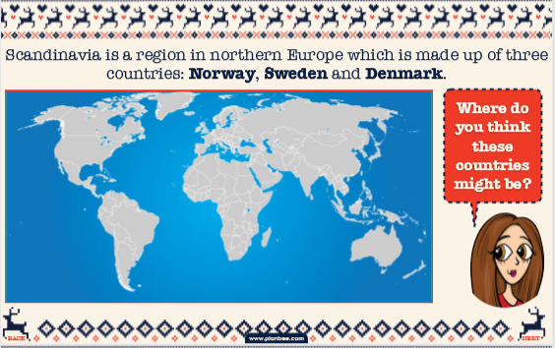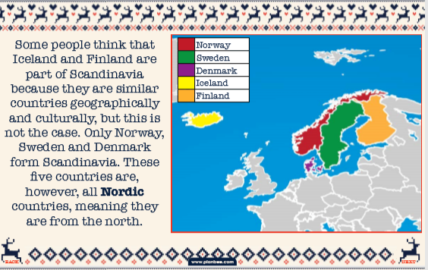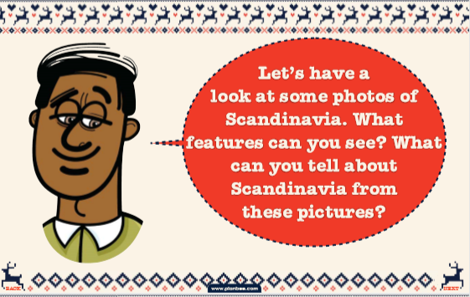

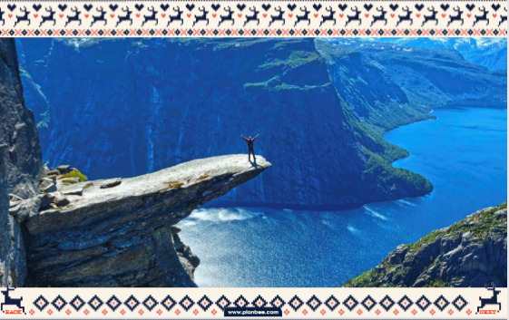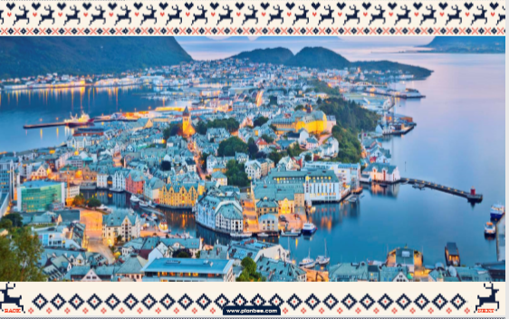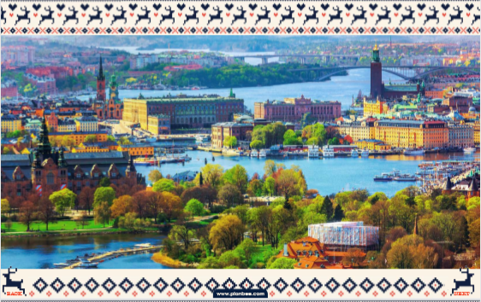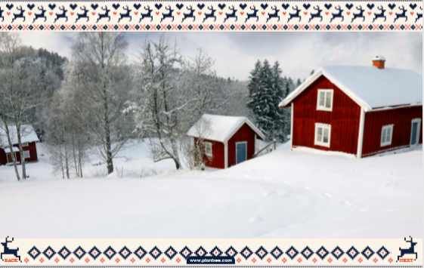
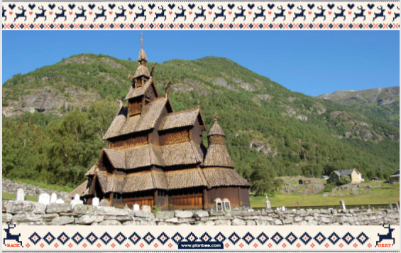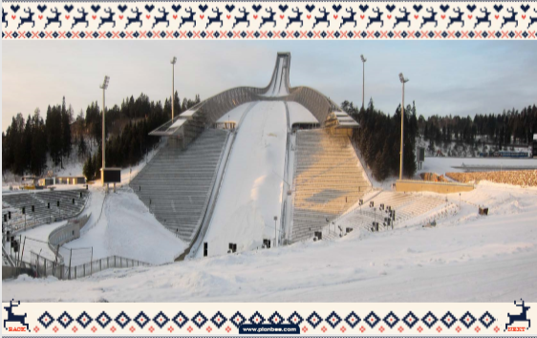
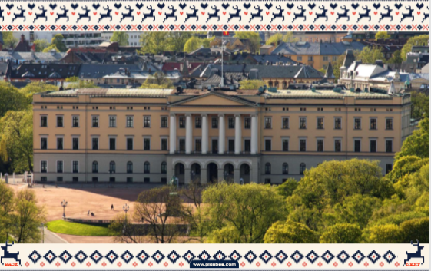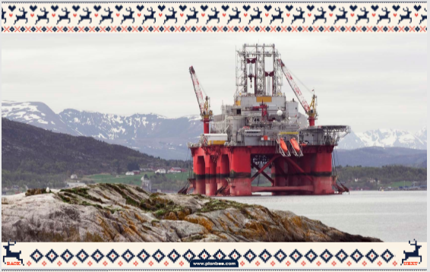
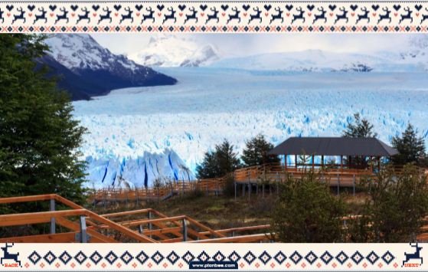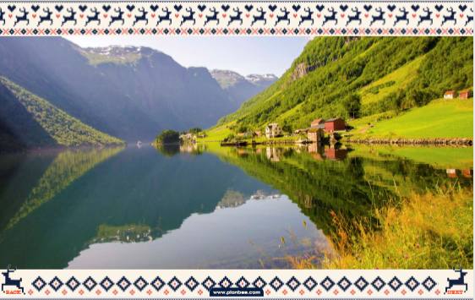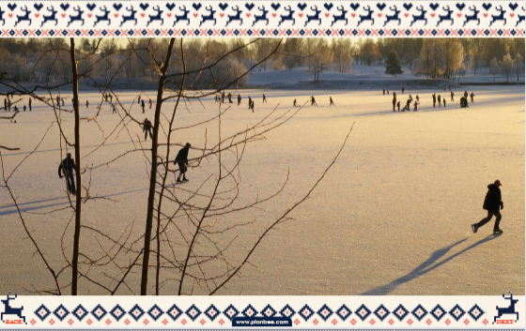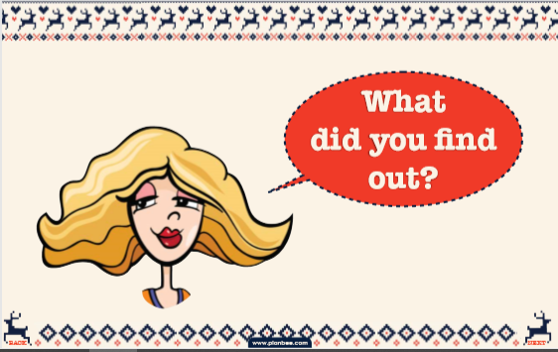

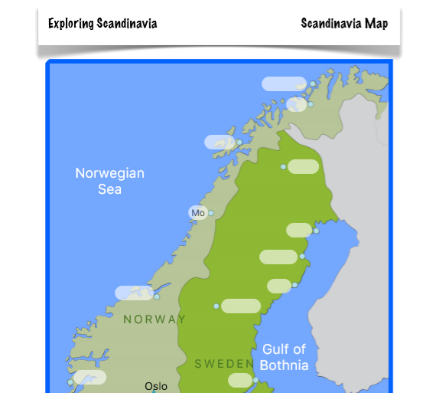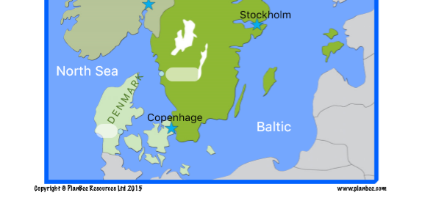

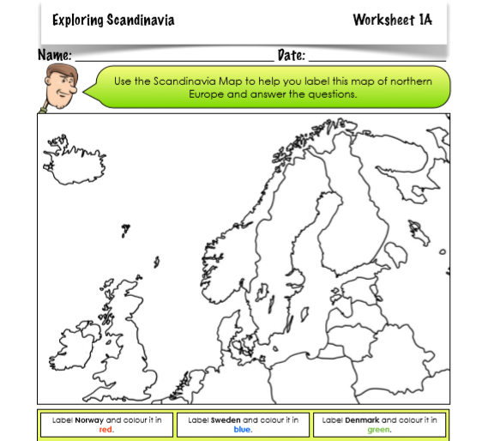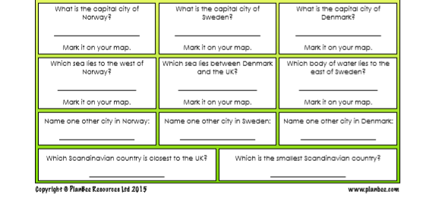

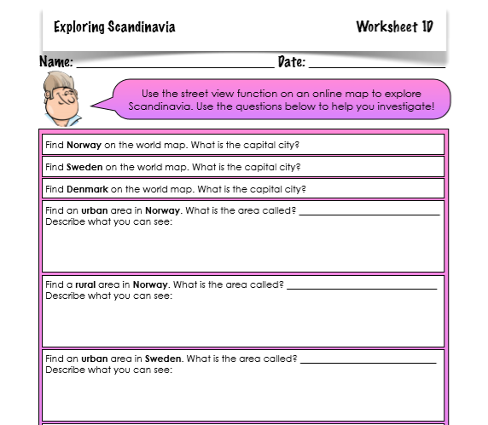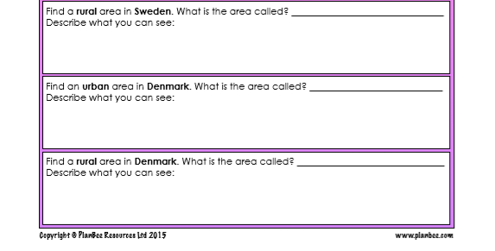

Tuesday 7th July | Core activities |  |  | Suggestions for additional activities.
9.00 – 9.30 | Daily Dashboard:  Quelle est la date aujourd’hui?  C’est mardi le sept juillet 2020.  Can you write the number date in Roman numerals?  Watch this fascinating video about Nordic Ice Skating and the noises created – you will need sound for this!  https://www.nationalgeographic.com/adventure/activities/winter-sports/skating-thin-black-ice-creates-sound-nordic-spd/  Nordic region countries speak languages belonging to the Germanic family. Finland is unusual in that it is part of the Finn-Uralic family of languages, related to Estonian.  Learn some finnish words and phrases relating to animals here:  https://www.youtube.com/watch?v=DJDEQpEfa1I  What is happening in the world? Have a look at https://www.bbc.co.uk/newsround or https://www.dogonews.com/ to see what is going on in the world. Choose a news article or two to read. |  |  |  | Today in 1919, the actor Jon Pertwee was born. Best known for his role as the third incarnation of the Doctor in Doctor Who, he was also the title character in Worzel Gummidge. Perhaps you caught the remake on the BBC over Christmas? About the adventures of two children and a scarecrow that comes to life?  It was pretty good, but here is a flavour of the original: https://www.youtube.com/watch?v=YtWH4CTo4wQ  On this day in 1967, England’s round-the-world yachtsman, Sir Frances Chichester, was knighted by Queen Elizabeth II. For the ceremony, the Queen used a sword that had originally belonged to Sir Francis Drake!  Drake served Queen Elizabeth I, daughter of Henry VIII. He was a Devonshire man! To find out more about him and his travels, read here: http://projectbritain.com/calendar/September/drake.html
9.30-10.00 | Grammar – see additional Grammar resources |  | Use your spelling shed login to practise by playing spelling games.
10.00- 10.30 | Time for some Physical activity.  In 2013, Andy Murray won his first Wimbledon title and ended Britain’s 77-year wait for a men’s champion with a victory over world number one Novak Djokovic. The Scot won 6-4, 7-5 and 6-4. Have you tried the Andy Murray 100 Volley Challenge yet? It is introduced by Andy Murray in a video linked to this document: https://www.activedevon.org/wp-content/uploads/2020/06/Andy-Murray-100-Volley-Challenge.pdf  This is the last challenge of the event and they are still accepting entries! It closes on the 12th July.  Or, take the ‘chance to shine’ up your bat and ball skills. Idea card found here:  https://www.chancetoshine.org/Handlers/GetImage.ashx?IDMF=6f5b7938-c76d-4d00-90ff-9311c3ed080d&h=350&w=350
10.30-11.30 | Maths – follow the links to find online lessons for each year group:  Year 3: https://classroom.thenational.academy/lessons/tell-the-time-to-5-minute-intervals-on-an-analogue-clock  Year 4: https://classroom.thenational.academy/lessons/to-investigate-roman-numerals-up-to-one-hundred  Year 5: https://classroom.thenational.academy/lessons/decimals-to-add-decimal-numbers  Year 6: https://classroom.thenational.academy/lessons/interpret-pie-charts |  |  |  |  | Alternatively, you could try out a BBC Bitesize daily lesson.
11.30-12.00 | Have a break and play a game or do another activity that you enjoy. | Fabulous food found in Finland contains staples similar to British food, such as pasties, new potatoes and sausages. Find out more about these, as well as less recognisable foods such as Salmiakki (salty liquorice) here:  https://www.visitfinland.com/article/iconic-finnish-foods-of-all-time/#6fbc00b4  An easier read is found here:  https://theculturetrip.com/europe/finland/articles/11-things-you-should-never-eat-or-drink-in-finland/
12.00- 1.00pm | Lunch break. Eat a healthy lunch and, if you are able, try to get outside for some fresh air!
1.00pm – 1.30pm | Reading time – Read this article to learn about the indigenous people of the Sapmi region, which stretches across the northern parts of Norway, Sweden and Finland.  https://www.natgeokids.com/uk/discover/geography/general-geography/sami-people-facts/  Or watch this incredible video from BBC showing the world of a Sami reindeer herder: https://www.bbc.co.uk/news/av/world-40686553/the-beautiful-world-of-a-sami-reindeer-herder |  |  |  | Keep reading online and completing Bug Club Comprehension questions  Or  Read a chapter or two of your latest reading book.  If you enjoyed the BBC clip, and have a spare 2 hours, why not watch this documentary following the migration of Norway’s Sami reindeer herds.  https://www.bbc.co.uk/iplayer/episode/m0001rz0/all-aboard-the-great-reindeer-migration
1.30pm- 2.00pm | Mental Health: Aspirations  What is meant by the word ‘aspiration’ or the verb ‘to aspire’. For example, “I aspire to be an outstanding teacher and a kind human being.”  Aspiration is about making deliberate choices about the sort of person you would like to be and setting goals that help you get closer to that ideal.  What are your aspirations for the future?  Complete the ‘What do you want for your future?’ and ‘My Goals’ activity sheets to help you reflect on your own goals and aspirations for the future.
2.00pm – 3.00pm | Theme – geography  Complete the wordsearch found below to find Scandinavian towns and cities. Watch out for unexpected adjacent consonants we do not have in English, such as SBJ and JL!  What would you expect the climate to be like in this part of the world?  Read the slides below.  Today you will be exploring the climate of Scandinavia using graphs and charts.  Main Task: read the climate cards below and choose some question cards to answer with them.  Diving deeper task: You could do this as well or instead. Use the information on the green sheet to complete task 2A and 2B.  Ext: How do these temperatures compare to the UK? Do they have more rainfall or less than Devon? How about Aberdeen in Scotland? |  |  |  | Literacy –  Imagine you have travelled to Scandinavia on holiday to go on a winter adventure. Look at the photos from yesterday and write some phrases that describe the scenes.  Use the phrases to write a diary entry or letter in role as a traveller, describing what you saw as vividly as you can. How will you make your writing exciting to read?  Alternatively, you could write a poem entitled ‘Norway’, composed entirely of rich, descriptive vocabulary to evoke the atmosphere of this snowy Northern country.
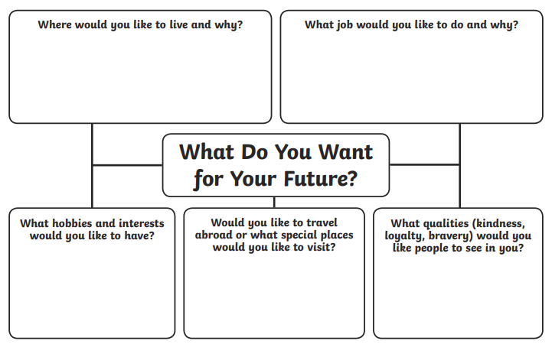
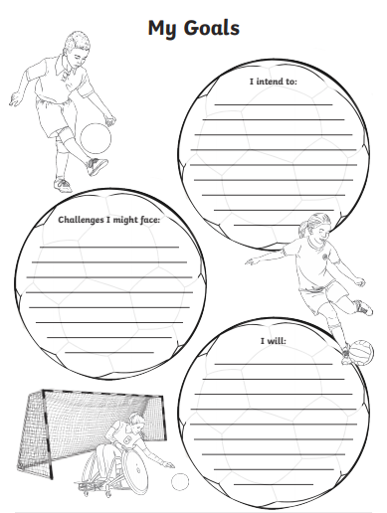

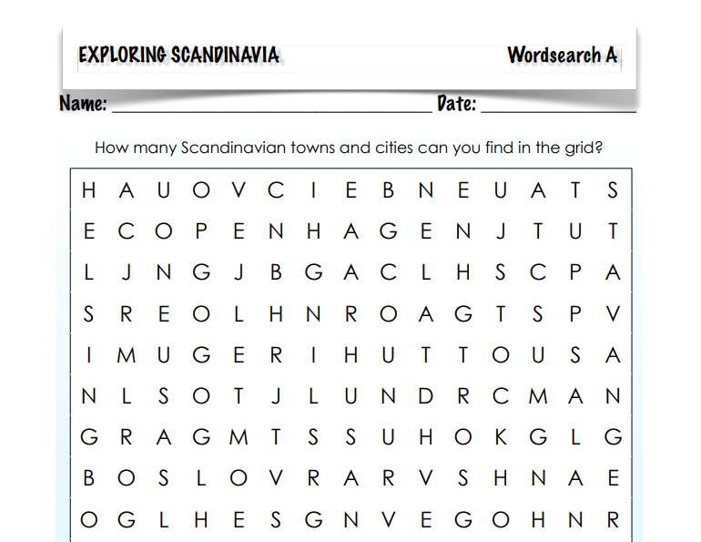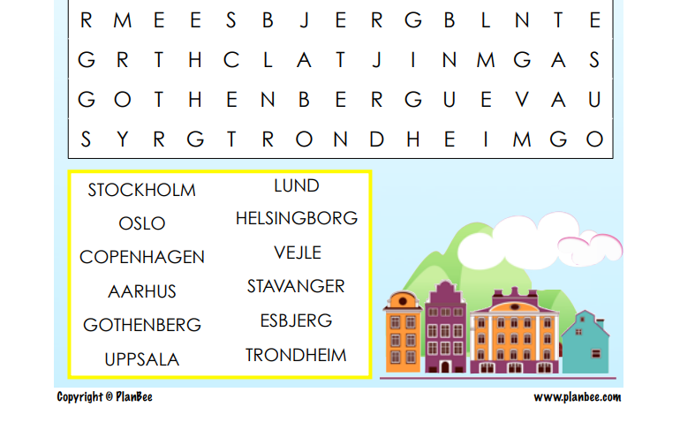

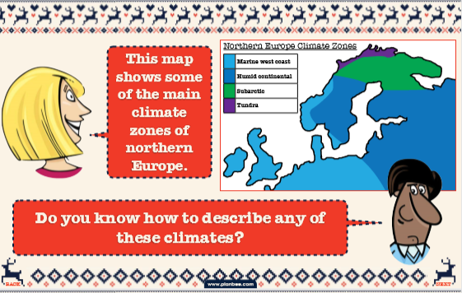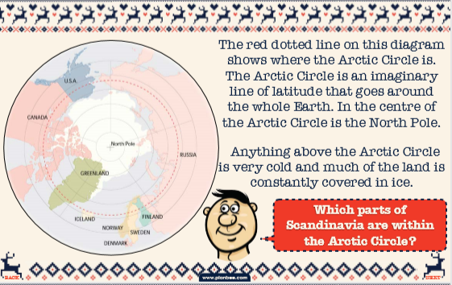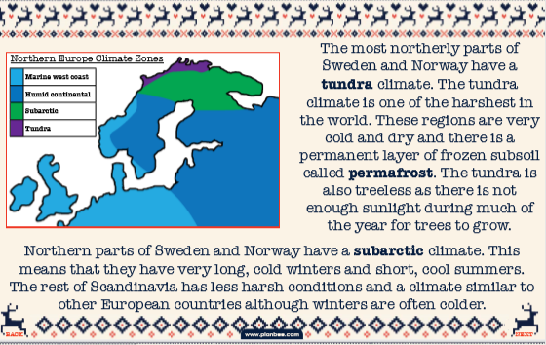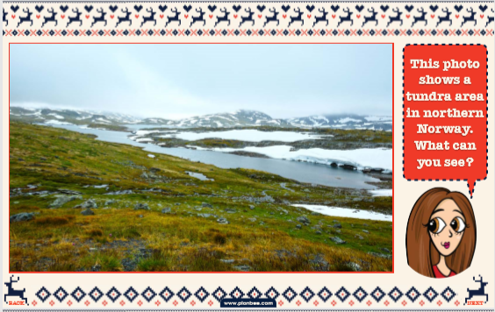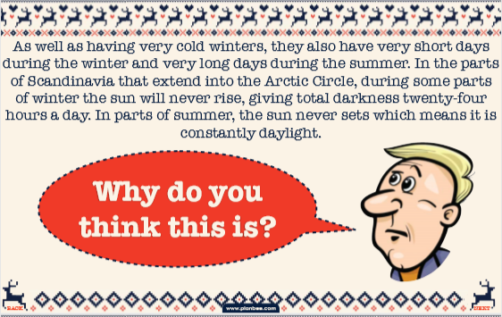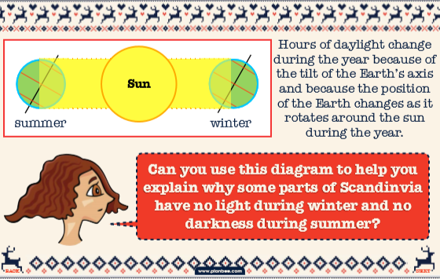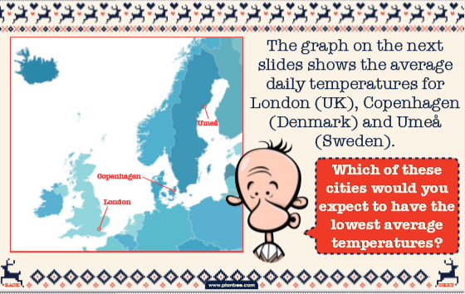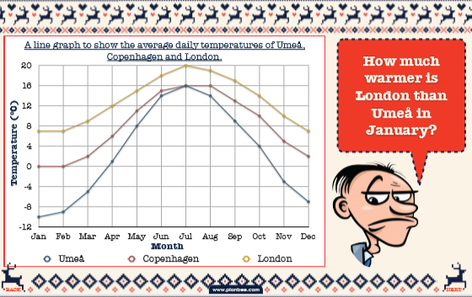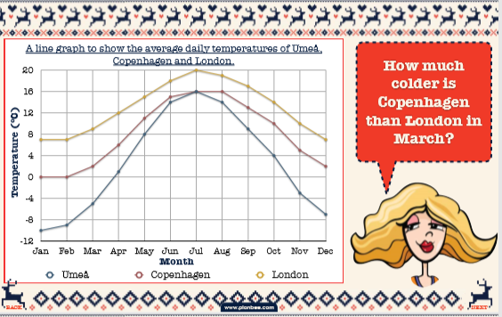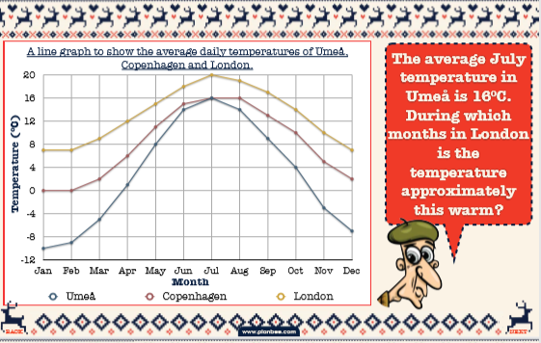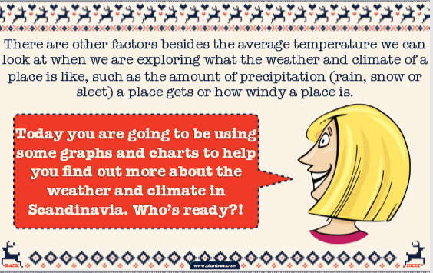
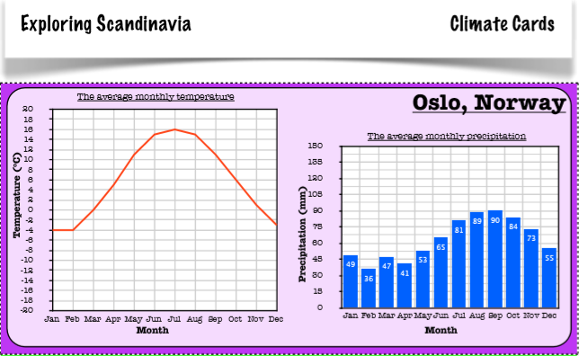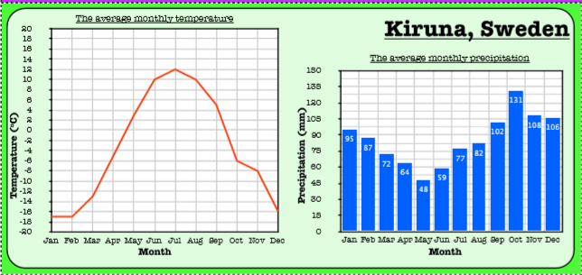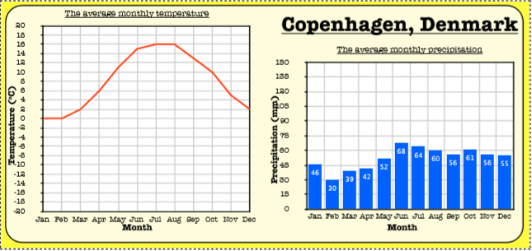
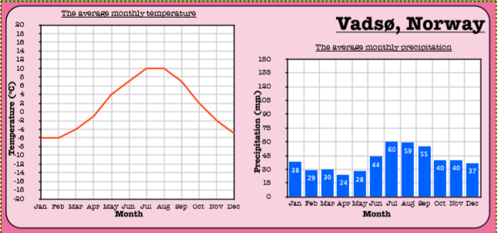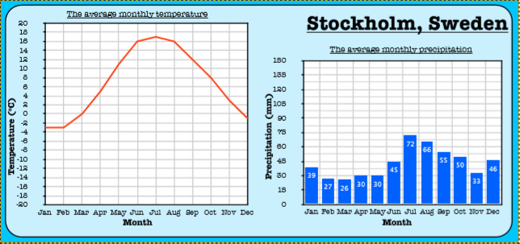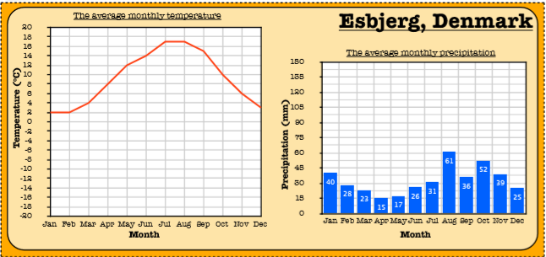

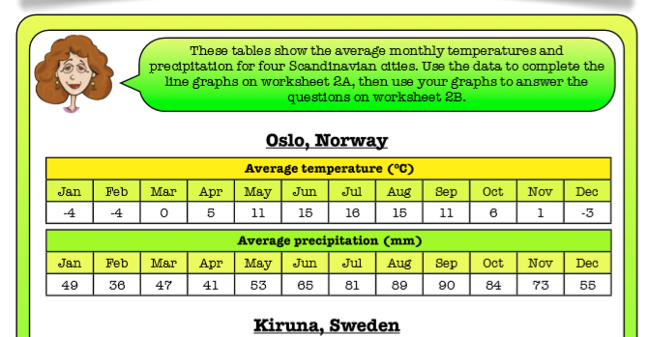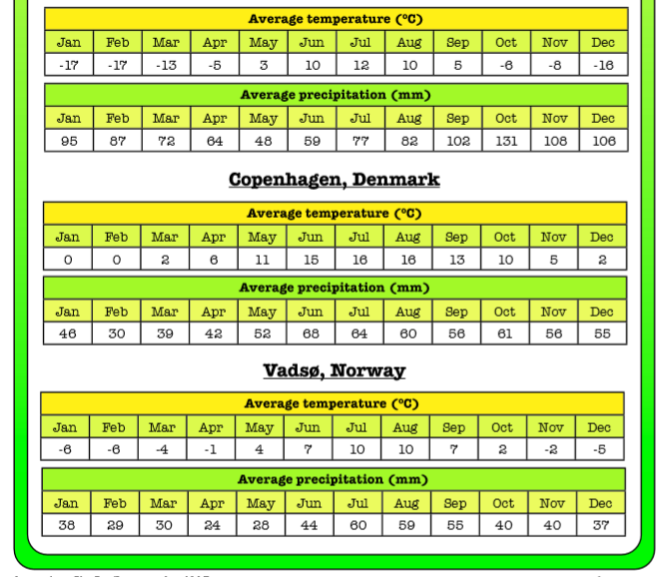

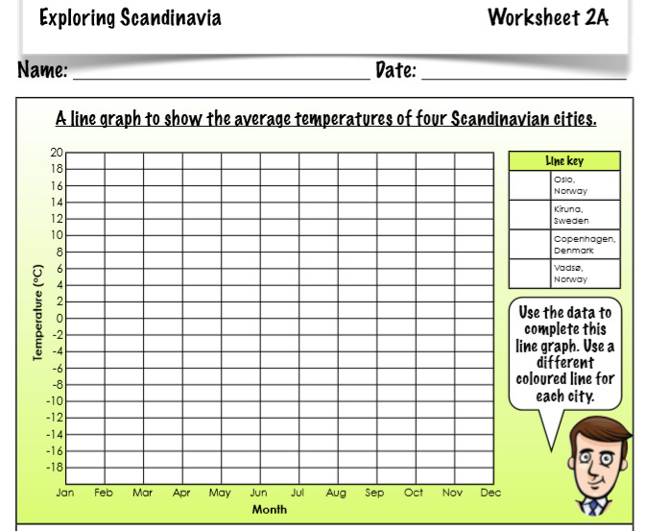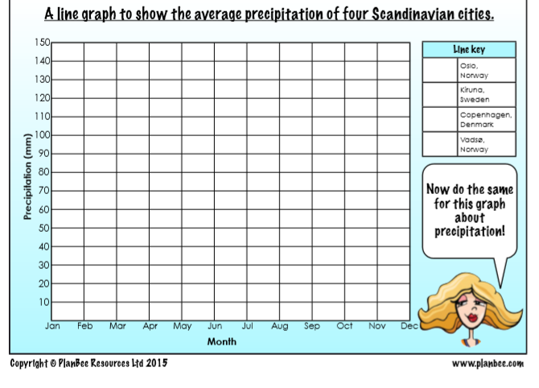
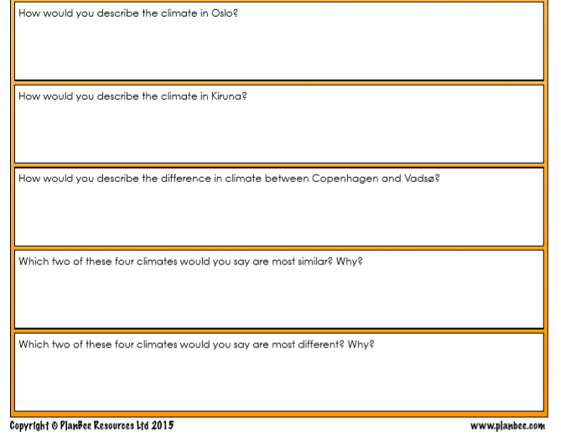
Wednesday 8th July | Core activities |  | Suggestions for additional activities.
9.00 – 9.30 | Daily Dashboard:  Quelle est la date aujourd’hui?  C’est mercredi le huit juillet, 2020.  Can you write the number date in Roman numerals?  What is happening in the world? Have a look at https://www.bbc.co.uk/newsround or https://www.dogonews.com/ to see what is going on in the world. Choose a news article or two to read.  On this day in 2000, J. K. Rowling’s fourth Harry Potter book, Harry Potter and the Goblet of Fire went on sale, breaking all previous publishing records. Have you read it? Which is your favourite book in the series? Which is your favourite film? |  | On this day in 1981, The Solar Challenger became the first solar-powered airplane to cross the English Channel. Then on this day in 2010, The Solar Impulse completed the first 24-hour flight by a solar powered plane. Learn more about the 2015-2016 First Round-The-World Flight in a solar-powered plane here: https://aroundtheworld.solarimpulse.com/adventure  In 1996, The Spice Girls debut single "Wannabe" was released in Great Britain. Have a listen here, you might recognise it from Tik Tok or the Haschak Sisters on Youtube! https://www.youtube.com/watch?v=gJLIiF15wjQ
9.30-10.00 | Grammar – see grammar resources
10.00- 10.30 | Time for some physical exercise –  Why not set up a circuit of strengthening activities and perform 10 at each station? How many times can you repeat the circuit? For ideas at home see here:  https://www.youthsporttrust.org/sites/default/files/Super%20Strength.pdf  Or watch the video here:  https://www.youtube.com/watch?v=0bjCC2dJ0Ps&list=PLnwoPgo24bhmqV8Y76iXnwYw9T9AlxbqJ&index=30&t=16s
10.30-11.30 | Maths – follow the links to find online lessons for each year group:  Year 3: https://classroom.thenational.academy/lessons/tell-the-time-to-1-minute-intervals-on-an-analogue-clock-past-the-hour  Year 4: https://classroom.thenational.academy/lessons/to-identify-and-complete-number-sequences  Year 5: https://classroom.thenational.academy/lessons/decimals-to-derive-addition-and-subtract-decimal-facts  Year 6: https://classroom.thenational.academy/lessons/use-fractions-to-express-proportions |  |  |  |  | How about a warm-up using Times Table Rock Stars? A little each day can really help to improve your scores!
11.30-12.00 | Have a break and play a game or do another activity that you enjoy. | Eat well – As we discovered in our farming project last Autumn, Summer is a great time to eat British-grown fruit such as strawberries, raspberries and apples, especially if grown in Devon. What’s your favourite fruit? Have you tried any new fruits recently? Remember it can take up to 20 tastes for a new flavour to become palatable so persevere!
12.00- 1.00pm | Lunch break. Eat a healthy lunch and, if you are able, try to get outside for some fresh air!
1.00pm – 1.30pm | Reading – Do you remember learning about the taiga biome when we visited Russia? It covers most of Sweden, Finland and much of Norway. Read this article from justfunfacts.com that talks about the coniferous forest and the plants and animals that thrive in its low temperatures.  http://justfunfacts.com/interesting-facts-about-taiga/  If animals and science are your passion, you could find out more about the animals and their adaptations, recording your findings as a report, after the mental health activity. (instead of the task relating to physical features) |  |  |  | Keep reading online and completing Bug Club Comprehension questions  Or  Read a chapter or two of your latest reading book.
1.30pm- 2.00pm | Mental Health Aspiration – role models  Look at the matching activity below and match the famous people to the statements about them. (SEAL activity sheet).  Think of someone famous that you admire – it could be one of the people mentioned in the last activity or someone else you know about them. Think about the following questions – you may want to do some more research or reading about your chosen person to try to discover the answers.  • What has the person achieved?  • Why do you respect the person for this? • What obstacles were in his or her way?  • How did he or she overcome them?  • Who helped the person achieve their goal?  • What do you think the person said/did when they felt like giving up?  • Is there anything that the person has done in achieving their goals that you think they should not have done?  Make a ‘thought shower’ of the qualities and attributes you admire in others.  You could make yourself a motivational poster to remind you of these qualities and think about how you could try to be like the person you admire. You could include some quotes or information about your role models or heroes.
2.00pm– 3.00pm | Theme  Today we are learning about the physical geography of Norway then writing about it.  Read the slides below and answer any questions – this could be verbally with someone from home or written down if you are working alone. Make sure you understand the definiton of the geographical terms used. (glaciers fjords mountains lakes waterfalls)  Task: write a postcard, letter or newspaper article about Norway. I’ve included a template below to support you with the article. |  |  | You can use the photos from Monday for this afternoon’s writing task, or check out Additional Information as there are specific photos from Norway in there.  Write a letter or postcard in role as a visitor to Norway or another Nordic country.

Aspiration and Inspiration
Can you match these famous people to the statements about them?
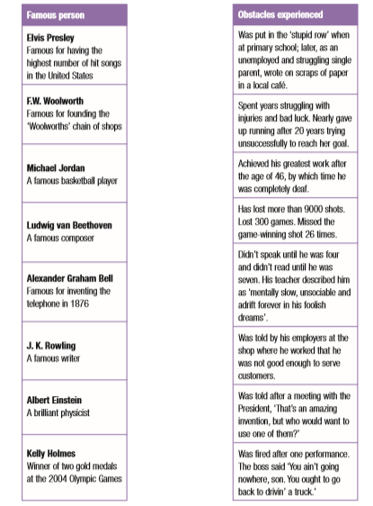

Answers:
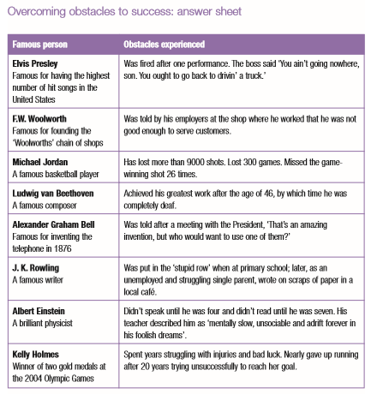

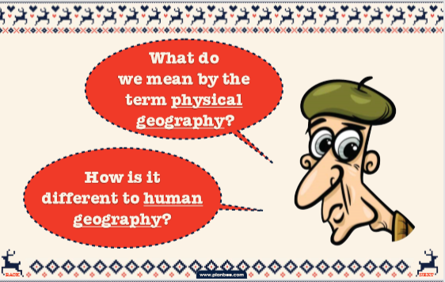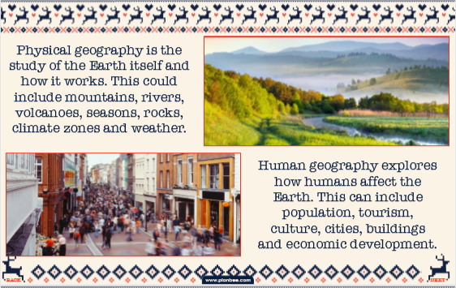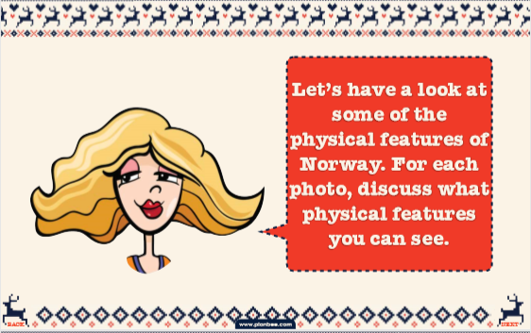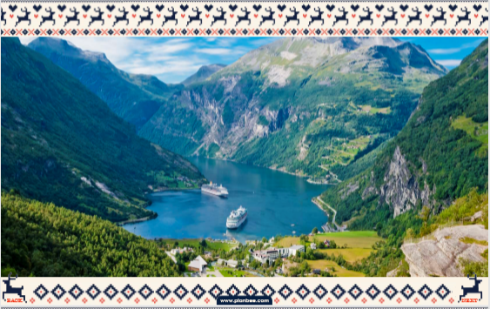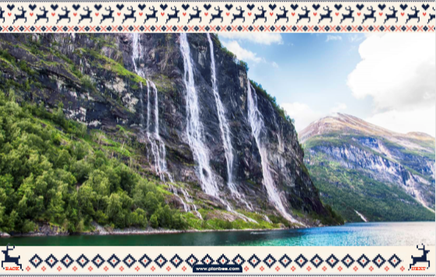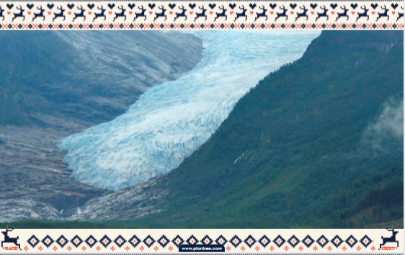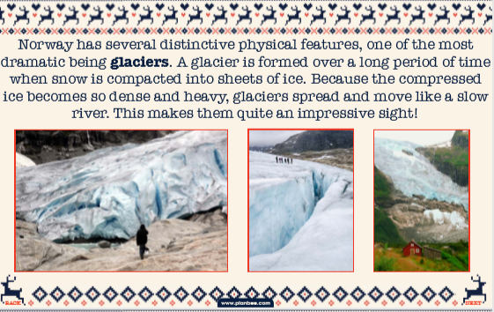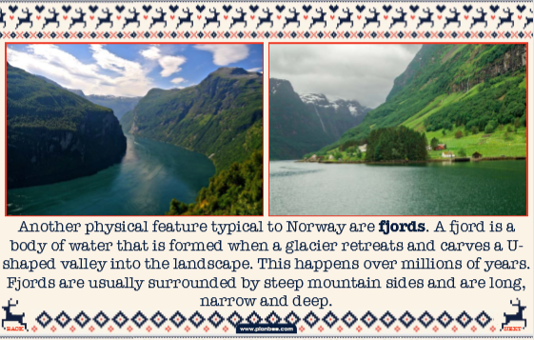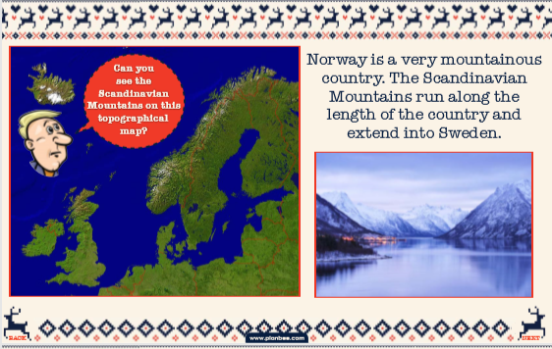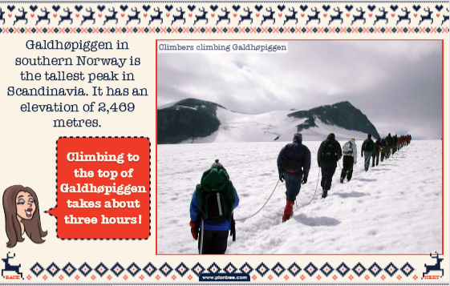
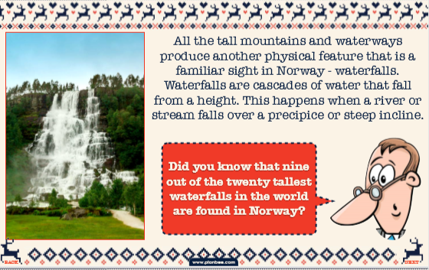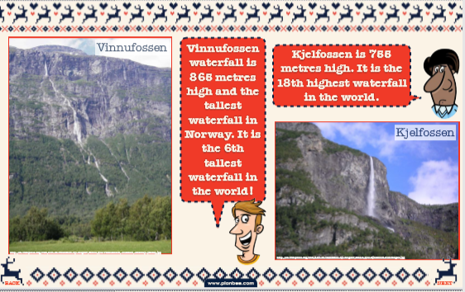
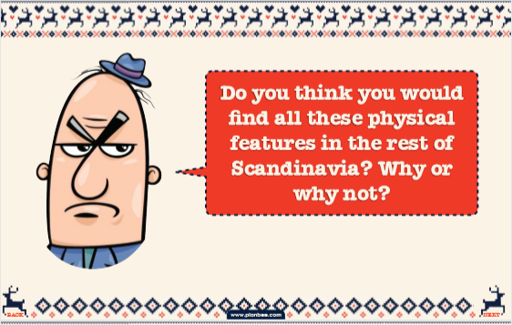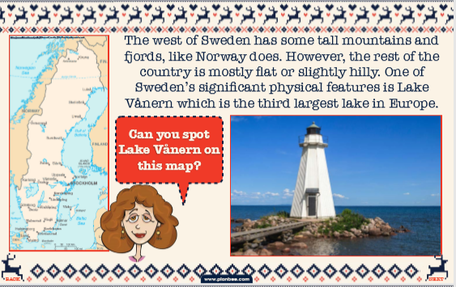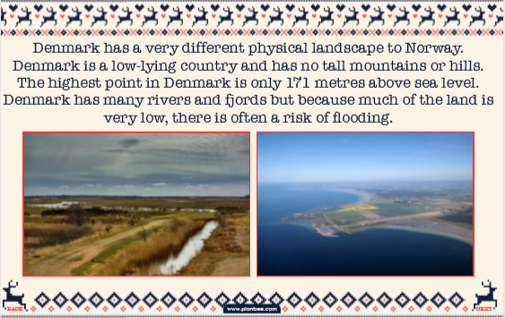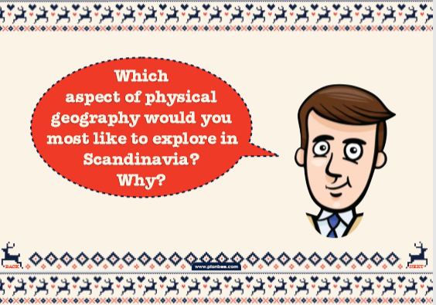
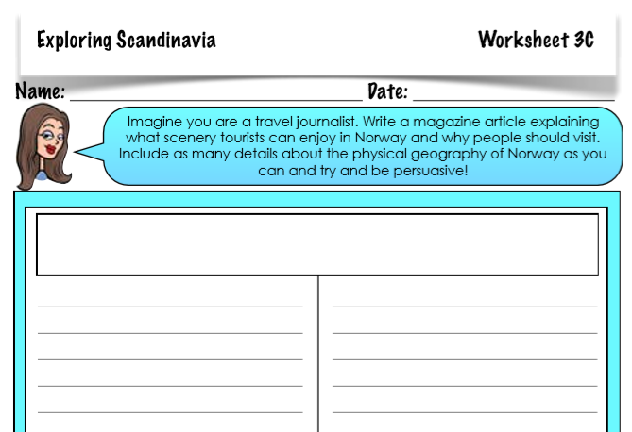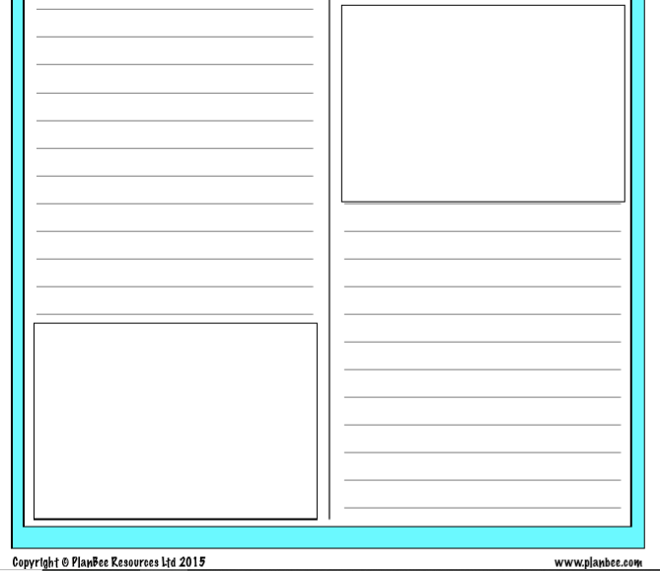

Thursday 9th July | Core activities | Suggestions for additional activities.
9.00 – 9.30 | Daily Dashboard:  Quelle est la date aujourd’hui?  C’est jeudi le neuf juillet 2020.  Can you write the number date in Roman numerals?  What is happening in the world? Have a look at https://www.bbc.co.uk/newsround or https://www.dogonews.com/ to see what is going on in the world. Choose a news article or two to read.  King Henry VIII had his six-month marriage to Anne of Cleves annulled on this day. Poor ‘horse-faced’ Anne – Hans Holbein made her much prettier in his painting and Henry was not impressed! What do you remember about Henry and his wives?  After Henry VIII died, his son sat on the throne for a short time. When he died, before his sister Mary took the throne, Lady Jane Grey was proclaimed Queen of England. Her reign only lasted nine short days. Learn more about her here: https://primaryfacts.com/492/lady-jane-grey-facts-and-information-about-the-nine-days-queen/  Or watch this video for Horrible Histories take on it!  https://www.bbc.co.uk/cbbc/watch/p01g2ppl  Bonus: Tudor Girl Power!  https://www.bbc.co.uk/cbbc/watch/horrible-histories-songs-tudor-queens-song |  |  | On this day in 2017, The Lake District became a UNESCO World Heritage Site, i.e. ‘a site of outstanding international importance and therefore as deserving special protection.’ Other World Heritage Sites include The Great Barrier Reef in Australia, The Great Wall of China and The Grand Canyon in Arizona, USA.  The national park is the first in the UK to get the honour, alongside Stonehenge, the East Devon Coast and West Devon tin mining landscapes. Scroll down to find all the sites in the UK here: https://whc.unesco.org/en/statesparties/gb  You can click through to any of the UK sites from here (warning: this site is wordy but has great photos of the various areas of Beautiful Britain) Have a look at some pictures of The Lake District here: https://whc.unesco.org/en/list/422  Which do you think is more beautiful: The Lake District or East Devon?  If you’d like to read more about heritage sites around the world, check out this blog – https://www.planetware.com/world/top-world-heritage-sites-per-1-2.htm
9.30-10.00 | Grammar – see Grammar resources
10.00- 10.30 | Time for some physical activity.  Practise your throwing skills with the ideas below. Can you improve your accuracy? What did you learn from each throw to adapt what you did the next time? https://www.youthsporttrust.org/sites/default/files/Home%20PE%20Climb%20the%20Ladder.pdf  Or have a go at Crazy Balloon Racing with the whole family. We recommend this is an outside activity! https://www.activekidsdobetter.co.uk/api/servlet/file/store66/item1103548/Active-Kids-Do-Better_Crazy-balloon-racing_Active-Home.pdf?version=4
10.30-11.30 | Maths – follow the links to find online lessons for each year group:  Year 3: https://classroom.thenational.academy/lessons/tell-the-time-to-1-minute-intervals-on-an-analogue-clock-to-the-hour  Year 4: https://classroom.thenational.academy/lessons/to-investigate-number-patterns  Year 5: https://classroom.thenational.academy/lessons/decimals-to-subtract-decimal-numbers  Year 6: https://classroom.thenational.academy/lessons/use-ratio-to-express-relationships |  |  |  | How about a warm-up using Times Table Rock Stars or else play a Maths game to help practise core number facts?
11.30-12.00 | Have a break and play a game or do another activity that you enjoy. |  |  |  |  | Care for others – what little job around the house could you do today to show care for someone in your family?
12.00- 1.00pm | Lunch break. Eat a healthy lunch and, if you are able, try to get outside for some fresh air!
1.00pm – 1.30pm | Keep reading online and completing Bug Club Comprehension questions. |  | Read a chapter or two of your latest reading book.
1.30pm – 2.00pm | Mental Health: Growth Mindset  Having a growth mindset means that you believe that you can learn, improve and achieve, even in the areas you find more difficult, by practising and applying effort. Why is this sometimes hard to do? We often worry too much about what other people will think of us and that can make us nervous to have a go at things in case others laugh at us or in case we fail. We can also sometimes be lazy about putting in the effort that is needed to overcome challenges. What makes you afraid to try?  Have a look at the clips at https://www.bbc.co.uk/teach/class-clips-video/pshe-ks2-growth-mindset/zkph92p  What is the message in each of these clips?  You may also find it helpful to look at the story ‘Your Fantastic Elastic Brain’ which is read on https://www.youtube.com/watch?v=8QSPfnQCIY0  Have a look at the posters below that describe a growth mindset and a fixed mindset and have a go at the sorting activity to think about the sort of things you need to say to yourself to help develop a growth mindset as well as ‘grit’: determination, resilience and perseverance.
2.00pm – 3.00pm | Theme – Geography/Art  Start today by completing the vocabulary sheet of geographical features below. This could be from your knowledge, dictionary or online resources.  When finished, why not create a landscape artwork that includes each of the features listed in the glossary? This could be felt pen, paint or even collage!  As an alternative to the art task, you might want to investigate human geography in Scandinavian countries. Look at the sheet below for a reminder of human geography vocabulary you might use and questions you might ask.  Then research online to find the answers to your questions. If I say F.I.N.D.S, can you name the countries of the Nordic Region? |  |  |  |  |  | I have provided data related to Norway in Additional Information if your internet is down!.
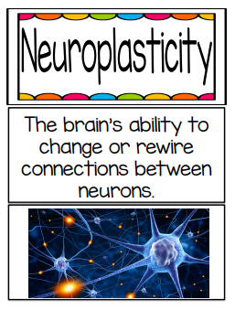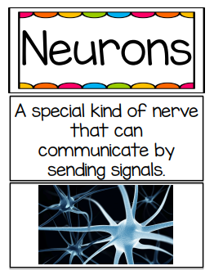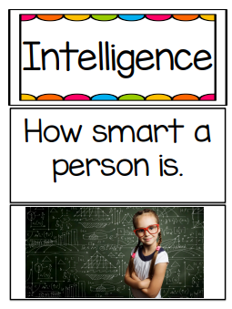
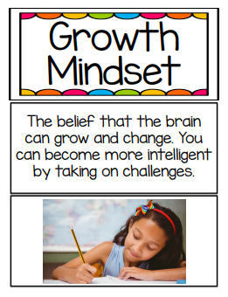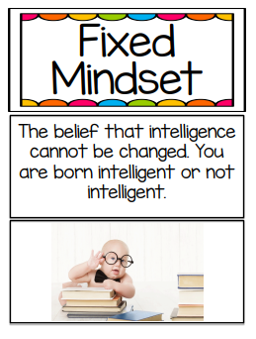
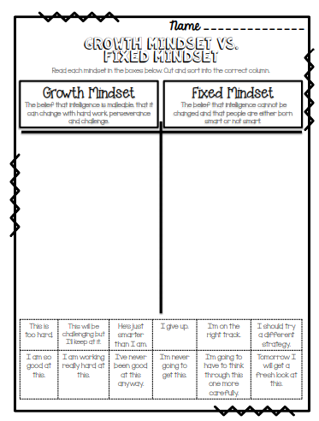

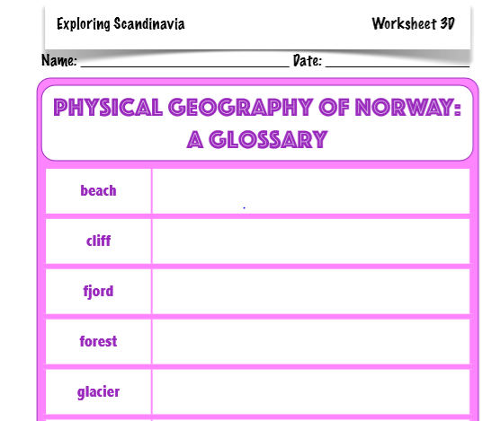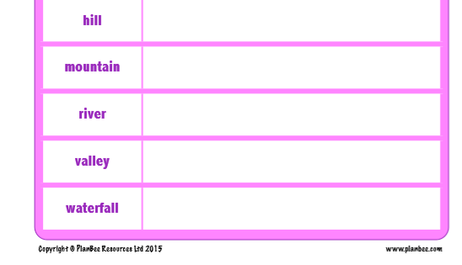

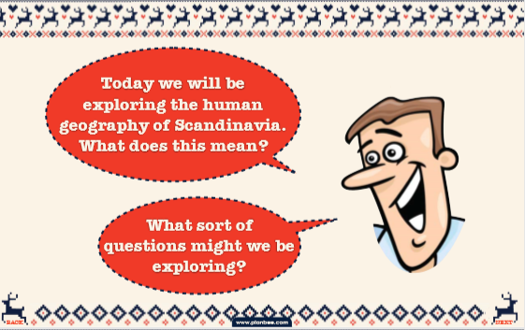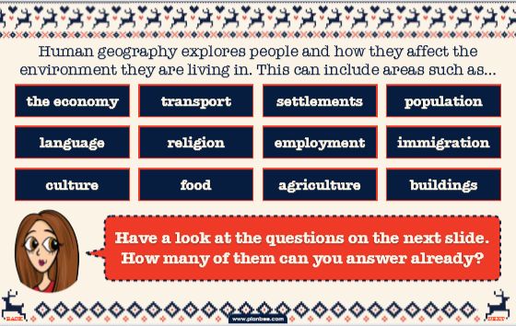
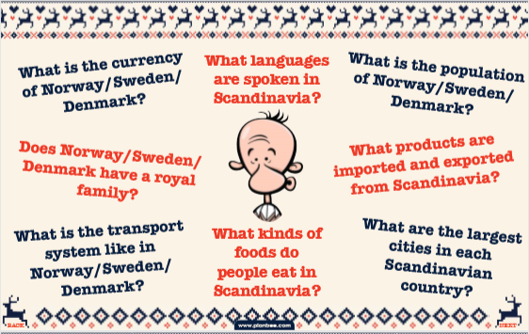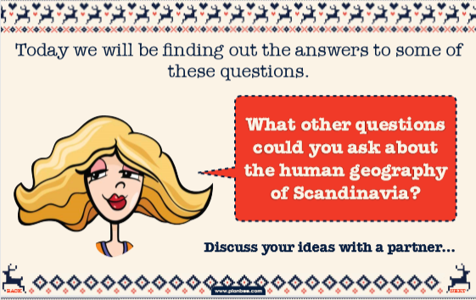

Friday 10th July | Core activities |  |  |  |  | Suggestions for additional activities.
9.00 – 9.30 | Daily Dashboard:  Quelle est la date aujourd’hui?  C’est vendredi le dix juillet, 2020.  Can you write the number date in Roman numerals?  What is happening in the world? Have a look at https://www.bbc.co.uk/newsround or https://www.dogonews.com/ to see what is going on in the world. Choose a news article or two to read.  In 1985, the Greenpeace flagship Rainbow Warrior was blown up in Auckland harbour, New Zealand, on orders of the French government. Read more here:  https://www.greenpeace.org/new-zealand/about/our-history/bombing-of-the-rainbow-warrior/  The French government decided they were dangerous – do you agree with their actions? Why/Why not? |  | In 1997 more than 100,000 people packed into Hyde Park in London for a countryside rally to protest against Government proposals to ban fox hunting. This discussion for and against hunting resulted in fox hunting with dogs being banned in 2004.  Gathering with likeminded individuals is only one way we can make a difference, to draw attention to an issue we believe in. Recently people gathered to protest racism in America after the death of George Floyd, despite the threat of the coronavirus.  What could you do today to draw attention to an issue dear to your heart? What could we do as a class in September to raise awareness of an issue, charity or cause?
9.30-10.00 | Grammar – see separate Grammar resources
10.00- 10.30 | Time for some physical activity.  Why not try out some chairobics from imoves:  https://player.vimeo.com/video/230127916  Alternatively, you could have a go at the Rounders England Running Challenge:  https://www.youtube.com/KZQVynSaEoE
10.30-11.30 | Maths – follow the links to find online lessons for each year group:  Year 3: https://classroom.thenational.academy/lessons/to-use-a-duration-to-find-a-start-and-finish-time  Year 4: https://classroom.thenational.academy/lessons/to-investigate-a-number-pattern  Year 5: https://classroom.thenational.academy/lessons/decimals-to-solve-and-represent-decimal-problems  Year 6: https://classroom.thenational.academy/lessons/scale-factor-in-shapes |  |  |  | Why not try a BBC Supermovers Maths video to help warm up your Maths brain while getting in a bit of movement?  https://www.bbc.co.uk/teach/supermovers/ks2-maths-collection/z7frpg8
11.30-11.45 | Have a break and play a game or do another activity that you enjoy. | Be proud of your very being! What have you done well this week? Why not award yourself another certificate!
11.45 – 12.00 | Collective Worship  You will find an Act of Worship designed for use at home by families at https://www.churchofengland.org/faith-action/faith-home/faith-home-videos . This month there are a range of themes to choose from, including kindness, resilience, and patience. There are plenty of these available if you would like to build in a daily worship time as a family.
12.00- 1.00pm | Lunch break. Eat a healthy lunch and, if you are able, try to get outside for some fresh air!
1.00pm – 1.30pm | Reading – Although we have avoided Vikings this week, due to our topic in Autumn term being ‘Traders and Raiders’, I’ve included a double page spread below to wet your appetite, in readiness for September!  What information was new to you? What did you notice about how the information was presented? |  |  |  |  |  | You could read another chapter of your current book.
1.30pm – 2.00pm | Mental Health: Growth Mindset  Do you remember the song, ‘The Power of Yet’. Here is a link to that song: https://www.youtube.com/watch?v=XLeUvZvuvAs and the Bruno Mars song: https://www.youtube.com/watch?v=pWp6kkz-pnQ  Watch and sing along with this song about having a go!  https://www.youtube.com/watch?v=6fq1jvIy2AE&list=RD6fq1jvIy2AE&index=1  Complete the ‘The Magic of Yet’ exercises (below).  You might also be inspired by watching some of the TED talks at https://childhood101.com/growth-mindset-videos/
2.00pm-3.00pm | Literacy  Using the information you’ve found out this week, you could create an advert for a Scandinavian holiday destination. Choosing one of the countries, think about its:  - location,  - climate,  - landscape,  - possible leisure activites,  - possible excursions to natural features… then sell it to your reader!  Write persuasively and descriptively to convey what a great holiday destination this is and how much fun and excitement they will have.  I’ve included an end of unit quiz below. You can look back at your work this week to help you! |  |  | Alternatively, you could imagine that you were able to accompany some travellers on a visit to a Scandanavian country.  Then write another letter or diary entry, in role as a visitor to Sweden or Finland, to describe the experience and what you observed about the life of the Scandinavian people.  As well as winter sports and cycling, the Scandinavian people are known for hiking in the majestic landscapes and wide open spaces. Why not round off our Scandinavian week by going for a hike this weekend, Devon-style, in the woods, by the beach or even across the moors.
 | 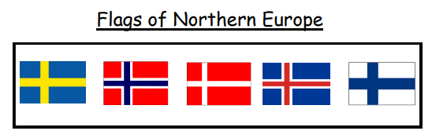Which of the flags can you identify of the Nordic Region after this week’s learning?
Leaving the chilly North, we’re heading to France next week, thanks to one of your classmates!
Hope you have a great weekend!

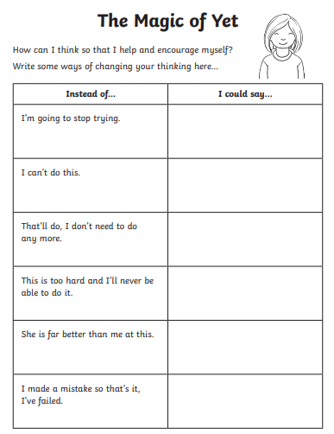

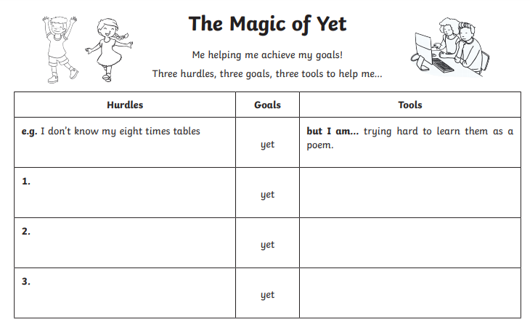

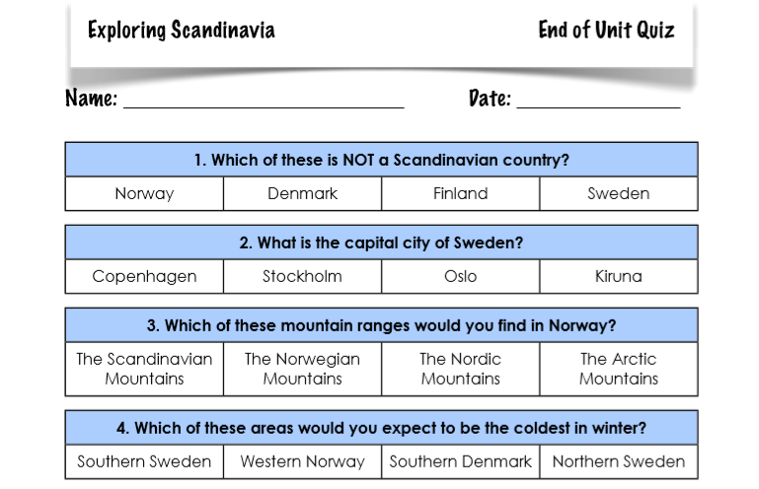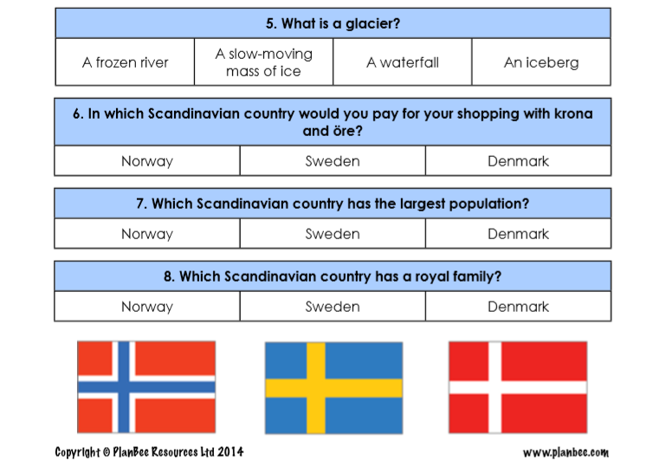

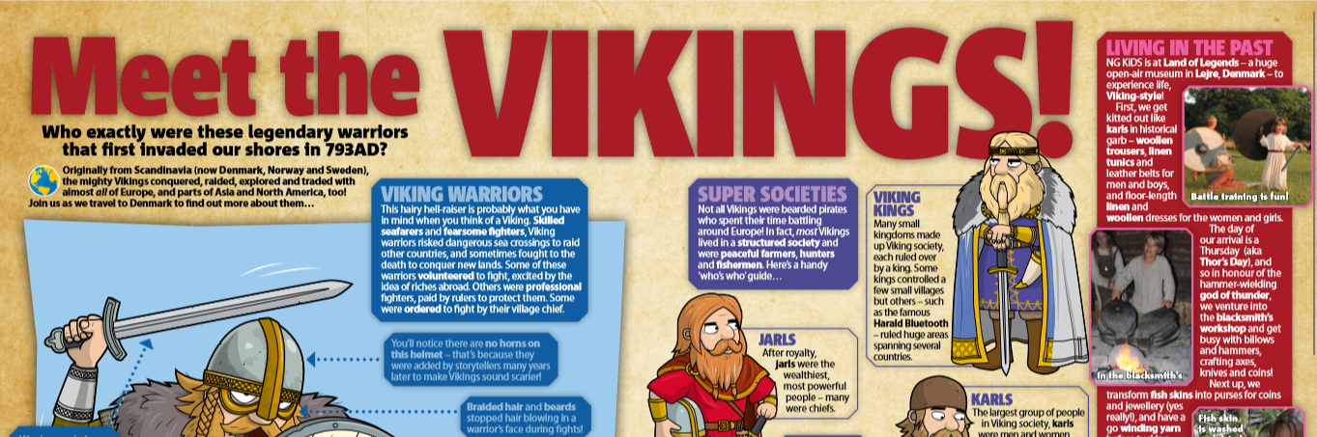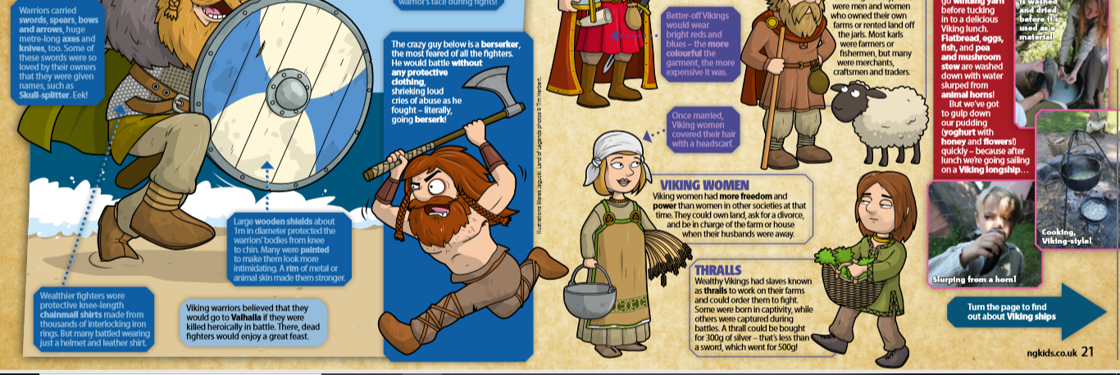
Desert

