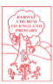
1.5.2020

Dear Class 1,
Hello again! How are you all? I hope you have all had a good week and have been keeping yourselves busy. This week, for home learning, we will be combining our theme of life cycles with Star Wars, to celebrate International Star Wars Day, on May 4th. I am a great believer that learning should be fun and evoke curiosity and enthusiasm in children, so if you find your children prefer to write about something else then that is absolutely fine to do so. These are strange times and you are all doing so well, persevering together to create memories your children will have for a life time. Therefore, please have fun with your learning!
On the website, shortly, there will be a document from the CAP UK with a list of activities for you all to try, should you wish to. These are aimed at helping support children and families through these different times. The first activity is to help name one of the KS1 Safe Superheroes, using alliteration. You should all be fantastic at this, after all those contributions of names for our class tadpoles!
In addition, John Lewis has launched a competition for children to design their own ‘Super Bear’, in which the winning design will be made into a real toy bear, to be sold in John Lewis stores and all proceeds will be going to support the NHS. Further information can be found on the John Lewis website: https://www.johnlewispartnership.co.uk/media/press/y2020/jl-and-wr-launch-soft-toy-design-competition.html
This week, I have attached some phonics flash cards and allocated some new phonics activities to your Bug Club accounts, so please do try and have a look.

Have a good week and ‘May the force be with you!’
Thinking of you all,
Mrs Jackson
Home Learning – Literacy (week beginning 4.5.2020)

Monday – WALT: make a prediction and create an illustration
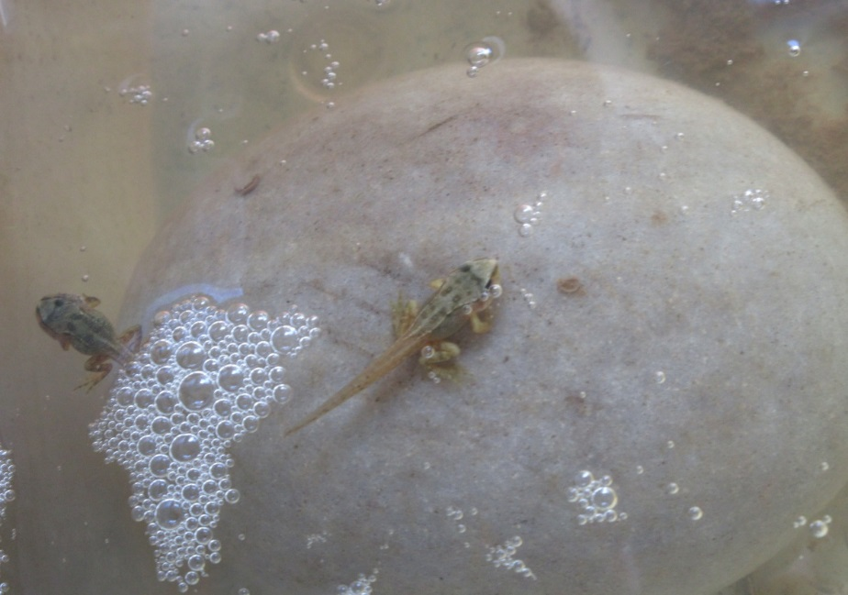
As I came down stairs this morning, I noticed two little froglets sat on top of a smooth, oval rock, I had placed inside the frog tank. They were sat there looking at me! They have inspired me to choose this weeks story, for our Literacy home learning: ‘Oi Frog!’ by Kes Gray and Jim Field.
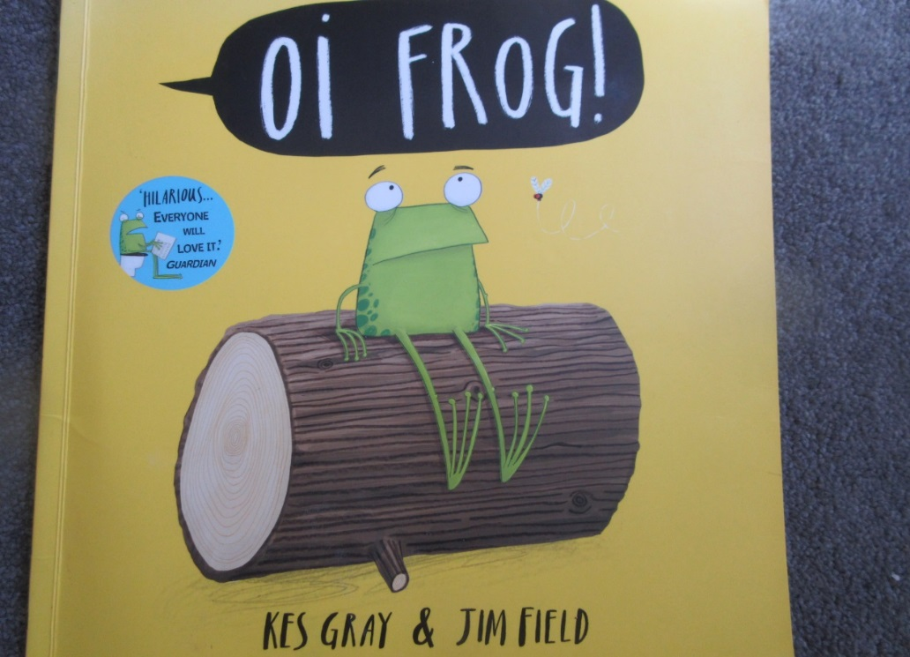

Before we start reading this story, have a look at the front cover and the title. What do you predict this story will be about?
Can you write your predictions and explain your thinking to your grown up or a sibling.

I predict this story will be about ___________________________________
because _____________________________________________________

Now, look closely at the illustrations on the first page (image below). How many different verbs can you think of to describe what the frog is doing? Can you list them in your books? Remember – a verb is a ‘doing’ word. For example: jump, walk.
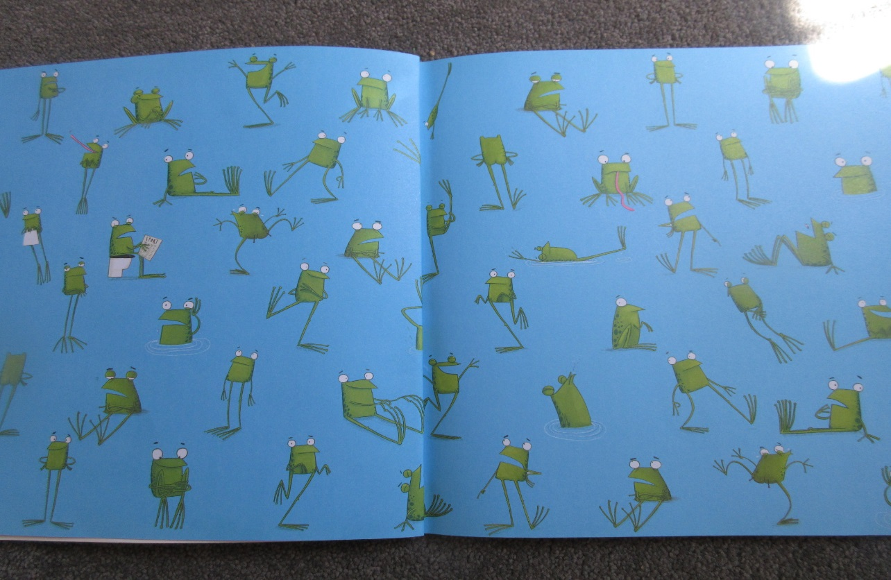
Finally, you are going to have a go at drawing your own frog character, in the style of Jim Field, the illustrator of ‘Oi Frog!’.
Paste the link, below, into your search bar and you can watch a lovely clip of Jim Field, talking you through step-by-step instructions, on how to draw ‘Oi Frog’. https://www.youtube.com/watch?v=DyCe11JJmk8
I would love to see your illustrations! Please take a photograph and email them into Mrs Jackson, at admin@farway.devon.sch.uk.
Tuesday – WALT: ask and answer ‘how’, ‘why’, ‘what’, ‘where’ questions.
Have a look at the images below. I have photographed the book we would be reading together in school. Why not have a go at reading the words to your parents and sibling!
There is a lot of ‘speech’ in this story, so think about how you would read the words inside the ‘speech marks’, to emphasise that the character is talking.
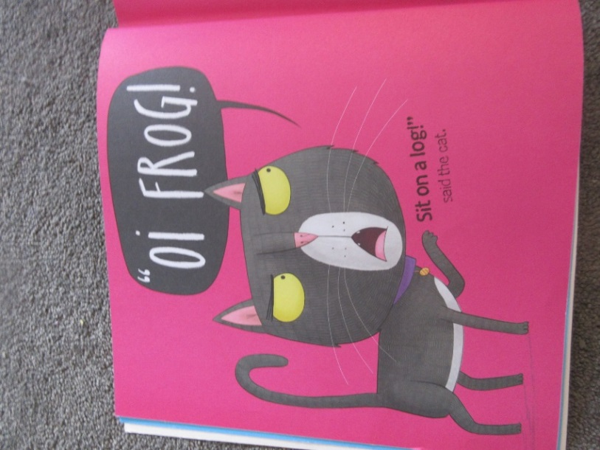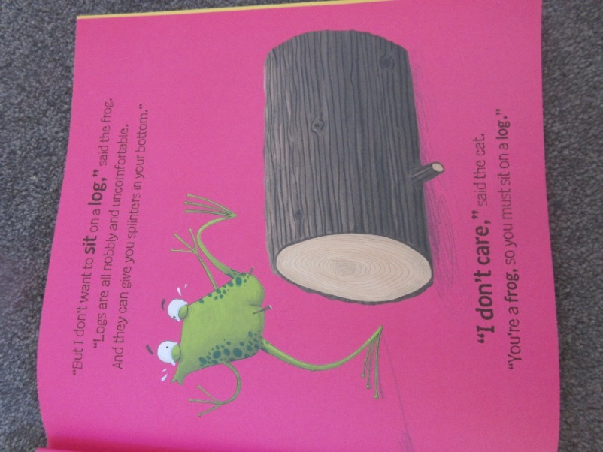
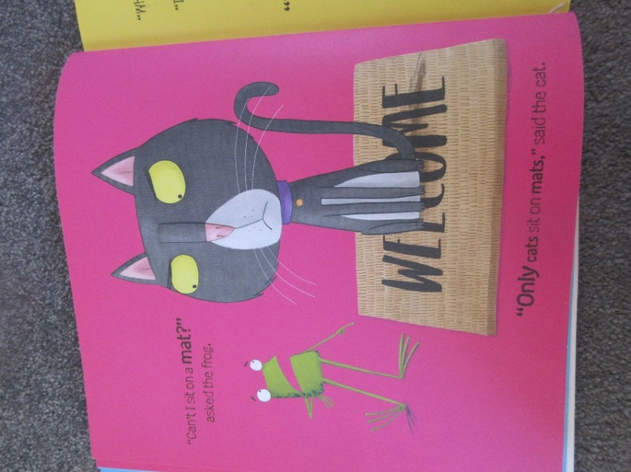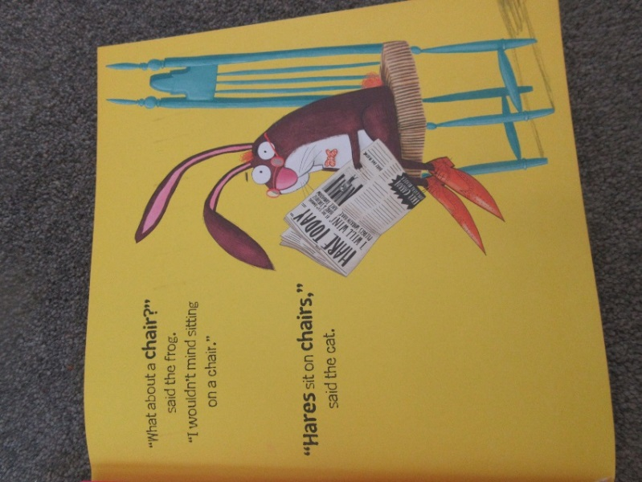

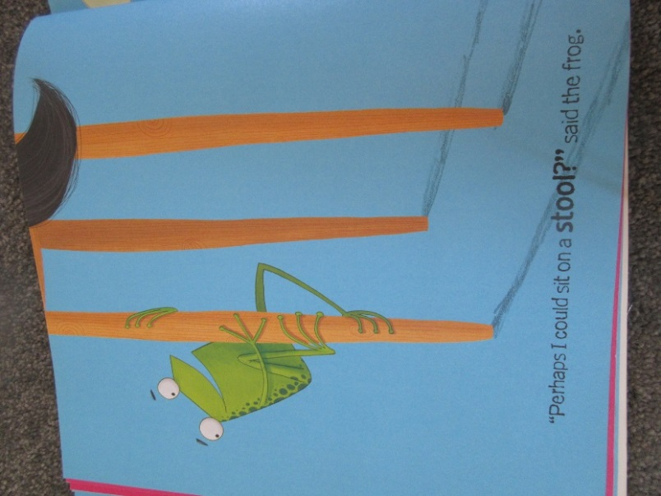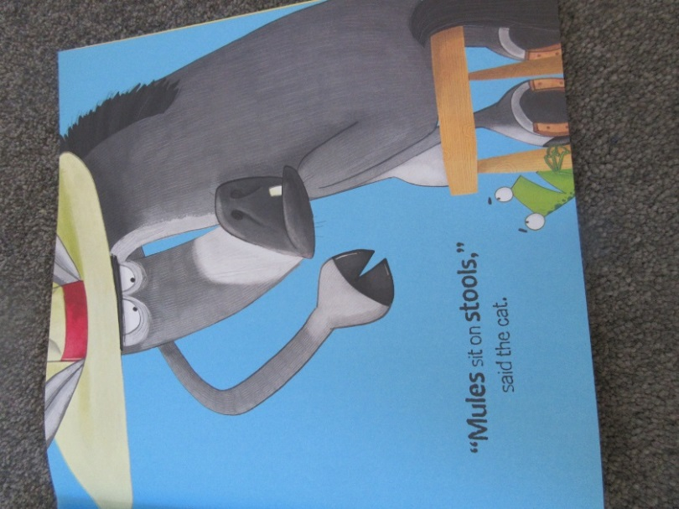
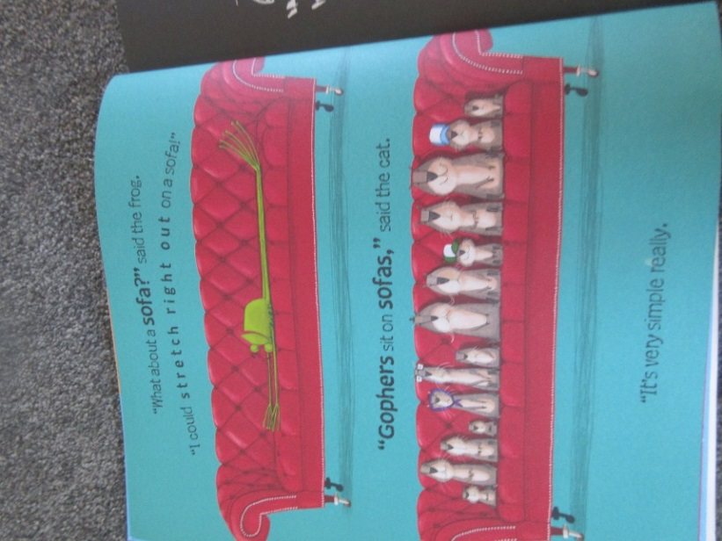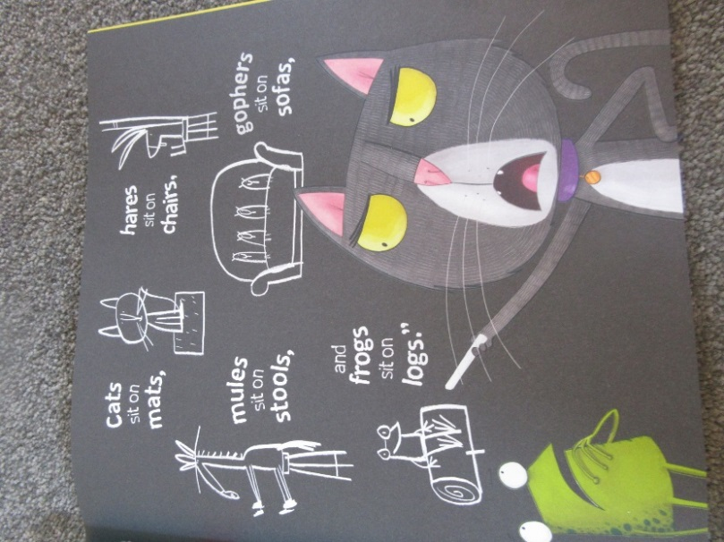
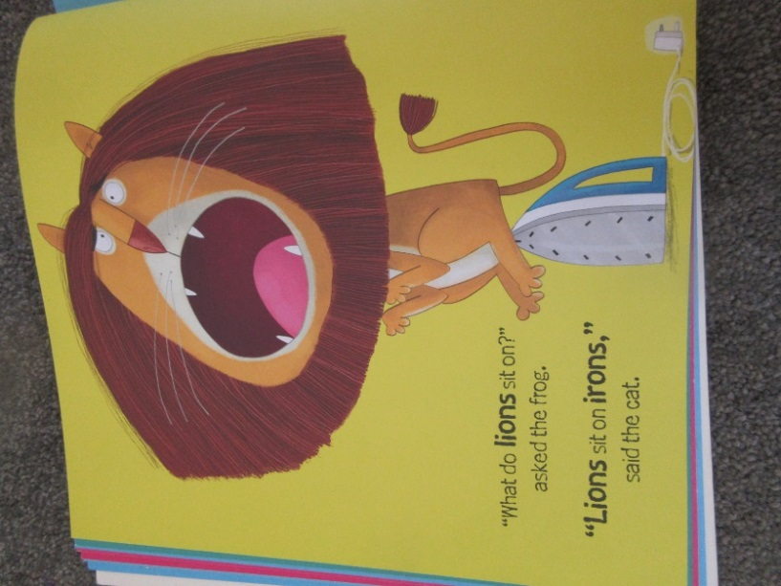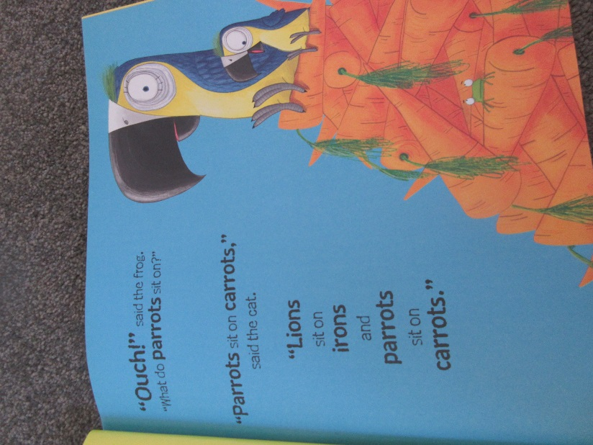
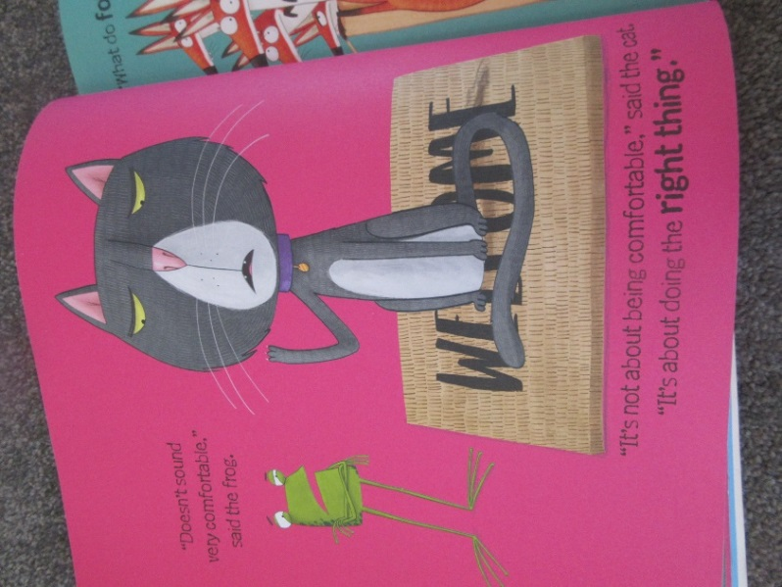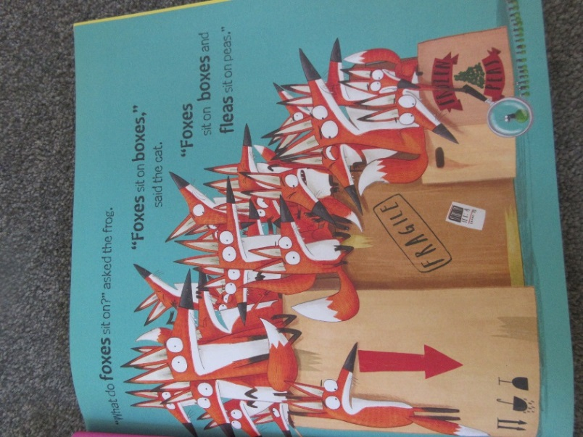
Now, have a go at answering these questions:
- What do you notice about the story?
- Where is your favourite place to sit and relax?
- The cat says, ‘’It’s not about being comfortable, it’s about doing the right thing.’’ What do you think the cat means by ‘the right thing’?
- Why do you think this? Can you give an example from the book?
- Think of some ‘how’, ‘what’, ‘where’, ‘why’ questions you might like to ask about this story.
If you can’t think of any questions to ask about the story, why not create some of your own questions about anything that interests you!

Wednesday – WALT: identify words that rhyme
Today, re read the beginning of ‘Oi Frog!’
Looking at the images, can you infer how the frog may be feeling? Explain your thinking. What clues are there from the image below?
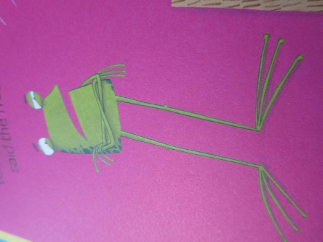
Yesterday, we explored what the cat meant by, ‘doing the right thing.’ If you answered that he was using rhyming – pairs then you were correct! Well done.
Thinking about rhyming pairs, can you write down all the rhyming pairs that you have found in the book so far? The first two have been done for you:
Word | Rhyming pair
frog | log
cat | mat

Have a look around your home or garden. Choose some interesting items and see if you can think of a rhyming word, to form a rhyming pair.
Make a note of these in the chart below. I have given you an example.
Word | Rhyming pair
chair | pear

Now, you can read the rest of the story to your parent or sibling.
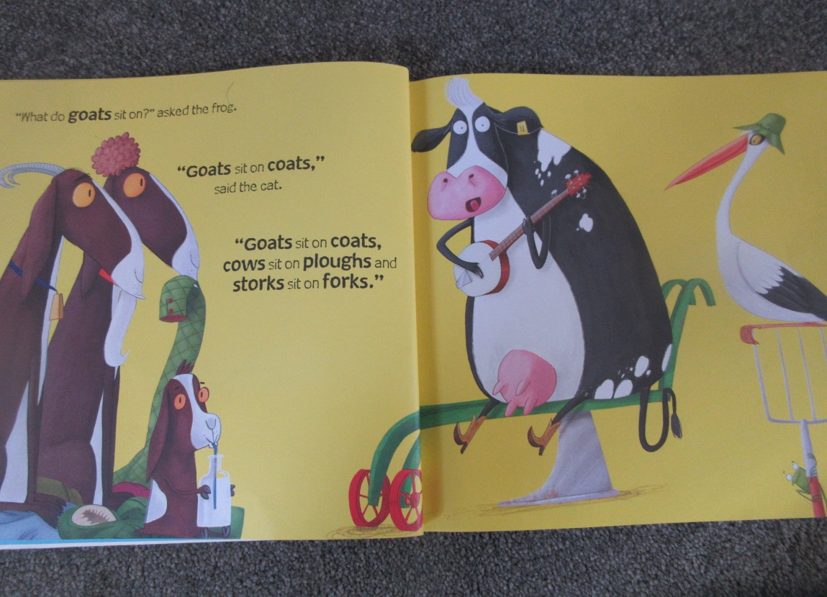
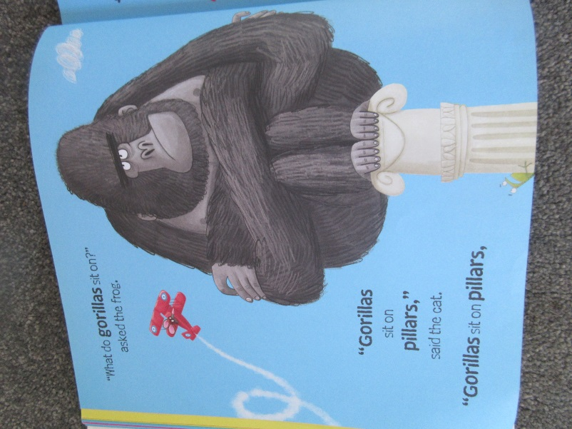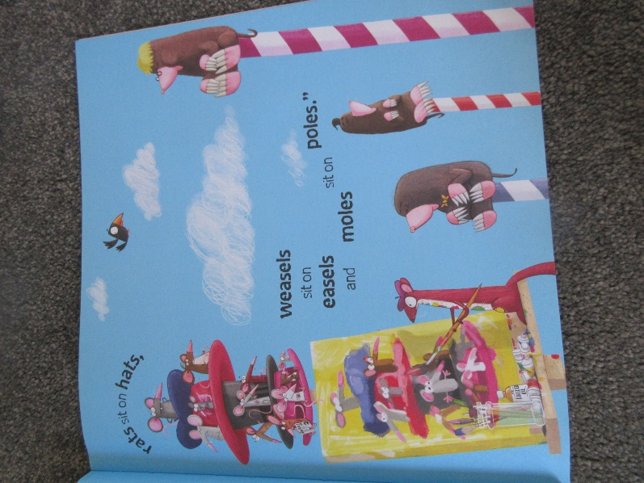
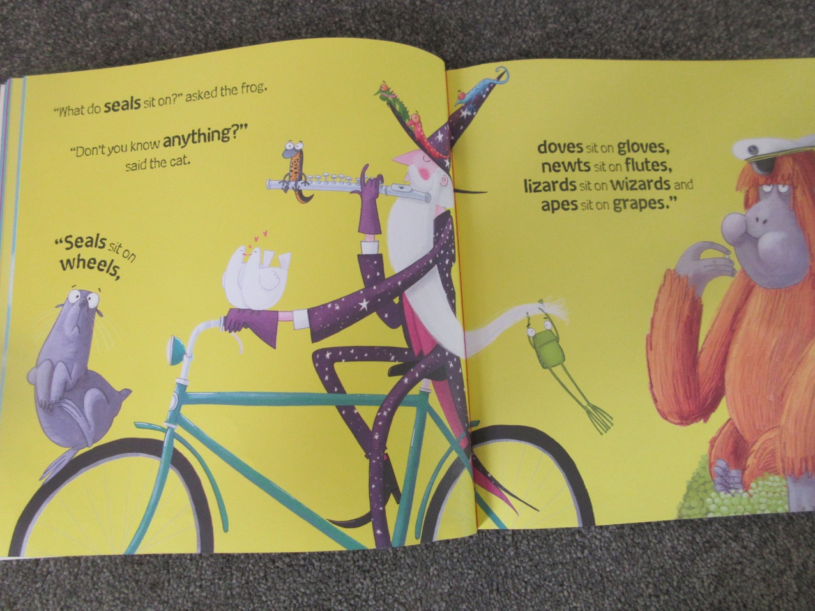
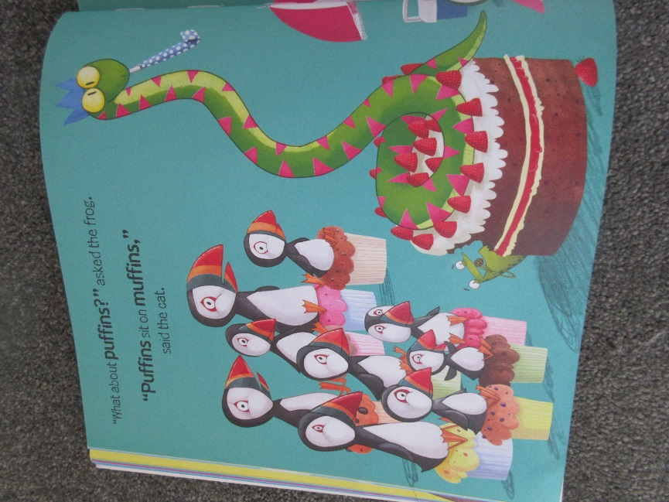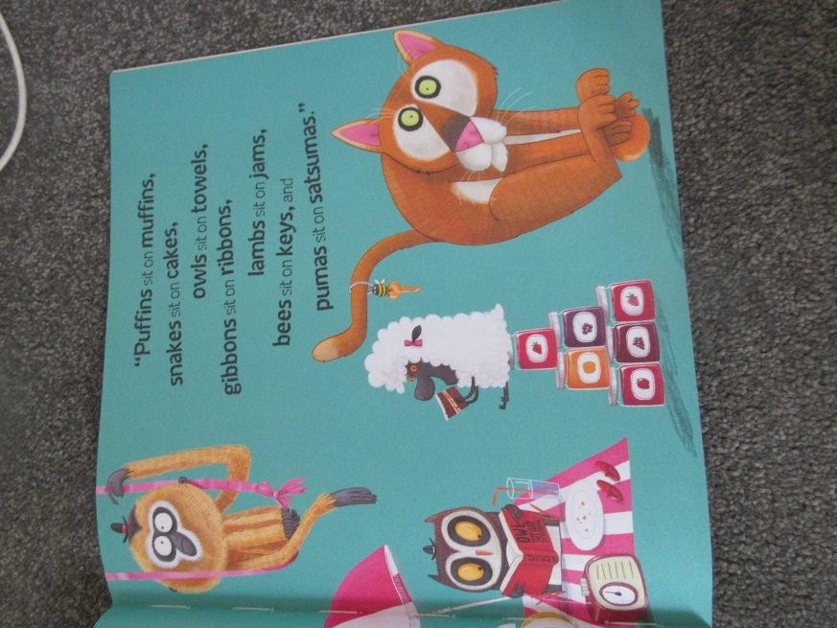
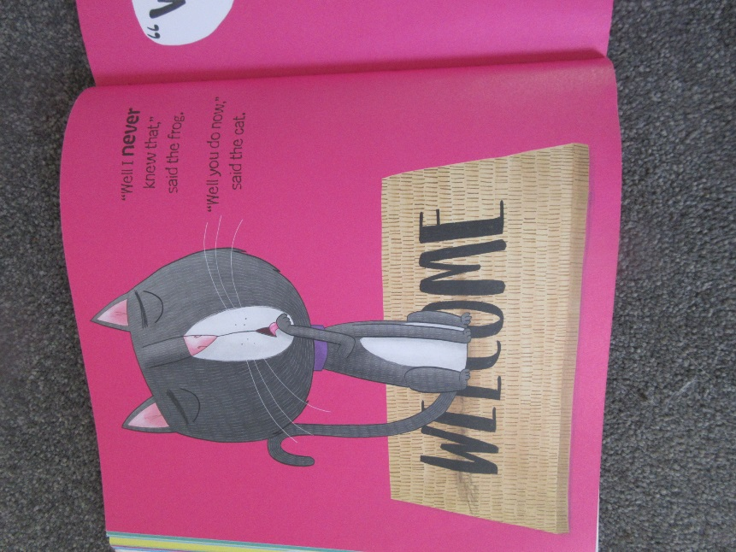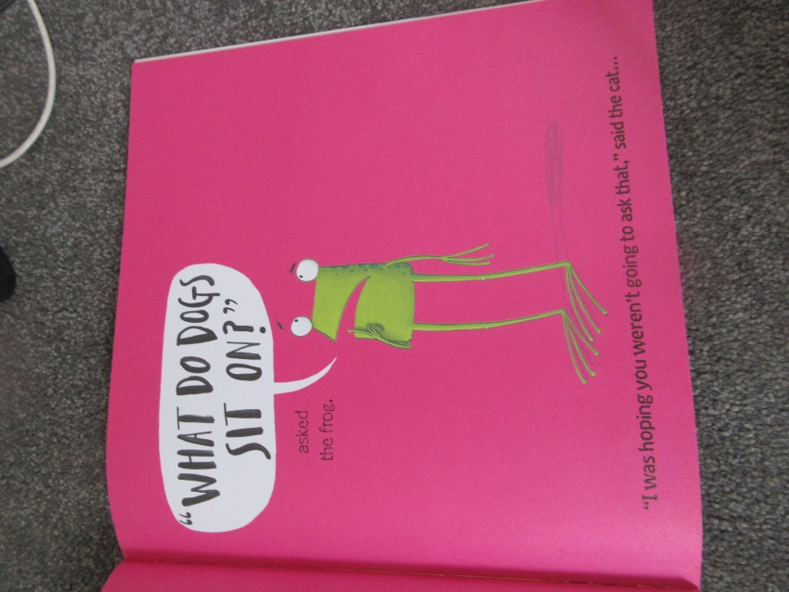

What else could the dog sit on? Remember the rule… the words need to rhyme.

Thursday – WALT: create our own rhyming words for your own story, in the style of ‘Oi Frog!’
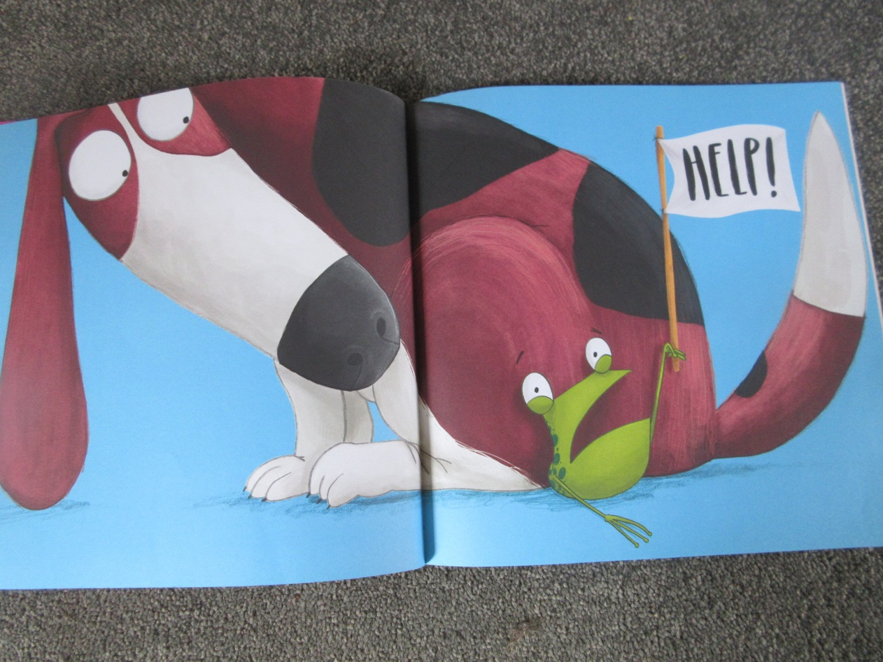
Here is the final page from our story this week. Did you predict the dog would sit on the frog? What other endings did you predict?
Choose an alternative rhymming pair and have a go at drawing a different ending for ‘Oi Frog!’ in your home learning books.

Next week, we will begin to write our own stories in the style of ‘Oi Frog!’. You can choose any theme to base your story on, but the layout will remain similar and the rhymming rule will still apply.

Today, we are going to start planning our rhyming pairs.
I have chosen to base my story on a Star Wars theme, in recognition of International Star Wars Day (May 4th). I also love Star Wars!
To start planning your story, first you need to think about what theme you may like to base your story on. It could be: animals, cars, transport, farming, space, Harry Potter, hobbies you like doing… the list is endless!
Next, you need to think of words that are associated with your theme. These are likely to be nouns (things, people or places). For example:
Word | Rhyming pair
Yoda
Ewok
Bear
Droid
Rey
Hans Solo
Storm Trooper
Chewbacca

When you have got your list of words, you need to think of their rhyming pair. I have kept the same theme as, ‘Oi Frog!’ Using the idea that the main character is looking for somewhere cozy to sit and relax.
This can be quite challenging, so parents are very welcome to help! I had to ask my whole family to help with rhyming Star Wars words!! It’s good to ask for help when we need it.
Star Wars themed word | Rhyming pair
Yoda | Cream soda
Ewok | Rock
Bear | Chair
Droid | Lloyd
Rey | Tray
Hans Solo | Mint Polo
Storm Trooper | Tutor
Chewbacca | Alpacca

Have a go at creating a list of your own rhyming pairs. I have created a table for you should you choose to use it, but only if it helpful.
Word | Rhyming pair

Friday – Bank Holiday Friday!
Next week we will be working really hard to create and illustrate our own story, in the style of ‘Oi Frog!’ so make sure you recognise how hard you have worked this week and go and have some fun today!

Have fun and enjoy time to relax and do something that makes you feel happy!

