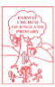
16.5.2020

Dear Class 1
I hope you have all had a good week and that you are keeping safe and taking care during this period of school closure? Have you been able to get outside and have some exercise this week? On Friday, I went for a lovely walk around my local area and saw lots of beautiful butterflies, fluttering around. On returning home, I discovered I had received an email to say the caterpillars had been dispatched!! ‘Wahoo!’ So, this week, I thought it would be nice to continue our learning on lifecycles and learn about the life cycle of the butterfly.
I have attached several craft ideas you could explore, to enhance your learning about butterflies, but these are in addition to the Literacy and Math tasks.
If you have any questions or would like to share any work, please email admin@farway.devon.sch.uk

With very best wishes,
Mrs Jackson.

Monday - WALT: sequence events in a story

Today, we will start by looking at a fabulous story, called, ‘The Very Hungry Caterpillar’, by Eric Carle.
Before we read the story together, have a go at the activities below:
- Write a prediction, in your home learning books, predicting what you think the story might be about?
- Can you think of any other words you could use to describe ‘very hungry’?

Copy and paste the link below to listen to the story ‘The Very Hungry Caterpillar’, being read to you by Eric Carle (the author) himself.
https://www.youtube.com/watch?v=vkYmvxP0AJI

In addition, the link below allows you to watch an animated version of ‘The Very Hungry Caterpillar’.
https://www.youtube.com/watch?v=75NQK-Sm1YY

Alternatively, if you have the book at home you can enjoy reading it together!

Now you have listened to or read the story of ‘The Very Hungry Caterpillar’, have a go at sequencing the events in the story, using the pictures below. It would be a good idea to cut out the pictures and stick them into your books.

Challenge: Can you write a sentence under each picture to retell the story.

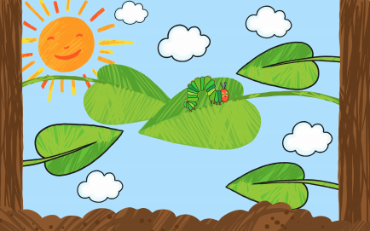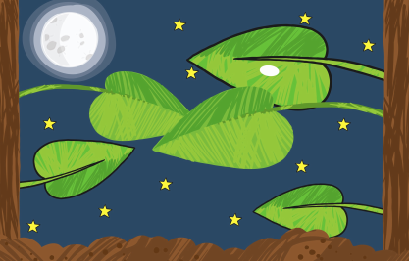
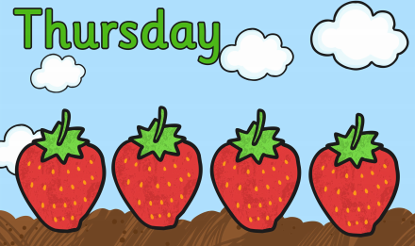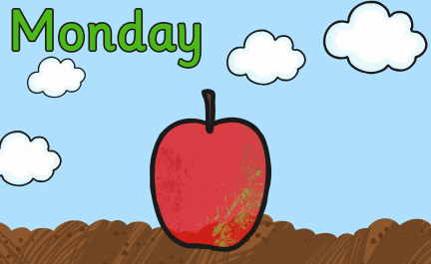
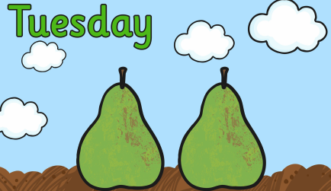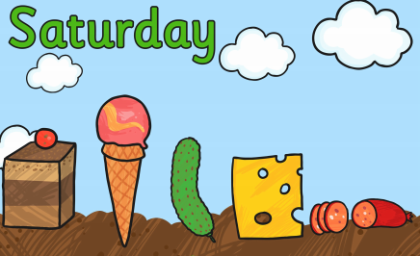
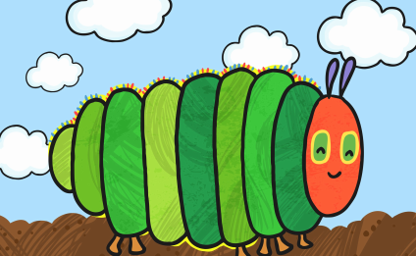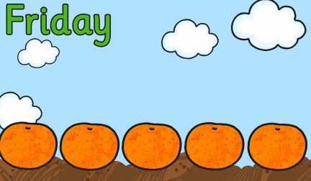
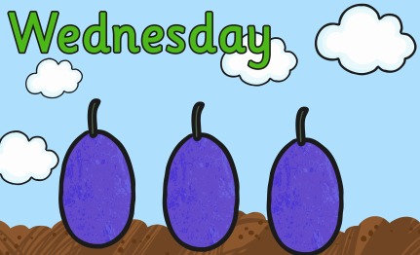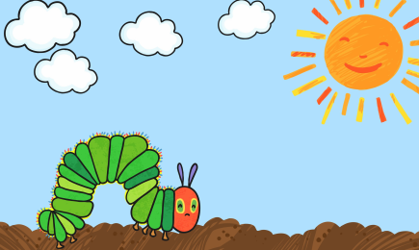
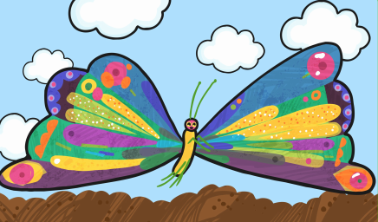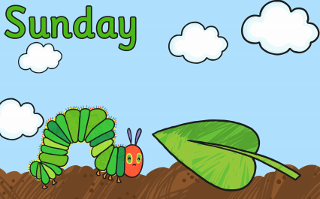
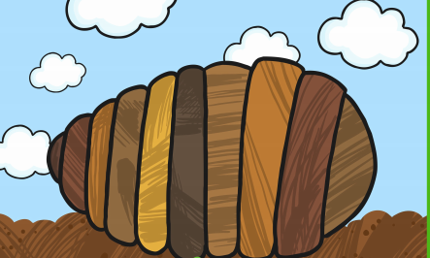

Tuesday – WALT: retell the story of ‘The Very Hungry Caterpillar’, by Eric Carle.
Today we are going to practise retelling the story of ‘The Very Hungry Caterpillar’, using props to support our story language.
- Recap the story of ‘The Very Hungry Caterpillar’, by either reading the book or using the links from yesterday.
- Orally rehearse parts of the story, using the sequence cards to help you remember the order of events happening.
- When you feel confident with retelling the story, cut out the images on the attached file and create puppets to act out the story to your family! In school, we would have stuck the images to lollisticks, to create puppets but if you do not have these at home you can equally use duplo bricks, straws, or cardboard (from cereal packets).
- Have fun!
Maybe you could film yourselves acting out the story and send to Mrs Jackson (who would LOVE to see them!!!) admin@farway.devon.sch.uk

Wednesday – WALT: identify the key stages of the Butterfly Life Cycle.
Using the sequence cards from Monday, can you identify the four key stages of the butterfly life cycle?
- What do you notice is similar to the stages of the frog life cycle and what do you notice that is different?
- Discuss your ideas with your parents or a sibling.

Next, can you complete the Life Cycle of the butterfly, using the chart below.
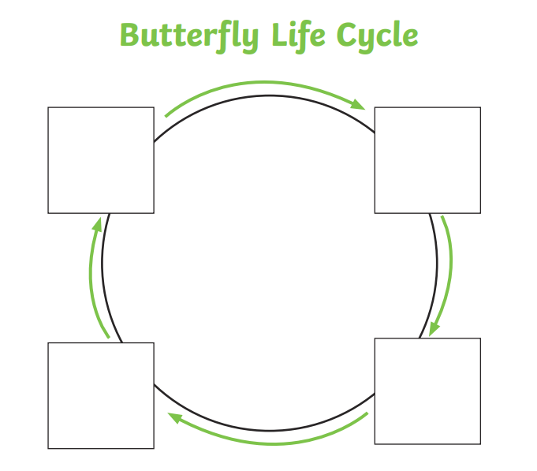
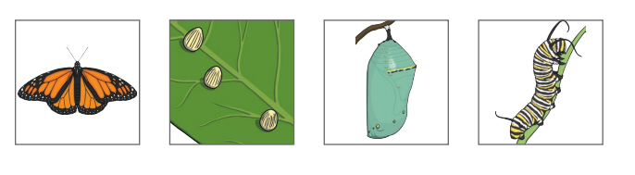

When you have completed your butterfly life cycle, can you write a few sentences, in your home learning books, to explain what is happening in each of the stages.

The bbc iplayer has a wonderful video on the butterfly life cycle, shown by Maddie, a presenter on ‘Do You Know?’ Please watch it, it will really enhance the experience of the children’s learning about butterflies and support their writing about the different stages.
https://www.bbc.co.uk/iplayer/episode/m0004xrx/sign/maddies-do-you-know-series-3-7-butterfly-and-wallpaper

Here is a vocabulary word mat. Look closely at the key words they use. For example: chrysalis.
Can you use this key vocabulary within your own writing to explain what is happening in each of the four stages of the butterfly life cycle.
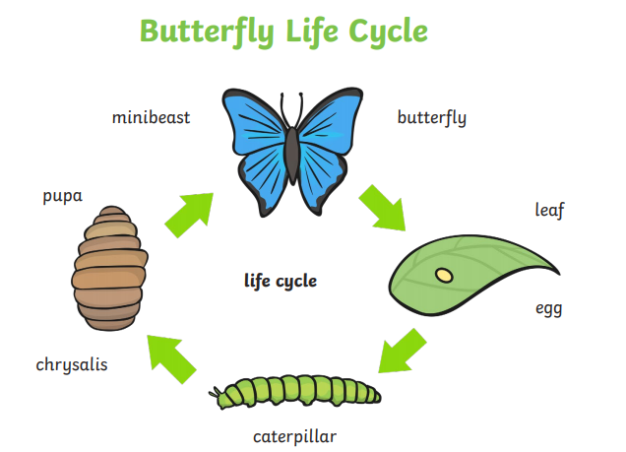
Thursday – WALT: spell the days of the week

Eric Carle’s story, ‘The Very Hungry Caterpillar’, tells us the story of a ravenous caterpillar hatching from its egg and setting off looking for food, before building a chrysalis around itself and transforming into a glorious butterfly. The story is based over the course of several weeks, mirroring the duration of the real butterfly life cycle. However, the main part of the story happens in the first week, in which the caterpillar is eating lots of food and rapidly doubling in size.
In Maths last week, we looked at Time and explored the number of days in a week.
- Can you remember, how many days there are in one week?
- Can you have a go at writing out the days of the week in your home learning books, without looking at them!
Remember: days of the week are names, therefore they need a capital letter.

So, that’s right there are 7 days on the week!
These are:
Monday
Tuesday
Wednesday
Thursday
Friday
Saturday
Sunday

Using the graph below, can you write a day of a week in each box, then cut out the different foods, the hungry caterpillar ate, and match them to the correct day.

Monday

Tuesday

Thursday

Wednesday

Friday

Saturday

Sunday

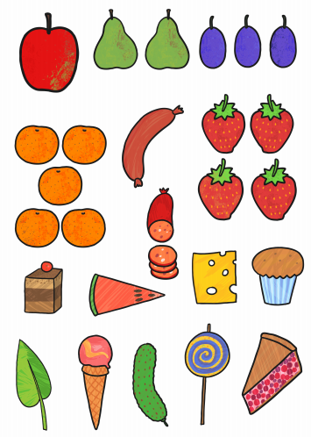

Friday – WALT: create a healthy eating menu for the Very Hungry Caterpillar.

Last term we were learning about space and you were asked to design a healthy living poster for an astronaut.
Can you remember what the word ‘healthy’ means?

When you are young and growing constantly (like you all are) it is important to try and eat a healthy balanced diet, to ensure you grow strong and keep you healthy.
Below is a plate of food, demonstrating the proportions of each food group that you need to stay strong and healthy. Have a look at the different food groups, can you think of any other foods you could add to the different food groups?
- Draw a circle in your home learning books and divide your plate into the 5 different sections, as shown below.
- Identify the foods that the very hungry caterpillar ate on his journey. Can you draw these foods on to your plate in the correct sections?
- Now, have a look and see, does his plate consist of healthy fruit, vegetables, and grain? Or does he eat a lot of cakes and ice-cream?
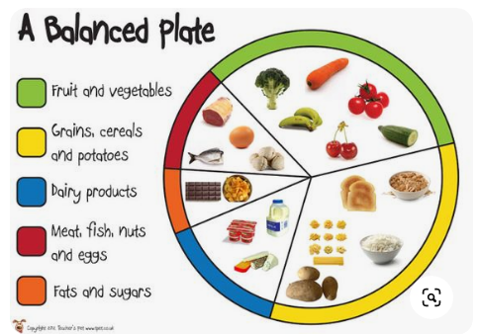
Your task today, is to design a healthy balanced plate for the Very Hungry Caterpillar!!

