3rd March 2023
Dear Parents,

In Class 1, our Maths topic has been Place Value. The children have been focussing on numbers up to 50, using their mathematical reasoning to discuss how they have solved mathematical sentences, using resources in the classroom and part-whole models. The children’s ‘maths talk’ is getting stronger week by week, as they continue to develop and refine their mathematical oracy.

In Literacy, the children have been reading ‘Goodnight Spaceman’ by Michelle Robinson. The children are building up to independently write a poem about something they dream of doing. They will continue to strengthen their letter formation by writing a few guided letters or words each morning during their phonics sessions, which is continuing to help build their stamina for writing in Literacy.

Class 1’s current unit is Moon Zoom and they recently went to Woodbury Salterton to experience a planetarium in a space dome! The day started off with a fantastic presentation inside the space dome. The children learnt about the planets and were then treated to a fantastic show of the stars at night. It was extremely dark inside the space dome and some of us were a little nervous about this, but the children were all very brave! What a fantastic day!

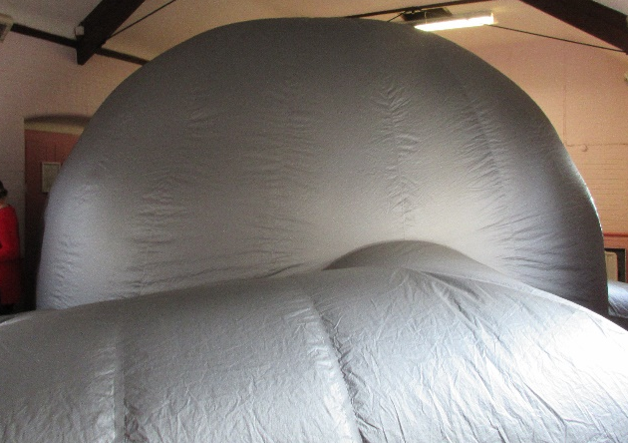, 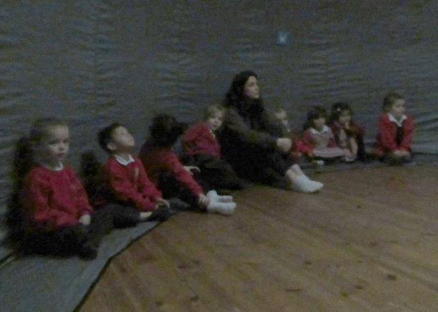

In design and technology, Class 1 are exploring a range of materials and basic vehicle structures, working towards building their own Lunar Rover. The children are using images and experimenting with designs to help them design something that might travel well on a range of surfaces.

Just before half term, Class 2 had an exciting start to the history part of their learning with a visit from renowned storyteller Clive Pig. He has travelled the world collecting folk myths and legends and told the children a number of tales from Mexico, interspersed with live music and singing! The children enjoyed the opportunity to spend time with friends from Branscombe, as well as get to know new friends from Woodbury Salterton. As always, the children engaged enthusiastically by asking questions and joining in with the storytelling.
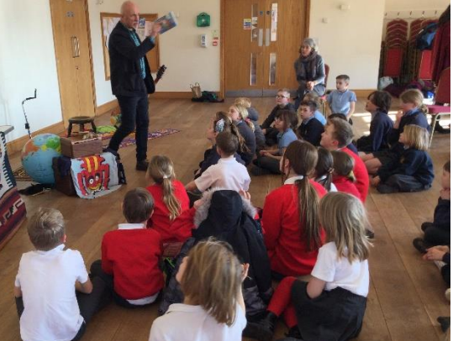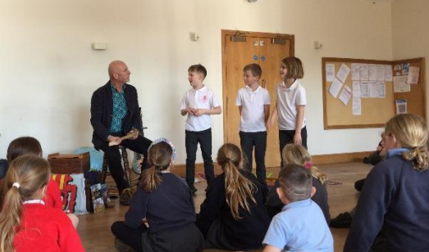

As part of Class 2’s learning about non-chronological reports through the book ‘Animalium’ by Jenny
Broom, the children have contributed to a non-chronological report about the ‘Day of the Dead’. This is a joyous festival celebrated in Mexico since the days of the Ancient Maya to remember their loved ones and ancestors.

In other lessons, Class 2 pupils have learned about the history and symbolism of the various parts of the three day festival, and then included that in their writing. They are now researching and collecting information about the Maya Gods to contribute to a class book.

During maths time, Class 2 pupils have been learning about fractions. Year 3 have been thinking about unit fractions and non-unit fractions and making a whole in different ways. After Year 4 had brushed up on their knowledge of tenths and hundredths, they then thought about ways to represent mixed numbers and how to simplify a fraction. Year 6 have been working with more complex fractions such as improper fractions and how to convert them to mixed numbers. This is helping them to calculate with fractions where the denominator is the same.

In P.E. Class 2 have moved on from hockey and are now learning football skills. Freddie, the sports coach, has commented on the children’s focus and attention in his lessons. He is impressed at the level of sportsmanship he sees each week, with pupils helping their friends to succeed while learning new skills. Our school has a culture, linked to the Orchard Aims, of being supportive and kind to all our members and it was lovely to hear that recognised by an outside provider.

One Friday, all the children joined in with children across the country to celebrate Number Day and raise money for the N.S.P.C.C. The children recently enjoyed the day and raised £30. Thank you to everyone who contributed.

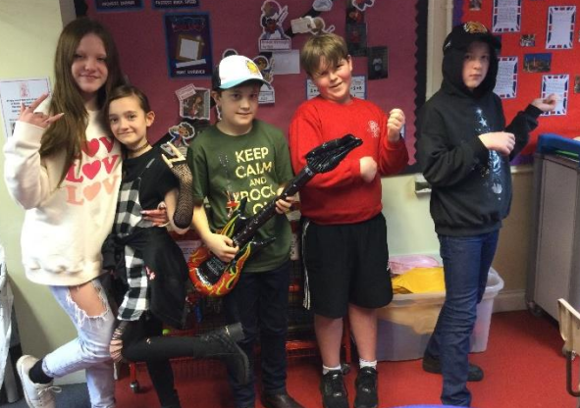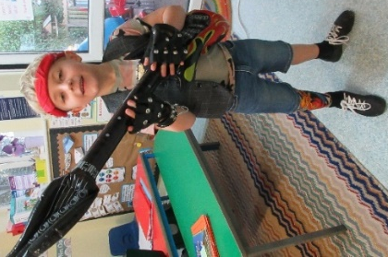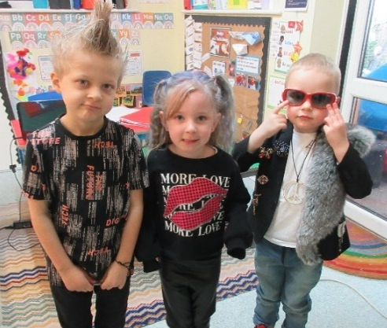

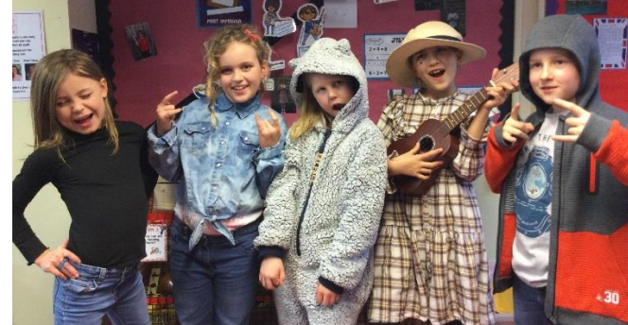

They all looked amazing in their rock star outfits and Class 2 spent the afternoon building their speed on Times Table Rockstars, sharing hints and tips for learning number facts. Big brothers in the class made a promise to support their younger siblings as they start their TT Rockstar journey. Well done to those who are working diligently on their speed and accuracy at home as well as in school.

Over the next few weeks, the children will be practising the dance they learned in P.E. before Christmas. This is because they have been invited to take part in a whole day dance festival as part of the school’s connection with Honiton Learning Community. After 3 workshops, the attending schools will all be sharing a dance. Watch out for the permission letter which will be coming out soon and apologies in advance if you hear the song a lot at home, with accompanying thuds and bangs as they practise their steps!

During science lessons over the last month, Class 2 have completed their learning about electricity and are now thinking about sounds and how we hear them. They have made observations during different listening tasks and suggested questions to investigate. Key words they will use include pitch and volume as they discover how to change these aspects of sound. This ties in with their musical learning this term, as they learn to play djembe drums, which are tuned percussion.

As part of their learning in R.E. about Christian baptism, some children brought in their christening items and shared them with the class. Lily talked to the class about the items in her baby box, which included her christening items. The children handled them respectfully and discussed the significance of the materials used. They then thought of questions they could ask a Christian about their faith and how that affects their life. Reverend Sue came to visit and gave us insight into how her beliefs have grown over time and how her belief in the Trinity helps her in her everyday life.

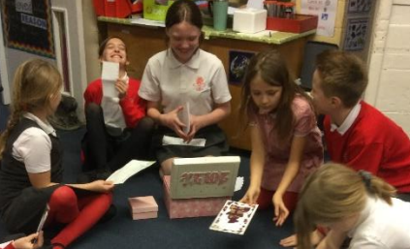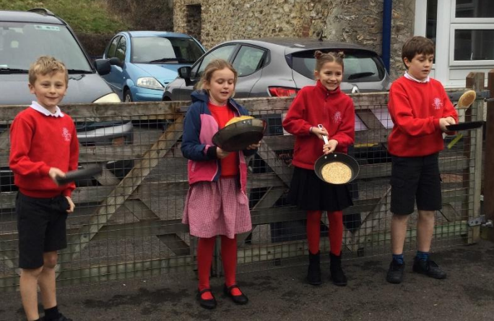

Already this half-term, the children have celebrated the start of Lent with a special Ash Wednesday service with Reverend Sue and then with the Farway CofE Primary School tradition of pancake races in the playground. In Collective Worship, as well as learning about the reasons why Lent is important to many Christians and is often a time of fasting and preparation for Easter, the children have begun to explore this term's theme of Service

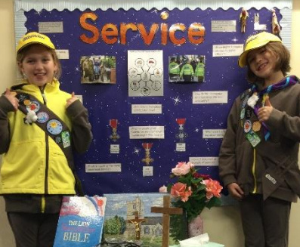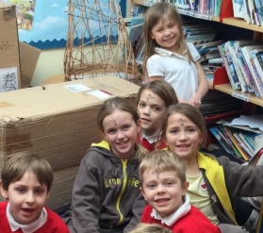

The children have been thinking deeply about what this value might look like in school and at home. Mrs Marsh is pleased to see the children’s efforts in this area and some children have earned certificates for their service to others. It was ‘Thinking Day’ for Brownies and Guides last Wednesday and Farway have two brownies in school. Betsy and Daisy wore their Brownie uniform to school and led a Collective Worship where they shared their sash and badges and explained how a Brownie shows service to their community.

Thank you for all your continued support.
God bless and have a lovely weekend.
Best wishes from Katie Gray and the staff at Farway CE School
Question of the month:

Class 1- What are some of the signs of spring that you have seen?

Class 2 - What if there wasn’t any electricity?

Orchard Aims
Class 1:
Olivia - for persevering in all her learning, and showing great interdependence.
Vika - for her enthusiasm and always offering a helping hand to her peers.
Leah - for her perseverance and hard work in phonics, and using these skills to help her with her writing.
Noah - for great work in phonics.
Well done everyone!

Class 2:
Oliver. Z – for his geographical knowledge of countries and cities which is incredible!
Lily – for preparing for P.E. every week despite it not being her favourite subject.
Alex – for being the embodiment of service, looking after everyone in school and stepping up if he can help them.
Zhenya and Daisy – for serving their peers by helping them with their learning.
Oliver. B – for his kindness during discussions, in making sure everyone’s ideas are heard.
Oliver. W – for always trying his best when learning, and for his perseverance (as nominated by Alex).
Key Dates – Spring Term 2023
Tuesday 14th March - Year 3 and 4 Tag Rugby Event.
Friday 17th March - Class 2 Devon school games - Dance day.
Monday 20th March – School Red Nose Day.
Tuesday 21st March - Parents’ Evening.
Wednesday 29th March - Easter Service 2.30pm in Farway Church- all parents invited.
Friday 31st March - Last day of term.
Monday 17th April - Back to school.

After School Clubs and Parents Evening
Art and P.E Club will continue this half term. Art Club will still take place during parents evening on Tuesday 21st March. Please return the form sent home or contact the office on 01404 871239 or admin@farway.devon.sch.uk to make an appointment to see your child’s teacher. We look forward to seeing you all there. Thank you.
Red Nose Day
This year we will hold Red Nose Day on Monday 20th March. The children are welcome to come to school on this day wearing a red nose and bring in a donation for charity, if they are able. Red Noses will not be allowed on Friday 17th March, as Class 2 will be out on a trip. Thank you for your support.

Sharing Assembly
Sharing assembly will continue each Friday afternoon at 3.10pm. All parents/carers are invited to come and see the children sharing their learning.

Parking
Please can parents not park outside the school at drop off and pick up times. We need to keep the area clear for health and safety reasons. Many of our children are small and especially vulnerable at this these times. Parking outside school is by pre-arrangement with the Head of Learning only. Thank you for your help with this.

Lost Jumpers
Unfortunately, we have had reports of a few lost red sweatshirts. We have looked for these in school and cannot trace them. Please can you all check your child’s sweatshirt to see if it is named, and return any muddled items to school. Thank you for your help.

Water Bottles.
Please remember that children should only be bringing water into school to drink, as we are trying to encourage healthy drinking throughout the day. Thank you for your help with this.

Thimbleweed Thursday’s
As you know Thimbleweed Thursdays is our new outdoor learning, running every week, as part of our standard timetable, for all Reception and Nursery pupils. After their normal Phonics session, taught in the classroom to ensure consistency, the remainder of the day is taught outdoors, whether it be Maths, Literacy, Story Time or Collective Worship. Snack will be eaten outdoors too, although we will return briefly to tables indoors for lunch. Therefore, we ask that all Reception and Nursery children come to school every Thursday wearing old comfortable clothes, ready to spend the day completely outdoors come rain or shine. They will need wellies (please do not arrive at school wearing these) and waterproofs. Additional socks, gloves and hats when the weather turns colder will also be required. It would be useful to provide a set of spare clothes should the weather, or a muddy puddle, get the better of us! Children MUST bring their own water bottle. Please also make sure all clothes, including spares are named. We appreciate your help with this.

School Uniform
Please can you ensure that your child has all their uniform named. It really helps at the end of the day to ensure that the correct jumper is returned to the correct child. Also, as the weather gets colder, please ensure that your child has a warm coat, a hat and gloves, and that all of these are named. Thank you for your help.

School Times
We ask that children are in school by 8.50am each day. Please remember if your child arrives after 9am they will be marked as late.
Breakfast Club
Our breakfast club continues each morning at 8am and costs £2 per session, including breakfast. Please fill in a form, available from the office, if you would like your child to come along. Thank you.
Sickness
Please remember if your child experiences sickness or diarrhoea that they need to stay off school for a full 48 hours afterwards. This is recommended guidance to stop the spread of illness. Thank you for your help.
Medication
If your child has medication that needs to be administered in school, then you will need to bring it to the school office, so that it can be stored securely. The medication must be in its original box with the prescription label attached, naming the child. You will also need to fill in a special form giving permission for the school to administer the medication. Please ask at the office for more advice. Many thanks.

Child Absence
If your child is unwell please telephone the school before 9am to let us know that they will not be attending. This is a legal requirement. As a school we legally have to account for pupil absences, to do this we need written confirmation of any absence. We routinely send home absence forms when children are away from school. If these forms are not returned your child’s absence will be marked as unauthorised. Spare forms are always available from the school office. Thank you.

Wellbeing
There has been much press in recent months about children’s mental health. As part of our drive to support this we are going to include something each month in the newsletter about Health and Wellbeing. We hope you find this section useful. If you have any topics you would like us to find some helpful tips about, please let us know.

The BBC have produced a Mental Health Toolkit called Headroom. This has been set up to give you tools to help with troubles surrounding mental health. Whether it is everyday tips, sounds to relax your mind, strategies to cope with parenting right now or films to get you talking, the BBC are there to help you look after yourself and your loved ones. As the children return to school next week it is worth having a look at the section on sleep to help them through busy days. Follow the link below to find all of the toolkit and resources for adults and children.

https://www.bbc.co.uk/programmes/articles/YfRzhXDKSZQxFVn30TlXBj/your-mental-health-toolkit

Collective Worship Activity
This term we will be focussing in school on the value of Service. We hope your family will find these ideas helpful as you explore the value and have fun together. If the children bring back something that you have done at home linked to the Collective Worship activity or can talk about a discussion they’ve had at home linked to it, then Mrs Gray will award them with a new special sticker.
