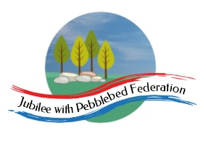

Class 2, Farway C of E Primary School

Dear Parents and Members of Class 2,

Believe it or not, it is Midsummer’s Day on Wednesday, so have a look at some of the suggestions we’ve made to celebrate at home: perhaps you could hold a mini-glastonbury at home! We are also using ideas from the University of Cambridge’s Festival of Well-being in this plan (https://www.wellbeing.admin.cam.ac.uk/activities-wellbeing) and also Virtual Maths Week London (https://www.mathsweeklondon.org/resources-ks2/).

This week looks slightly different to the usual home learning we have been doing. Instead of exploring a country across the week, we’d like to set you a project. You are going to choose a country then find activities and links to it that someone else could follow to learn about your country. We’ve provided a schedule of possible activities but please select from these ideas: there is no expectation that all will be completed.

If you have difficulty accessing the internet to research, we have also included activities that can be done offline related to creating your own imaginary country; thinking about the culture and physical attributes, making up a flag, a national dress, monuments, landmarks... Do give us a call if you’d like these printed off into a pack that you can then pick up from school.

Staying safe online is an ongoing topic when we are in school. The London Grid for Learning has produced daily sheets that children can discuss and complete, reminding them how to stay safe online and what to do if we feel unsafe. The sheets can be found in this google doc - https://drive.google.com/drive/folders/1QNW6BVhopXbwIo9mQIs6M-A49g5zAxFT

Happy learning! I look forward to seeing you all again soon,

Mrs Marsh

The most important thing you can do to support your child’s learning whilst schools are closed is to ensure that they read every day and they continue to practise their number bonds and times tables.

Don’t forget to keep using the accounts you have through our school to practise basic skills, such as reading, reading comprehension (Bug Club), Times tables (Times Table Rock Stars) and Spelling (Spelling Shed). I have set work on TTRS each week and I shall be checking these sites regularly to keep an eye on what you’re doing. Feel free to challenge me (Irox Peel) to a Rockslam competition!

Week beginning Monday 22nd June

Monday  22nd June | Core activities |  | Suggestions for additional or alternative activities.
9.00 – 9.30 | Daily Dashboard:  Quelle est la date aujourd’hui?  C’est lundi vingt-deux juin 2020.  Can you write the number date in Roman numerals?  The University of Cambridge is running The Festival of Well-being this week – find out more here:  https://www.wellfest.admin.cam.ac.uk/about  Discovery Day is celebrated in the province of Newfoundland and Labrador on the nearest Monday to June 24. It is also known as Cabot 500 Day and remembers Giovanni Caboto’s (also known as John Cabot) discovery of the province’s island portion.  Watch this video that explains the history of Canada in 10 minutes: lots of British involvement!  https://www.youtube.com/watch?v=zz440EuFK8Q  You could start to collect ideas for daily dashboard in your project today – choose one event/occasion per day, tell us about it or provide a link, then suggest a fun follow up activity. You’ll have time on Friday afternoon to do this 😉 |  | Have you ever fancied carving soap? The Festival of Well-being is running a zoom class between 3pm and 4pm this afternoon – sign up here now!  https://www.wellfest.admin.cam.ac.uk/creative-activities  If you can’t make it they will be putting the videos online afterwards here, with pre-recorded talks and events also available: https://www.wellfest.admin.cam.ac.uk/recorded-events  Virtual Maths Week London starts today – they have converted their usual program in light of recent events and said  ‘This year, we’ll be bringing you a week of activities and events that can be accessed online, in your garden or on your daily walk. Whether children are in school or at home, we want to encourage everyone to be maths heroes & celebrate maths!’  Sign up for free here:  https://www.mathsweeklondon.org/
9.30-10.00 | Grammar – see additional Grammar resources |  | Use your spelling shed login to practise by playing spelling games.
10.00- 10.30 | Time for some PE –  This week is National School Sports Week. The Youth Sport Trust have compiled some fantastic resources to ensure children and families can continue to engage with a wealth of activities at home. The PDF resource (via the link below) has videos for the activities (just click on the red named activity and it will take you to the video link showing activities at home).  https://www.youthsporttrust.org/national-school-sport-week-home  Alternatively, why not check out the new Andy Murray 100 Volley Challenge as part of the #Devon Virtual Games competition at www.activedevon.org It starts today and closes on the 12th July.  The ‘Pentathalon’ challenge is only running for one more week – remember to log your details by Sunday.
10.30-11.30 | Maths – follow the links to find online lessons for each year group:  Year 3: https://classroom.thenational.academy/lessons/ordering-mass  Year 4: https://classroom.thenational.academy/lessons/measures-weight-two-point-seven  Year 5: https://classroom.thenational.academy/lessons/volume-to-read-scales-when-measuring-volume  Year 6: https://classroom.thenational.academy/lessons/problems-with-units-of-area |  |  | Parents! Check out Maths on Toast, the family maths charity who focus on developing a growth mindset in maths. They explain maths thinking using the analogy of toast here:  https://www.mathsontoast.org.uk/fun-maths-at-home/the-toast-model/  The questions to ask children in the ‘toast zone’ are exactly what they would be asked in school!
11.30-11.45 | Have a break and play a game or do another activity that you enjoy. | Keep active in mind and body – why not make an origami penguin by following instructions from  https://www.spri.cam.ac.uk/museum/resources/penguinorigami.pdf linked to the Festival of Well-Being.
11.45-12.00 | Collective Worship You will find an Act of Worship designed for use at home by families at https://www.churchofengland.org/faith-action/faith-home/faith-home-videos . This month there are a range of themes to choose from, including kindness, resilience, and patience.
12.00- 1.00pm | Lunch break. Eat a healthy lunch and, if you are able, try to get outside for some fresh air!
1.00-1.30pm | Reading - Search using ‘name of your country’ and ‘kids’ to find a website with easy to read information about your chosen country. Write down its address for your reader. After reading the webpage, write 5 questions for your reader to answer. This will start to build your reader’s knowledge about your country. |  | Keep reading online and completing Bug Club Comprehension questions  Or  Read a chapter or two of your latest reading book.
1.30pm – 2.00pm | Mental Health  Our focus this week is ‘Feelings and Emotions’, linked to our 10-a-day focus on talking about your feelings. Who could you talk to about how you have been feeling? Why not create a feelings ‘barometer’ so that you can communicate your feelings to your family without even needing to speak. You can download an emotions fan at https://www.elsa-support.co.uk/emotion-fans-with-synonyms/ or use the wheel below. |  | Write a list: what makes you feel happy…sad…angry…frustrated…bored…excited? When you feel sad, angry, worried or upset, what helps to calm you down? Write a list of strategies for keeping calm so that you can refer to it when you are next upset. Or make a collection of images that will help you to focus your thoughts on things that will help you feel calmer or happier.
1.30pm – 3.00pm | Project – Geography Link –  We usually start by looking at things like flags, National Anthem, famous landmarks and population. These are called human geography.  Where will you send your reader to find out this information? How will you ask them to record the information they find?  We used https://www.3dgeography.co.uk a few times but there are other geography websites available.  You could suggest reading and interpreting climate graphs to compare the climate in your country capital with that in London. You could also suggest revising 4-figure grid references or compare your country’s homes with British homes.  You could suggest a visit to your country’s capital city, using google maps: street view allows you to ‘walk the streets’ using archived photos. Even better if you planned a walk that visited specific landmarks – a chance for you to practise giving directions and writing instructions. |  | For an ongoing list of learning activities when internet is not available, check out the list below and keep a copy on the fridge!  Alternative task: If you don’t have access to the Internet or books to be able to research a country, why not invent your own country?  So, today, give your country a name, design a flag for the country and draw a map, showing physical features such as rivers, mountains and coasts, as well as some of the main towns and cities.

Home Learning without a Screen

Here are 25 fun and meaningful ideas to choose from:
- How many different words can you make from the letters in this sentence, below? Grab a pencil and paper and write a list!
‘Learning from home is fun’
- Thank a community hero. Think of someone that helps you in some way and write a short letter to thank them.
- Get building! You could build a Lego model, a tower of playing cards or something else!
- Can you create your own secret code? You could use letters, numbers, pictures or something else! Can you get someone else to try and crack it?
- Start a nature diary. Look out of the window each day and keep note
of what you see. Birds, flowers, changes in the weather, what else?
- Hold a photo session. Use a camera or a mobile phone to take some snaps. What will you photograph? Your pets or toys perhaps?
- Build a reading den. Find somewhere cosy, snuggle up and read your favourite book!
- Use an old sock to create a puppet. Can you put on a puppet show for someone?
- Make a list of all the electrical items in each room of your home. Can you come up with any ideas to use less electricity?
- Design and make a homemade board game and play it with your family.
- Do something kind for someone. Can you pay them a compliment, make them something or help them with a task?
- Can you create a story bag? Find a bag and collect items to go in it that relate to a well known story. If you can’t find an item, you could draw a picture to include.
- List making! Write a list of things that make you happy, things you’re grateful for or things you are good at.
- Design and make an obstacle course at home or in the garden. How fast can you complete it?
- Can you invent something new? Perhaps a gadget or something to help people? Draw a picture or write a description.
- Keep moving! Make up a dance routine to your favourite song.
- Write a play script. Can you act it out to other people?
- Read out loud to someone. Remember to read with expression.
- Write a song or rap about your favourite subject.
- Get sketching! Find a photograph or picture of a person, place or object and sketch it.
- Junk modelling! Collect and recycle materials such as yoghurt pots, toilet rolls and boxes and see what you can create with them.
- Draw a map of your local area and highlight interesting landmarks.
- Write a postcard to your teacher. Can you tell them what you like most about their class?
- Draw a view. Look out of your window and draw what you see.
- Get reading! What would you most like to learn about? Can you find out more about it in books? Perhaps you can find a new hobby?

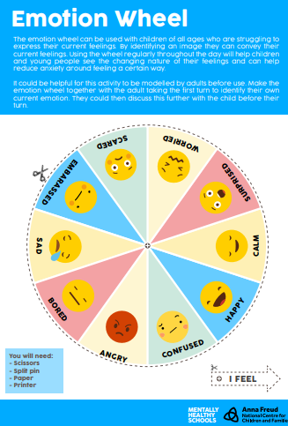

Tuesday 23rd June | Core activities |  |  |  |  | Suggestions for additional activities.
9.00 – 9.30 | Daily Dashboard:  Quelle est la date aujourd’hui?  C’est mardi vingt-trois juin 2020.  Can you write the number date in Roman numerals?  The United Nations have declared 23rd June to be Public Service Day. This is when we can celebrate people who work in public service such as nurses, firefighters, police officers, sanitation workers and administrators.  Why not create a poster or write a thank you card to recognise everything they’ve done during Lockdown to keep our country moving forward.  https://www.un.org/en/observances/public-service-day |  |  |  |  |  | What is happening in the world? Have a look at https://www.bbc.co.uk/newsround or https://www.dogonews.com/ to see what is going on in the world. Choose a news article or two to read.
9.30-10.00 | Grammar – see additional Grammar resources |  | Use your spelling shed login to practise by playing spelling games.
10.00- 10.30 | Time for some Physical activity.  Have a go at Mr Williams’ plank challenge again. Be warned – the timing of this can be quite tricky! https://youtu.be/bA4fFzhbHJw  If that’s not enough, try the 60-second ball challenge: https://www.youthsporttrust.org/sites/default/files/Figure%20of%208%20Challenge.pdf  If you did them back at the beginning of June, how does that compare to this time? Was it easier? Quicker? What if you did it every day for a week?
10.30-11.30 | Maths – follow the links to find online lessons for each year group:  Year 3: https://classroom.thenational.academy/lessons/add-and-subtract-mass  Year 4: https://classroom.thenational.academy/lessons/measures-money-buying-fruit  Year 5: https://classroom.thenational.academy/lessons/volume-to-investigate-and-explain-cubed-numbers  Year 6: https://classroom.thenational.academy/lessons/volume-of-cubes-and-cuboids |  |  |  | How about a warm-up using Times Table Rock Stars or else play a Maths game to help practise core number facts?  Why not visit https://nrich.maths.org/9803 and have a go at one of the Maths investigations there. Be warned – these will really make you think!
11.30-12.00 | Have a break and play a game or do another activity that you enjoy. | Ask for help – Is there something you have been finding confusing or difficult in your learning – or in life? Who could you talk to today to ask for help?
12.00- 1.00pm | Lunch break. Eat a healthy lunch and, if you are able, try to get outside for some fresh air!
1.00pm – 1.30pm | Reading - COMPLETE THE OPPOSITE OF WHAT YOU DID YESTERDAY  Search using ‘name of your country’ and ‘kids’ to find a website with easy to read information about your chosen country. Write down its address for your reader. After reading the webpage, write 5 questions for your reader to answer. This will start to build your reader’s knowledge about your country. |  |  |  |  | Keep reading online and completing Bug Club Comprehension questions  Or  Read a chapter or two of your latest reading book.
1.30pm-2.00pm | Mental Health  Today we are thinking about managing our emotions through mindful ness. Complete a mindfulness. Mindfulness means paying full attention to something. It means slowing down to really notice what you're doing. Being mindful is the opposite of rushing or multitasking. When you're mindful, you're taking your time. You're focusing in a relaxed, easy way. Why not try a meditation from Go Noodle.  https://www.youtube.com/watch?v=bRkILioT_NA
2.00pm – 3.00pm | Project/Literacy –  Find a video about life in your country and note down the link. Remember to include the phrase ‘for children’ in your search so that you ensure the videos you are watching are appropriate for the audience. What writing task could you set your reader after they’ve watched the video? You could ask your reader to write a diary entry or a letter in role as a traveller. Or perhaps a poem composed of rich, descriptive vocabulary to evoke the atmosphere.  Extending the learning about life in your country:  You could direct your reader to a specific website that includes the information you want to share.  Next set them a writing task, such as note-taking followed by an explanation paragraph.  Alternatively you could ask them to write a longer non-fiction piece about life in your country. |  |  | Alternative task:  If you are inventing your own country instead of researching a real one, why not have a go at making a 3D map of the country. You could use building blocks such as Lego or papier mache (paper with flour and water paste) on a wooden board.  Can you invent, design and build some of the country’s famous landmarks or buildings? You could use recycled materials to make models of these or draw sketches of them. Then write a paragraph of description about their history that might appear in a tourist guide book.

Wednesday 24th June | Core activities |  |  |  |  | Suggestions for additional activities.
9.00 – 9.30 | Daily Dashboard:  Quelle est la date aujourd’hui?  C’est mercredi vingt-quatre juin, 2020.  Can you write the number date in Roman numerals?  What is happening in the world? Have a look at https://www.bbc.co.uk/newsround or https://www.dogonews.com/ to see what is going on in the world. Choose a news article or two to read. | Today is Midsummer’s day! Find out more about the traditions of this date here:  https://www.wincalendar.com/uk/Midsummer-Day  Today would have been the first day of Glastonbury Festival in Somerset. Watch this clip from last year here:  https://www.youtube.com/watch?v=3mLPxaCTvzc&list=PLV5BFkI9SS7iKM8v84HwHc1ZSnJTxfnLx&index=2 This year’s line-up would have included Taylor Swift and Lana Del Rey and was rumoured to include the Spice Girls and My Chemical Romance too. Find the full list that was being updated until Covid19 shut everything down: https://thefestivals.uk/glastonbury-2020-lineup/  Why not search some of these names on Youtube and see how many songs you recognise?
9.30-10.00 | Grammar – see grammar resources
10.00- 10.30 | Time for some physical exercise –  Visit this page from Festival of Well-being for links to a pilates or yoga session. These are not only good for your body health but also your mental health!  https://www.wellfest.admin.cam.ac.uk/keeping-active
10.30-11.30 | Maths – follow the links to find online lessons for each year group:  Year 3: https://classroom.thenational.academy/lessons/solve-problems-involving-mass  Year 4: https://classroom.thenational.academy/lessons/measures-money-souvenirs  Year 5: https://classroom.thenational.academy/lessons/volume-to-estimate-the-volume-of-objects  Year 6: https://classroom.thenational.academy/lessons/convert-between-standard-units-of-mass |  |  |  | How about a warm-up using Times Table Rock Stars? A little each day can really help to improve your scores!  Check out these warm up activities from Maths on Toast - https://www.mathsontoast.org.uk/fun-maths-at-home/maths-resources/
11.30-12.00 | Have a break and play a game or do another activity that you enjoy. |  | Eat well –Check out the nutrients contained in your favourite snacks. Are they providing your body with useful nutrients, or do they contain excessive amounts of sugar, fat or salt? If so, why not research some healthy alternatives?
12.00- 1.00pm | Lunch break. Eat a healthy lunch and, if you are able, try to get outside for some fresh air!
1.00pm – 1.30pm | Reading – direct your reader to a website about a famous person from your country – this could be a musician, an artist, an actor or a politician.  After reading the webpage yourself, write some comprehension questions for your reader. Some could be direct retrevial questions (where were they born?) but  Can you ask questions that require your reader to use each of the following reading skills?  - Direct retrevial questions (eg. where were they born?)  - Questions to clarify the precise meaning of words (eg. What does the author’s choice of the word….. tell you about their feelings or opinions about this person? What does the word/ phrase…. mean?)  - Questions that require the reader to infer or ‘read between the lines.’ (eg. Why do you think the subject of this biography decided to…?)  - Questions to invite the reader’s opinion about what they have read (eg. What is your opinion of this person? Why? Do you think they made the right decision when they…?) |  |  |  |  | Keep reading online and completing Bug Club Comprehension questions  Or  Read a chapter or two of your latest reading book.
1.30pm-2.00pm | Mental Health  Today, we are thinking about positivity and gratitude. Why not create a gratitude treasure chest? Each day you could add to it things you find to be grateful for (eg. my mum gave me a hug, my friend called me up, I really enjoyed my lunch). You could start by completing the ‘Gratitude Heart’ activity below.
2.00pm -3.00pm | Project – Art  Perhaps there is a style of art that relates to your country that you could introduce to your reader. For example, rolling green fields often relate to England whereas red and yellow sunsets with silhouttes of giraffes relate to Kenya.  Alternatively, you could find a famous artist from your country through google. Find and share links to some of their artwork then challenge your reader to recreate the artwork. |  |  | Alternative task:  Think about the people in the country you have invented. What language do they speak? (You could even invent a few words of the language!) What sort of clothes do they wear? (You will need to think carefully about the climate here). Draw a picture of the country’s National costumes. What is the population of the country? Where do most people live – in towns and cities or in the countryside? What are the main industries or sources of income for the country? What do people like to do in their spare time?  Write a report about these things. Remember to use subheadings for the different sections and illustrate your report with pictures where you can.  You could invent an imaginary artist from your country and produce one or two pieces of art. How will you make these distinctive so that your imaginary artist has a recognisable style?

Here is an example of a ‘Gratitude Heart’. There is a template below for you to create your own.
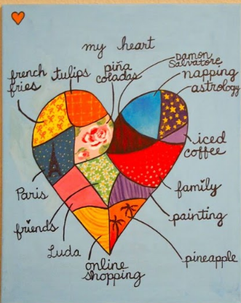

Thursday 25th June | Core activities | Suggestions for additional or alternative activities.
9.00 – 9.30 | Daily Dashboard:  Quelle est la date aujourd’hui?  C’est jeudi vingt-cinq juin 2020.  Can you write the number date in Roman numerals?  What is happening in the world? Have a look at https://www.bbc.co.uk/newsround or https://www.dogonews.com/ to see what is going on in the world. Choose a news article or two to read. | Today is Day of the Seafarer, which commemorates and recognizes the importance of transportation of objects by sea. The International Maritime Organization states that ships transport around 90% of all goods in the world. This observance was first celebrated by the International Maritime Organization in 2010.  Learn more about this year’s focus, to recognise seafarers as key workers entitled to support in 2020, here:  http://www.imo.org/en/About/Events/dayoftheseafarer/Pages/Day-of-the-Seafarer-2020.aspx  You could draw a picture, create a poster of write a letter of support, then send it to a Devon port such as Teignmouth.  #SeafarersAreKeyWorkers
9.30-10.00 | Grammar – see Grammar resources
10.00- 10.30 | Time for some physical activity.  As part of National Sports Week, choose another of the suggestions found here.  https://www.youthsporttrust.org/system/files/resources/documents/YST_NSSW_Activities.pdf
10.30-11.30 | Maths – follow the links to find online lessons for each year group:  Year 3: https://classroom.thenational.academy/lessons/read-a-scale  Year4:  https://classroom.thenational.academy/lessons/measures-length-flag-pole  Year 5: https://classroom.thenational.academy/lessons/volume-to-describe-volume-in-cubic-units  Year 6: https://classroom.thenational.academy/lessons/solve-problems-involving-calculation-of-measure |  |  |  |  | Alternatively, you could investigate maths in real life though this lesson created between the London Grid for Learning and HM Coastguard, offered as free access at the moment.  Clips are found here:  https://lgfl.planetestream.com/View.aspx?id=156~3z~hVBtNa  Topics covered are found here:  http://sar.lgfl.org.uk/
11.30-12.00 | Have a break and play a game or do another activity that you enjoy. |  | Care for others – what little job around the house could you do today to show care for someone in your family?
12.00- 1.00pm | Lunch break. Eat a healthy lunch and, if you are able, try to get outside for some fresh air!
1.00pm – 1.30pm | Keep reading online and completing Bug Club Comprehension questions  Or  Read a chapter or two of your latest reading book.
1.30pm-2.00pm | Mental Health  Today we are thinking about worry and anxiety. Have a look at the story, ‘The Huge Bag of Worries’: https://www.youtube.com/watch?v=qBcakxX9LTM  This may be familiar to you. What do you tend to worry about? Why not create a worry doll (see below) to tell your worries to. |  |  | Or, use the ‘Worry Monster’ template at https://www.elsa-support.co.uk/worry-monster-craftivity/ to have a think about anything that is worrying you at the moment. Who could you talk to to share these worries? Remember, often, sharing our worries makes them go away!
1.30pm – 3.00pm | Project – science task  This part of the project is where you link some science in related to your country. The easiest way is through looking at the animals and their habitat but for some alternatives remind yourself of KS2 topics at BBC Bitesize.  Just scroll past the game to find guides to all the science topics from UK’s National Curriculum: The Living World, The Human Body, Materials, Forces and Motion, Light and Sound, Electricity and Earth and Space  https://www.bbc.co.uk/bitesize/subjects/z2pfb9q  You could start by:  - selecting a video from Bitesize to teach your reader about the topic;  - link a website that gives additional information;  - then suggest activities or even make a worksheet for them to complete.  - Activities could be writing-based, art-based or design technology-based – it’s up to you! |  |  |  | Alternative task:  Consider the plants and animals that might be found in your imaginary country – these could be real or imaginary, or a mixture of both. Again, you will need to consider the different habitats where the animals live and how they are adapted to live in the climate of your country. You could draw pictures and annotate them so show the features of the animals and how they are adapted to their habitat. Alternatively, you could invent some food chains or make a food web for each of the different habitats to be found in the country.

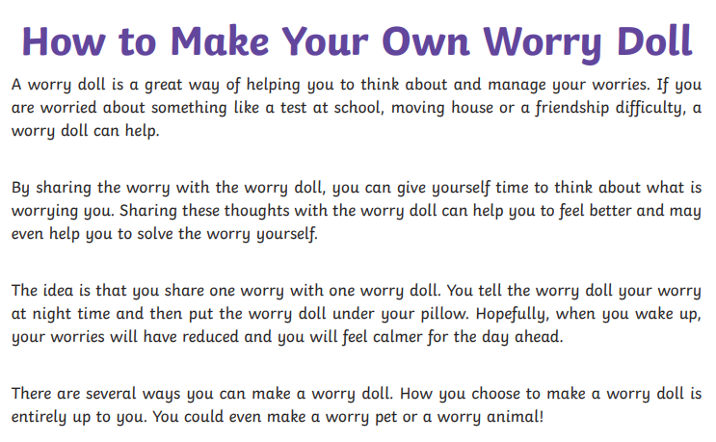
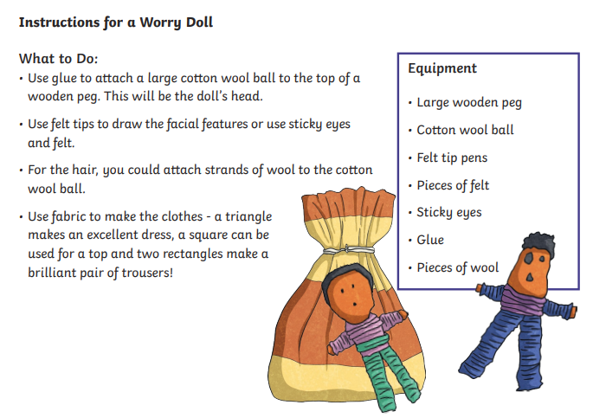

Friday 26th June | Core activities |  | Suggestions for additional activities.
9.00 – 9.30 | Daily Dashboard:  Quelle est la date aujourd’hui?  C’est vendredi vingt-six juin 2020.  Can you write the number date in Roman numerals?  What is happening in the world? Have a look at https://www.bbc.co.uk/newsround or https://www.dogonews.com/ to see what is going on in the world. Choose a news article or two to read. |  | It’s ‘Take Your Dog to Work Day’ in the USA today!  Can you think of three jobs you could take your dog to work every day? Are there any jobs you couldn’t take your dog with you ever? I’m thinking a heart surgeon couldn’t!  Does this affect your future career plans?  Which other pets would appreciate a day at work with their owner?
9.30-10.00 | Grammar – see separate Grammar resources
10.00- 10.30 | Time for some physical activity.  Follow this link to find a game of ‘Find the Rainbow’ : https://www.getset4pe.co.uk/resourcebank/viewresourcefile?id=11651  Or have a go at the ‘This is PE’ throwing techniques lesson: https://www.youtube.com/watch?v=tQO0kwC-mmI&list=PLYGRaluWWTojV3An2WEgsQ4qGFy_91jDL&index=21
10.30-11.30 | Maths – follow the links to find online lessons for each year group:  Year 3: https://classroom.thenational.academy/lessons/read-capacity-and-volume  Year 4: https://classroom.thenational.academy/lessons/measures-mixed-measure-problems-fe977c  Year 5: https://classroom.thenational.academy/lessons/volume-to-convert-units-of-volume  Year 6: https://classroom.thenational.academy/lessons/convert-between-units-of-time |  |  |  | Why not try a BBC Supermovers Maths video to help warm up your Maths brain while getting in a bit of movement?  https://www.bbc.co.uk/teach/supermovers/ks2-maths-collection/z7frpg8
11.30-11.45 | Have a break and play a game or do another activity that you enjoy. | Be proud of your very being! What have you done well this week? Why not award yourself another certificate!
11.45 – 12.00 | Collective Worship  You will find an Act of Worship designed for use at home by families at https://www.churchofengland.org/faith-action/faith-home/faith-home-videos. This month there are a range of themes to choose from, including kindness, resilience and patience.
12.00- 1.00pm | Lunch break. Eat a healthy lunch and, if you are able, try to get outside for some fresh air!
1.00pm – 1.30pm | Choose a book you know well – can you retell it to someone in your family? |  |  | You could read another chapter of your current book.
1.30pm-2.00pm | Mental Health  Watch the video of the book ‘Lucy’s Blue Day’. Discuss the emotions in the story and think about things that make us feel ‘blue’. What can help us ‘let go’ of our blue feelings? Feeling blue is natural but there are things we can do to get ourselves out of our blue mood if we choose. Think about the things that  make our hair turn red/green/yellow?  https://www.youtube.com/watch?v=UmrUV8v-KQg |  | Complete the ‘Making Negative Thoughts into Positive Thoughts activity below.
2.00pm – 3.00pm | Project  Use this afternoon to complete your project, using this checklist:  - Do you have 4 activities? One for each afternoon, with Friday as a finishing day?  - Check your web addresses/links are correct.  You could suggest alternatives to your tasks, |  | Alternative task:  What else could you invent about your country. You might wish to consider how the country is governed (Is there a monarch and a prime minister? Is there a president?) and invent some interesting stories from the history of your country. Alternatively, you could think about the traditional religion and beliefs of your invented country. You could even write a national anthem for your country!

