Maths Home Learning – week beginning 1st June

This week we are going to continue recapping some of our previous learning on weight and mass.
Monday – WALT: remind ourselves on the key vocabulary and concepts when exploring weight and mass.

First, take some time exploring the key vocabulary below. Discuss the meanings with your family.
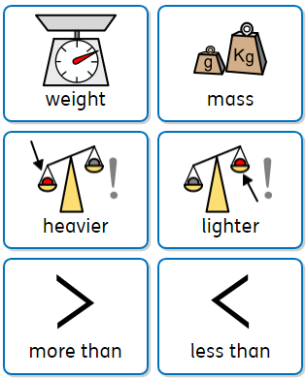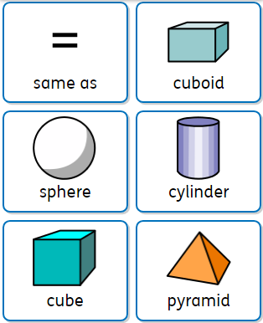

Next, look around your surroundings:
- Can you find something that is heavier than your favourite cuddly toy? How do you know it is heavier?
- Can you find something that is lighter than your favourite cuddly toy? How do you know that it is lighter?

- I wonder, are heavy objects always bigger than smaller objects? Explore this thinking further. I would love to see photos of your learning!

Finally, have a go at answering the questions below.
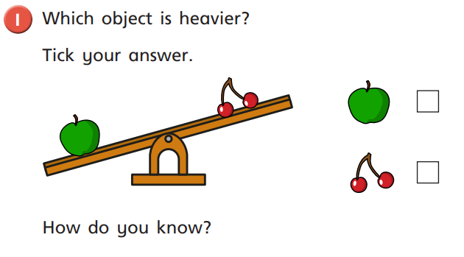

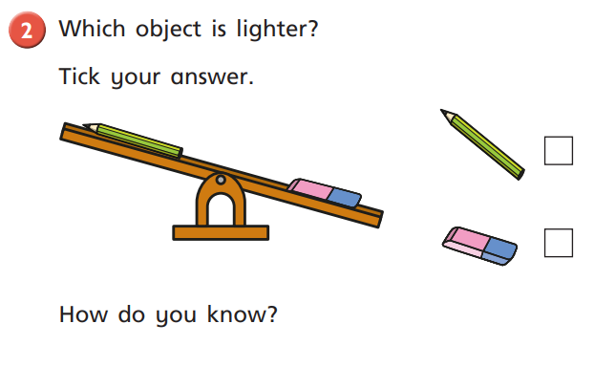
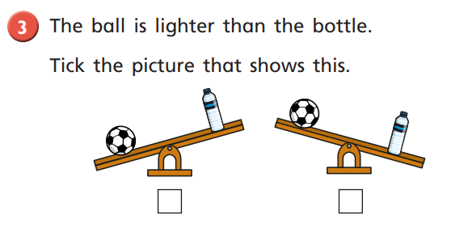

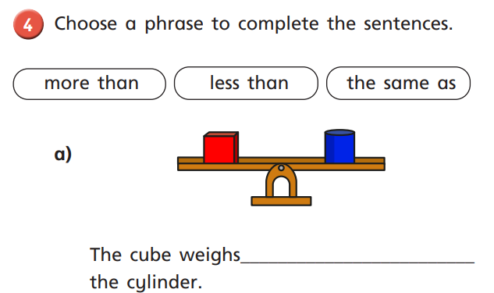
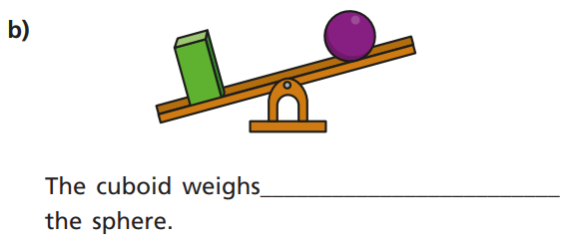

Tuesday – WALT: measure mass
If you have a set of scales and some cubes (or Lego bricks) at home, this would be a fantastic activity to play around with and explore measuring the mass of a variety of objects, within and around your home.
I wonder, how many cubes does your favourite toy weigh?
- Can you compare how many more or less cubes your favourite toy weighs compared to an apple?
- What other objects could you measure?

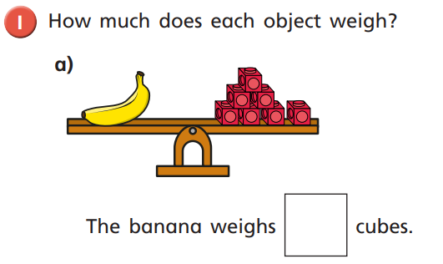
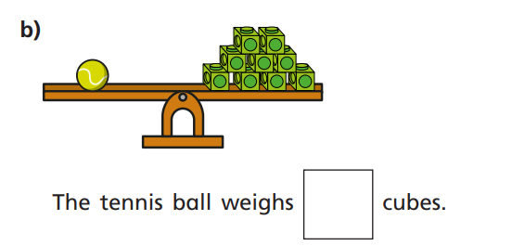
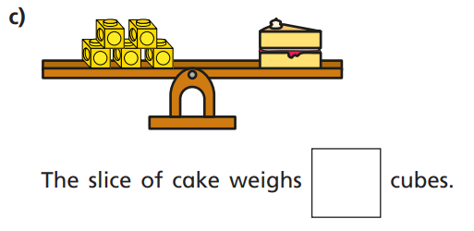
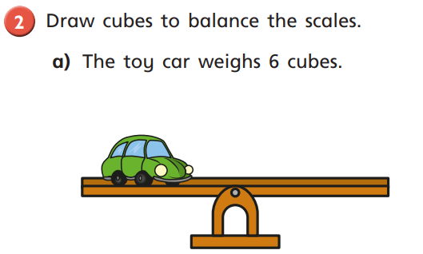

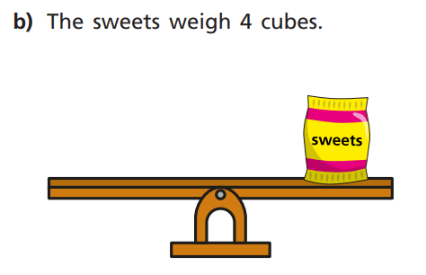

c) How many more cubes does the toy car weigh compared to
the bag of sweets?

Wednesday – WALT: compare mass

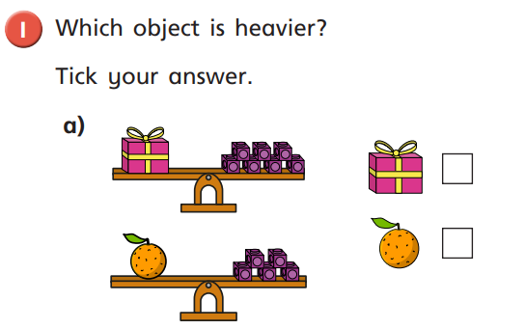

The _______ is _____ cubes heavier than the _________.

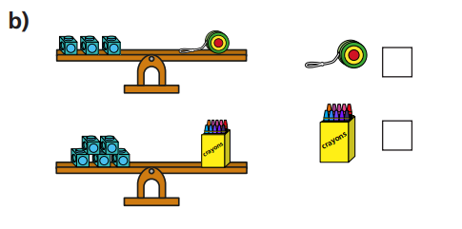

The _______ is _____ cubes heavier than the _________.
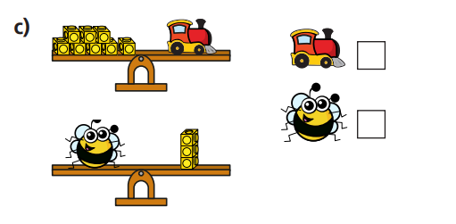
The _______ is _____ cubes heavier than the _________.

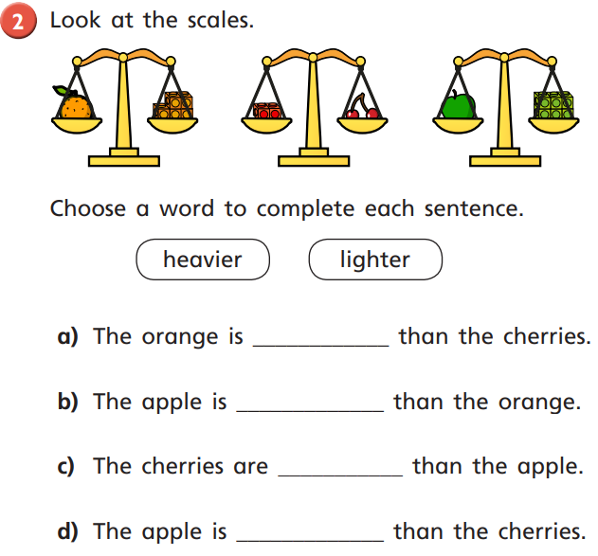
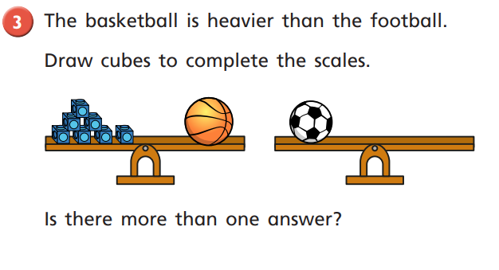
Thursday – WALT: explore capacity and volume
First, take some time exploring the key vocabulary below. Discuss the meanings with your family.
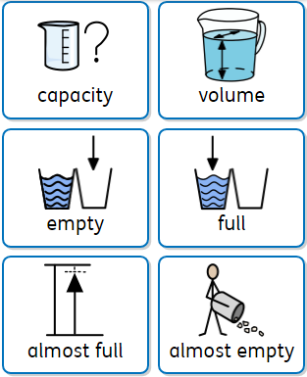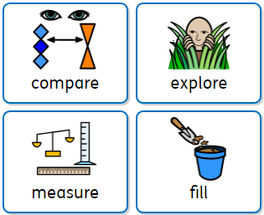
Next, fill up a paddling pool, sink or tub with water and have fun exploring these concepts, using the key vocabulary. I would love to see photos!
- Can you show half full?
- Can you show almost full?
- Can you show almost empty?
- Can you show full?
- Discuss how you know.

Finally, have a go at answering the questions below.
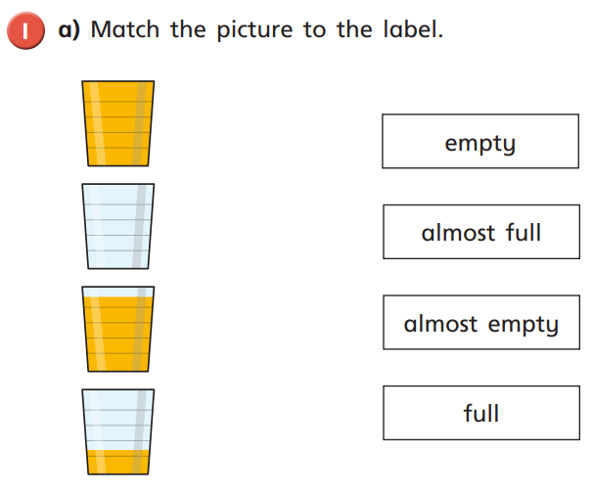

b) Colour in the empty glasses below, to match their label.
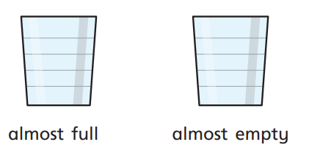
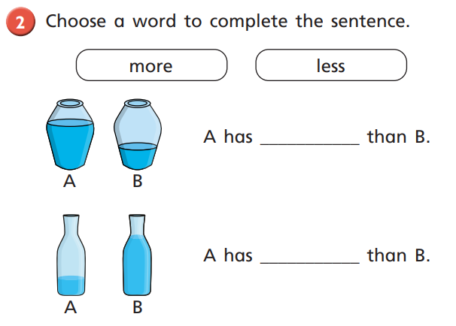

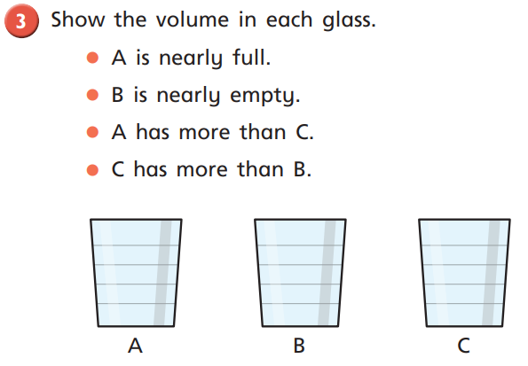
Challenge your parents to answer this question also and compare your answers.

Friday – WALT: measure capacity
In school, the children would have been measuring capacity using real cups, jugs and containers of various volumes. If you are able to provide this experience at home, that would be fantastic to enhance their learning. If not, then don’t worry, there are videos for the children to watch on: https://whiterosemaths.com/homelearning/year-1/ - week 1.

