Maths Home Learning for Summer Term 1 - Week 2

WALT: find a half and a quarter of a shape and of different amounts.

Monday – WALT: find half of a shape
Today: Children explore finding a half for the first time using shapes and sets of objects. They will use the vocabulary ‘half’ and ‘whole’.
It is important that they know that a half means ‘one of two equal parts’ and are able to count them.

In school children would explore showing and finding half of a real-life object. Demonstrating that a half is one of two equal parts.
Can you cut an apple, a cake or a banana into half? Have a look closely… are there two parts? Are both parts equal?

Remember: equal means the same amount/size.
Thinking in terms of fairness. How can we cut these objects in half, to share between two friends? Is each part equal?
- Draw a line down each object to show a half.
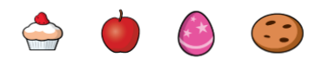

Challenge: Can any of the objects be cut in half in more than one way?

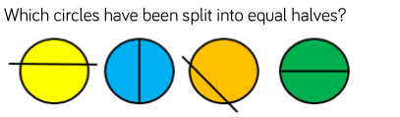
Explain your thinking.

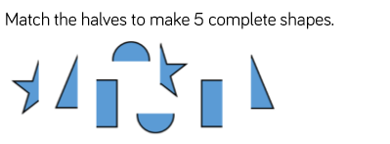

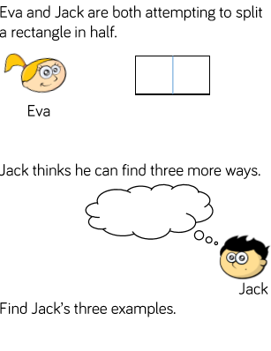
You can use a rectangle piece of paper to explore Jack’s ways?
Remember: half is one of two parts and each part is equal.
5.
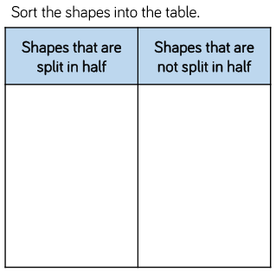
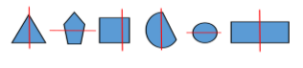
Can you draw and sort any more shapes?

Tuesday - WALT: find half of an amount using real resources
Children can use concrete resources at home to practise finding a half of an amount. For example: Lego, apples, elephants, toy cars.
- Using your chosen resources, can you find half of 8 (elephants, Lego bricks, toy cars)?
Remember: half is one of two equal parts

So, I know 8 elephants, shared into two equal parts is 4.

Therefore, half of 8 elephants is 4 elephants.

Using your own resources can you try writing your own stem sentences to show half of these amounts:
- 8
- 10
- 12
- 20

For example: Half of 8 ________ is 4 ________.

Wednesday – WALT: find half of an amount (pictorial)
1.
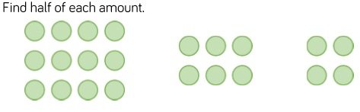
Can you write the answers using the stem sentneces from yesterday?
I know half of _______ counters is ___________ counters.

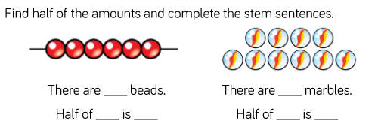

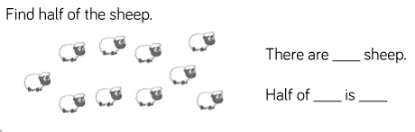

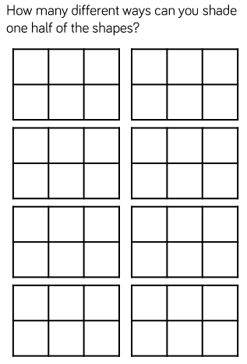

Challenge:
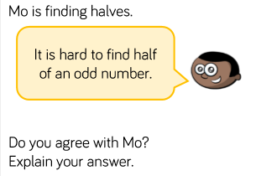
Remember: when we tried to halve 7 pancakes. How did we find half of this amount?
Thursday – WALT: find a quarter of a shape
- Exploration task
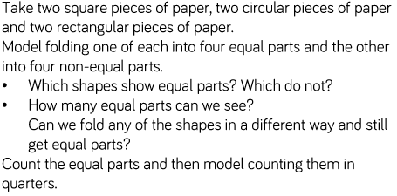
Children need to know that a quarter is one of four equal parts.

- Colour a quarter of each shape. Can you colour it in different ways?
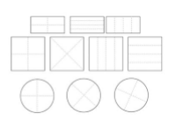

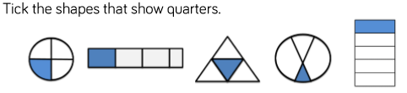
Explain your thinking. Can you use the vocabulary: four, equal, parts and one in your answer.
_______________________________________________
_______________________________________________

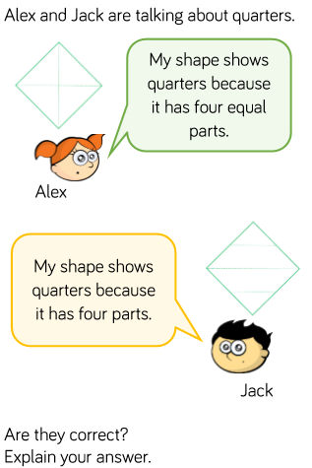

Challenge:
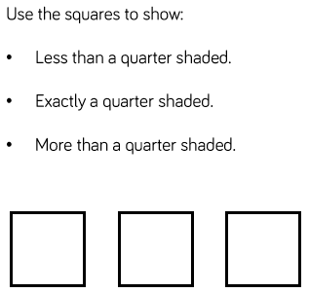

Friday – WALT: find a quarter of an amount
On Tuesday you practised finding a half of an amount, using your chosen resources. Today, have a go at finding a quarter of 8, using the same resources.
Remember: a quarter is one of four equal parts.
So, a quarter of 8 elephants is 2 elephants.

Can you use your resources to find:
- A quarter of 4
- A quarter of 10
- 1 is one quarter of ______
- 3 is one quarter of _______

Challenge: 3 quarters of 12 is ________

