Maths Home Learning – week beginning 8th June

Monday - WALT: creating our own number lines and ordering numbers
Fill in the missing numbers on these number lines. Make sure your numbers are in the correct order and facing the right way, please.
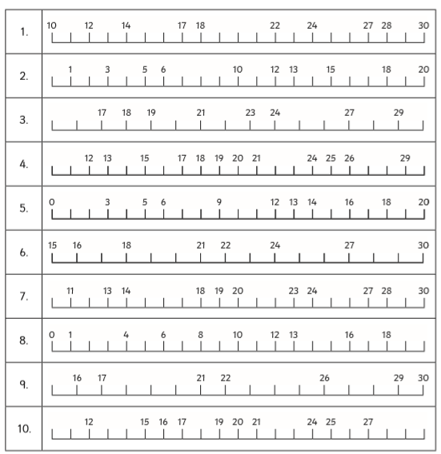
Now, have a go at filling in the missing numbers on these number lines.
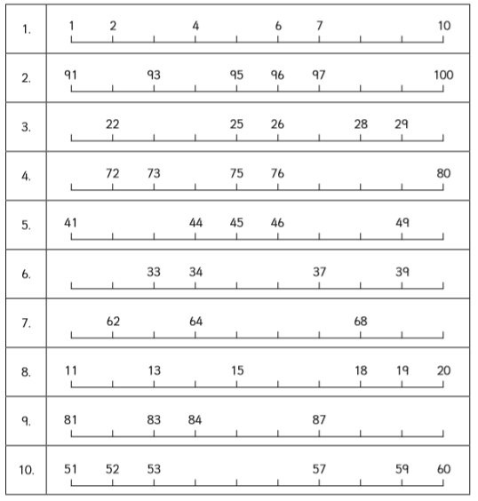
Finally, have a go at designing and creating your own number line to help you with your learning this week.
Here are some examples to inspire you:
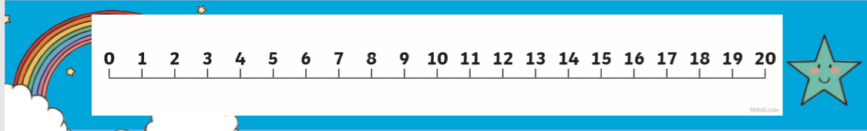

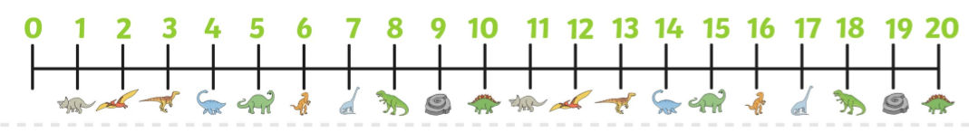
You can be as creative as you like, but remember the numbers need to be in the correct order.
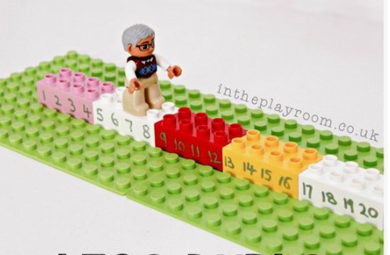

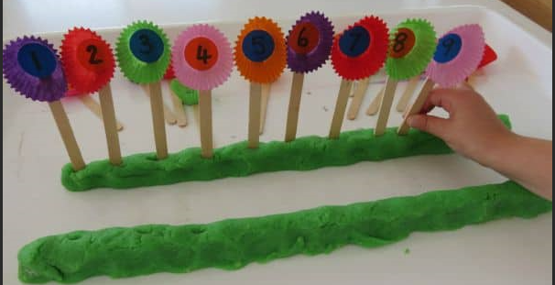
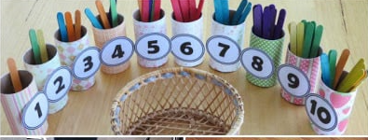

Tuesday – WALT: recap counting on using a number line
Today we are going to recap how we use a number line, by adding two numbers together.
Rules when using a number line:
1. Always start on the given number. For example: 9 (in the first question).
2. Count on or back the number of spaces corresponding to the number you are adding or subtracting from your given number. For example: 6 (in the first question)
3. You count on for adding
4. You count backwards for subtracting
Now, have a go at using your own number line or the one below, to answer the first question.
1.
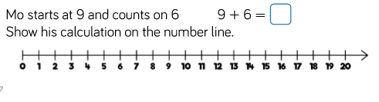
2. Daisy is practising using her number line. She wants to know what number she will land on when she starts on 15 and jumps on 4 spaces.
Can you help her?

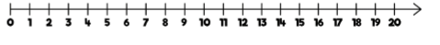
Now, write the number sentence for Daisy's sum.
Remember: when jumping on, you are adding two numbers together.

3. Now, practise using your number line to find out these answers:
a) 7 + 8 = b) 6 + 5 = c) 9 + 7 =
d) 19 + 5 = e) 17 + 8 = f) 13 + 9 =

4. Reasoning:
Jessica starts at 9 and adds on 5.
Oliver starts at 5 and adds on 9.
Show your calculations on the number lines. What do you notice?
Does this always happen? Which method do you like best? Why?

5.
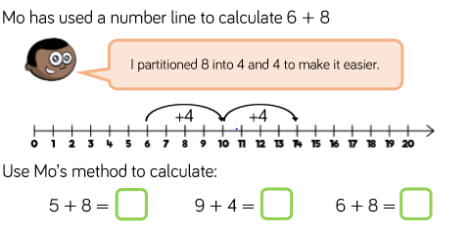

6.
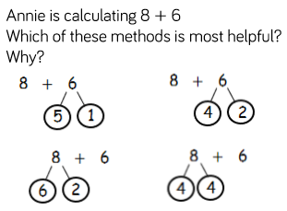
Show these calculations on a number line. Try drawing your own number lines in your workbooks but remember to use a ruler.

Wednesday - WALT: practising using a number line to subtract two numbers (not crossing ten)
Number lines are also fantastic to support our counting backwards and subtracting two amounts together. Today we are going to practise this method using simple number combinations, just to consolidate understanding of he method and to gain confidence.
What do you notice happening to the numbers when we are subtracting?

1. There were 9 sheep grazing in the field. 3 ran away. How many sheep are left?
Use the number line to help you to work out your answer.
Remember: when subtracting we count backwards on the number line.
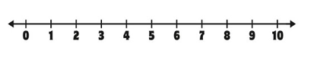
Now, represent the calculation using these different methods.
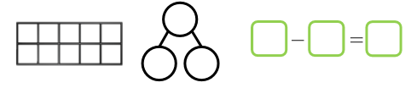
2. Have a go at practising using your number line to work out these simple calculations.
a) 10 - 4 = b) 8 - 3 = c) 9 - 7 =

3.
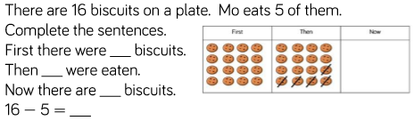
Use the number line to help you.

4. Use the number line to support you working out these calculations.
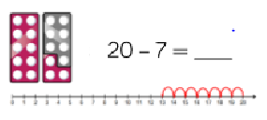
a) 20 - 7 = b) 20 - 8 = c) 18 - 6 =
d) 19 - 4 = e) 17 - 6 = f) 19 - 7 =

5. Reasoning:
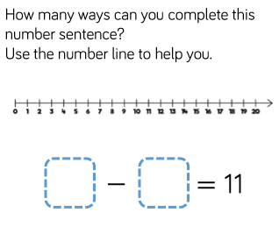
Thursday - WALT: practising using a number line to subtract two numbers (crossing ten)
When subtracting two amounts, where they cross ten, it is important children think about partitioning to make ten.
Tens frames and number lines are particularly useful to model this strategy.
Below are some useful images to remind children of their number bonds to ten.
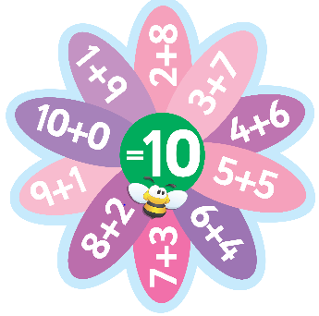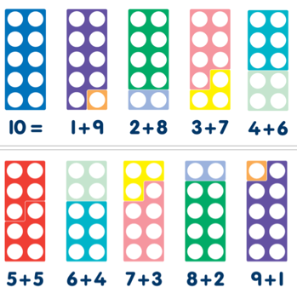
This would be a good point for children to practise making these number bonds with Lego bricks (if you have them) or something similar. For example: 'Here's one I made earlier'.

See if you can identify the number bonds and write the sums beside the picture.
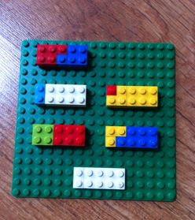

1. Example:
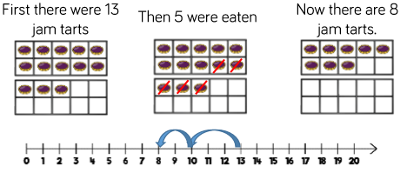
You try:
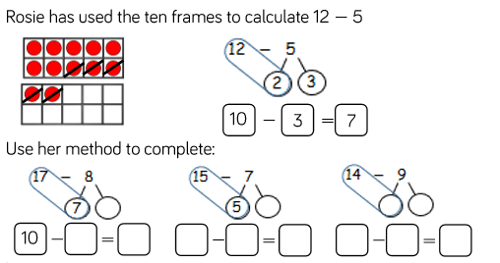
Use the number line below to help you.

2. Elodie bakes 14 cupcakes. Ruben eats 9 cupcakes. How many will she have left? Use the number line to support your calculation.
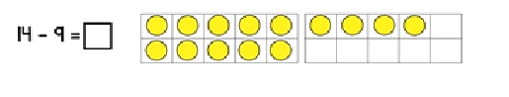
Use the number line to help you practise the method you used for qu 1. Remember to partition to 10 first.
So, 9 is made up of 5 + 4. Count back 4 first, to get to 10. Then, count back 5.
3. Use your number line to work out these calculations, by partitioning to ten, firstly (where appropriate).
a) 18 - 9 = b) 16 - 7 = c) 18 - 6 =
d) 15 - 6 = e) 14 - 9 = f) 20 - 11 =

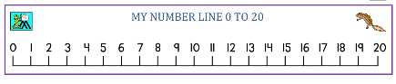
4.
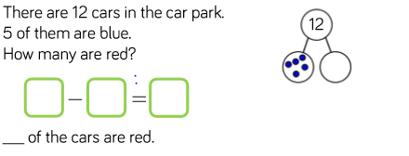
Use the number line to help you.

5. Reasoning:
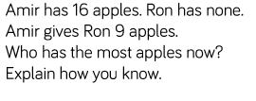
Use your number line to help you.

Friday - WALT: practise using our number lines to help us answer subtraction word problems.

1. If you had 17 slices of pizza and 9 slices were eaten, how many would you have left? Use the number line to help you.
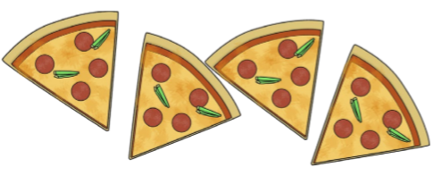
Write the number sentence.

2. If you have 15 lettuces growing in your garden and 6 lettuces get eaten by slugs, how many lettuces would you have left?

Write the number sentence.

3. If you count 12 lady birds in your garden and 7 fly away, how many ladybirds would be left?
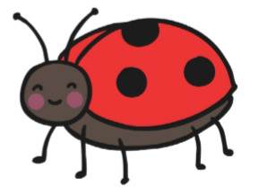
Show your thinking on the number line and write the number sentence.

4. Izabelle had blown up 13 balloons for her party. Unfortunately, 6 of the balloons burst. How many balloons would she have left?

5. Jessica counts 20 rabbits in a field. Suddenly, there is a loud noise and 11 rabbits hop away. How many are left?

6. Challenges:
If you have 21p and you spend 13p on a bar of chocolate, how much would you have left?
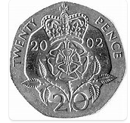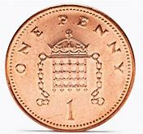

Use the 0 - 30 number line to help you.
Remember: partition 13 into 10 and 3. Then subtract 10, then 3.

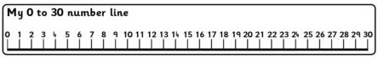

7. There are 24 people on the bus to Exeter. There are three bus stops to Exeter. 9 people get off the bus at the first bus stop and 2 people get off the bus at the second bus stop. How many people are left to get off the bus at the last bus stop?
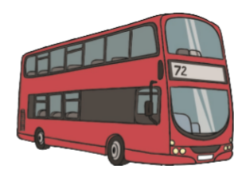
Use the number line to help you and write a number sentence to show your thinking.

8. On a hot sunny day, there were 27 people sunbathing on the beach. 8 people get up and go for a swim. How many people are left sunbathing on the beach?

