Farway Church of England Primary School
Church Green,
Farway, Devon,
EX24 6EQ

Executive Headteacher:- Mrs Katie Gray

(01404) 871239 admin@farway.devon.sch.uk www.farway.devon.sch.uk
4th November 2022
Dear Parents,

In R.E. lessons during the first half of the Autumn Term, the children in Class 1 and our E.Y.F.S. unit have been learning about what it means to belong to a faith community. They began by thinking about what and who is special to them and why, as well as what it means to belong to their family. Following this, the children considered how living in Farway, or attending the school, means that they all belong to the same community. They discussed what is special about the Farway community and looked at objects belonging to the school - including the badge, uniform, website, logo and aerial photo of the school. The children noticed that all of these items belong to school, but what matters in school is the people. This led to them considering some big questions such as: Do the people belong to the school, or does the school belong to the people? Do we belong together? How does it show? The children came to the conclusion that school communities are built out of shared interest, kindness, doing things together and working as a team through problems. They made the link that this happens in families and in religious communities.

Over the course of the following weeks, the Class 1 children had the opportunity to learn about ways people in different religions belong together and how they show it. They learnt about symbols associated with different religions and stories of belonging such as ‘The Lost Coin’. They considered how when a new baby arrives it is a very special time, indeed it is like a gift has been given to the family. They found out how a new baby is welcomed into religious groups and investigated what happens at a traditional Christian baptism and compared it with a Jewish ceremony. Finally, they investigated weddings and learnt that marriage involves looking after each other for the rest of your lives, so people make promises to each other on their wedding day. They were most excited to dress in their finest outfits to visit the church and hold a baptism and wedding at the end of half term.

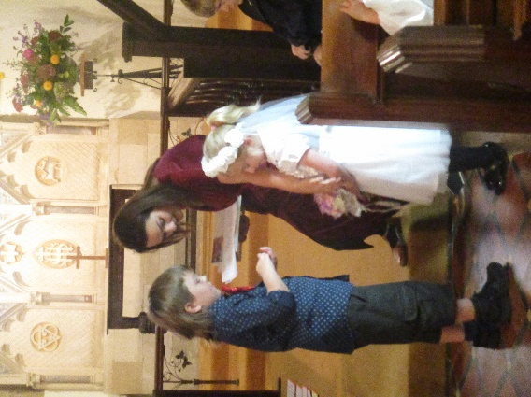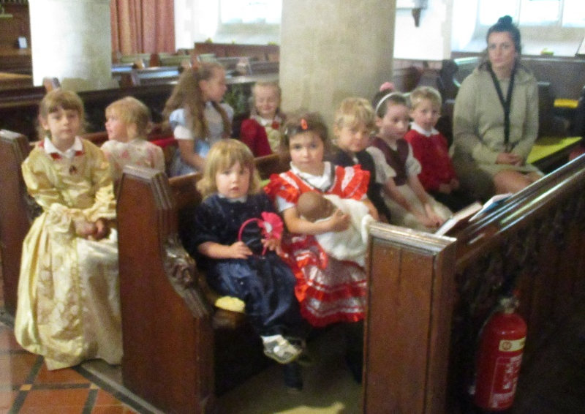

​
Miss Harvey-Jones was delighted to run Class 1’s first ‘Thimbleweed Thursday’ session this week. Some of you will already be aware that ‘Thimbleweed Thursdays’ involve the children arriving at school ready to embrace the great outdoors. After their normal Phonics session, taught in the classroom to ensure consistency and fidelity to our scheme Phonics Bug, the children pull on their wellies and wave goodbye to the indoor environment. The remainder of the timetable and lessons are adapted to be taught outdoors, whether it be Maths, Literacy, Story Time or Collective Worship. Snack is eaten outdoors, although the children return briefly to tables indoors for lunch. Afternoon activities are carefully planned to link in particular to the 'Understanding the World' area of statutory Early Years Curriculum, whilst enabling the children to refine aspects of the ‘Characteristics of Effective Learning’. We are particularly excited by this new aspect of our programme of learning, since for many of our children their well-being is at their highest when they are outside, so it is only natural that we would capitalise upon our knowledge of the children, planning with this in mind.

Whilst we have always had, and continue to maintain, an ethos whereby children have access to our dedicated outside area whatever the weather, this has enabled us to enhance our practice through the use of our wider outdoor spaces, shaping our field, mud kitchen and garden to be an extension of our classroom. Embedding opportunities for a series of planned, quality outdoor learning experiences that are progressive and sustainable within our curriculum, has a great many advantages, including enabling the children to develop the skills of enquiry, critical thinking and reflection, as well as building positive relationships and improving self-awareness and understanding of others, to name but a few. Despite the inclement weather conditions, week 1 was a wonderful success. The children had a great deal of fun building a dinosaur swamp, making their own mud paint (used alongside fig leaves they were able to paint dinosaur footprints) and also had the opportunity to use clay and the natural materials that they scavenged on a hunt around the field, to create model hedgehogs.

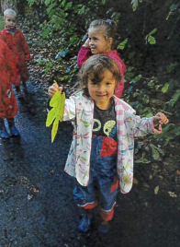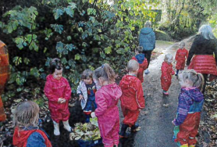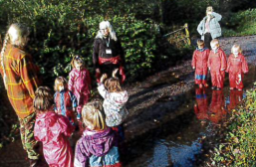

This term Class 1’s key text in Literacy is ‘Meerkat Mail’, drawing on knowledge from their trip to the Axe Valley Wildlife Park. We will be working towards making a ‘Top Trump card’ about a meerkat. In science, we will be learning about animals and habitats, exploring the conditions which affect animals and plants. They will be working towards creating a poster about how to care for an animal. Class 1 are continuing to build their mathematical reasoning (‘math talk’), exploring numbers to 20 and using key words and symbols to explain our answers (less than <, more than >, equal to =).

We would like to take this opportunity to outline Class 1’s Phonics teaching for the next month so that you are better prepared to support pupils in their reading journey.

- Reception: Target phoneme /h/ written as 'h'.
 | Monday | Tuesday | Wednesday | Thursday | Friday
Week 1 | Target phoneme /e/ written as 'e' | Target phoneme /u/ written as 'u' | Target phoneme /r/ written as 'r' | Language Session: Learn to read and spell irregular words “the”, “no” and “go” | Assessment and revision session
Week 2 | Target phoneme /h/ written as 'h' | Target phoneme /b/ written as 'b' | Target phoneme /f/ written as 'f' and 'ff' | Target phoneme /f/ written as 'l' and 'll' | Language Session: Learn to read and spell i
Week 3 | Phase 2 assessments and directed sessions as required.
Week 4 | Target phoneme /j/ written as 'j' | Target phoneme /v/ written as 'v' | Target phoneme /w/ written as 'w' | Target phoneme /x/ written as 'x' | Language Session: Learn to read and spell the irregular words “me
Week 5 | Target phoneme /y/ written as 'y' | Target phoneme /z/ written as 'z' | Target phoneme /qu/ written as 'qu' | Language Session: Learn to read and spell the irregular words “he”, “my”, “by” and “she” | Assessment and revision session

Key Stage 1: Target split digraph /o-e/ such as in joke.
 | Monday | Tuesday | Wednesday | Thursday | Friday
Week 1 | /igh/ as /i/ | /oa/ as /ow/ | /oa/ as /o-e/ | /oa/ as /oe/ | Language Session: Looking at Spelling, Punctuation and Grammar
Week 2 | /oo/ as /ew/ | /oo/ as /ue/ | /oo/ as /u-e/ | /oo/ as /u/ and /oul/
Week 3 | /or/ as /aw/ | /or/ as /au/ | /or/ as /al/ | /ur/ as /ir/
Week 4 | /ur/ as /er/ | /ur/ as /ear/ | /ow/ as /ou/ | /oi/ as /oy/
Week 5 | /ear/ as /ere/ and /eer/ | /air/ as /are/ and /ear/ | /c/ as /c/ | /c/ as /k/

The children in Class 2 have now completed their diary entries as air force pilots or evacuees. Their ability to refer to everyday life in World War 2, discuss the realities of bombing and share the feelings evoked at that time was breath-taking. Why not read them while visiting Class 2 during the next Sharing Assembly (at 3.10pm on Friday)? You will find them displayed and also hear directly about the exciting work completed across the school. Class 2 are now learning about ways to persuade our reader, through looking at war time propaganda and speeches. They are getting ready to convince their readers using persuasive devices including modal verbs.

In Maths, the Class 2 children have been working hard on developing their addition and subtraction skills. As well as building and strengthening their mental strategies, they have been learning jottings and more formal methods such as recording in a column. Although their first thought should be ‘can I do this mentally’, sometimes the calculation requires many steps and many exchanges. Another vital skill is their knowledge and quick recall of multiplication table facts, both 4x5=20 and 20 divided by 5 = 4.

We appreciate your support in encouraging all Class 2 children to continue practising their times tables online using Times Table Rockstars. Research shows that practising something little and often is more effective than in one long session. Therefore, less than 10 minutes a day will impact your child’s ability to recall these facts quickly and accurately. As they move on in Maths to multiplication and division over the coming month, they will find learning new methods involving larger numbers, which are easier to solve if the main facts are at their fingertips. Class 2’s first target is set to 20 minutes (or more!) over the week, from Friday to Friday. We’ll keep you posted on how they are doing.

Before half term the Class 2 children were fortunate enough to receive a visit from Mr John Rogers, who is Miss Algar’s Grandad. He came to talk to the children about his experiences as a small child during wartime. He shared photos and primary sources, such as ration books and identity cards. Something else he brought in was a model of his childhood home and garden, made out of cardboard boxes. This included an air raid shelter made out of corrugated material. These shelters were called Anderson shelters and many families across the country had one in their back garden. Class 2 have been learning about the Battle of Britain, focusing on spitfires and other airplanes of the time. They were fascinated to learn from someone there at that time that each airplane was recognizable from its engine sound and silhouette.

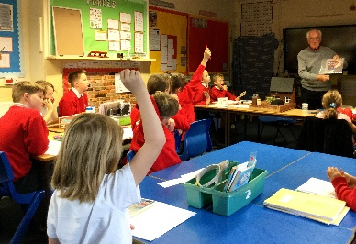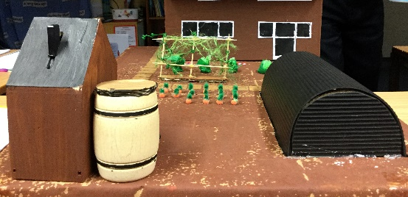

Class 2 enjoyed immensely their science lesson at Honiton Community College. They worked with the Science teacher, Ms Knight, to continue their science learning by focusing on air resistance. They also thought about the value of repeated tests to find an average. Quick paced, the children were discussing and problem-solving throughout. As always, Mrs Marsh was proud that the children gave such a good impression of Farway children as polite, hard-working learners.

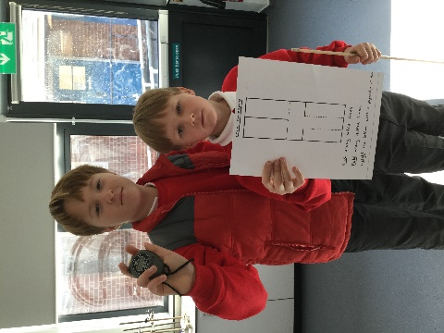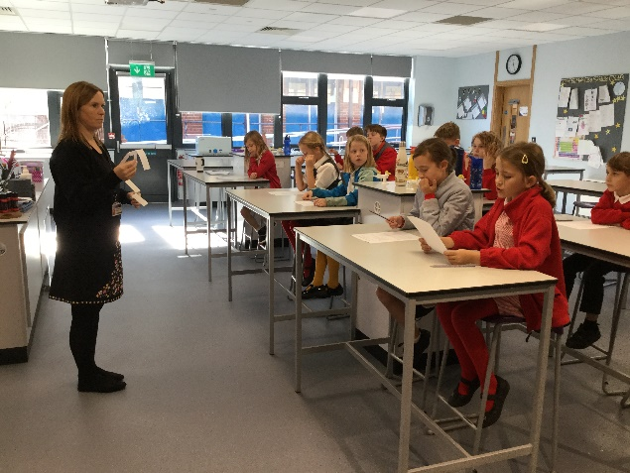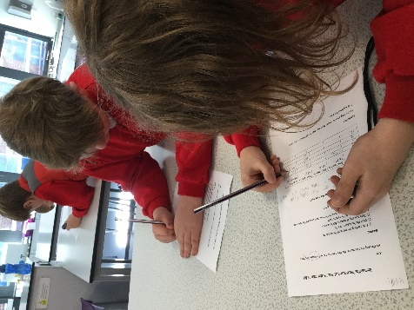

Class 2’s swimming lessons have been a great success. All children will receive a certificate of their achievements, but special mention goes to Oliver W who worked with the group at the deep end, developing and refining his swimming strokes. The swimming instructor commented on his focused attention at all times and improvement of his breast stroke. Also, well done to Lucas who moved groups half way through, due to his stamina growing. He can now easily complete lengths of the pool. Finally, well done to Betsy who can now swim without a float aid.

Our Year 3 and 4 children recently attended a dance event held at Honiton Community College with their friends from Broadhembury and Mrs Marsh. They were taught a dance, section by section, and from the moment they arrived were fully engaged and enthusiastic. Mrs Marsh was pleased to see the music work they had completed focusing on pulse and beat translated to smooth group dancing. The final dance was very impressive after only 40 minutes. In Mrs Marsh’s opinion, as good as any Britain’s Got Talent entry!

Class 2 insisted they wanted to share some specific work they have completed over this month. They have been learning to code using an online program called scratch. Having been set the challenge of creating a ‘Catch Game’, they have been engrossed this week in building their algorithms. Some have asked to continue at break and lunchtime! An important part of coding is the ability to be flexible and try things out. Another learning power that is important when coding is perseverance – keep on trying and don’t give up and get discouraged. The children showed incredible resilience in their attitude to coding, supporting one another with “Ten a Day for Mental Health” suggestions. Well done to them!

Thank you for all your continued support.
God bless and have a lovely weekend.
Best wishes from Katie Gray and the staff at Farway CE School

Orchard Aims

Class 1:
We are very pleased to celebrate our Orchard Aims and
Building Learning Power certificate winners: Anna - for making links
between learning and things she already knew.
Olivia - for being a good friend, kind, caring and considerate.
Robyn - for her hard work in Literacy and good ‘Maths Talk’.
Blake - for Super paint mixing in art.

Class 2:
Daisy – for incredible diary writing in role as a historical person.
Oliver W – for reading 10 books in the Reading Challenge, including chapter books!
Noah – for his insightful contributions in history sessions.
Tom – for being kind, caring and considerate, particularly to the younger children.
Oliver B – for being a positive, hard-working confident learner: every single day!

Question of the month:

Class 1: What questions would you ask if you were a rabbit?
Would they be different if you were a cat?

Class 2: If you were in charge of improving your school, what three things would you change first? Why?

Key Dates – Autumn Term 2022
Tuesday 8th November - Year 5 & 6 Gymnastics at H.C.C.
Thursday 11th November - Remembrance Day.
Monday 14th November - Anti Bullying Week.
Wednesday 16th November - Individual School Photos.
Friday 18th November - Children in Need.
22nd November - Year 5&6 Sports Hall Athletics at H.C.C.
Thursday 24th November- Flu Vaccinations in school – please sign up online.
29th November - KS1 Multi-sports.
Wednesday 30th November - Stir up Sunday.
Thursday 1st December – Christingle.
Friday 16th December- Last Day of term.

Important notices
Poppies
We now have poppies in school, if your child would like one, please bring in a donation. Thank you.
Children in Need
On Friday 18th of November we will be supporting Children in Need. The theme this year is SPOTacular so we are inviting children to come into school dressed in spots. We are also asking the children to think about what makes them SPOTacular. Class 1 children can work with you to think of words and phrases that describe them and that make them special and Class 2 can put together a presentation in the form of a piece of writing, poster, pictures, or computer presentation which explains what makes them special and SPOTacular. We will look at these on Children in Need day. We are also asking for a £1 donation from any families who would like to donate to the charity
Clothing
Please can we ask that all clothing that comes in to school is named? This should include clothes for Thimbleweed Thursdays, especially all puddle suits, the spare clothes children bring and the bags they bring them in. Also please can everyone have a water bottle in school every day, especially Nursery ad Reception children on Thursdays? Thank you.
Christmas Play
Due to unforeseen circumstances we have had to change the date of our Christmas Play, once we have confirmed a new date with the church we will let you all know.
School Access
Please note that the school grounds are strictly off limits outside of school hours, including during the school holidays. This is very important for Health and Safety reasons.
School Times
We ask that children are in school by 8.50am each day. Please remember if your child arrives after 9am they will be marked as late.
Breakfast Club
Our breakfast club, continues each morning at 8am and costs £2 per session, including a choice of cereal, toast and bagels. Please contact the office if you would like your child to come along. Thank you.
Sickness
Please remember if your child experiences sickness or diarrhoea that they need to stay off school for a full 48 hours afterwards. This is recommended guidance to stop the spread of illness. Thank you for your help.
Medication
If your child has medication that needs to be administered in school, then you will need to bring it to the school office, so that it can be stored securely. The medication must be in its original box with the prescription label attached, naming the child. You will also need to fill in a special form giving permission for the school to administer the medication. Please ask at the office for more advice. Many Thanks.
Cool Milk
If you would like your child to have milk each day please register online. Under 5’s will be registered if you let the office know that your child. Children who are entitled to Free School Meals can have milk free each day. Please let the office know if you would like this to happen. Thank you for your help.

Child Absence
If your child is unwell please telephone the school before 9am to let us know that they will not be attending. This is a legal requirement. As a school we legally have to account for pupil absences, to do this we need written confirmation of any absence. We routinely send home absence forms when children are away from school. If these forms are not returned your child’s absence will be marked as unauthorised. Spare forms are always available from the school office. Thank you.

Water Bottles
Please could we remind all parents that all children including nursery children should have a water bottle in school at all times? Please do not send in juice in bottles. Thank you for your help with this.

Wellbeing
There has been much press in recent months about children’s mental health. As part of our drive to support this we are going to include something each month in the newsletter about Health and Wellbeing. We hope you find this section useful. If you have any topics you would like us to find some helpful tips about, please let us know.

Life can be very busy and it is sometimes hard to relax and have time to be peaceful for even a few minutes. Use these kids meditations to support your children in this, ‘Peace Out’ is a series of guided relaxations and visualizations for kids.
https://cosmickids.com/?video_series=peace-out

Peace Out - Cosmic Kids
A lovely guided meditation for kids - all about loving kindness. We imagine our loving thoughts as ripples on a lake's surface. When we think kind thoughts, they find their way out into the world and make it a better […]
cosmickids.com

Collective Worship Activity
This term we will be focussing in school on the value of Wisdom hope your family will find these ideas helpful as you explore the value and have fun together. If the children bring back something that you have done at home linked to the Collective Worship activity, or can talk about a discussion they’ve had at home linked to it, then Mrs Gray will award them with a new special sticker.

